PLANT BIOMASS MEASUREMENTS:
In the field: (Try to take all measurements between 10 a.m. and 2 p.m. on a clear day.)
1. Record location or site name, date, and sky conditions.
2. Take a GPS reading recording your coordinates and the coordinate system you used. (Note: The GPS reading is taken one time only once per site, we do not need to record for each rep in the same area or for every recurring visit to the same area.)
3. Take two photos per site: one of the overall landscape with the plot in the center of the frame, and one looking at a single rep showing the quadrat encompassing the target plant. Label the photos, or record their number on the datasheet.
4. Choose a random sample area for your quadrat. Please walk around the back side of the sample area to make sure not to trample the stand in front of the area you will be taking light measurements. Avoid choosing areas adjacent to where previous samples were taken. In a natural setting: if possible, choose an ungrazed area. In a crop setting: avoid edges of the plot, try to make sure that the sample is taken in the plot interior, and sample mid row to mid row to get a representative sample. We recommend a quadrat 50cm wide by the length of your light bar. The length of your light bar is determined by the number of activated segments (light bar length with all segments activated is 80cm). See ‘AccuPAR LP-80 Basics Standard’ for how to use the light bar, and activating segments.
5. If there are any non-targeted plants in or overshadowing your quadrat, remove them, or relocate the quadrat. We only want canopy cover from targeted species.
6. Record the time of day, average phenology, and the average plant height in centimeters.
7. Take light interception readings using the ceptometer:
a) Select an area under direct sunlight near your plots, and level the external sensor on the tripod. (Note: Whenever you move the tripod, you must level the sensor and calibrate again.)
b) Calibrate the light bar with the external sensor: Take at least 10 measurements with the light bar under direct sunlight. (Note: Make sure you are facing the sun and not shading the light bar or the external sensor.) Record the shown average of all 10 measurements on our datasheet, or by pushing enter and annotate the record.
c) Measure LAI of the canopy using the light bar: Take at least 6 evenly spaced measurements in each quadrat near ground level. For each measurement the light bar is placed perpendicular to the rows and is moved laterally along the width. For 50cm width, measurements are taken every 10cm. Record the average. (Note: The main thing is not to bias the sample in favor of more plant or bare ground.)
8. Harvest plants: Remove all plant material in quadrat directly above the height that light was measured and place in labeled bag (Label contains: species, rep, date, location).
9. Repeat steps 4-8 three more times for a total of four reps for each of the targeted plant(s). For the four reps, make sure you measure plants on the same soil or ecological site. (Note: When you return to the general area for future measurements, select the same species to measure but not the exact same plant/plot area as you previously measured.)
In the lab: Process plant material (Samples must be processed upon immediate return to lab.)
1. Weigh entire sample brought from field and record.
2. If the entire sample is greater than 100g take a representative subsample. This should be between 10 – 30% of the entire sample but no less than 100g. Weigh and record the subsample weight. (Note: Make sure to try to select a subsample with the same proportion of green leaves, dead material, stems, and reproductive structure as the entire sample).
3. If you do not have a LI-3100 leaf area meter, place the subsample in a labeled sealed plastic bag and overnight it and the datasheets to:
Amber Williams
808 East Blackland Road
Temple, TX 76502
Please do not send sample on Friday or right before a holiday.
3. If you do have a LI-3100 leaf area meter:
a) Separate the subsample into dead material (anything completely brown), stems, leaves, and reproductive structures.
b) Record the weight of the dead material, stems, and reproductive structures.
c) Area of each structure will be determined using the LI-3100 leaf area meter. Run the dead material, stems, leaves and reproductive structures through separately and record the area of each.
d) Place the entire sample into a paper bag.
e) Dry in a 66º C (150º F) oven for 3 days.
f) Record the dry weight of the entire sample.
g) Grind dry sample to send off for nutrient analysis.
4. Pick your area.
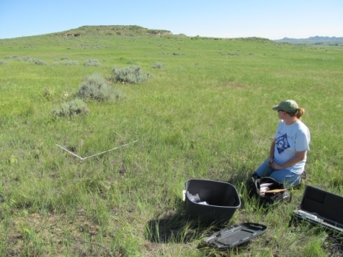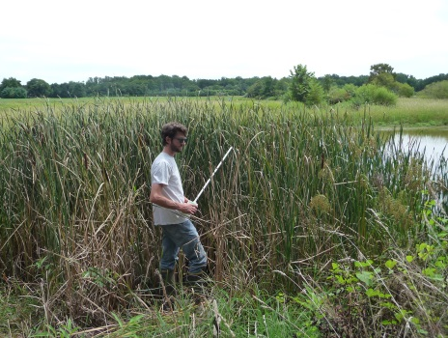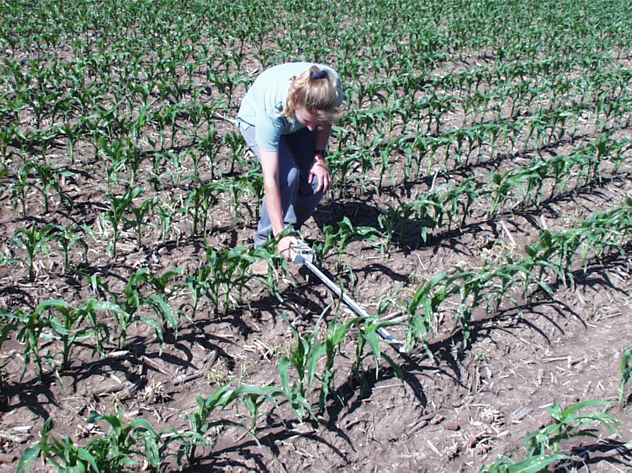
5. Remove non-targeted plants.
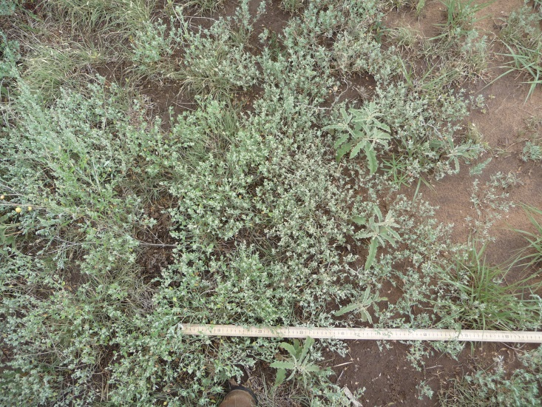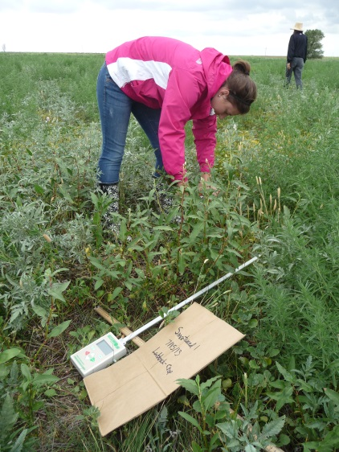
Example of prepared quadrat. 6. Measure height.
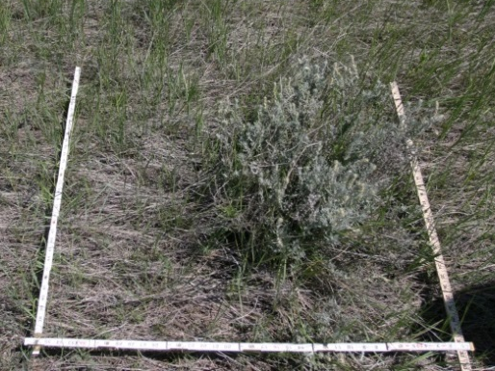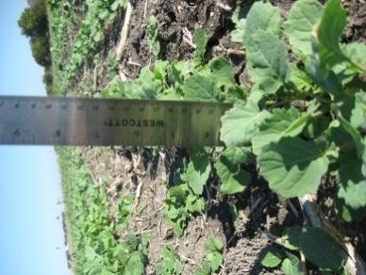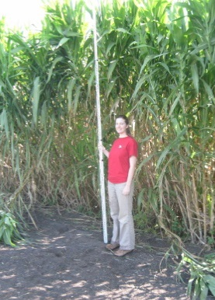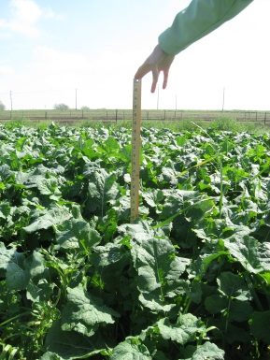
7a. Level tripod with external sensor. 7b. Calibrate ceptometer and external sensor
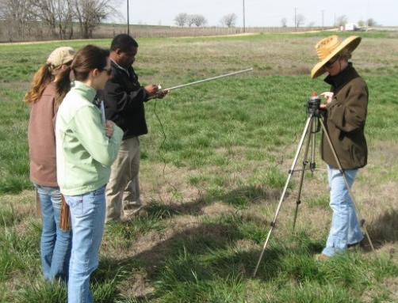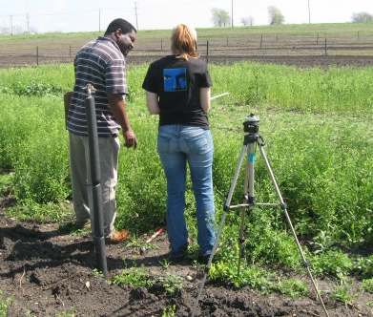

7b. Calibrate ceptometer and external sensor. 7c: Measure midrow to midrow.
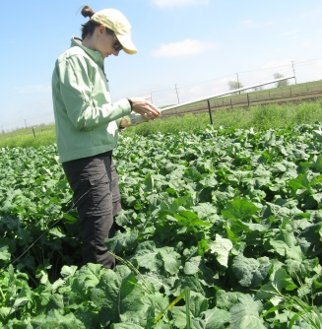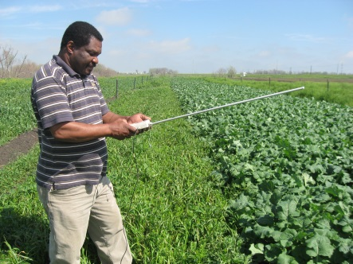
7c. Measure light in quadrat by moving laterally across the area.
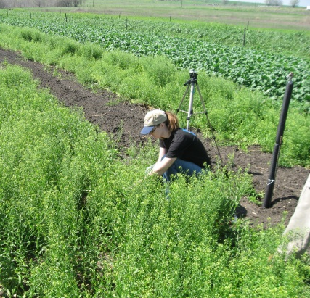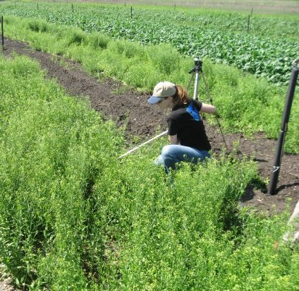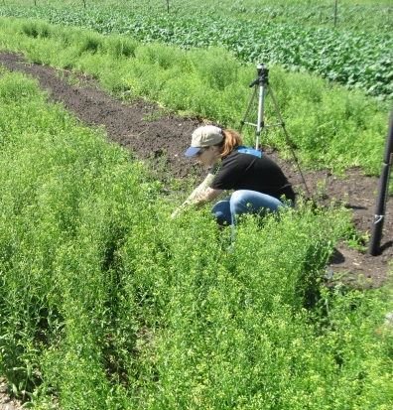
7c: Measure light in quadrat.
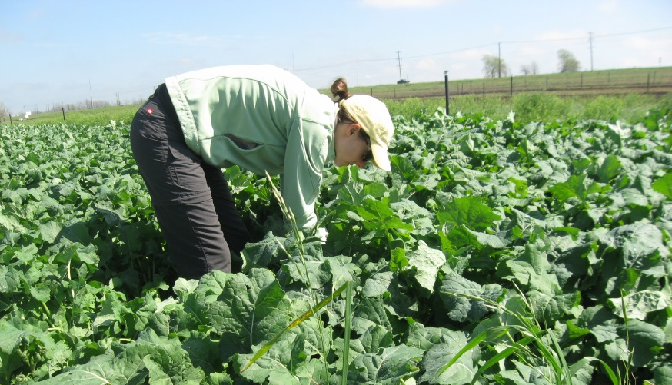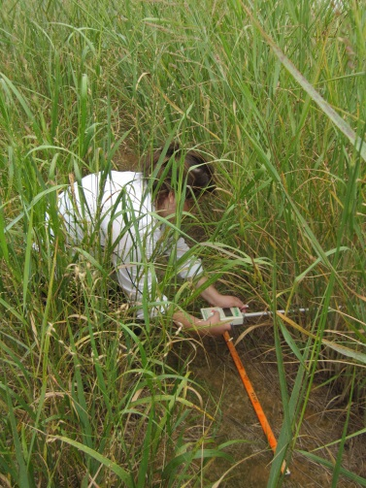
7c: Measure light in quadrat. 8: Label bag for harvest.
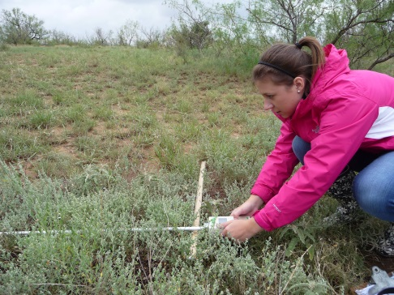

8: Harvest.
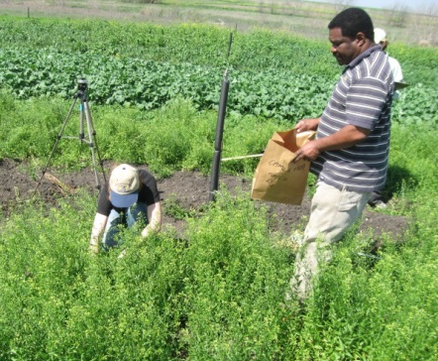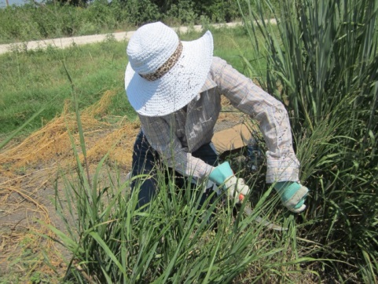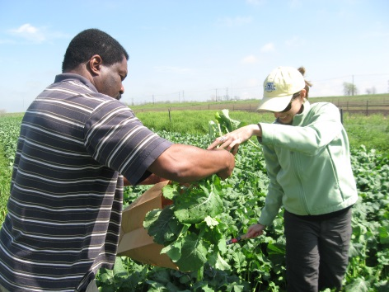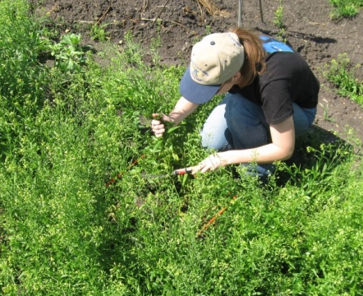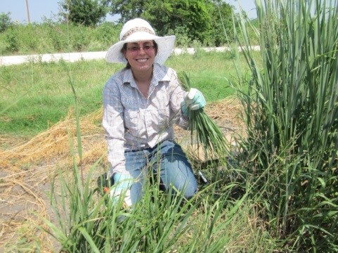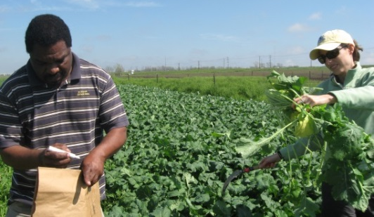

Relevel tripod and calibrate after moving. Lab1: Weigh sample.
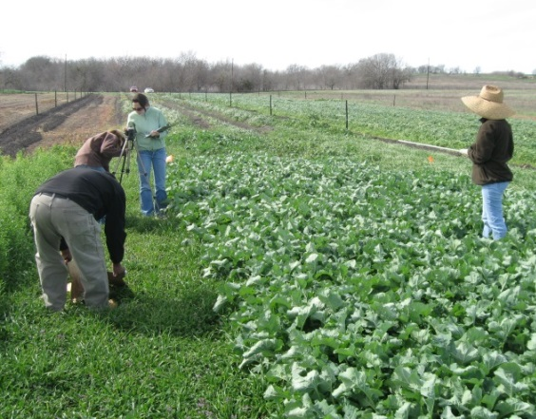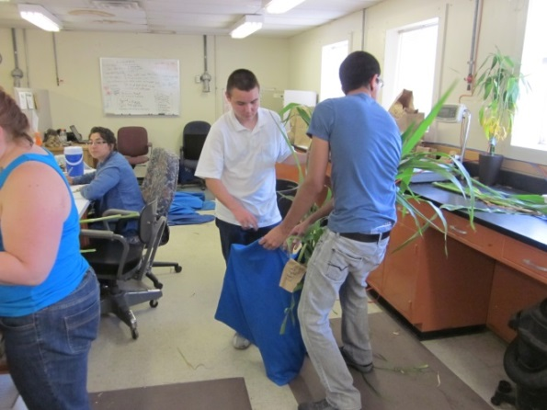
Lab2: Choose representative subsample. Lab3a: Separate then weigh plant structures
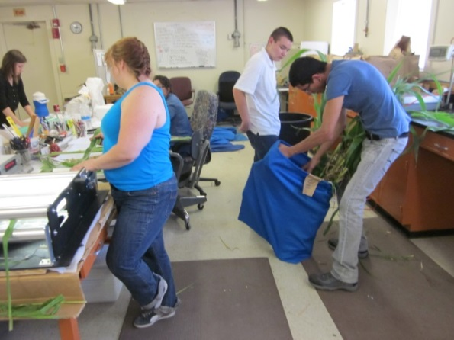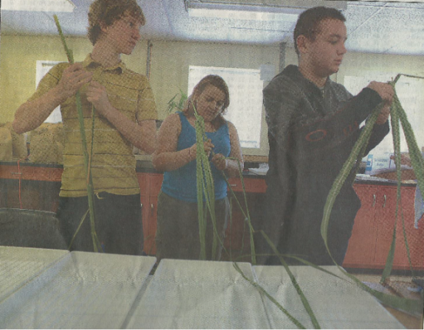

Lab3c: Run structures through leaf area meter individually, leaves are shown here.
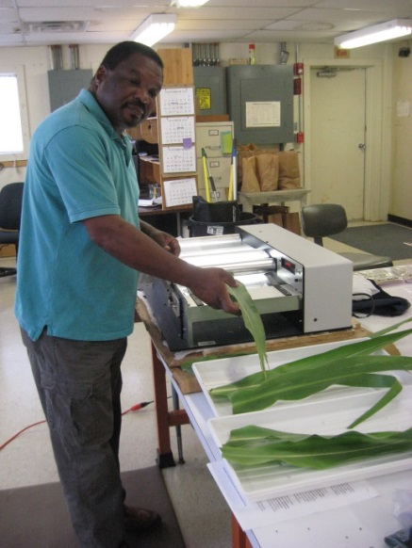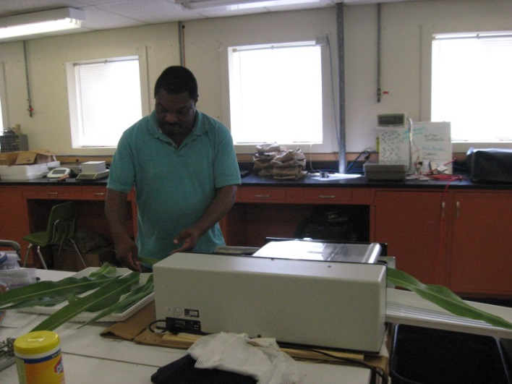
Lab3d: Return subsample to total sample. Lab3e: Dry samples then weigh them. 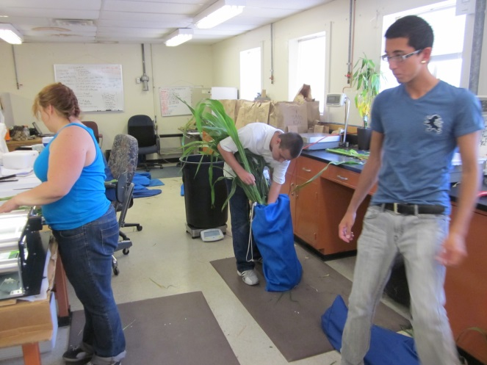 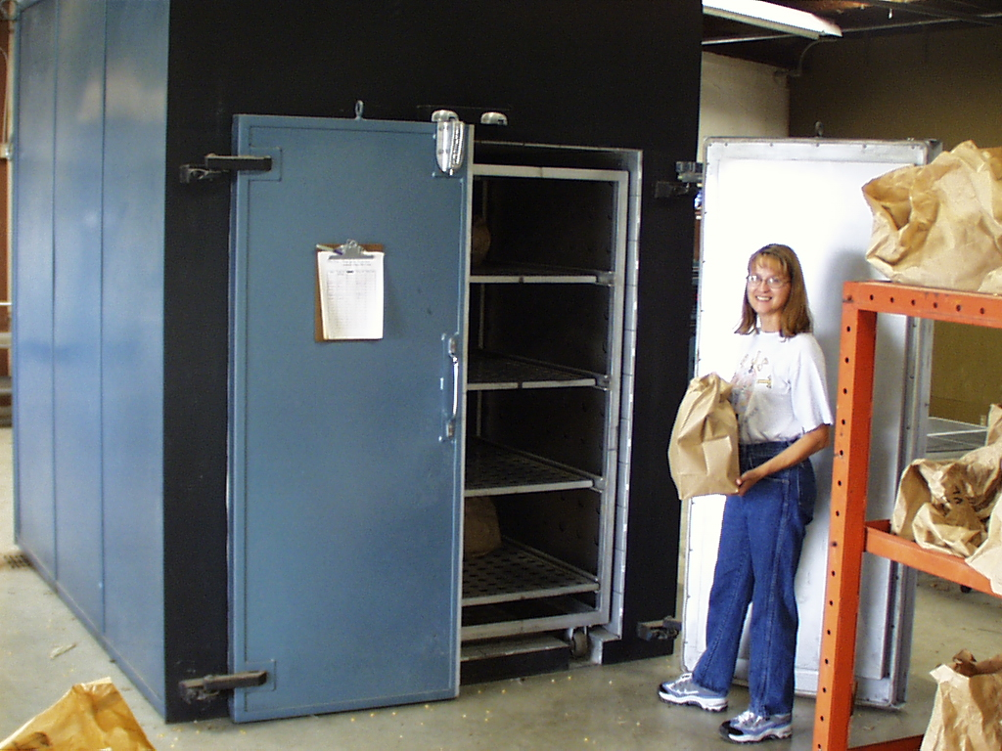
Lab3g: Grind dried plant material then
send off for analysis. Happy Sampling!
