**ANNUAL REPORT FOR 2019**

**National Clonal Germplasm Repository**

**33447 Peoria Road, Corvallis, OR 97333-2521**

**Phone 541.738.4200 FAX 541.738.4205**

**Kim.Hummer@ars.usda.gov** [**http://www.ars.usda.gov/pwa/corvallis/ncgr**](http://www.ars.usda.gov/pwa/corvallis/ncgr)

# 

# National Clonal Germplasm Repository Staff

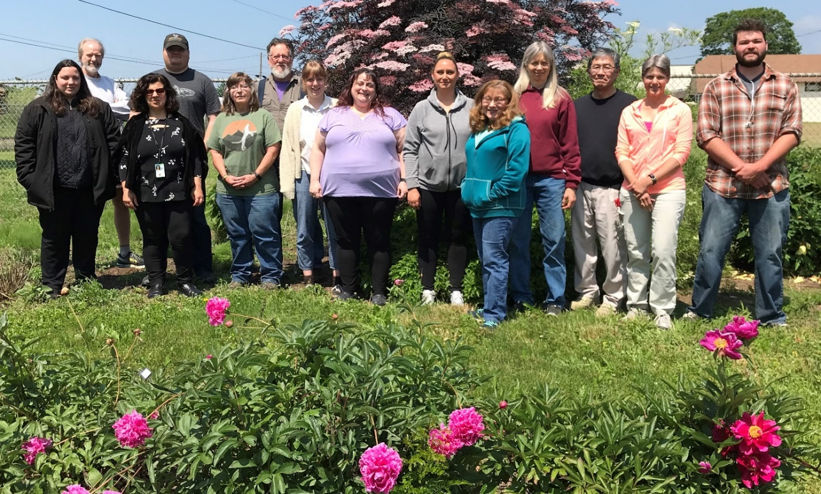

Photo by Kim Hummer

**Permanent and Term Federal Staff**

Kim Hummer, Research Leader/Curator

Joseph Postman, Plant Pathologist/Curator

Nahla Bassil, Geneticist-Plants

Jim Oliphant, *Vaccinium/Fragaria* Mgr.

Jeanine DeNoma, *Humulus/Mentha* Mgr.

Missy Fix, Bio. Science Tech/Distribution

April Nyberg, Bio. Science Tech-Genetics

Jill Bushakra, *Rubus/Ribes* Mgr.

Barb Gilmore, Field Mgr/Curator, Trees

Jason Zurn, Research Associate, Genetics

Ashley Winters, Program Support Asst.

**Temporary Staff & Students**

Jack Brennan, Bio Science Res Tech

Mandie Driskill, Bio Science Res Tech

Sunny Green, Bio Science Tech

Debra Hawkes, Bio Science Tech

Laura Duncan, Bio Science Tech

Colette Lambert, Bio Science Tech

Jane Olson, Bio Science Tech

Katie Pardee, Bio Science Res Tech

Cory Paterson, Ag. Science Tech

Laura Duncan, Bio Science Tech

Jaimie Green, Bio Science Aid

Jun Tanaka, Volunteer /Easter Seals

Chuck Murarz, Volunteer /Easter Seals

Tyler Young, Volunteer /BENCO

**Graduate Students & Visiting Scientists**

Christina Mulch, GRA, OSU, Hort.

Ozge Yalcin, GRA OSU, Hort.

Craig Hardner, Australia

Linlin Chang, China

Priscilla Marchi, Brazil

**Stakeholder/Service Accomplishments**

* 13,007 active accessions, 73 genera and 799 taxa of 683 species of temperate fruit, nut, and specialty crops were conserved.
* Obtained 272 new accessions and 546 new inventory items in CY 2019.
* Shipped 6,605 items.
* Collaborated with NGRPL, Ft. Collins, CO, on backup seedlot preservation, pollen preservation, and on the cryopreservation protocols of dormant blueberry, hazelnut, pear, currant, and gooseberry.
* Collaborated with staff of NCGR-Davis to backup genetic resources of hazelnuts in Parlier, and butternuts and kiwifruit in Corvallis, Oregon.
* Trained/Collaborated with visiting scientists from China, Australia, Brazil, and the US.
* Participated on Governing Board for USDA National Clean Plant Network.
* Participated as Editor of *Chronica Horticulturae* for ISHS.
* Participated on the advisory board for North American Raspberry/Blackberry Assoc (NARBA).
* Participated as First Vice President for the American Pomological Society.
* Expanded potted greenhouse backup collections of *Pyrus* and *Cydonia* for accessions represented by a single tree and at risk of loss due to disease susceptibility, lack of hardiness or small tree size.

**Research Accomplishments**

* Determined a *Rubus* phylogeny using target capture sequencing
* Determined that the most recent common ancestor for *Rubus* is from North America and that it dispersed over land bridges to Asia, Europe, and South America during the early Miocene.
* Determined that *Rubus* diversified greatly on many continents (particularly China) during the middle of the Miocene.
* Detected Black currant reversion virus infection in black currant (*Ribes nigrum*) collection; worked with APHIS to develop a national response plan for this disease.
* Used chloroplast DNA sequence data to differentiate pear species groups, and to identify genetic relationships between pears and other related crops in collaboration with NCGRP, Fort Collins.
* Used interstem grafts to evaluate pear germplasm for dwarfing potential. Correlated pear mother tree architecture traits with dwarfing potential.
* Developed a high-density SNP array for large-scale genotyping of pear germplasm for marker assisted breeding and germplasm collection diversity analysis in collaboration with UC Davis.
* Analyzed genetic diversity and population structure of American wild southeastern blueberry germplasm in the NCGR collection- Identified true-to-type Florida-4B using parentage analysis and provided evidence of its hybrid status (*V. darrowii* and *V. fuscatum*).
* Demonstrated the diagnostic potential of a current marker for *Phytophthora* crown rot in the University of Florida breeding program but not in other diverse germplasm preserved at the NCGR.
* Demonstrated the usefulness of a bioinformatics pipeline in identifying subgenomes of the octoploid strawberry.
* Discovered a potentially novel gene for black spot resistance in rose.
* Identified *Vaccinium* germplasm that is slow to become infected with, and potentially resistant to Blueberry shock virus.

**Administrative Overview**

**Kim Hummer, Research Leader, Specialty Crop Curator**

**Staffing Changes**

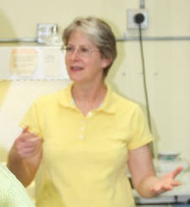Over the past several years, we have seen the beginning of the changing of the germplasm guard. The year 2019 was no exception with several great changes in our staffing. Joseph Postman (right), our quintessential pear curator and employee of 38 years, resigned in August 2019. He began working at the NCGR in a technical position in 1980. He began his career testing our plants for viruses and diseases and managing the pathogen elimination program. Over the years, he developed an appetite for pear and pome fruit germplasm. He was selected as our tree curator. He worked very hard for the tree fruit and nut research community. He participated on many international plant collecting expeditions for the National Plant Germplasm System. He forged great friendships with the North American Fruit Explorers, Home Orchard Society, Seed Saver’s Exchange, and Northern Nut Growers. He worked with the Animal and Plant Health Inspection Service on the Tier 1 committee to determine the development and course of the National Clean Plant Network. For the next several months, Joseph will be finishing a few of his grant projects on a volunteer basis, so we at the NCGR-Corvallis see him from time to time. We have begun the recruitment for the vice-Postman replacement. This vacancy recruitment process is very slow for permanent positions in the federal government now so we will send out a notice when our action becomes active. In the meantime, Dr. Barbara Gilmore (left) has been our acting pome fruit curator. She is busy managing the tree collections for disease infections and coordinating the order process for dormant scionwood distribution.

This past summer, Jack Brennan returned to Corvallis. We were able to hire him in a temporary Bio. Sci. Technician position for six months. He has greatly helped with farm management operations.

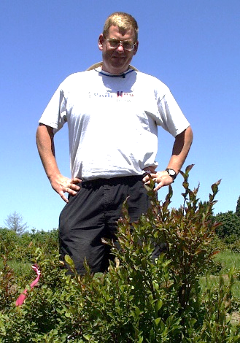Memoriam

Dr. Chad Finn, Geneticist, at USDA ARS Horticultural Crops Research Unit, died unexpectedly on 17 December 2019. Although Chad Finn was not our employee, he was an integral part of our team. He was an advisor on our Small Fruit Crop Germplasm Committee and chaired that committee for a decade or more. He collaborated so closely with our scientists that we would see him almost daily. His friendly imposing personality and booming laughter brought the scientific world of berry genetics and breeding together for positive collaboration. We still hear his commanding voice echoing down our halls. We will work to complete our cooperative projects as a tribute to his great ability to bring people together for plants, science, and fun.

**EEO/CR/Outreach**

* At least 4 physically-challenged individuals were trained in horticultural plant management and label preparation.
* Through a Research Support Agreement with Oregon State University one graduate student was trained.
* During the winter, 3 physically challenged high school students (program was funded through local school district grants) were trained in greenhouse management activities.
* 15 mentally or physically challenged individuals from a local private organization (Work Unlimited) were trained in strawberry greenhouse activities.
* NCGR staff attended Fascination of Plants day; 2 job fairs, and mentored high school students to improve job recruitment skills; Periwinkle School Science Night with staff from HCRU.
* NCGR staff gave approximately 27 tours and presentations to industry practitioners, representatives and producers, and 5 presentations to schools on genetic resource conservation, fruit tree grafting and demonstrating determining botanical nomenclature.
* NCGR staff provided site tours and visits to approximately 337 students from local high schools, community colleges, and universities.

**Budget**

Our total federal budget is $1.534 million. The FY 2019 net to unit budget has remained level at about $1.3 million since 2005. Our federally supported staff had a peak of 17 FTE in 2005 but has been declining since then to 11.48 FTE for FY 2020. Each year our scientific staff obtains extramural funding of $200 to $300 K from a wide variety of research granting opportunities to supplement our base federal funds. Our scientists have been successful in obtaining federal agriculture grants as well as those from commodity commissions and research consortium funding. Our location administrative costs (IRC) are 14.4 %.

**Budget History**

**Employee Summary**

**Facilities**

Our boiler sprung leaks in the summer and was replaced in November. Electrical circuits throughout the building complex, particularly in the greenhouses and screenhouses, were improved with fault protection. The potting area was moved from the headhouse to outdoors under a roof. This reduces the particulates that could potentially be airborne in the headhouse. Algae built up in our greenhouses and on the outsides of the headhouse and on the concrete screenhouse walkway. Pressure washing of our facilities was arranged through a local contractor. A temporary growing area, SH-11, remains under construction next to SH-07. This will provide space for *Vaccinium* which are presently over-running the greenhouses.

**BIG NEWS:**

The NCGR-Corvallis appeared on the President’s budget for architectural planning funding to replace 4 greenhouses and 6 screenhouses. This facilities repair was passed by US Congress! This year, NCGR-Corvallis received $13.5 M facilities funding for wholesale repair and replacement of our 6 screenhouses and 4 greenhouses, and the attached headhouse. We are working with ARS administrators and facilities managers to develop the plans and repair/replace these growing structures. This is GREAT! We are looking forward to FY 2020. We’ll keep you posted on the progress of the upgrade of our facilities. These are the “before” images of house 5.

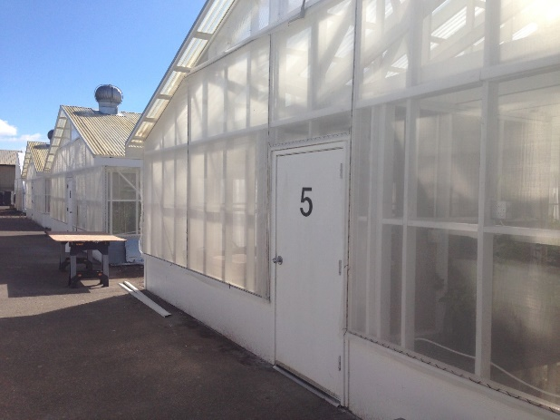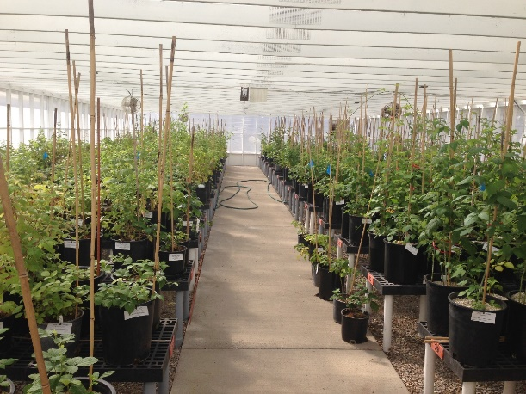

**Germplasm Collections**

**Corvallis Germplasm Collections 2010 -2019**

**Bars represent number of accessions in the NCGR Collection. Line represents number of accessions distributed.**

**Corvallis Germplasm Collections – Accession counts by crop – January 2020**

**Corvallis Germplasm Collections – Total accessions (13,007) by genus, January 2020**

**Major assignment**

|  |  |  |
| --- | --- | --- |
| **Genus** | **Common Name** | **Accessions** |
| ***Corylus*** | Hazelnut | **844** |
| ***Fragaria*** | Strawberry | **2008** |
| ***Humulus*** | Hop | **647** |
| ***Mentha*** | Mint | **455** |
| ***Pyrus*** | Pear | **2377** |
| ***Ribes*** | Currant/gooseberry | **1337** |
| ***Rubus*** | Black/raspberry | **2221** |
| ***Vaccinium*** | Blueberry/cranberry | **1910** |
| ***Total*** |  | **11,799** |

**Other berries**

|  |  |  |  |
| --- | --- | --- | --- |
| **Genus** | **Common Name** | | **Accessions** |
| ***Actinidia*** | | Hardy Kiwifruit | **59** |
| ***Agapetes*** | | Ericaceae | **20** |
| ***Aronia*** | | Aroniaberry | **9** |
| ***Asimina*** | | Pawpaw | **8** |
| ***Cavendishia*** | | Ericaceae | **5** |
| ***Dimorphanthera*** | | Ericaceae | **2** |
| ***Empetrum*** | | Crow berry | **17** |
| ***Epigaea*** | | Ericaceae | **1** |
| ***Gaultheria*** | | Ericaceae | **43** |
| ***Gaylussacia*** | | Huckleberry | **17** |
| ***Hippophae*** | | Sea buckthorn | **1** |
| ***Lonicera*** | | Blue honeysuckle | **82** |
| ***Lycium*** | | Wolfberry | **14** |
| ***Macleania*** | | Ericaceae | **5** |
| ***Micromeria*** | | Ericaceae | **1** |
| ***Pernettya*** | | Ericaceae | **1** |
| ***Potentilla*** | | Quinquefoil | **8** |
| ***Psammisia*** | | Ericaceae | **1** |
| ***Pycnanthemum*** | | Mountain mint | **95** |
| ***Sambucus*** | | Elderberry | **175** |
| ***Schisandra*** | | Magnoliavine | **10** |
| ***Sibbaldia*** | | Rosaceae | **2** |
| ***Symphysia*** | | Ericaceae | **2** |
| ***Total*** | |  | 578 |

|  |  |  |
| --- | --- | --- |
| **Other tree relatives** | |  |
| **Genus** | **Common Name** | **Accessions** |
| ***Amelanchier*** | Serviceberry | **48** |
| ***Amelasorbus*** | Inter-generic hybrid | **1** |
| ***Castanea*** | Chestnut | **3** |
| ***Chaenomeles*** | Asian quince | **48** |
| ***Crataegomespilus*** | Inter-generic hybrid | **3** |
| ***Crataegosorbus*** | Inter-generic hybrid | **1** |
| ***Crataegus*** | Hawthorn | **28** |
| ***Crataemespilus*** | Inter-generic hybrid | **2** |
| ***Cydonia*** | Quince | **143** |
| ***Docynia*** | Asian quince | **2** |
| ***Juglans*** | Butternut | **28** |
| ***Malus*** | Apple | **10** |
| ***Mespilus*** | Medlar | **61** |
| ***Peraphyllum*** | Crab apple | **7** |
| ***Physocarpus*** | Ninebark | **1** |
| ***Pseudocydonia*** | Asian quince | **4** |
| ***Pyracomeles*** | Inter-generic hybrid | **1** |
| ***Pyronia*** | Pear-Quince hybrid | **7** |
| ***Sorbaria*** | False spiraea | **1** |
| ***Sorbaronia*** | Inter-generic hybrid | **7** |
| ***Sorbocotoneaster*** | Inter-generic hybrid | **3** |
| ***Sorbopyrus*** | Sorbus-Pyrus hybrid | **11** |
| ***Sorbus*** | Mountain ash | **136** |
| ***Total*** |  | 556 |
| **Other ornamentals** | |  |
| **Genus** | **Common Name** | **Accessions** |
|  |  |  |
| ***Buxus*** | Boxwood | **1** |
| ***Arbutus*** | Strawberry Tree | **3** |
| ***Camellia*** | Tea Camelia | **1** |
| ***Ceanothus*** | Ceanothus | **38** |
| ***Celtis*** | Hackberry | **1** |
| ***Cornus*** | Cornelian Cherry | **2** |
| ***Elaeagnus*** | Autumn Olive | **12** |
| ***Fagus*** | Beech | **2** |
| ***Holodiscus*** | Beauty Bush | **3** |
| ***Kalmia*** | Mountain Laurel | **2** |
| ***Rhododendron*** | Rhododendron | **6** |
| ***Rhodomyrtus*** | Rose Myrtle | **1** |
| ***Toona*** | Chilean Myrtle | **1** |
| ***Zelkova*** | Zelkova | **1** |
| ***Total*** |  | 74 |

**Greenhouse/Screenhouse *Fragaria*, *Vaccinium* and Quarantine Collections**

**By Jim Oliphant**

* Developed a bulk custom soilless medium for use in the containerized collections.
* Hardwood chips have replaced pumice as a topdress on containerized plants in our screenhouses.
* Pesticides were applied to control aphids, scale, and spider mites.
* Pump was installed for the de-ionized water supply for specific challenging-to-grow plants.
* *Vaccinium* and *Rubus* plants remain in quarantine from 2015 collection to Vietnam.
* Established humid tropical conditions in GH1 to maintain tender accessions. A montane- like environment is under construction for subtropical high elevation crop relatives.
* *Vaccinium* crop wild relative including the entire cranberry collection were repropagated for invigoration of the foundation stock.
* Unknown *Vaccinium* species bloomed and were identified to *V. triflorum* and *V. globosum*.

## *Mentha/Pycnanthemum/Humulus* and *In Vitro* Collections

**By Jeanine DeNoma**

## *In Vitro* collection. Forty-nine accessions of *Fragaria* were identified as having *Strawberry mild yellow edge virus* (SMYEV). Two were duplicate accessions; the remainder were scheduled for meristem treatment to eliminate the virus. Five accessions still healthy in StarPacs in cold storage were propagated in tissue culture and used for meristems. The remainder meristems were obtained from runners on screenhouse plants. One accession, CFRA 442.001 Pioneer did not produce runners this year. Meristems were cut from the other 41 accessions. A total of 282 meristems were cut. Of these, 193 meristems survived and were propagated for ELISA testing.

*Pycnanthemum*: One accession CPYC 44.001 was lost in the greenhouse but recovered from StarPacs in cold storage, propagated and is ready to be rooted for the greenhouse. CPYC 17.001 was highly at risk in the screenhouse. Shoot tips were collected, propagated and rooted in tissue culture and are now ready to replace the screenhouse plant.

*Rubus*: The accession CRUB 1868.001 Tulameen was recovered from StarPac in cold storage to replace screenhouse material. This particular explant was collected from the screenhouse in 2007 so is of interest for molecular variety identification. Five *Rubus* accessions were received from the berry breeding program; these were propagated, rooted and transferred to the greenhouse for the collection.

***Humulus***. There are 392 accessions of *Humulus* in the screenhouse. Thirty-four of these accessions are untested heat-treated meristems representing six accessions cut by Dr. Cai in 2016. Ten core accessions were repropagated by rhizome in the screenhouse, following our success propagating 91 accessions by rhizomes in 2017. We up-potted to P86 pots 242 plants representing 113 accessions from softwood cutting from the virus infected collection in SH7. Another 121 pots representing 54 core accessions are in one gallon pots in the greenhouse, primarily for replacement in the core collection.

***Mentha***. There are 439 screenhouse and greenhouse accessions in the *Mentha* collection. The entire core and non-hardy *Mentha* collection of 48 accessions were up-potted from rhizomes propagated in 2018 and were replaced with two new pots of each. All 14 of the *Mentha* virus collection accessions replaced with newly propagated plants from rhizomes. Of the 376 non-core accessions, 229 accessions were repropagated in 2019; the remainder 146 accessions are scheduled for repropagation this coming year.

***Pycnanthemum***. There are 33 growing accessions in the screenhouse collection. Of these, 21 accessions were repotted to two 5-gallon pots each. Another six accessions were repotted to a single 5-gallon pot and five accessions were repropagated into 1-gallon pots. Two accessions are being recovered in tissue culture and will be moved to the greenhouse in the spring.

## *Rubus/Ribes/Sambucus* Collections

**By Jill Bushakra**

*Rubus*

* Pruning and fertilizing entire collection; repotting into new style pots, labelling and updating inventory for plants in houses 1 & 3 completed
* Propagation of tip-layering genotypes as needed
* Provided material to Patrick Di Bello and Melinda Guzman (Bob Martin) for RNA analysis; provided material to Mary Peterson (Chad Finn) for Boysen field trial; worked with staff from Pairwise Plants, North Carolina, to provide approximately 600 accessions of the *Rubus* collection for DNA analysis and phenotyping; provided material for Ava Howard of Western Oregon University for Rubus water relations study; collected leaf material for cytology study conducted in The Netherlands
* Attended teleconference for PGOC meeting; presented on Repository resources to growers at Caneberry day and annual Oregon Raspberry and Blackberry Commission meeting
* Wrote SOP for emptying the debris trailer
* Pressure washed aisles and benches in houses 1 & 3; put down weed mat in Rubus side of house 3, vacuumed leaves
* Worked with Jun Tanaka on seed evaluation for viability
* Obtained replacement plants from nurseries; obtained new seed lots from Lund University, Sweden; researching identification of NZ *Rubus*
* Obtained virus/pathogen data from Driscoll’s on plants sent to them
* Controlled for pests as needed; maintained pesticide applicator license through continuing education credits
* Prepared houses for winter (washing screen, hanging plastic) and for spring (removing plastic, vacuuming leaves)
* Updated GRIN and included patent information; scanning and attaching intake information into GRIN

*Ribes* field

* Propagated species *Ribes* and cultivar *Ribes* in situ layering and cuttings; obtained replacement plants from nursery; obtained new cultivar, ‘Oregon Snowflake’, developed by Dr. Ryan Contreras, Oregon State University ornamental breeder
* Researching proper name for cultivar ‘Redstart’
* Pruned, weeded (hand and chemical), and fertilized field collection
* Worked with Joseph and Jason to test black currants for Black currant reversion virus (BRV); worked with Jeanine to propagate meristems from BRV infected plants
* Inventoried collection and updated GRIN records
* Harvested dormant wood for cryopreservation
* Observed flowers on *Ribes dicanthum* and *R. komorovii* to determine sex of the plants. Installed out irrigation drip tape in cultivar field. Drove and operated field equipment for flailing, tilling, mowing, and spreading mulch. Mulched entire *Ribes* cultivar field with fir sawdust.

*Ribes* screenhouse collections

* Fertilized and pruned all plants
* Updated GRIN records as necessary

*Sambucus*

* Inventoried and fertilized
* Received new cuttings from Pat Byers and put in propagation
* Updated GRIN records

*Lonicera*

* Inventoried and fertilized
* Contacted a nursery to look into replacement plants
* Updated GRIN records

**Corvallis Seed Lab**

**By Missy Fix**

****During CY 2019, 1899 seed accessions were shipped. 1672 were from the small fruit genera and 227 from the tree genera.   The most requested Genus was the *Fragaria* with 934 requests.  *Humulus* was the next popular with 817 requests.  We received and or collected 92 seed accessions –70 *Fragaria*, 26 *Humulus*, 27 *Rubus*, and 18 *Vaccinium*.  We continue to support requestors wanting material for educating K-12, home schooling, non-profit, community gardening projects and classes with our educational seed of blackberry, yellow raspberry, red raspberry, blueberry, hops, strawberry, pear seed and Mint rhizomes (when available).  This service has been for the most part, a welcomed offering among the various communities.

In continuing with Germplasm seed preservation 1349 accessions for *Fragaria, Rubus, Ribes* have been selected thus far, in increments of 250, 500, or 1000 (depending on the seed amount totals per accession). These seeds being sent for backup preservation at Ft. Collins. For those accessions with more than 3000 seeds on hand will also be backed up at Svalbard in 1000 seed increments.

**Distribution**

* In CY 2019, NCGR staff shipped 6,605 items as seeds, cuttings, runners, scionwood, rooted plants, tissue cultures and DNA and leaf samples and informational material.
* In CY 2019, 958 new orders were received. 662 orders were completed. 602 of these were domestic orders and 30 international.
* The *Fragaria* and *Rubus* topped the list of crops distributed this year – *Fragaria* topped out with 1458 items shipped, *Rubus* with 1413 items shipped. Domestic individuals, state agencies and universities, and ARS researchers received the most germplasm from Corvallis in 2019.
* With the various educational systems such as grade schools, home schooling, and community gardening arenas requesting plant and or seed material, the addition of our educational seed has allowed us to fill orders that otherwise would have been cancelled. In all 205 educational seed packets and plant cuttings were distributed.

**Molecular Genetics**

**By Nahla V. Bassil**

**Students**

Christina Mulch, MS student at OSU, is using expression analysis to fine map aphid resistance in this crop. New MS student, Ozge Yalcin, arrived from Turkey and is considering different blueberry projects.

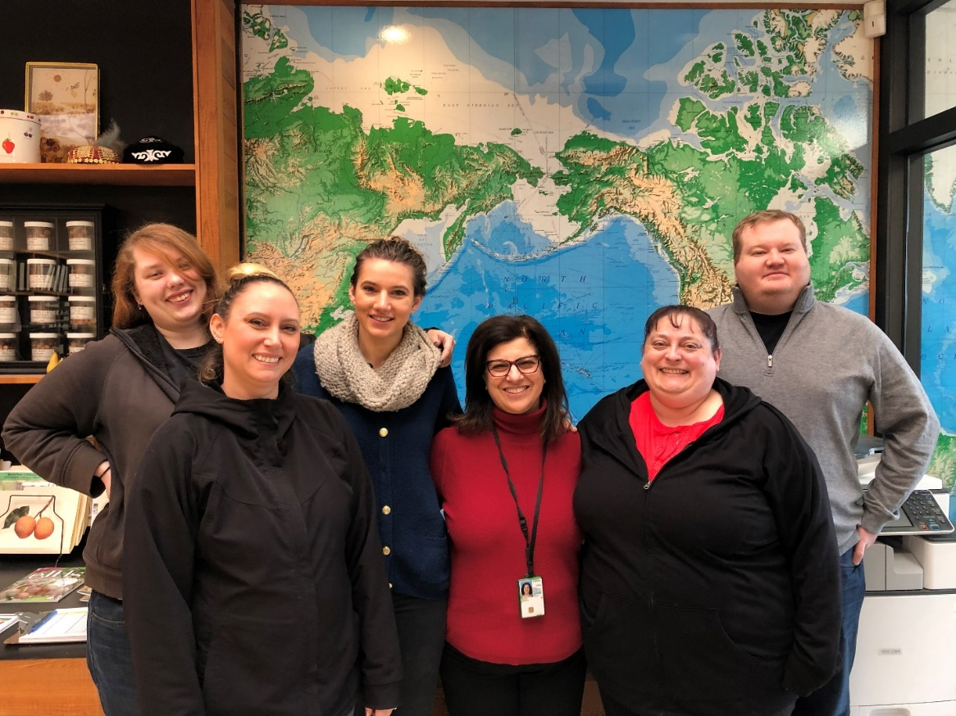

*Genetics Lab Team: From Left to Right Jamie Green, Mandie Driskill, Christina Mulch, Nahla Bassil, April Nyberg, and Jason Zurn*

**Completed Projects**

**Developed a handbook for strawberry DNA tests:**Since its beginning in 2009, the USDA-NIFA-SCRI-funded RosBREED project has developed many genomic resources, including diagnostic tests, to facilitate DNA-informed breeding for horticultural quality and disease resistance traits. Diagnostic tests have also been developed by international partner organizations during this same time. DNA testing is an important tool that can help breeders select potential cultivars without the need to maintain plants long term or perform expensive phenotypic trials. DNA tests allow breeders to make decisions sooner in the selection process, prioritize offspring with higher potential, and be more efficient with available resources. It also allows curators to develop specific collections known to have alleles for desirable traits. To assist breeders and laboratories interested in diagnostic testing, we developed a handbook of DNA tests available at this time for strawberry. This handbook has detailed information about each test and the names of positive and negative controls available at the NCGR for each test. The handbook will continue to be updated as new tests are developed in its online location at the Genome Database for the Rosaceae (GDR).

**Mapped the Black Spot Resistance Locus *Rdr3* in the Shrub Rose ‘George Vancouver’ and developed Diagnostic Markers for DNA-Informed Breeding:** Diplocarpon rosae, the cause of rose black spot, is one of the most devastating foliar pathogens of cultivated roses (Rosa spp.). The primary method of disease control is fungicides and they are viewed unfavorably by home gardeners due to potential environmental and health impacts. Planting rose cultivars with genetic resistance to black spot can reduce many of the fungicide applications needed in an integrated pest management system. To date, four resistance genes have been identified in roses (*Rdr1, Rdr2, Rdr3,* and *Rdr4*)*. Rdr3* was never mapped and is thought to be unique from *Rdr1* and *Rdr2.* It is unknown if it is an allele of *Rdr4*. To assess the novelty of *Rdr3*, a mapping population was created by crossing the *Rdr3* containing cultivar George Vancouver with the susceptible cultivar Morden Blush. The mapping population was genotyped with the rose 68K Axiom array and mapped using the ‘polymapR’ package. *Rdr3* was mapped to a chromosome 6 homolog confirming it is different from *Rdr1* and *Rdr2,* found on chromosome 1, and from *Rdr4*, found onchromosome 5. The mapping information was used in conjunction with the *Rosa chinensis* genome assembly to develop new tightly-linked SSRs for marker assisted breeding. Three markers were able to predict the presence of *Rdr3* in a 63-cultivar validation set. Additionally, 12 cultivars appear to have resistance genes other than *Rdr3.* The improved diagnostic markers will be a great asset to the rose breeding community toward developing new black spot resistant cultivars.

**Used Blackberry fingerprinting set to confirm parentage in new cultivars and identity in the NCPN collection:**An 8-SSR fingerprinting set has already been developed to fingerprint and validate parentage in blackberries. We used this fingerprinting set to confirm parentage of two new releases from Chad Finn’s breeding program, ‘Eclipse’ and ‘Galaxy’. Comparison of the fingerprints of 51 blackberry accessions from the NCPN to that from Chad Finn’s and/or that from the NCGR identified a single cultivar representative, ‘Black Pearl’ with two genotypes. ‘Black Pearl’ from the NCGR (CRUB 2232.001) is very closely related to that from Chad’s field and from NCPN. Parentage analysis is in progress to identify the genotype that could have resulted from the reported cross.

**Confirmed identity of blueberry cultivars by DNA Fingerprinting:** The genotypic identity of the blueberry cultivars in the NCGR collections is critical to genebank management and operations. We had previously developed a 5-SSR fingerprinting set of tri-nucleotide-containing SSRs in blueberry. The objectives of this study were to use this 5-SSR blueberry test to compare fingerprints of all plants representing the most requested blueberry cultivars in the screenhouse and field collections of the NCGR; conduct parentage analysis to confirm identity; establish reference fingerprints for these cultivars; and expand the fingerprinting set with additional long core repeats, if needed. The SSR-set distinguished all but ‘Lateblue’ and ‘Berkeley’ and was supplemented with five additional SSRs with long core repeats to generate a 10-SSR fingerprinting set. Genotyping 367 samples with one or both of these SSR sets and conducting parentage analysis when possible detected 54 true-to-type (TTT) cultivars, 13 sets of homonyms, and ten groups of synonyms. Parentage analysis identified five of the TTT cultivars among the homonyms (‘Bluecrop’, FL 4B, ‘Nelson’, and ‘Clara’) and ‘Elizabeth’ among the synonym sets. A public database of these reference genetic profiles is available on GRIN-Global. We plan to continue adding to this database and eliminate redundant genotypes for more efficient management of blueberry diversity. Confirmed blueberry genotypes will benefit the germplasm community for use in continued breeding and genetic studies.

**Contributed to a new reference genome for pear:** Developed a high density genetic map of ‘Bartlett’. This map was used as an anchor to the improved assembly of the double haploid European pear (*Pyrus communis* L.) genome (referred to as BartlettDHv2.0), obtained using a combination of Pacific Biosciences RSII Long read sequencing (PacBio), Bionano optical mapping, chromatin interaction capture (Hi-C), and genetic mapping. A total of 496.9 million bases (Mb) corresponding to 97% of the estimated genome size were assembled into 494 scaffolds. Hi-C data and a high-density genetic map allowed us to anchor and orient 87% of the sequence on the 17 chromosomes of the pear genome. About 50% (247 Mb) of the genome consists of repetitive sequences. Comparison with previous assemblies of *Pyrus communis* and *Pyrus x bretschneideri* confirmed the presence of 37,445 protein-coding genes, which is 13% fewer than previously predicted.

**Mapped fire blight resistance in pear:** Three pear families were phenotyped for fire blight resistance at the USDA-ARS-AFRS in Kearneysville during 2017 and 2018. These populations were also genotyped with the new 70K pear array. The percentage of current season’s shoot that was blighted was calculated. The phenotypic distributions for each population were severely skewed toward resistance and the number of genes mediating resistance could not be easily discerned. Chromosome scale linkage groups were established for each population using a cross-pollinating mapping approach with JoinMap 5. Each high-quality map had approximately 30,000 markers distributed across the whole genome. An integrated two-way pseudo-testcross approach was used to map QTLs using MapQTL 6. A significant QTL (α = 0.05) mediating resistance was identified for each population in a similar region on chromosome 2. Fire blight resistance QTLs have been previously reported in this region for ‘Harrow Sweet’ and ‘Moonglow’ (a parent of ‘Potomac’). The presence of the chromosome 2 QTL in NJA2R59T69 is interesting as the resistance originated from a non-*P. communis* source like ‘Potomac’ and ‘Old Home’.

**Projects in progress**

**Using synteny and candidate genes to identify loci controlling fruit sweetness in blackberry:**Increased sugar content is one of the most important traits desired by blackberry consumers. A synteny-based approach was used to identify candidate genes responsible for sugar production in blackberry (*Rubus* L.). Three sugar quantitative trait loci (QTL) were identified from the GDR QTL database that are conserved among apple, peach, and alpine diploid strawberry. The physical regions for these QTLs were identified in the *F. vesca* v1.1 assembly and 26 genes with functions associated with sugar production were extracted. Additionally, 789 sugar-associated genes were extracted from the *M. domestica* v3.0.a1 assembly. The strawberryand appl*e* genes were used to conduct a BLAST search in the GDR *Rubus* reference transcriptome. Of 279 *Rubus* candidate transcripts identified, predicted exons were used to design 9,355 Hyb-Seq baits. The baits covered 99.6% of the targeted regions. These baits were used in conjunction with PacBio sequencing to genotype 40 cultivars with high and low sugar content from the University of Arkansas and USDA blackberry breeding programs. A total of 430,167 high quality circular consensus sequences (CCS) were generated. Alignment to the ‘Hillquist’ blackberry and *Rubus occidentalis* genomes, followed by variant identification resulted in 929,430 and 1,324,854 markers, respectively. Welch’s t-test and a Benjamini-Hochberg correction identified 467 and 312 significant loci from the ‘Hillquist’ and the *R. occidentalis* genotype tables, respectively. Population structure modeling identified a total of 173 loci that were significantly (α = 0.05) associated with sugar production regardless of population structure. We are in the process of validating these loci using KASP genotyping.

**Developing two fingerprinting sets in red raspberry:** DNA sequence data from the public domain and that we have previously generated was mined for structural variants and long core repeat simple sequence repeats. After alignment to the black raspberry genome, we identified 9,717,410 sequence variants and 126,616 putative SSRs. Subsequent filtering identified 1,995 genomic regions for assay design. We submitted these genomic regions to IDT for design of a of a 1,000 locus RhAMPSeq assay that would allow for a single multiplexed reaction. The assay will be used to genotype of our red raspberry collection. A second small scale SSR-based fingerprinting assay will be developed using the most informative SSRs from the RhAMPSeq assay.

**Fine mapping black raspberry aphid resistance to the North American large raspberry aphid:** Market expansion of black raspberry is currently hindered by aphid-vectored viruses, such as Black Raspberry Necrosis virus. Natural, genetic resistance to aphids exits and has been identified from three geographic sources: Maine, Michigan, and Ontario. These sources are being used by Chad Finn to breed cultivars with durable aphid resistance. We have developed three new populations (ORUS 5291, ORUS 5296, and ORUS 5306), that are expected to segregate for each of these three sources, to fine map this trait. Segregation of resistance in each of these populations was phenotypically evaluated by aphid inoculation resulting in segregation ratios of 1:1 resistant (R) to susceptible (S) by Chi-squared analysis. Differential expression in 10 R and 10 S seedlings is being assessed with IsoSeq (Full-Length Isoform Sequencing) for one source (ORUS 5306). In addition, Illumina Sequencing for 5 R and 5 S seedlings from each population before and after aphid inoculation is being evaluated. We plan on performing fine mapping of QTL (Quantitative Trait Loci) for aphid resistance in each of these populations using previously developed microsatellite markers and new markers identified using IsoSeq. Our goals are to use these resources to develop useful genetic markers for each source of resistance, and to allow pyramiding of these resistance loci in new breeding populations.

**Assessing genetic diversity in the cultivated strawberry (*Fragaria* ×*ananassa*) collection at the NCGR:** The USDA-ARS national collection includes 560 diverse *Fragaria* ×*ananassa* accessions of modern and historical U.S. and foreign cultivars and breeding selections. An initial core subset of 447 *Fragaria* cultivars (304) and world species (143) was identified in the 1980s by the curator and the Small Fruit Crop Germplasm committee members to represent maximum genetic diversity. Very little has been done to characterize these accessions genotypically. Pedigrees are unknown for many. Since the original core designation, an additional 160 cultivated strawberry cultivars were received by NCGR. The objectives of this study is to genotype the entire *F.* ×*ananassa* collection, assess genetic structure and diversity, confirm pedigrees within the collection, and identify a core collection based on genetic data. The Knapp group has already genotyped 211 of these accessions with the IStraw35 Axiom strawberry array. We submitted DNA from the remaining 332 accessions for genotyping with a new strawberry array that contains 6,000 markers in common with the IStraw35 Axiom and ~40,000 SNPs well distributed across the new ‘Camarosa’ genome assembly. Curation of the genotypic data is currently in progress.

**Evaluating genotype x environment interactions for predicting SSC in strawberry:** Strawberry fruit flavor is due to a complex mix of sugars, acids, and aromatic compounds. Consumers tend to prefer sweeter strawberry cultivars. Therefore, sweetness has been an important target trait for breeders. The majority of strawberry soluble solids are sugars, and soluble solid content (SSC) is used as a proxy to determine sweetness. A strong genotype × environment (G × E) interaction has been observed for SSC, causing difficulties when studying the genetics underlying SSC in individual environments. A meta-analysis of multiple environments may provide new insights toward unraveling the genetics underlying SSC. Genotypic and phenotypic data were collected for 3,407 total individuals from seven breeding programs (four in the United States, one from Spain, the United Kingdom, and Australia). Subsets of the individuals were evaluated for SSC in 19 environments. Genotypic information from the 90K and 35K Axiom arrays was reduced to 12,951 high quality single nucleotide polymorphism markers shared by all accessions. Missing data was imputed, linkage disequilibrium was calculated, and a relationship matrix was constructed for all samples. Using this information, multiple G × E models were evaluated for their predictive ability among environments. Results are being analyzed to identify genomic models that can be used to predict strawberry SSC in new environments.

**Improving sampling and detection protocols to survey *Ribes* germplasm for black currant reversion virus:** Reversion disease, caused by the eriophyid mite transmitted black currant reversion virus (BRV) is one of the most economically important diseases of black currants (*Ribes nigrum*) worldwide. As such, a national quarantine program has existed in the United States to prevent the entrance of both the mite and BRV. The enforcement of the BRV quarantine can be difficult as the virus exists at a low titer and can be unevenly distributed within the plant. In October 2016, BRV was detected in several black currant accessions at the USDA NCGR in Corvallis, OR using deep sequencing and reverse transcription PCR (RT-PCR). To better determine how widespread BRV is within the collection, we are conducting a survey of the *R. nigrum* germplasm using RT-PCR and are evaluating droplet digital PCR (ddPCR) as a method to improve detection. Samples have been collected during three time points (May, July, and October) to try and identify ideal sampling times given the virus’s low titer in planta. Preliminary work has shown ddPCR is better at overcoming PCR inhibitors naturally present in the *Ribes* leaves. No positive samples were observed during the July collection, including positive controls. The virus may not have built up a high enough titer by July for detection. A subsequent test of the samples from October identified a large number of false positives. We are currently assessing new markers to develop an improved test.

**Developing a multiplex fingerprinting set in hops:** We are developing, testing, and applying two economically viable sets of DNA-based markers for fingerprinting 328 hop accessions from the USDA ARS National Clonal Germplasm Repository world collection; 223 cultivars and selections from the USDA ARS breeding program; and 26 wild samples from the University of Nebraska-Lincoln. Our objectives are to develop markers that can separate botanical varieties of native hops as well as identify standard hop cultivars. The two DNA tests were developed and are being tested at this time. They consist of a single nucleotide polymorphism (SNP) based fingerprinting set, and a simple sequence repeat (SSR) based set. The SNP set consists of 28 SNPs that were converted to a Kompetitive allele specific PCR (KASP) KASP assay by the company LGC Ltd. After testing 44 SSR primer pairs in 16 diverse hop accessions, we selected nine highly polymorphic SSR primer pairs to make up a multiplexed DNA test. We are comparing these two tests in 192 samples to ensure they distinguish each unique genotype. The DNA tests and fingerprinting information will be made available to service providers.

**Accomplishments**

* Established a reference chromosome-scale genome sequence for pear using new techniques. This updated, high-quality pear reference genome will be useful for comparative genomics across the horticulturally important Rose family and enable the development of marker assisted breeding in these fruit crops.
* Identified a region on chromosome 2 that controls fire blight resistance from three different pear sources.
* Identified true parents of new USDA-ARS blackberry cultivar Eclipse using the blackberry fingerprinting set.
* Developed a handbook of strawberry DNA tests that had reference genotypes with known genotypes maintained at the NCGR.
* Identified *Rdr3* as a unique gene for resistance to black spot in roses and developed diagnostic markers that can identify it.
* Confirmed identity of 54 unique blueberry cultivars using pedigree-based analysis with the blueberry fingerprinting set. We also identified 13 homonym sets, and 10 synonym sets of blueberries in the NCGR national blueberry collection and among those obtained from two nurseries, five breeder collections (OR, MN, MS, NJ, and NC) across the US.
* A highly efficient Axiom® 70K SNP array was developed for genetic analysis, high-density mapping and characterization of pear germplasm using sequence data from more than 2000 accessions from the USDA *Pyrus* germplasm collection in collaboration with the University of California, Davis.
* New seed accessions including 34 Pyrus samples and 2 *Docynia* samples were added to NCGR Corvallis collections. New clonal accessions including 2 *Chaenomeles* trees, 49 *Corylus* trees, 10 *Crataegus* trees, 17 *Cydonia* trees, 6 *Mespilus* trees, 5 *Photinia* plants and 29 *Pyrus* trees were added to NCGR collections.
* Developed a reliable *Corylus* species. reference database of 195 accessions through the implementation of a DNA fingerprinting set. Implementation of this test together with the addition of more unique accessions to the reference database will help verification of trueness-to-type of economically important cultivars for the hazelnut industry.
* Identified likely original ‘Boysen’ genotype among four genotypes in the industry (nurseries and private collections) using the blackberry fingerprinting set; and determined its parentage as resulting from the cross between ‘Logan’ x ‘Austin Mayes’.
* Surveyed genetic diversity of mint crop ancestors, *Mentha aquatica* and *Mentha suaveolens*, and determined their ploidy, essential oil composition, and relative Verticillium wilt resistance. This study provided updates of accession descriptions in the GRIN database, and is expected to increase the utility of the *Mentha* collection to the research community.
* Established a reference chromosome-scale genome sequence for black raspberry using new techniques. This updated, high-quality black raspberry reference genome will be useful for comparative genomics across the horticulturally important Rose family and enable the development of marker assisted breeding in these berry fruit crops.

**Tree Fruit Curation**

**By Barb Gilmore, Field Manager and Tree Fruit Crop Manager**

 This year our efforts have been focused on fighting fire blight in the *Cydonia, Pyrus, Mespilus* and *Sorbus* and continuing the ongoing war with Eastern Filbert Blight (EFB) in the *Corylus* collection. In the *Corylus* we are seeing less and less each year, but it remains a perennial pest.

The fire blight invaded the main *Pyrus* collection this year and has required severe pruning of some of the pear trees. We had the pathogen cultured, and this strain is not resistant to streptomycin, the number one preferred antibiotic. The North Farm *Pyrus* have been cut down to their main scaffolds, as have some of the *Sorbus* trees. We have also started bringing down the species pears in the main collection; Because of their height we can’t harvest scionwood and we can’t monitor them for fire blight strikes. This height reduction will allow antibiotic sprays to reach the tree tops and prevent further spread of the pathogen. Also our plan is to spray a dormant copper spray on the trees and then spray with antibiotics during the bloom period for all four orchards. This fire blight pressure made us decide that it is necessary to move the *Sorbus* and the *Cydonia* collections to a different area of the North Farm. Many of the trees in the *Cydonia* collection have systemic infections of fire blight. This systemic infection resists pruning and sprays. The infection continues moving through the tree throughout the summer with young branches showing flagging and death. Those diseased branches must be pruned out and removed from the field. We hope by starting afresh that we can prevent a systemic infection from reoccurring. The *Sorbus* collection abuts Peoria Road and this location prevents air-blast sprayer use on those trees. We have started *Sorbus* seeds and will use these seedlings for rootstocks. *Sorbus* grafts are most successful when the scionwood is grafted onto the same *Sorbus* species rootstock. Once we have established trees in a new location on the North Farm then the old trees adjoining Peoria Road will be removed.

In the *Corylus* collection all of the trees have been reduced to a more manageable height, about 12 feet high. In past years, we scouted for dead limbs to alert us to EFB strikes, but what we observed this year was EFB pustules on healthy appearing limbs. We had a professor from Oregon State University confirm our diagnosis that this was indeed EFB before it has the chance to girdle the branch, which results in branch death. This will require manual inspection of each tree in future years. The pustules on healthy appearing branches caused us to decide to increase our spray schedule to six times per spring instead of the four. A result of the many species in the collection is a longer leafing-out period, much longer than is seen in a typical Oregon hazelnut orchard. The six times per spring spray schedule will start in Mid-March and continue until mid-May. This extended spray program will better protect the young leaves from infection. There is too much inoculum present in this area to not be ever vigilant with our sprays and scouting.

Another main goal that we have achieved for the North Farm is that many of the collections now have drip irrigation. The drip irrigation will provide a more favorable growing environment for our trees, but even more important is that it will reduce water mist from the water wheel irrigation system that we previously used in past years. The mist that the water wheels produce provides moisture for the fire blight inoculum to spread further. Irrigation rates are highest during warm temperatures which creates the perfect environmental conditions for fire blight to spread.

Weeds are a problem on this farm as on any farm, and glyphosate, Surflan, Rely and Casoron were used on the orchards and fields this year. Another method we used for weed control was the zero-turn Kubota mower. This mower allows us to get close to the trees and knock down living and dead weeds. The Stihl weed wacker was used to remove dead suckers and to knock down weeds in the *Pyrus* and the *Corylus* fields. The pear field was groomed extensively for Joseph Postman’s retirement ceremony. Normally, we don’t use insecticides on our collections, but a passive yellow jacket control system was implemented in the pear field to prevent yellow jacket injuries.

All collections received fertilizer, and we continued to use the 20-12-8-8 that is purchased from Wilco. The plants respond very favorably to that mix and it can be applied with the tractor pulled applicator. This fertilizer is applied at a low rate, about 10 pounds of nitrogen per acre. At that rate moderate growth is encouraged, but the trees don’t demonstrate rampant growth.

**Plant Pathology**

**By Jason Zurn (and Joseph Postman**)

****Reversion in black currants, a devastating disease of black currants in Europe, is caused by Blackcurrant reversion virus (BRV). This disease is spread by the black currant gall mite. A quarantine has been in place for many years to prevent both BRV and the eriophyid mite (*Cecidophyopsis ribis* J. C. Fischer), from entering the United States. In 2016, BRV was detected in the US for the first time using high throughput DNA sequencing. It was found in the black currant cultivar *Ribes* *nigrum* ‘Burga’ growing in the NCGR *Ribes* collection in Corvallis, Oregon. A second test using reverse-transcription polymerase chain reaction (RT-PCR) was conducted on ‘Burga’ as well as 11 other black currants which exhibited suspicious leaf symptoms to confirm the presence of the virus. Four of the 11 black currants tested positive for the disease and subsequent sequencing of the amplicons confirmed the presence of BRV. Three of the four black currants which tested positive were growing in the U.S. for more than 20 years. These plants were tested when they entered the U.S. using a graft assay and were determined to be BRV-free. At the time, this was the only tool available for BRV detection. In early 2019, deep sequencing data generated by Ruhui Li (Research Plant Virologist, USDA-ARS NGRL, Beltsville, MD) was analyzed confirming the presence of BRV. A note reporting the presence of BRV in the U.S. was published in Plant Disease (Zurn et al., 2019). Laboratory testing of black currant clones for BRV was coordinated by Jason Zurn (USDA-ARS NCGR, Corvallis, OR). The entire USDA black currant germplasm collection was sampled in April, July, and October 2018 and stored in a -80 freezer for later testing. July samples tested negative by two different PCR techniques. A revised RNA extraction protocol on the October collection resulted in a large number of positives. It is unknown if these positives are false positives or if BRV is more pervasive in the collection but at a low titer than previously thought. Further study will continue on the presence of this virus in the New PCR primers were designed using virus sequence information and are being evaluated for their ability to detect BRV in *Ribes nigrum* germplasm.

Fire blight, caused by the bacterial pathogen, *Erwinia amylovora*, is a constant challenge for pear growers in the U.S. In 2019, work was conducted to map fire blight resistance loci in three segregating populations using resistance data collected by Jay Norelli (USDA-ARS AFRL, Kearneysville, WV) during the 2017 and 2018 growing season in Kearneysville. In each population a significant loci were detected on chromosome 2 for each growing season. The loci in two of populations are identical and correspond to a previously identified resistance locus. The locus in the third population was found in a slightly different location and appears to be unique. Within the two regions there are a total of 30 genes that have functions typically associated with disease resistance. Continued research efforts are being focused on identifying the genes responsible for conferring fire blight resistance. In order to preserve these populations for future research efforts, bud wood was sent from Kearneysville to the USDA-ARS NCGR in Corvallis, OR. Bud grafting was conducted on OHxF 333 rootstocks and the germplasm is being maintained are part of the collection.

Over the past 40 years, clonal germplasm known to be infected with viruses, viroids, and phytoplasmas were acquired by the staff of the USDA-ARS NCGR. These plants were obtained to be positive controls for pathogen testing of the NCGR collection and are maintained in quarantine greenhouse. We have now added these virus positive standards to the NCGR accession and inventory data on GRIN-Global. Virologists and plant protection agencies will find these accessions interesting as positive controls or as unique isolates for study within their research programs. As such, a focus was placed on curating plants containing virus and phytoplasma isolates in 2019, for distribution to plant virologists and plant protection agencies. Individual accession numbers were assigned for these pathogen isolates that separate them distinctly from non-infected clones. In total 172 new accession numbers were added for these pathogen isolates that commonly afflict 7 genera maintained at the USDA-ARS NCGR in Corvallis, OR. These isolates may be an important resource for plant virologists and can be distributed on a case-by-case basis. Orders can be placed on GRIN-Global by searching for accession group name = virus/species through the “Advanced Search Criteria” option.

## Publications

Bassil, N.V. 2019. David Grandison Fairchild: Plant hunter extraordinaire and father of foreign plant introduction. Journal of American Pomological Society.73:139-144.

Carter, K., Zurn, J.D., Bassil, N.V., Finn, C.E., Hummer, K.E. 2019. The importance of being 'Boysen': Examining genotypic variation with simple sequence repeat markers. Journal of American Pomological Society. 73:47-52.

Finn, C.E., Strik, B., Mackey, T.A., Jones, P., Bassil, N.V., Martin, R.R. 2019. ‘Echo’ ornamental reflowering blueberry. HortScience. 54(2):368-370. https://doi.org/10.21273/HORTSCI13646-18.

Finn, C.E., Strik, B., Yorgey, B., Peterson, M.E., Jones, P., Lee, J., Bassil, N.V., Martin, R.R. 2019. ‘Hall’s Beauty’ thornless trailing blackberry. HortScience. 54(2):371-376. https://doi.org/10.21273/HORTSCI13678-18.

Hardigan, M., Poortan, T., Acharya, C., Cole, G., Hummer, K.E., Bassil, N.V.,

Edger, P., Knapp, S.J. 2018. Domestication of temperate and coastal hybrids

with distinct ancestral gene selection in octoploid strawberry. The Plant

Genome. 11(3):180049. https://doi.org/10.3835/plantgenome2018.07.0049.

Hummer, K.E., Williams, K.A., Bushakra, J. 2019. North American crop wild relatives of temperate berries (*Fragaria* L., *Ribes* L., *Rubus* L., and *Vaccinium* L.). In: Greene S., Williams K., Khoury C., Kantar M., Marek L., editors. North American Crop Wild Relatives, Volume 2. Cham, Switzerland: Springer. p.283-327. https://doi.org/10.1007/978-3-319-97121-6_9.

Mccoy, J., Young, J.H., Nifong, J.M., Hummer, K.E., De Noma, J.S., Avendano- Arrazate, C.H., Greene, S.L., Kantar, M.B. 2019. Species for medicinal and social use with an emphasis on *Theobroma cacao* L. (cacao), *Nicotiana tabacum* L. (tobacco), *Actaea racemosa* L. (black cohosh), and *Humulus* *lupulus* L. (hops). In: Greene S., Williams K., Khoury C., Kantar M., Marek L., editors. North American Crop Wild Relatives, Volume 2. Cham, Switzerland: Springer. p. 645-692. https://doi.org/10.1007/978-3-319-97121-6_9.

Montanari, S., Bianco, L., Allen, B., Martinez-Garcia, P., Bassil, N.V., Postman, J.D., Chagne, D., Evans, K., Dhingra, A., Troggio, M., Neale, D. 2019. Development of a highly efficient Axiom® 70K SNP array for Pyrus and evaluation for high-density mapping and germplasm. BMC Genomics. 20:331. https://doi.org/10.1186/s12864-019-5712-3.

Sandhu, D., Pudussery, M.V., Ferreira, J.F., Liu, X., Pallete, A., Grover, K.K., Hummer, K.E. 2019. Variable salinity responses and comparative gene expression in woodland strawberry genotypes. Scientia Horticulturae. 254:61- 69.https://doi.org/10.1016/j.scienta.2019.04.071.

Schlautman, B., Zalapa, J.E., Covarrubias-Pazaran, G., Rodriguez-Bonilla, L., Hummer, K.E., Bassil, N.V., Smith, T. 2018. Genetic diversity and cultivar variants in the NCGR cranberry (Vaccinium macrocarpon Aiton) collection. Journal of Genetics. 97(5):1339–1351. https://doi.org/10.1007/s12041-018-1036- 3.

Verma, S., Evans, K., Guan, Y., Luby, J., Rosyara, U., Howard, N., Bassil, N.V., Bink, M., Van De Weg, E., Peace, C. 2019. Two large-effect QTLs, Ma and Ma3, determine genetic potential for acidity in apple fruit: Breeding insights from a multi-family study. Tree Genetics and Genomes. 15:18. https://doi.org/10.1007/s11295-019-1324-y.

Vining, K., Pandelova, I., Hummer, K.E., Bassil, N.V., Contreras, R., Neill, K., Chen, H., Parrish, A., Lange, B.M. 2019. Genetic diversity survey of Mentha aquatica L. and Mentha suaveolens Ehrh., mint crop ancestors. Genetic Resources and Crop Evolution. 66:825-845. https://doi.org/10.1007/s10722-019-00750-4.

Volk, G.M., Henk, A.D., Richards, C.M., Bassil, N.V., Postman, J.D. 2018. Chloroplast sequence data differentiate Maleae, and specifically Pyrus, species in the USDA-ARS National Plant Germplasm System. Genetic Resources and Crop Evolution. 66(1):5-15. https://doi.org/10.1007/s10722-018-0691-9.

Zurn, J.D., Ho, T., Li, R., Bassil, N.V., Tzanetakis, I., Martin, R.R., Postman, J.D. 2019. First report of Blackcurrant reversion virus in Ribes nigrum germplasm in the United States. Plant Disease. 103:1051. https://doi.org/10.1094/PDIS-03-18-0526-PDN.

Zurn, J.D., Zlesak, D., Holen, M., Bradeen, J., Hokanson, S., Bassil, N.V. 2018. Mapping a novel black spot resistance locus in the climbing rose Brite Eyes™ (‘RADbrite’). Frontiers in Plant Science. 9:1730. https://doi.org/10.3389/fpls.2018.01730.