

United States Department of Agriculture
Agricultural Research Service

EASTERN REGIONAL RESEARCH CENTER FACT SHEET

PROCESSING METHODS FOR HISPANIC-STYLE CHEESES
WITH UNIQUE FUNCTIONAL PROPERTIES
Dairy Processing & Products Research Unit (DPPRU)

Background:
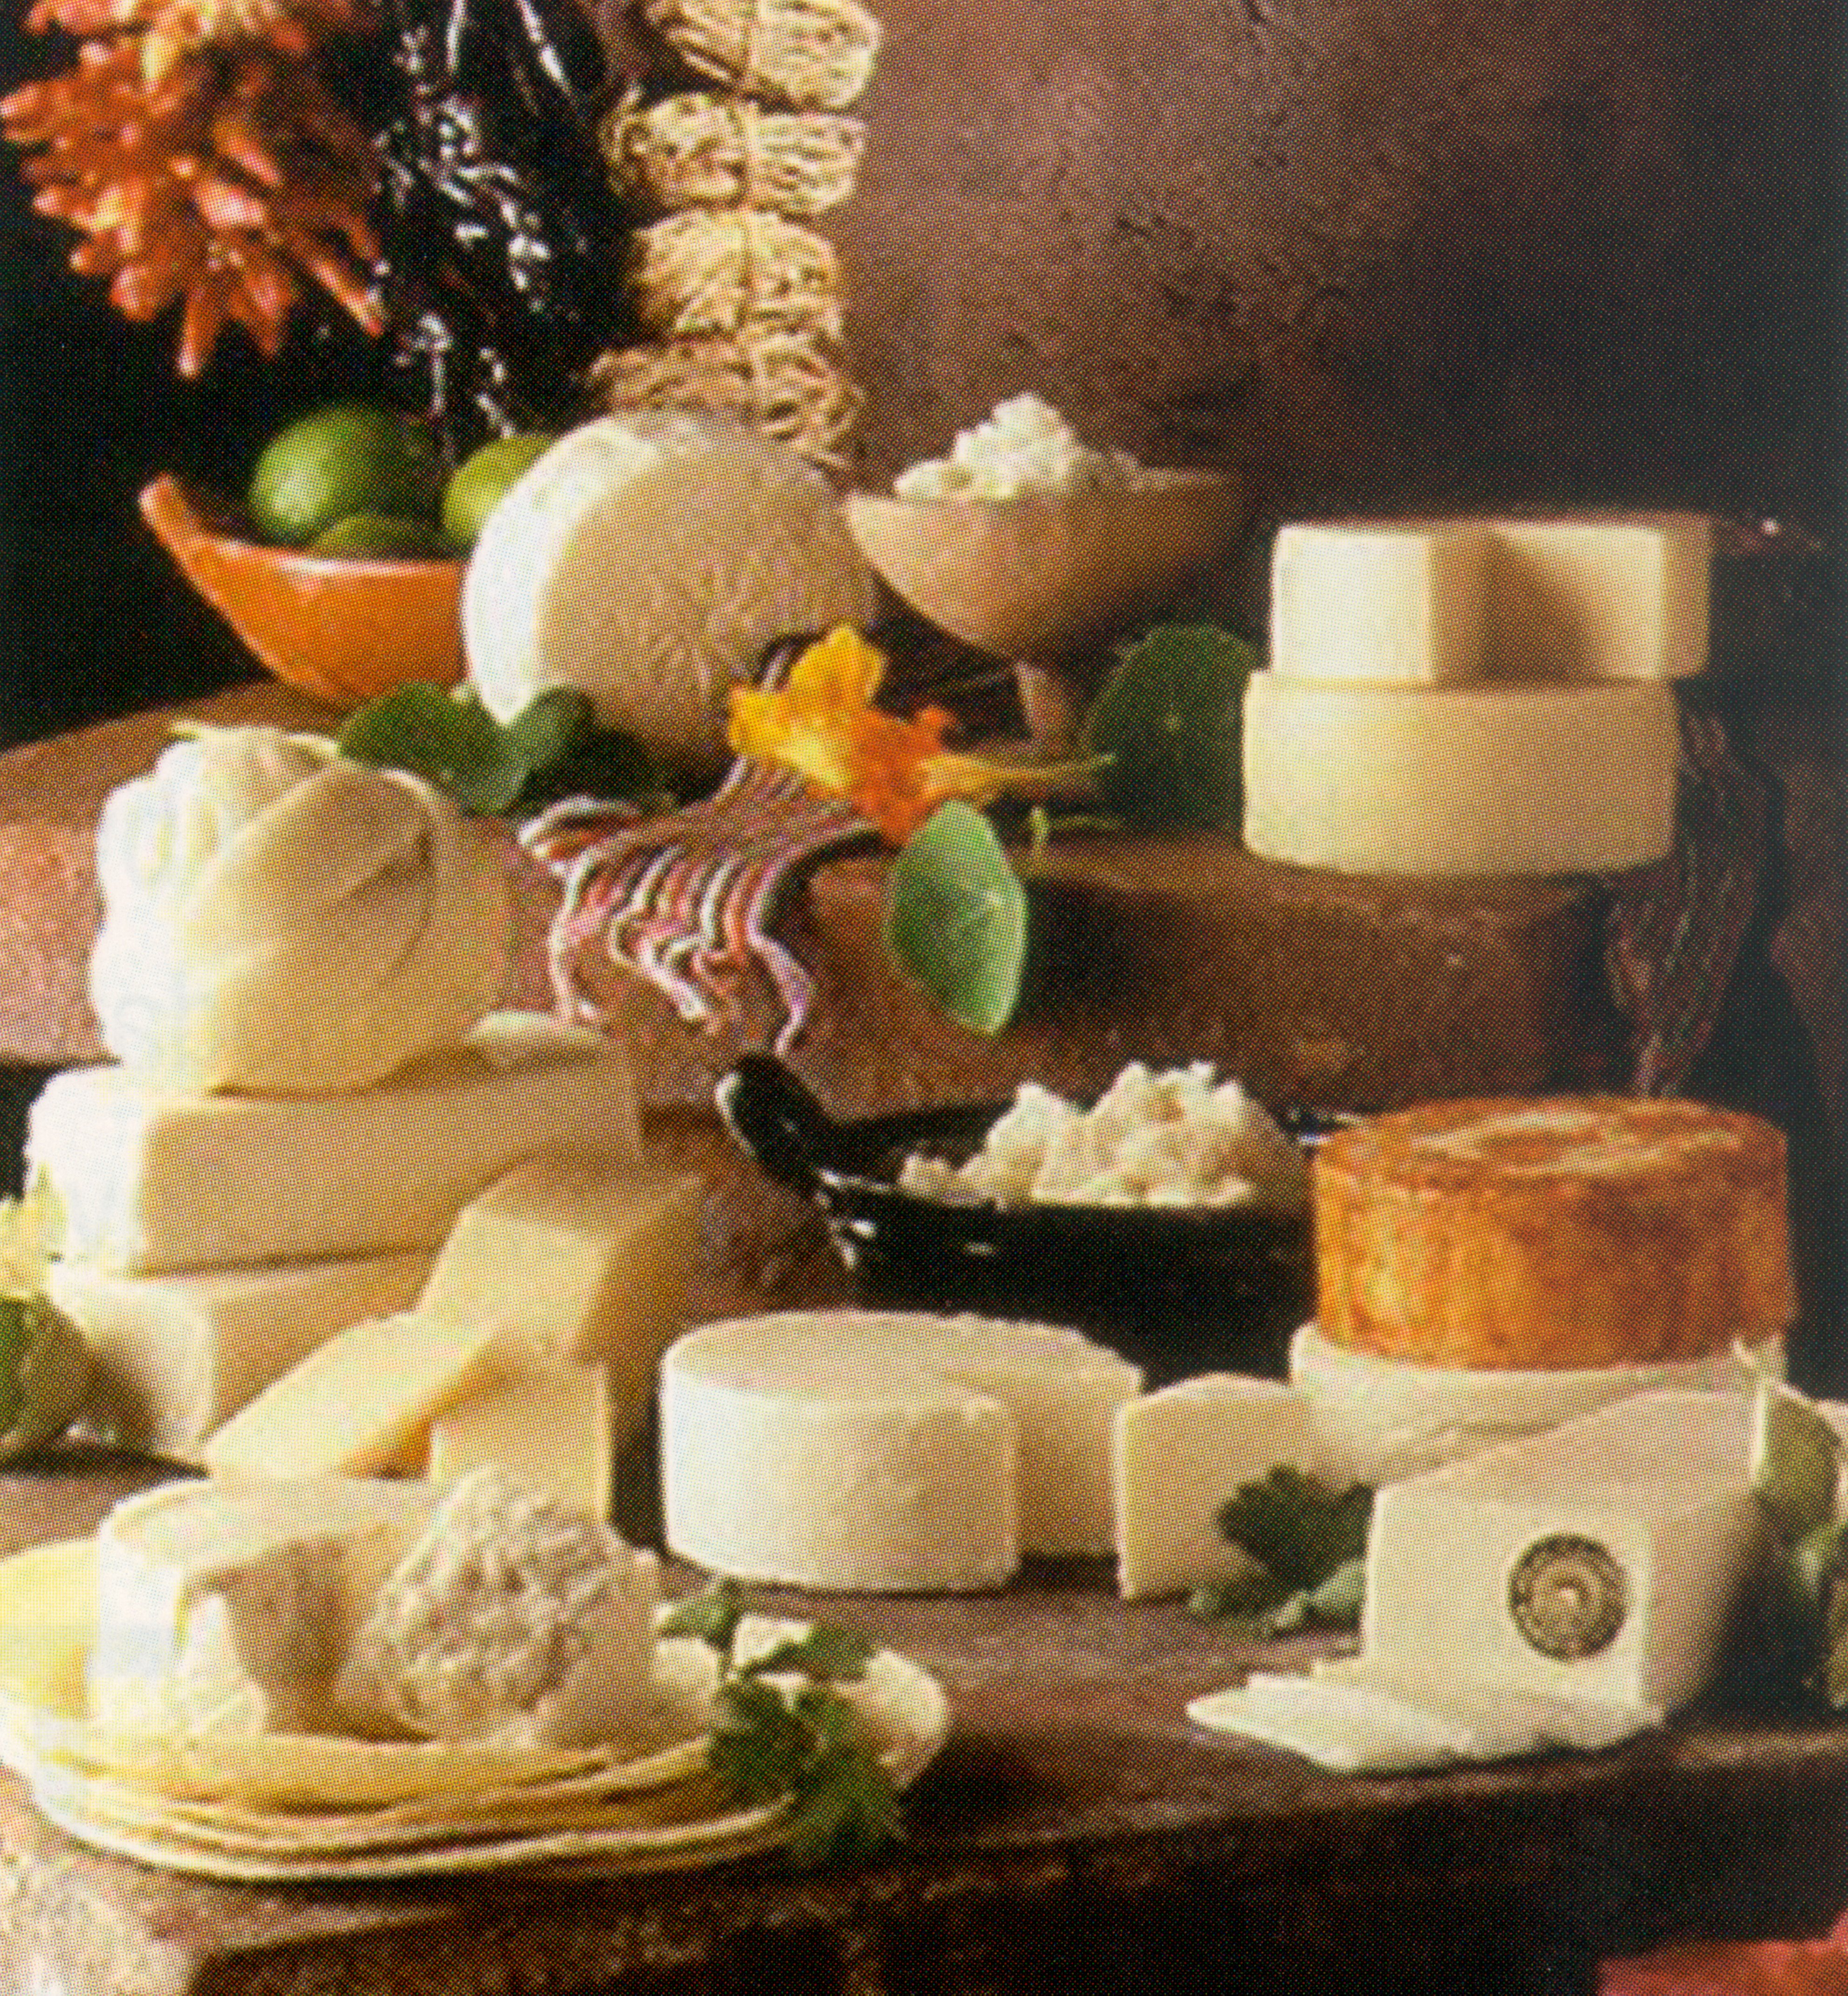
The American consumer and food service industries are demanding new cheeses that are nutritious and safe, have great flavor and texture, and have properties that fit specific recipe requirements. Hispanic-style cheeses meet this challenge because of the diversity in their flavors, textures, and cooking traits. Hispanic-style cheeses are defined as cheeses developed in the Spanish-speaking countries of Mexico, the Caribbean, and Central and South America. The cheese making methods originally brought by settlers for European-style cheeses have, over the years, been modified by various factors and cultural preferences to produce cheeses that have different combinations of flavors, textures, and cooking properties.

Hispanic-style cheeses are one of the fastest growing styles of cheese in the U.S. because of the growing Hispanic population and the incorporation of the Hispanic cuisine into the American diet. Federal Standards of Identity for Hispanic-style cheese have not been established and, as a result, considerable brand-to-brand variation exists for these cheeses sold in the U.S. In Mexico, traditionally-made cheeses are usually manufactured from raw milk and are noted for their unique flavor and cooking properties. However, the cheeses also have limited shelf life because of a high microbial load that may lead to food safety concerns. In the U.S., cheesemilk must be pasteurized for all cheeses that are sold fresh (less than 60 days of aging). Because pasteurization reduces much of the natural microflora in milk, cultures must be added back during the cheesemaking process and, as a result, Hispanic-style cheeses made in the U.S. typically do not have the same flavor and properties of the traditionally-made (raw milk) cheeses.

Research is needed to characterize the attributes (chemical, functional, textural, sensorial, and microbiological) that make Hispanic-style cheeses unique, to understand the impact of processing conditions on the properties of the cheeses, and to determine the interrelationships among the properties, such as the role of microflora present in traditionally-made and pasteurized milk cheeses in flavor development and formation and stability of the cheese matrix.

Research Objectives:

The objectives of this research are to evaluate three popular Hispanic-style cheeses (Queso Blanco, Queso Chihuahua or Menonita, and Queso Fresco) in the following manner:

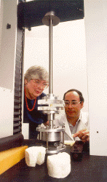
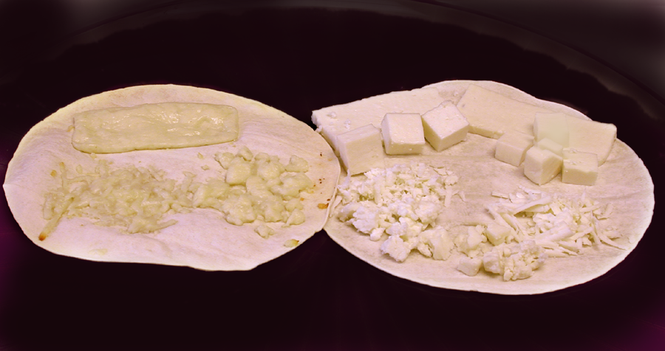
1. Characterize and quantify the chemical, functional, and physical properties of traditionally-made and pasteurized Hispanic-style cheeses.
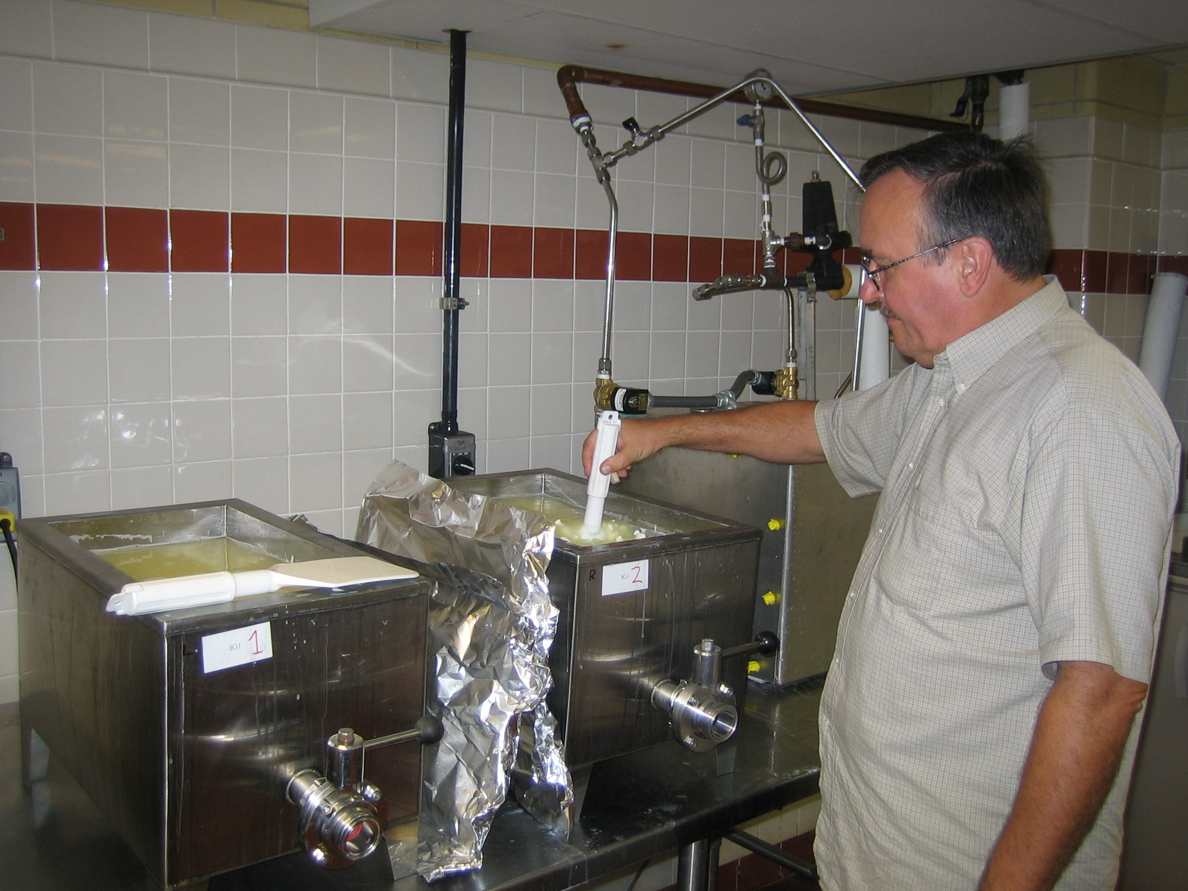
2. Identify the cheesemaking steps or parameters that are responsible for giving the cheeses their unique characteristics, and develop cheesemaking methods to produce pasteurized Hispanic-style cheeses that meet U.S. regulations and retain the desirable properties of the traditionally-made cheeses.

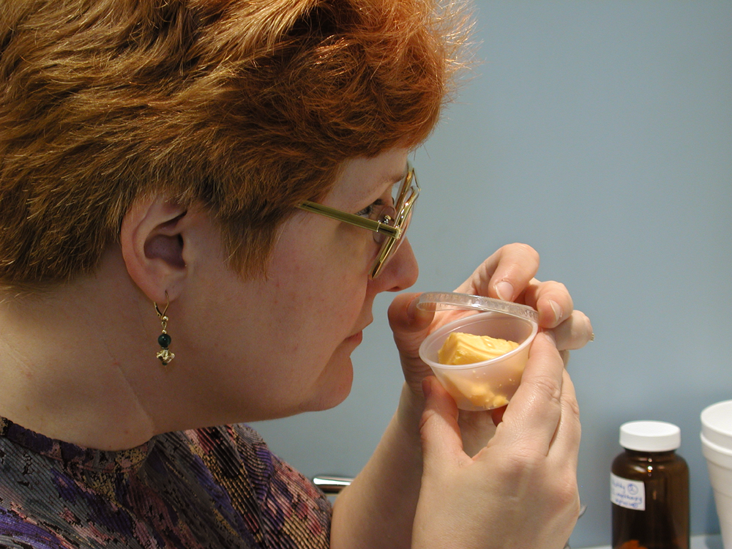
3. a) Develop sensory flavor and texture profiles for the cheeses to determine the key sensory properties that define the cheeses.
b) Characterize the microflora found in the traditionally-made (raw milk) cheeses, determine their roles in creating the unique properties of the cheeses, and identify culture blends for making Hispanic-style cheeses.
c) Determine degree of proteolysis in Hispanic-style cheeses and related to flavor/ texture development, the microflora present in the cheeses, and the stability of the cheese matrix (functional and textural properties).
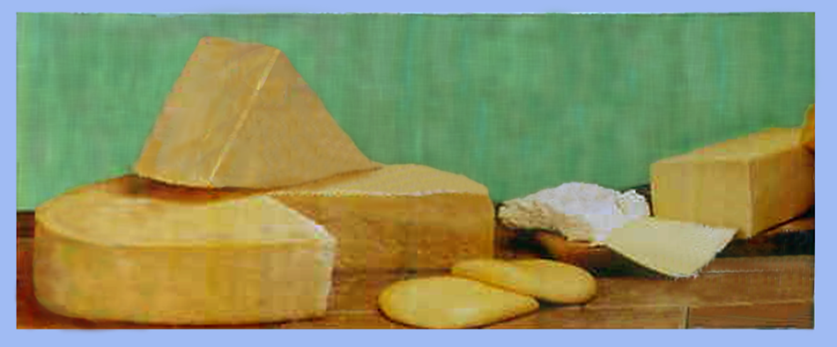
Benefits of Research:
Overall, this research will provide guidelines to help cheese producers meet the growing market demand for quality Hispanic-style cheeses and will help expand the utilization of American produced dairy foods in domestic and foreign markets.

Accomplishments:
For the American consumer to enjoy a truly authentic Hispanic dish, the meal must be prepared using Hispanic-style cheeses that are true to their traditional tastes, textures, and cooking traits.

- The different Hispanic-style cheeses can now be identified by the unique characteristics that make them different from other cheeses available in the market. Our research provides the quantitative data required by Federal and State agencies to develop Standards of Identity for use by the cheese industry and specifications needed to bring Hispanic-style cheeses into Federal food programs such as the School Lunch Program. The distinctive properties (such as flavor, texture, and cooking traits) are available for Queso Chihuahua (Menonita), Queso Fresco, and Queso Blanco.

- Cheese making trials are underway to identify the manufacturing steps that contribute to the uniqueness of Queso Chihuahua (Menonita). Once perfected, the cheese making protocols will result in uniform, high-quality Hispanic-style cheeses that retain the desired flavors and properties of the traditionally-made cheeses.
- The unique flavors and textures found in Hispanic cheeses are related to the bacteria found in the cheeses. Our research has identified the specific cultures found in traditionally-made Queso Chihuahua (Menonita) and Queso Fresco cheeses. This is the first step in understanding their role in making Hispanic-style cheeses unique.

Collaborative research and dissemination of research



Collaborative research with Dr. MaryAnne Drake, Southern Dairy Research Center, North Carolina State University, Raleigh, to develop sensory traits of Hispanic-style cheeses.

Specific Cooperative Agreements with the Centro Investigacion en Alimentacion y Desarrollo (CIAD) -Cuauhtémoc and CIAD-Hermosillo to study local traditionally-made cheeses.


USDA, Foreign Agricultural Service, three year grant. “Modification of Cheesemaking Parameters to Extend the Shelf-life of Hispanic-Style Fresh Cheese” to partially support the collaborative research between DPPRU, ARS, and CIAD-Cuauhtémoc.

- Three symposia have been organized to highlight Hispanic-style cheeses at the annual scientific meetings of the American Dairy Science Association, the Institute of Food Technologists, and the American Chemical Society. Through our CIAD collaborator, one workshop has been organized for cheese manufacturers in Mexico.

- Since 2002, 11 research posters have been presented at the annual meetings of different professional associations.

- Since 2001, collaborations established with specialty cheese producers.

Principal Investigators: Diane Van Hekken (Lead Scientist, Chemist), Moushumi Paul (Chemist), John Renye (Microbiologist), Michael Tunick (Chemist), Neil Goldberg (Mechanical Engineer), Peggy Tomasula (Research Leader, Chemical Engineer)

Project Personnel: Susan Iandola, Raymond Kwoczak, John Mulherin, James Shieh, Brien Sullivan.

http://ars.usda.gov/naa/errc/dppru file updated November 15, 2006

Other links
www.ciad.mx
www.ncsu.edu and www.ncsu.edu/sensory/
www.fas.usda.gov/icd/rsed/res-scient-exchangesold.asp

