USDA Hemp Phenotyping and Protocol Handbook, Version 4
V4 Editors: Zachary Stansell, Anthony Barraco, Anya Osatuke, Roque Evangelista, Korey Brownstein, Kevin Hernandez, Sadie Kraft, Ana Gabriela Itokazu, Tyler Gordon
2025-12-16
Table of contents
1. ABOUT 5
1.1 Download 5
1.2 Objectives 5
1.3 Versioning 6
1.4 V4 Editors 7
1.5 Boxes 8
1.6 Keywords 9
1.7 Language 9
1.8 Data types & units 9
2. PASSPORT 10
2.1 Accession 10
2.2 Germplasm source 11
2.3 Sampling & location 12
3. ARCHITECTURE 12
3.1 Morphology 13
3.2 Uncrewed aerial vehicle evaluation 15
3.3 Remarks 15
4. LEAF 16
4.1 Morphology 16
4.2 Imaging 17
5. SEX & INFLORESCENCE 21
5.1 General remarks 21
5.2 Sex ratio 22
5.3 Phenology 23
5.4 Inflorescence 23
5.5 Remarks 23
5.6 Female Flower Induction 24
5.7 Male Flower Induction 25
6. SEED 27
6.1 General 27
6.2 Shattering 28
6.3 Proccessing 30
6.4 Germination & Viability 30
6.5 Yield 33
6.6 Moisture content 33
6.7 Oil content 34
6.7.1 Solvent Extration 34
6.7.2 TD-NMR 37
6.8 Fatty acid composition 40
6.9 Protein content 43
6.9.1 Kjeldahl 43
6.9.2 Combustion 46
7. FIBER 50
7.1 Yield 51
7.2 Quality 53
8. SECONDARY METABOLITES 55
8.1 Chemotype 55
8.2 Cannabinoids 55
8.3 Other metabolites 58
8.4 Remarks 64
9. PATHOGEN/PEST 65
9.1 Fungal and oomycetes 66
9.2 Bacterial 68
9.3 Virus/Viroid 69
9.4 Remarks 69
9.5 Invertebrate 70
9.5.1 Corn earworm 70
9.5.2 Hemp russet mite 73
9.5.3 Twospotted spider mite 75
9.5.4 Cannabis aphid 79
9.5.5 Other pests 82
10. APPENDICES 84
10.1 Germplasm Regeneration Protocol 84
10.2 Feral Hemp Collection 84
10.3 Threshing 87
10.4 Cloning 89
10.5 Tissue Culture 94
10.6 Pollen Collection Protocol 94
10.7 Management of Fungal Specimens and Isolates Generated through Hemp Research 98
11. REFERENCES 101

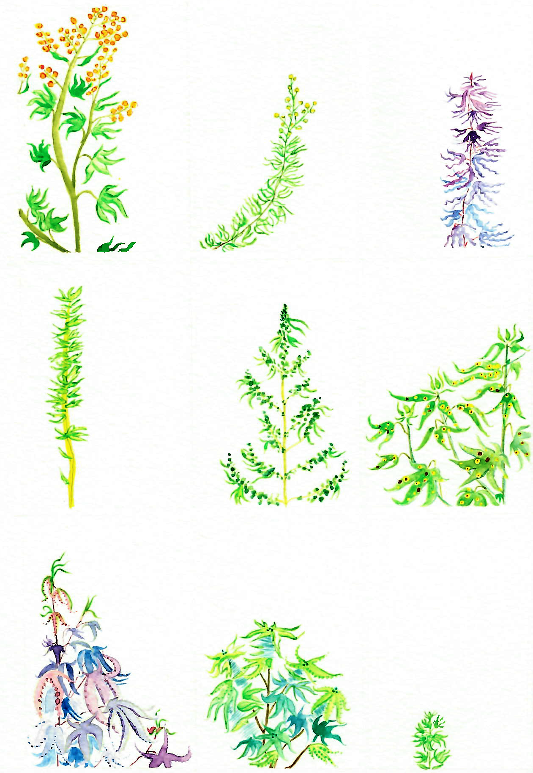

1. ABOUT

1.1 Download
Download V4 Handbook as PDF, 4.95 MB⬇️
Download V4 Handbook as MS Word docx, 36.8 MB⬇️

1.2 Objectives
The USDA Hemp Phenotyping and Protocol Handbook, Version 4 was undertaken with the following objectives:
- To assist breeders and researchers in identifying accessions with specific traits to facilitate germplasm selection within hemp (Cannabis sativa L.) improvement programs.
- To identify gaps in the existing hemp collections and help formulate strategies for future collection and conservation efforts.
- To designate and maintain a core collection of critical materials.
- To increase NPGS user utility and accessibility to hemp germplasm and associated data.
- To identify duplicate accessions and reduce costs of hemp genetic resource conservation.
The methods and protocols are based on peer-reviewed literature and/or crowd-sourced from the hemp community. Robust, reliable, and high-dimensional data generated from these phenotyping efforts empowers conservation of hemp genetic diversity and supports selection of materials with unique trait combinations for breeding programs.
We have attempted to compile a list of standardized characterization and evaluation methods to capture passport information and to quantify morphology, horticultural and agronomic quality, pathogen resistance, and metabolic profile. The USDA-ARS Hemp Germplasm Laboratory uses this document to standardize data collection across the broader pool of hemp germplasm and publishes new versions periodically as better information emerges. We emphasize that these methods and protocols are not necessarily “the best”, rather as an effort to show our work and perhaps provide some value to those who apply the scientific method to this wonderful and multifaceted plant.
The information gained from these phenotyping efforts will be digitally stored and made publicly available within GRIN-Global alongside the hemp germplasm held within the USDA-ARS Hemp Germplasm Laboratory at the Plant Genetic Resources Unit (PGRU) in Geneva, NY. The GRIN-Global HEMP crop page is located here. Phenotypic summaries of PGRU hemp genetic resources can be accessed on GRIN here.
Examples of the germplasm held at PGRU can be seen: ‘G 33199; NY Feral’ collected from a colonial-era hemp farm; the owner described that hemp plants grew after removal of a historic stone fence; or G 33714; ‘Humla Jungli’ described by the donor as collected in the Humla District of Far-Western Nepal, a 3 hours walk east of Yalbang where uncultivated cannabis plants grew profusely on the disturbed land along the mountainside above the Karnali River.
PGRU coordinates hemp germplasm collection and exchanges from domestic and foreign sources. Information related to plant genetic resources increases usefulness to diverse stakeholders. Phenotypic data can be collected during collection, routine multiplication, and germplasm evaluation and breeding experiments. If you are willing to contribute germplasm or its associated information, PGRU requests as much data associated with these materials as possible be included.
Collected data can be stored in a spreadsheet using the trait_name as column headings and PUID as row names. Our lab prefers the conventions of “Tidy Data” 1,2. Data can be emailed to the hemp germplasm curator (zachary.stansell@usda.gov) for inclusion into GRIN-Global. Please do not hesitate to reach out with any questions, comments, suggestions!

1.3 Versioning
This is version 4.0 of the USDA Hemp Phenotyping Handbook published December 2025. Here, we try to draw on new experiences, publications, and conversations since the publication of version 1.0 in September 2021.
- Small details are clarified throughout
- Expanded sections
- Renamed from Hemp Descriptor and Phenotyping Handbook to Hemp Phenotyping and Protocol Handbook to reflect increased emphasis on hemp protocols and workflows
- New protocols:
  - Rapid Six Cannabinoid HPLC assay.🔗 (370 KB️⬇️)
  - Hemp TZ and Viability assay.🔗 (354 KB⬇️️)
  - Shattering assay.🔗 (543 KB⬇️️)️
  - Seed-to-Seed regeneration protocol (1.17 MB⬇️️
  - Female and male Flower Induction
    - Female Induction🔗 (140 KB️⬇️️)️
    - Male Induction🔗 (120 KB⬇️️)️
  - Protocol for evaluating hemp seed oils/fatty acids, moisture, and protein.🔗 (803 KB⬇️)️
  - PGRU’s Hemp Tissue Culture Protocol🔗 (218 KB⬇️️️)
Archived versions of the Hemp Phenotyping and Descriptor Manual can be found here:
- Version 3🔗 Archived 2025-09-24
- Version 2🔗 Archived 2023-06-07
- Version 1🔗 Archived 2023-02-16

1.4 V4 Editors
- Zachary Stansell (Hemp Curator/Geneticist, USDA-ARS, Plant Genetic Resources Unit; Phenotyping Handbook Project Lead, corresponding author 📧: zachary.stansell@usda.gov)
- Anthony Barraco (Biological Science Technician, USDA-ARS, Plant Genetic Resources Unit; Protocol Development)
- Roque Evangelista (Research Chemist, USDA-ARS NCAUR, Bio-Oils Research Unit; protocl development)
- Korey Brownstein (Research Chemist at USDA-ARS NCAUR, Functional Foods Research Unit. His research involves identifying, isolating, and characterizing natural products derived from plants (i.e., phytochemicals))
- Ana Gabriela Itokazu (PhD Candidate, Auburn University, Protocol Development, Editing)
- Anya Stansell/Osatuke (Research, literature summaries, drafting, editing of original source (V1) document. Anya contributed most of the artwork that appears in this document.)
- Tyler Gordon (Research Geneticist/Hemp Breeder, USDA-ARS, Plant Genetic Resources Unit; 📧: tyler.gordon@usda.gov. Protocol Development and Editing.)
The authors gratefully acknowledges the critical review, editing, and the numerous suggestions for improvements made by Ademola Aina, Olivia Aldin, Masoume Amirkhani, Craig Beil, Gary Bergstrom, Mark Berhow, Peter Bretting, Charlie Brummer, Mark Bridgen, Kadie Britt, Zachary Brym, Carlyn Buckler, Ali Cali, Brian Campbell, Craig Carlson, Jeffrey Carstens, Ernst Cebert, David Chalkley, Chengci Chen, Alyssa Collins, Whitney Cranshaw, Randy Crowl, Heather Darby, David Dierig, Jorge de Silva, Chris Delhom, Sadanand Dhekney, Shelby Ellison, David Fang, Tori Ford, David Gang, Nicholas Genna, Heather Grab, Jason Griffin, Kelly Gude, Joshua Havill, Yu Jiang, Nick Kaczmar, Joanne Labate, Michael Loos, Jessica Lubell-Brand, Tyler Mark, Victoria Meakem, Daniel Meyers, Virginia Moore, Maylin Murdock, Jay Noller, Luis Alberto Monserrate Oyola, Dániel Pap, Anthony Rampulla, Bear Reel, Andrew Ristvey, Moira Sheehan, Savanna Shelnutt, Chris Smart, Larry Smart, Faith Sparks, George Stack, Jeffrey Steiner, Conor Stephen, Alan Taylor, Jacob Toth, Daniela Vergara, and Don Viands.
The drawing on the front cover is used with permission by Anya Stansell/Osatuke. Kadie Britt provided many primary source images and text for the invertebrate section. Craig Carlson provided original figures, methods, and many ideas. Jacob Toth, Joshua Havill, Savanna Shelnutt, Brian Campbell, Shelby Ellison, and Jeffrey Carstens provided many helpful comments, references, protocols, and edits. We have tried to acknowledge everyone who’s helped with this work, but any omissions are solely Zachary Stansell’s fault.
This work has drawn heavily on input from the Cornell Hemp Stakeholder Survey. Please take the survey if you have not already done so.
Please contact zachary.stansell@usda.gov with any questions, comments, remarks, or ideas.
The United States Department of Agriculture (USDA) prohibits discrimination in its programs on the basis of race, color, national origin, sex, religion, age, disability, political beliefs, and marital or familial status. Not all prohibited bases apply to all programs. Persons with disabilities who require alternative means for communication of program information (Braille, large print, audiotape, etc.) should contact the USDA Office of Communications at (202)720-5881 (voice) or (202)720-7808 (TOO). To file a complaint, write to the Secretary of Agriculture, U.S. Department of Agriculture, Washington, DC 0250, or call (202)720-7327 (voice) or (202)720- 1127 (TOO). USDA is an equal employment opportunity employer.

1.5 Boxes
Throughout this document there are special colored text boxes:
Phenotype/Descriptor
trait_name [datatype; units]
elevation_meters [decimal; m]
Elevation of collecting site above sea level.
🧪Phenotyping Protocol🧪
Seed germination
- 10 waterproof trays
- Sterile water-holding material (cotton wool, paper towels)
- 200 seeds, stored between 4 to 56 weeks…
📐Equation📐
Percent moisture may be calculated as:
$$\frac{\left(wet-dry\right)}{wet}×100\%$$
📜List📜
Invertebrate pests
- Acherontia atropos
- Aculops cannabicolus
- Aecidium cannabis
- …
📚Additional References📚
One of the earliest publications lauding hemp was “The Praise Of Hemp Seed” by John Taylor (1620).

1.6 Keywords
- hemp
- Cannabis sativa L.
- germplasm
- phenotype
- trait
- characterization
- evaluation
- USDA-ARS
- NPGS
- PGRU

1.7 Language
GRIN-Global supports displaying data in multiple languages for system-level data. That is, if the system requires text to be displayed that is not actual GRIN-Global data, that text should be in the appropriate language for the current user. This is accomplished by using a table ending with _lang as a child table.

1.8 Data types & units
Units
All units are SI unless otherwise indicated.
datetime
A datetime data type that can handle time in nanoseconds and has a year range extending from the year “0001” to “9999.”
decimal
The decimal data type can store a maximum of 38 digits, all of which can be to the right of the decimal point. The decimal data type stores an exact representation of the number; there is no approximation of the stored value.
int
The integer data type is stored as a 4-byte integer; numeric values can range from $-2^{31}$ through $2^{31}-1$.
nvarchar
An nvarchar field can store a string of text characters (maximum 4,000). The “n” in nvarchar means uNicode. “varchar” is an abbreviation for variablelength character string. Essentially, nvarchar is variable text field that supports two-byte characters, therefore capable of handling non-English symbols.

2. PASSPORT
An accession consists of seed or plant material representing a sample of a single species, collected at a single time and location. An accession may be a sample of multiple plants found at the same location at the same time, or it may be collected from a single individual. By default, NPGS will retain different samples of a putative cultivar/population as discrete inventories nested within the Plant Introduction accession.

2.1 Accession
taxonomy_species_id [nvarchar]
Scientific name of accession linking the accession record to its taxonomy parent (genus / species). Modified from GRIN-Global. Subtaxon may be included:
- ‘subsp.’ (subspecies)
- ‘var.’ (variety; not the same as the breeder’s named variety [uniform & stable product of breeding] or cultivar.)
- ‘f.’ (form)
- ‘group’ (botanical variety not cultivar name )
PUID [nvarchar]
If persistent, unique identifier has been previously assigned, report. Assigned to one accession to be unambiguously referenced at the global level, with associated information aggregated via automated means. Genebanks not applying a true PUID should use a combination of Institute Code, Accession Number, and the Genus as a globally unique identifier. Modified from Bioversity International, FAO (2015).
improvement_status [nvarchar]
Short paragraph. If known, elaborate on material improvement status, e.g., wild, landrace, breeding material, hybrid, founder stock, colonal selection, mutant, polyploid, mapping population, transgenic, etc.
plant_name [nvarchar]
Top name assigned to display (sometimes referred to as the top name), typically given by farmer, breeder, seed-saver. Cultivar name is a possible type of top name. If in non-Latin alphabet, provide original spelling alongside a Latin-alphabet transliteration in remarks. Modified from GRIN-Global and Bioversity International, FAO (2015).
accession_pedigree [nvarchar]
Description of plant pedigree, if known, e.g.:
- “Selection from ‘Carmagnola’”
- ‘Beniko’/‘Carmagnola’//‘Futura 75’///‘Carmaleonte’/‘Felina 32’//‘Futura 75’ * “Mutation found in ‘Beniko’”
ploidy [int]
Record ploidy if known. If mixoploid or other, elaborate in passport_remarks. See Adriel Garay and Sabry Elias (1998).
accession_ipr [nvarchar]
State PVP registration status, if applicable. U.S. Link.
Varieties may also be protected by a U.S. Plant Patent (e.g. CW2A) or Utility Patent and/or Plant Breeder’s Right from a UPOV country; e.g., Canada.
- US patents search
- UPOV requires account to search Variety Database.
- Canada
crop_use [nvarchar]
Explain crop use(s); e.g., oil, fiber, secondary metabolite, ecosystem services.

2.2 Germplasm source
source_cooperator_id [nvarchar]
Field associating the cooperator (person or organization) who was the source of the germplasm. See Appendix.
collector_cooperator_id [nvarchar]
Indicating the individual collecting sample. See Appendix.
developer [nvarchar]
List the name of the organization (or person) that bred the material.

2.3 Sampling & location
Modified from S-1084 Collection Protocols, GRIN-Global, personal conversations with hemp researchers (Shelby Ellison and Jeffrey D. Carstens), and Bioversity International, FAO (2015) standards. See Appendix.
number_plants_sampled [int]
Number of plants sampled to collect the accession material (S-1084 Collection Protocols). See Appendix.
source_date [datetime]
Date when germplasm is collected from source material (S-1084 Collection Protocols).
geography_id [nvarchar]
The internal geographic identifier indicating the cooperator’s country and state (S-1084 Collection Protocols).
elevation_meters [decimal; m]
Elevation of collecting site above sea level (S-1084 Collection Protocols).
latitude & longitude [decimal]
Latitude and longitude in decimal degree format. The format is 10 integers and 8 decimals. Positive values are east of the Greenwich Meridian; negative values are west of the Greenwich Meridian ( S-1084 Collection Protocols).
coordinate_method [nvarchar]
Georeferencing method used (e.g., GPS, map, estimated). Modified from Bioversity International, FAO (2015).
uncertainty [decimal; m]
Maximum coordinate uncertainty radius.
georeference_datum [nvarchar]
Geodetic datum/spatial reference system; WGS84 datum is preferred.
accession_inv_voucher_note [nvarchar]
If applicable, include additional voucher information.

3. ARCHITECTURE
Unless stated otherwise, measure plant architecture traits as the mean of 10 unpruned plants during week of sampling. Samples submitted to NPGS will be evaluated using similar protocols as described below.

3.1 Morphology
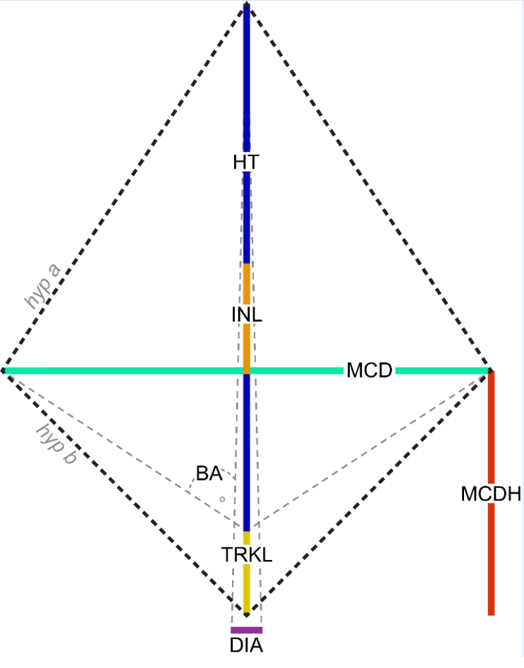
Kite model architectural traits modified from Carlson et al. (2021).
ht [decimal; cm]
Height of the stem from the ground to the tip of the apical inflorescence, modified from (2021).
mcd [decimal; cm]
Maximum canopy diameter (mcd) as width of plant at widest set of branches (2021). Measured from widest tip to tip without stretching branches. Include flowering tissue in measurement.
mcdh [decimal; cm]
Height evaluated at maximum canopy diameter (mcdh) from ground to max canopy diameter (2021).
trkl [decimal; cm]
Trunk length (trkl) is evaluated as distance from ground to first branch (2021).
inl [decimal; cm]
Average internode length (inl) is calculated between internodes along the primary stem (50 cm max, see diagram) (2021).
$$inl=\frac{ht-trkl}{branches}$$
hyp_a and hyp_b [decimal; cm]
Calculated (2021).
$hyp.a=\sqrt{{\left(ht-mcdh\right)}^{2}+{\frac{mcd}{2}}^{2}}$.
$$hyp.b=\sqrt{mcdh^{2}+{\frac{mcd}{2}}^{2}}$$
kite_perimeter [decimal; cm]
Calculated (2021).
$$kite.perimeter=2×\left(hyp.a+hyp.b\right)$$
kite_area [decimal; $cm^{2}$]
Calculated (2021).
$kite.area=\frac{ht×mcd}{2}$.
ba [decimal; (0-180°)]
Kite branch angle ba is calculated from the lower kite triangle, using the difference of maximum canopy diameter height and trunk length (2021).
$$ba=arctan\frac{mcd}{2\left(mcdh-trkl\right)}$$
nodes | nodes_opp | nodes_alt [int]
Number of internodes (nodes) per plant; nodes are by definition $2×$ branches (2021). Number of opposite internodes (nodes_opp) per plant. Number of alternate internodes (nodes_alt) per plant. When grown from seed, branching is initially opposite, transitioning to alternate as the plant matures. Plants propagated from cuttings generally have alternate branching in the whole plant Stack et al. (2021).
branches [int]
Number of branches per plant (2021). When grown from seed, branching is initially opposite, transitioning to alternate as the plant matures. Plants propagated from cuttings generally have alternate branching in the whole plant Stack et al. (2021).
$$branches=\left(n.opp*2\right)+n.alt$$
kite_circularity [categorical]
A continuous scale of apical dominance can be derived (2021):
$$kite.circularity=\frac{4π⋅kite.area}{kite.perimeter^{2}}$$
dia [decimal; mm]
Diameter of the stem at soil level using calipers, forestry or fabric measuring tape, modified from Carlson et al. (2021).
pith_diameter [decimal; mm]
Diameter of the pith in the stem cross section at stem midpoint, modified from International Union for the Protection of New Varieties of Plants (2012).

3.2 Uncrewed aerial vehicle evaluation
uav_xxx [TBA]
See Carlson et al. (2021).

3.3 Remarks
architecture_remarks [nvarchar]
If possible, report date of measurement [days from sowing], sex average, minimum, and maximum height and width observed in a planting (cm).
📚Additional References📚
- Anderson (1980)
- Werf, Haasken, and Wijlhuizen (1994)
- Werf et al. (1995)
- Meijer and Keizer (1996)
- Ranalli (1999)
- Mishchenko and Lajko (2016)
- Magagnini, Grassi, and Kotiranta (2018)
- Backer et al. (2018)
- Spitzer-Rimon et al. (2019)
- Carlson et al. (2021)
- Danziger and Bernstein (2021)
- Stack et al. (2021)
- Vergara et al. (2021)

4. LEAF
Unless otherwise noted, gather leaf data from the uppermost set of mature leaves, as mean of 5 leaves gathered from each of 10 different plants immediately before onset of flowering.

4.1 Morphology
petiole_length [decimal; cm]
central_leaflet_length [decimal; cm] central_leaflet_width [decimal; cm]
Leaf is flattened and measured from tip until start of rachis; petiole is flattened and measured from base of rachis until petiole base, modified from International Union for the Protection of New Varieties of Plants (2012) and Anderson (1980).
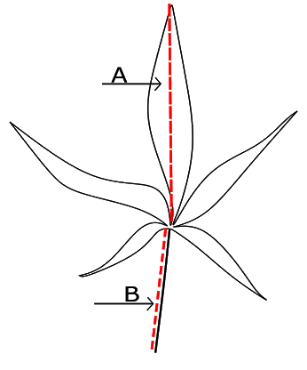
(A) central_leaflet_length and (B) petiole_length measurement.

4.2 Imaging
leaf_color_L [decimal]
leaf_color_a [decimal]
leaf_color_b [decimal]
The average color of uppermost set of mature leaves, collected before flowering, measured with a colorimeter, modified from -International Union for the Protection of New Varieties of Plants (2012). A RHS color chart may also be used, but values should be converted to (L*a*b*) before addition to GRIN. From Wikipedia (accessed 2023-01-11): The CIELAB color space, also referred to as L*a*b*, is a color space defined by the International Commission on Illumination […] in 1976. It expresses color as three values: L* for perceptual lightness and a* and b* for the four unique colors of human vision: red, green, blue and yellow. CIELAB was intended as a perceptually uniform space, where a given numerical change corresponds to a similar perceived change in color.
There are many programmatic solutions to convert colors (I use R for everything: 1,2,3) as well as many online tools (e.g., Colormine).
Consider printing a label to include in the scan as well. PGRU germplasm imaging and scans typically include accession ID, species, and plant id name (e.g. ‘FIN-314’). PGRU uses a small color wheel in the corner of our templates (️DOWNLOAD️), but that might not be necessary for you since you are measuring color with a colorimeter.
leaf_variegation [nvarchar; Y/N]
Indicate whether variegation has been noted or is present.
Variegated leaves are most likely not virus based, but it might be worth investigating.
leaf_scan_protocol [.jpg or .png]
🧪Scan protocol🧪
Equipment
- Flatbed scanner
- Desktop monitor
- Black cloth, ideally velvet, of equal dimensions to scanner bed.
Protocol
- Gather one mature leaf from a representative sample of 10 plants a week before the onset of flowering. Retain petioles. Keep on ice if wilting is a concern.
- Scan leaves within the hour of collection using a scanner with the lid open, draping black fabric over the leaves to absorb background light. Include scale or ruler (cm) and puid.
- Convert the scanned leaf image into .png file and save.
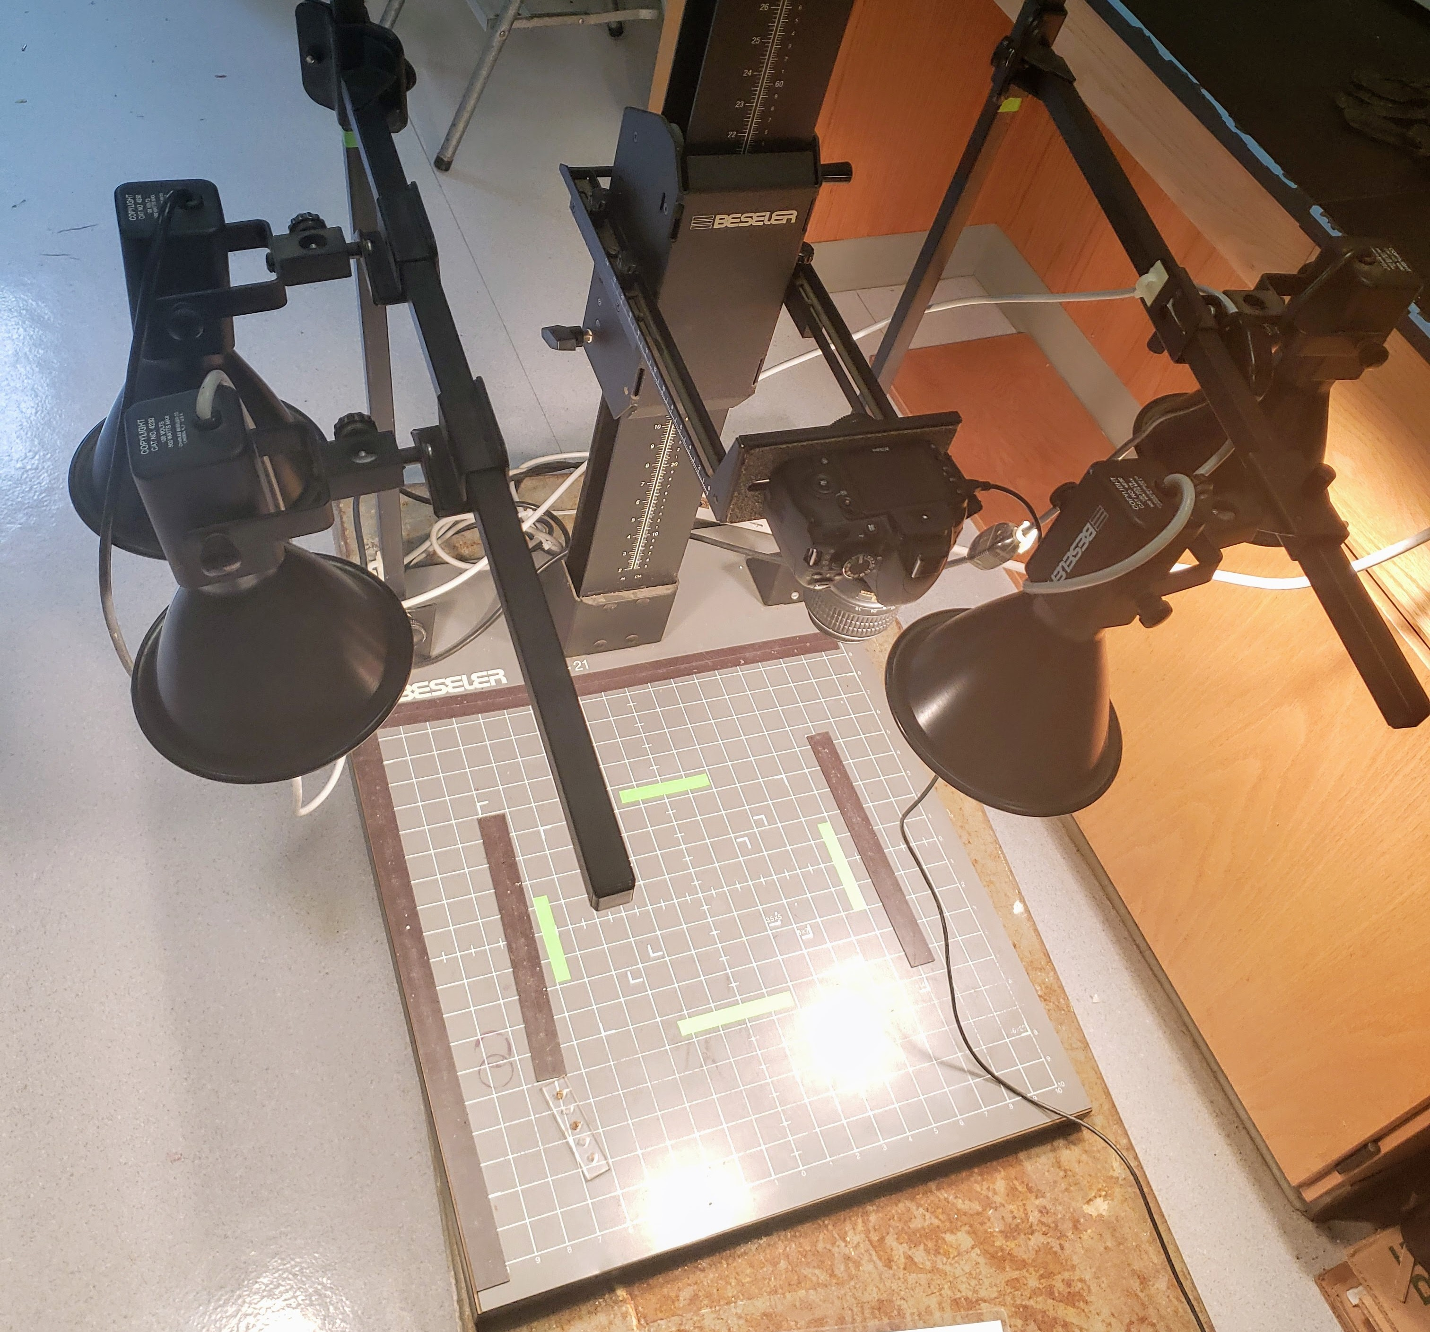
Leaf imaging setup at PGRU
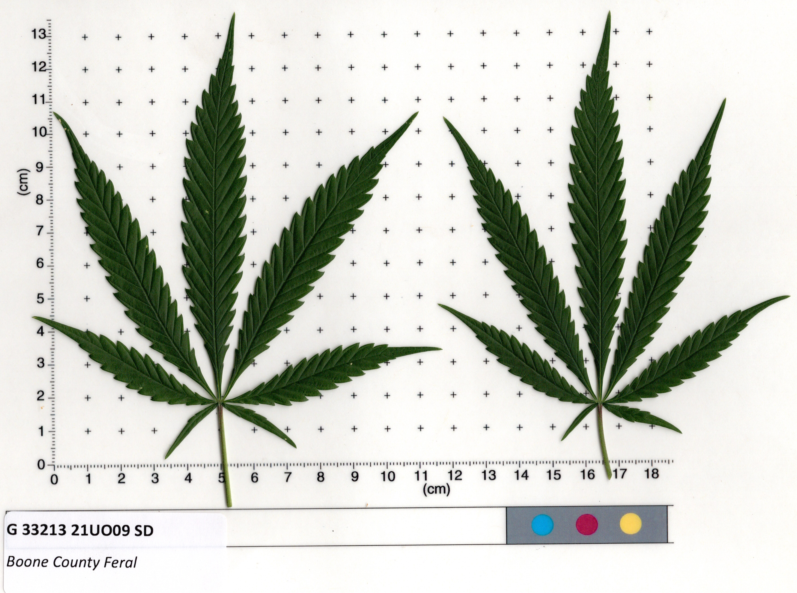
Leaf scan example from routine phenotyping at PGRU
📚Additional References📚
- Haney and Kutscheid (1975)
- Dayanandan and Kaufman (1976)
- Anderson (1980)
- Meijer and Keizer (1996)
- Amaducci et al. (2008)
- Hall, Bhattarai, and Midmore (2012)
- Mishchenko and Lajko (2016)
- Magagnini, Grassi, and Kotiranta (2018)
- Spitzer-Rimon et al. (2019)
- Carlson et al. (2021)
- Stack et al. (2021)
- Vergara et al. (2021)

5. SEX & INFLORESCENCE

5.1 General remarks
Phenotyping sex characters is (in our experience) more complex than it might seem initially. At PGRU HGL, we have evaluated phenotypic sexual expression at both the plot level and by measuring many individual plants. Some groups have simply recorded the sex of 100 preselected individuals at harvest. Both approaches should produce the same phenotype. In our 2022 field trials in Geneva, NY, we recorded the exact first flowering date (of pistillate and staminate flowers) of > 2,400 individuals and then calculated (by population) the mean percent female, male, and monoecious. Specify your approach in sex_remarks, as well as sowing/transplanting date, field or greenhouse conditions, and photoperiod.
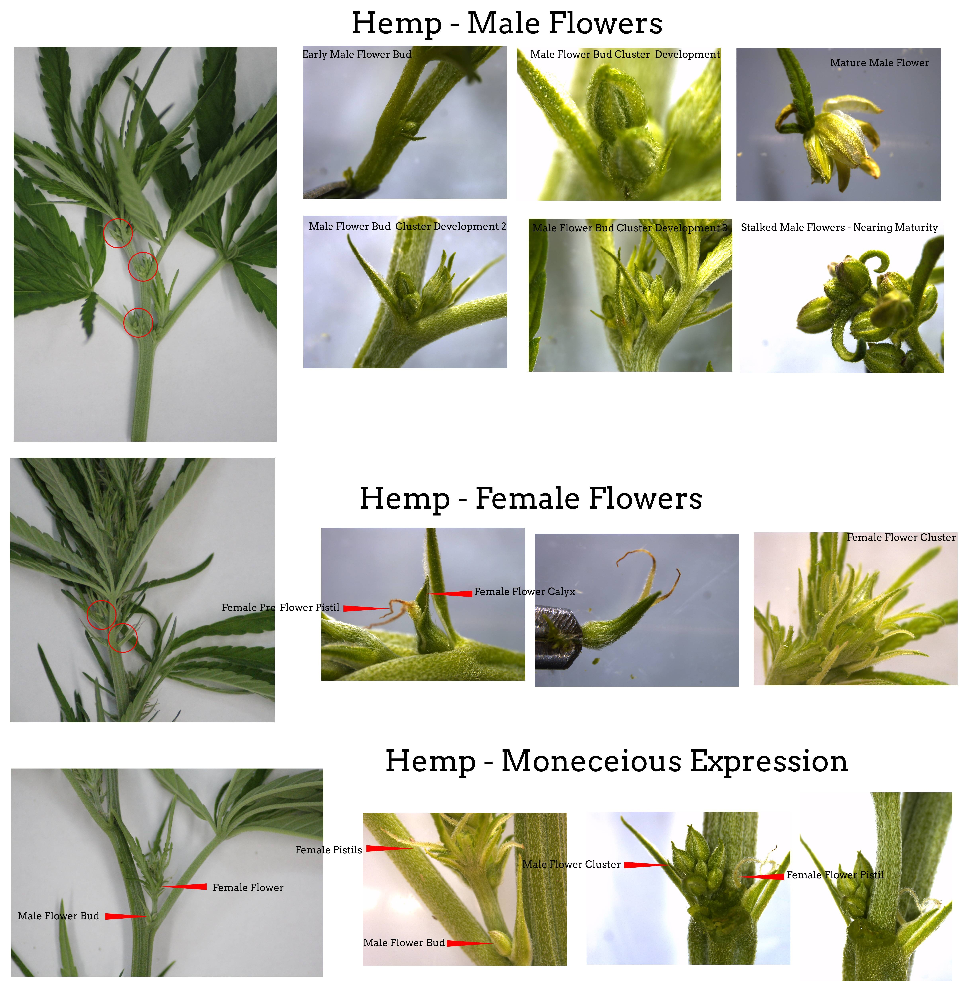
Hemp flowering guide with permission from L. Smart Laboratory

5.2 Sex ratio
sex_ratio [nvarchar]
Sex ratio during flowering.
Target a sample of 100 individuals in the field before flowering begins. Label and number sample plants clearly. Record F:M:O; as the ratio of female, male, and monoecious (individuals with male and female flowers) individuals, respectively.
If plants are wild-collected, 100 plants may not be available; measure as many as possible (See S-1084 Collection Protocols).

5.3 Phenology
date_flower_female [datetime]
date_flower_male [datetime]
date_flower_monoecious [datetime]
Pre-terminal date when axial flowers with shortening internodes and terminal pistils (clusters of flowers at shoot termini) were observed Carlson et al. (2021). Record sowing/transplanting date in sex_remarks. See also Faux et al. (2013); Shams et al. (2020).
days_2_female [integer; d]
days_2_male [integer; d]
days_2_monoecious [integer; d]
days_2_female = date_flower_female - sow date
days_2_male = date_flower_male - sow date
days_2_monoecious = date_flower_monoecious - sow date
maturity [int; d]
Days from germination to commercial maturity, calculated as harvest date - sowing date.
day_neutrality [nvarchar]
Describe flowering behavior as critical day length and/or day neutral response. Calculate as percent of plants in population exhibiting day neurtrality. A more precise definition is required to define this phenotype quantitatively.

5.4 Inflorescence
inflor_length [decimal; cm]
Length of inflorescence cluster at the uppermost branch, excluding leaves. Remove leaves with more than 1 leaflet. Retain stems and seeds; inflorescence may be retained as clusters.
inflor_weight [decimal; cm]
Measure weight after drying at room temperature for >48 hr.
inflor_yield [decimal; $kg⋅ha^{-1}$]
Combine inflorescence dry weight data with planting density to calculate kg/ha.
inflor_color [nvarchar; L*a*b*]
Measured with a colorimeter at commercial maturity. A RHS color chart may also be used, but values should be converted to (L*a*b*) before adding to GRIN.

5.5 Remarks
sex_remarks [nvarchar]
Short paragraph, if possible/applicable include:
- If plants were grown in fields, greenhouses, or growth chambers.
- Planting density (e.g., $\frac{seeds}{m^{2}}$) if applicable.
- Female and male bract, stigma, and flower color.
- Date of collection.
- Day length (hh:mm) on the date of the first observed open female flower.

5.6 Female Flower Induction
Protocol developed by Tyler Gordon based on (Moon, Lee, et al. 2020).
️DOWNLOAD FILE (140 KB⬇️)️
🧪Ethephon Solution Preparation and Application🧪
Objective
Induce female flower development in genetically male hemp plants. This will allow for inbreeding of male hemp plants.
Supplies
- Florel Brand Growth Regulator (3.9% ethephon); Hummert Item: 65093300; EPA Reg. No. 54705-8
- Reverse osmosis (RO), or deionized (DI) water
- 500 ml spray bottle marked with a 15 ml fill line
Personal Protective Equipment
- Nitrile gloves
- Safety goggles
- Respirator for applications
- Long-sleeved shirt and long pants, shoes plus socks
Protocol
- Read and become familiar with the product Florel Brand product label and SDS sheet.
- Wear nitrile gloves, safety goggles, and long-sleeved shirt, long pants, and shoes with socks.
- Prepare ~100 ppm ethephon solution in a 500 ml spray bottle by adding 15 ml of ethephon to the 15 ml fill line and adding 485 ml of RO water to the 500 ml fill line.
- Mix 100 ppm ethephon solution thoroughly.
- Prepared ethephon solution can sit on a temperature stable shelf for over a year.
- Spray plants with emerging male flower primordia (about 1 week after transferring the plants to 12-hour daylength) until primordia are fully wetted, but before runoff occurs (~1.0 mL).
- Spray the plants only one time because multiple applications will severely stress and potentially kill the plants.
- Once the plants are dry, cover them with a 15-μm mesh bag to ensure selfing.
- Harvest seeds about 6-8 weeks after ethephon application, once seeds are fully mature and plants have dried down to below 10% moisture.

5.7 Male Flower Induction
Protocol developed by Tyler Gordon based on (Lubell and Brand 2018; Cameron and Reid 1981).
️DOWNLOAD FILE (120 KB⬇️)️
🧪Silver Thiosulfate (STS) Solution Preparation and Application🧪
Objective
Induce male flower development in genetically female hemp plants. This will allow for inbreeding of female hemp plants.
Supplies
- Silver nitrate 99%, (169.87 g/mol), Sigma Item: 209139
- Sodium thiosulfate 99%, (158.11 g/mol), Sigma Item: 217263
- Reverse osmosis (RO) or deionized (DI) water
- 1 L flasks
- 500 ml spray bottle
- Precision balance accurate to 0.01 g
- Weigh boats or weigh paper
- 200 ul pipette and tips
Personal Protective Equipment
- Nitrile gloves
- Safety goggles
- Respirator for applications
- Lab coat
- Fume hood with good ventilation
Protocol
- Read and become familiar with the SDS sheets for silver nitrate and sodium thiosulfate.
- Wear gloves, safety goggles, lab coat and work in the fume hood when preparing stock solutions.
- Prepare 20 mM silver nitrate solution in a 1 L flask (3.40 g/L), store in a dark bottle or in the dark if possible or make solution the day it is used.
- Prepare 20 mM sodium thiosulfate solution in a 1 L flask (3.16 g/L).
- On the day of application, mix 20 ml of the 20 mM silver nitrate solution with 80 ml of 20 mM sodium thiosulfate solution in a 500 ml spray bottle. Change final volume as needed while maintaining the 1:4 ratio.
- Mix 4 mM STS solution thoroughly.
- Spray the uppermost raceme of plants with emerging flower primordia until slight runoff occurs.
- Spray the complete contents of the bottle, do not reuse contents as the solution will quickly oxidize.
- Freshly prepare and apply STS solution before transferring plants to 12-hour days, then once a week for two weeks, for a total of three applications.
- When stigma primordia begin to appear, cover the plant with 15 uM fabric to ensure selfing.
- It is possible to over apply STS and we have found female plants where every female flower had been converted into male flowers and no seeds were produced, so try to focus the application on only the top racemes.
- Harvest seeds about 6-8 weeks after STS application, once seeds are fully mature and plants have dried down to below 10% moisture.
📚Additional References📚
- Schaffner (1921)
- Grishko, NN and Levchenko, VI and Seletski, VI (1937)
- Werf, Haasken, and Wijlhuizen (1994)
- Mandolino et al. (1999)
- Ranalli (1999)
- Lisson, Mendham, and Carberry (2000)
- Shao, Song, and Clarke (2003)
- Pahkala, Pahkala, and Syrjälä (2008)
- Cosentino et al. (2012)
- Hall, Bhattarai, and Midmore (2012)
- Faux et al. (2013)
- O. V. Razumova (2014)
- Lynch et al. (2016)
- Olga V. Razumova et al. (2016)
- Vergara et al. (2016)
- Punja, Rodriguez, and Chen (2017)
- Zhang et al. (2018)
- Eichhorn Bilodeau et al. (2019)
- Salentijn, Petit, and Trindade (2019)
- Kovalchuk et al. (2020)
- Punja and Holmes (2020)
- Toth et al. (2020)
- Adal et al. (2021)
- Danziger and Bernstein (2021)
- Dowling, Melzer, and Schilling (2021)
- Hurgobin et al. (2021)
- Stack et al. (2021)

6. SEED
Samples submitted to NPGS will be evaluated by a USDA-ARS laboratory using similar protocols as described below.

6.1 General
hundred_seed_weight [decimal; g]
Record mass of 100 seeds.
thousand_seed_weight [decimal; g]
Record mass of 1000 seeds.
seed_image [.jpg or .png]
🧪SEED IMAGE🧪
Equipment
- Flatbed scanner
- Desktop monitor
- Black cloth, ideally velvet, of equal dimensions to scanner bed.
- Transparent, flat-bottomed tray or transparency film to protect scanner bed from scratches.
Protocol
- Gather a sample of 20 grains.
- Scatter samples across tray or transparency film.
- Convert the scanned seed image into .PNG file and save.
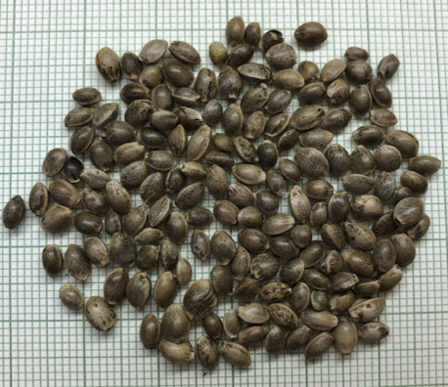
Seed image. Photo credit Alan Taylor, Michael Loos, and Masoume Amirkhani
seed_size_length [nvarchar, mm]
seed_size_width [nvarchar, mm]
Size of the largest, smallest, and median seed in the lot (mm) as L:S:M using Tomato Analyzer, Smart Grain, Photoshop, GNU Image Manipulation Program, or other imaging software to make these calculations based on a scanned image of 20 seeds. Our lab routinely runs samples through a MARViTECH Seed Analyzer.
$$seedmoisture=\frac{\left(wet-dry\right)}{wet}×100\%$$

6.2 Shattering
shatter_fraction [%]
🧪SHATTER TEST🧪
Method developed by Dr. Tyler Gordon at USDA-ARS PGRU Hemp Germplasm Laboratory.
️DOWNLOAD FILE (543 KB⬇️)️
Objective
Clean seeds and estimate the percentage of seeds shattered out of a hemp inflorescence.
Equipment
- Seed Hybridization Pollinating Bag, size 25.4 cm (10-inch) x 30.48 cm (12-inch), 336 $μ$M pore diameter, 1000/box, Item: PQ218
- Black cable ties 19.05 cm (7.5-inch) #50 reusable 1000/box or regular cable ties 17.78 cm (7-inch) black-100/pk, Part No: L-7-50-0-C
- United Label Slip Tag, Blue slip labels 2.54 cm (1-inch) x 17.78 cm (7-inch) 1000 labels per case, Item: TX1071T-BU
- Almaco air blast seed cleaner with 0.635 cm (¼-inch) sieve, and catchment pan.
- Coin envelopes size 10.80 cm (4 ¼-inch) wide by 6.35 cm (2 ½-inch) tall QUA50262
Protocol
- Record the female terminal flowering date.
- Approximately five weeks after terminal flowering, place a 336 uM Pollinating Bag over the top 30.48 cm (12 inches) of a single raceme with the pollinating bag and secure it tightly with the 19.05 cm (7.5-inch) zip tie.
- Add a slip tag about 2.54 cm (1-inch) below the zip tie to help identify the plant at harvest. Bagging can coincide with floral sampling. Fig. 1A and 1B.
- Cut the hemp stem below the zip tie when the stem is turning brown, the fan leaves are falling, and the plant is starting to senesce. Fig. 1C.
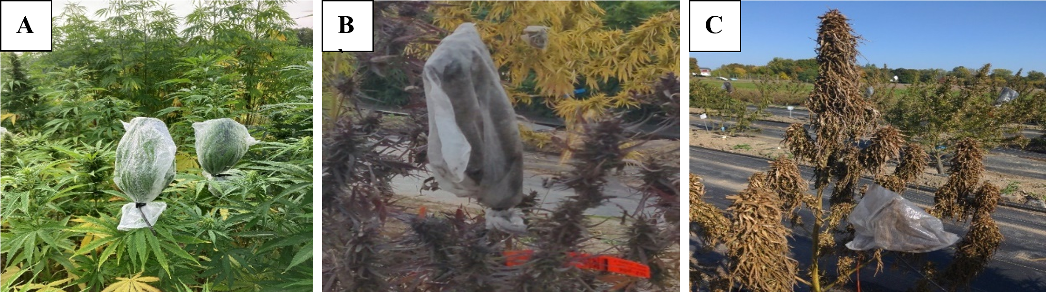
Fig. 1: Pollination bags placed over hemp inflorescences, note the slip tag in B, and the fully senesced plant in C that is ready for harvest.
- The inflorescence should be dry (<10% moisture) before threshing and cleaning the seeds. One to two weeks in a well-ventilated room with low humidity is usually sufficient to dry the inflorescences and seeds.
- Release the zip tie and empty the pollination bag over a 0.635 cm (¼-inch) sieve with a solid bottom pan or collection container arranged below the sieve. Ideally, this will be done with a seed blower that will allow the chaff to be blown out, and the seeds will be retained. An example of the USDA seed cleaning operation is shown in Fig 2. Note that the blower setting needs to be adjusted so seeds are not discarded with the chaff.
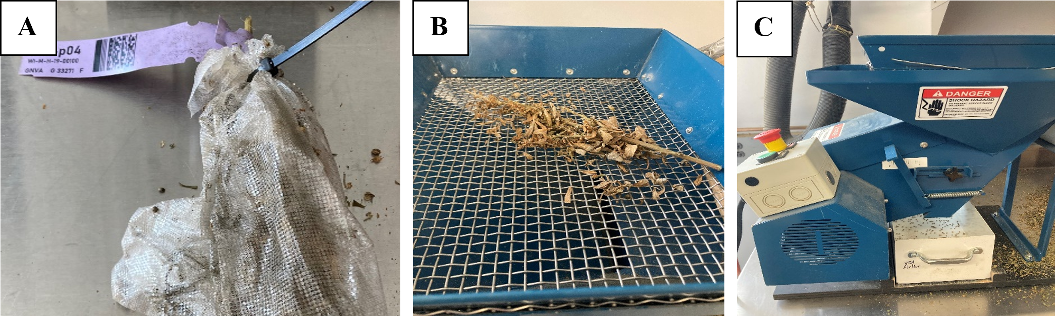
Fig. 2: Pollination bag clipped and ready for processing A, hemp inflorescence on the 0.635 cm (¼-inch) sieve B, and clean processed seeds falling into the catch pan after chaff has been blown out C.
- Weigh the seeds that fall into the solid pan after removing the pollination bag, this is the shatter seed weight.
- Remove the remainder of the seeds that are still in the raceme over the sieve and into the pan. Add the clean seeds to the shatter seed fraction and obtain the total weight of seeds in the 30.48 cm (12-inch) section of raceme that was in the pollination bag.
- Divide the shatter seed fraction weight by the total seed weight to obtain the seed shatter percentage. Seeds that were loose in the bag/total seed weight in the bag = seed shatter fraction.
- This seed can be stored in a three-coin envelope at 4 °C for later seed size and quality analysis.

6.3 Proccessing
See Appendix Method Developed by Anthony Rampulla at USDA-ARS PGRU Hemp Germplasm Laboratory.

6.4 Germination & Viability
percent_germ [%]
🧪SPROUT TEST🧪
Method developed at USDA-ARS PGRU Hemp Germplasm Laboratory with support from Michael Loos and Alan Taylor at Cornell University.
Equipment
- 10 waterproof trays
- Sterile water-holding material (cotton wool, paper towels)
- Water source
- 200 seeds, stored between 4 to 56 weeks after harvest in dry conditions between 16 - 25 ˚C.
Protocol
- 4 sub-samples of 50 seeds are isolated.
- Each sub-sample is spread evenly on trays lined with water-holding material. Seeds may be placed on top of water holding material and in between rolls.
- Each tray is saturated with water and placed in a temperature-controlled room: 16 hours of dark at 20 °C, 8 hours of light at 30 ˚C. Trays are kept moist.
- Live, normal, sprouted seeds are counted by hand, sprouts are then removed from the germination tray.
- After 7, 14, and 21, days the number of live, normal, sprouted seeds is counted by hand. The duration of experiment may be extended if dormancy is an issue (record in germ_remarks)
- Germination percentage for each tray is calculated as: $\frac{sprouted}{total}×100\%$ and averaged per tray.
- Consider executing TZ tests for lots with high dormancy to verify they truly are dormant and not dead.
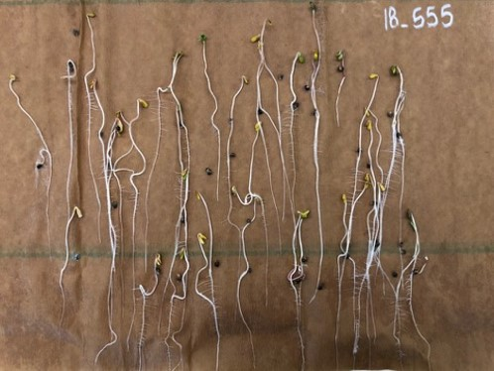
Seed germ testing (photo credit: Alan Taylor, Michael Loos, and Masoume Amirkhani).
Modified from Seed Laboratory Oregon State University (2018), NPGS protocols, and communication with Alan Taylor, Jeffrey Carstens, and Joshua Havill.
percent_viable [%]
🧪VIABILITY TEST🧪
Method developed at USDA-ARS PGRU Hemp Germplasm Laboratory by Sadie Kraft. DOWNLOAD FILE (354 KB️⬇️)
Summary
This method is used to determine whether ungerminated seeds are viable but not germinating, indicating dormant seed, or if they are dead seeds and thus unviable. Seeds are bisected and placed in a solution that chemically reacts with the dehydrogenase enzymes present within living seed. If the enzymes are present, they will react with the solution and stain the seeds red, if the enzymes are not present, the seeds will not stain. Both outcomes provide valuable information and insight for various applications. Define TZ solution as: 2,3,5-Triphenyl-2H-tetrazolium chloride solution.
Equipment
- Razorblade or scalpel
- Storage bottle for the TZ solution
- Vial or storage bottle to perform the test in
- 1 % solution of TZ (CAS 298-96-4). Make a 1% TZ solution by weighing out 1 g of TZ and adding it to 100 mL of double distilled water.
Protocol
- Gather seeds for TZ test. If using seeds that have not undergone a germination test, soak seeds in DI water for 18-24 hours before performing the TZ test, this helps to soften the seed coat.
- Using a razor blade or scalpel, bisect the seeds longitudinally, exposing a cross section of the embryo.
- Place one half of the embryo (with or without the seed coat) in an empty vial. Repeat this until you have one half of all seeds subject to TZ test in the vial.
- Add enough of the 1% TZ solution so that bisected embryos are completely submerged in the solution.
- Allow the seeds to soak in the solution for 24 hours, in the dark, at room temperature.
- After 24 hours, pull the seeds out of the solution to assess viability. A seed is viable if it is fully stained a deep red; if more than 50% of the embryo contains a deep red staining with the remaining area a lighter stain; if 2/3 or more of the radicle was fully stained; and if 50% or more of the distal end of the cotyledon fully stained (Rachel Jacob et al., 2022).
- Note that a 1% solution, under the above conditions, seems to work well for hemp seeds, as too strong or too weak of a solution can either provide over or under staining, giving false results. However, the concentration of solution, as well as the soak time and temperature, can be adjusted to the needs of the individual project.
germ_remarks [nvarchar]
Record any dormancy issues and stratification methods used. Dormancy in feral/naturalized populations may also be important to characterize.

6.5 Yield
grain_yield [decimal; kg/Ha]
Subsample larger strip trials (transect method) at seed maturity. Subsamples are chosen depending on the size of the field/plot to estimate kg/hectare.

6.6 Moisture content
seed_moisture [%]
🧪Moisture content🧪
Developed by Roque Evangelista at USDA-ARS NCAUR in accordance with (Collison 2017; AOAC 2024b, 2024c).
Equipment and supplies
- Forced-draft oven
- Aluminum moisture dishes with tight fitting lids (51 mm D)
- Analytical balance (0.001g accuracy)
- Desiccator cabinet with desiccant
- Drying trays (dimensions to fit on desiccator cabinet shelf)
Procedure:
- Set oven temperature to 130 °C
- Label aluminum weighing dish and lid and dry in the oven for about an hour.
- Store dried aluminum dish in the desiccator cabinet.
- Weigh aluminum moisture dish ($W_{t}$) then add about 10 g whole seeds sample. Record total weight ($W_{T}$). Prepare in duplicate.
- Arrange aluminum dish on dryer tray.
- Put drying tray in the oven and dry for 3 h.
- Remove tray from the oven and put the lids on each aluminum dish.
- Transfer drying tray with dried samples into the desiccator cabinet to cool down.
- Weigh aluminum dish with dried samples ($W_{D}$).
- Calculate moisture content
$$MC\%=\frac{\left(W_{T}-W_{D}\right)}{\left(W_{T}-W_{t}\right)}×100$$
Note:
If the seed moisture is > 13%, start drying at 100 °C for 24 – 36 h, them raise oven temperature to 130 °C and continue drying for another 3 h.
References:
- American Oil Chemists’ Society (AOCS) Official Method Af 2-54 - Moisture and Volatile Matter in Flaxseed. Collison, M.W. (Ed.). (2017). Official Methods and Recommended Practices of the AOCS, 7th Edition. AOCS Press.
- American Oil Chemists’ Society AOCS Official Method Ai 2-75 - Moisture and Volatile Matter in Sunflower Seed. Collison, M.W. (Ed.). (2017). Official Methods and Recommended Practices of the AOCS, 7th Edition. AOCS Press.

6.7 Oil content

6.7.1 Solvent Extration
🧪Oil content [Solvent extraction method]🧪
Developed by Roque Evangelista at USDA-ARS NCAUR in accordance with (AOAC 2024d, 2024f; Collison 2017).
Equipment and supplies
- Analytical balance (0.001 g accuracy)
- Mechanical mill - easy to clean, grinds seed uniformly without heating or appreciably change the moisture, volatile matter, or oil content
- Mechanical micro grinder - capable of producing particle size of less than 160 µm
- Cellulose extraction thimbles (25 x 80 mm)
- Absorbent cotton
- Butt-type extraction apparatus (see figure)
  - Water-cooled condenser
  - Extraction tube (32mm O.D. x 125mm, overall length 230mm)
  - Soxhlet flask (200-250 mL)
  - Hot plate with temperature control
- Technical n-hexane
- Pumice stone or other anti-bumping granules (dried at 130 °C for 2 h and stored in airtight jar)
- Fume hood
- Rotary evaporator
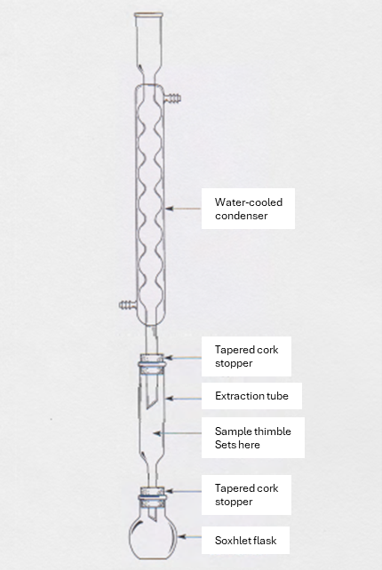
Butt type extration setup
Procedure
- Clean seed sample of impurities. Use a magnet to remove fine metal particles, if present.
- Determine moisture content of the sample. If moisture content is > 10%, dry in an oven set at ≤ 80 °C. to bring moisture to less than 10%.
- Store sample in airtight jar.
- Grind at least 50 g of seeds so that no whole seeds remain and 95% passes through the 1 mm sieve. Transfer all ground seeds into an airtight jar. Determine moisture content.
- Weigh 10 g of ground seed into the extraction thimble and plug with cotton wool. Load the thimble into the extraction tube.
- Drop a few granules of pumice stone in the Soxhlet flask and weigh to the nearest mg. Pour about 125 mL of n-hexane into the flask.
- Assemble the extraction apparatus (as shown in the figure) in the fume hood.
- Start the cooling water to the condenser.
- Turn on the heater for the Soxhlet flask. Increase the temperature gradually so the n-hexane reflux rate is at least 3 drops per second. Continue extraction for 4 h. Turn off the heater and cool.
- Remove the thimble from the extraction tube and air-dry in the fume hood to remove the residual solvent.
- Grind the content of the thimble using a micro grinder to particle size less than 160 µm. Put the finely ground sample back in the thimble. Use cotton wool to collect any sample particles from the grinder and place it in the thimble.
- If needed, add more solvent in the flask containing the first extract and continue extraction for another 2 h. Allow to cool and air dry the thimble in the fume hood.
- Repeat steps 11 and 12 and do third extraction for 2 h.
- Evaporate the solvent in the flask at 80 °C under reduced pressure using a rotary evaporator.
- Allow the flask to cool in the desiccator for at least an hour and weigh to the nearest mg.
- Repeat steps 14 and 15.
- The difference in weight should not exceed 10 mg. If it does, repeat heating for 10 minutes, cooling down and weighing until the difference between two successive weighing does not exceed 10 mg.
- If a slight increase in weight is observed, take the previous lowest weight.
Calculations
$$oil content \%=\frac{m_{1}}{m_{o}}×100$$
Where:
$m_{1}$ = the mass of dried oil (extract) in the flask, g
$m_{0}$ = the weight of test sample (step 4), g
References:
- American Oil Chemists’ Society (AOCS) Official Method Am 2-93 - Oil Content in Oilseeds. Collison, M.W. (Ed.). (2017). Official Methods and Recommended Practices of the AOCS, 7th Edition. AOCS Press.
- American Oil Chemists’ Society (AOCS) Official Method Ai 3-75 - Oil content of Sunflower Seeds, Collison, M.W. (Ed.). (2017). Official Methods and Recommended Practices of the AOCS, 7th Edition. AOCS Press.

6.7.2 TD-NMR
🧪Oil content TD-NMR🧪
Non-destructive method using Time-Domain Nuclear Magnetic Resonance (TD-NMR).
The method described below is for the Minispec mq20 (Bruker); developed by Roque Evangelista at USDA-ARS NCAUR in accordance with (AOAC 2024e; Collison 2017).
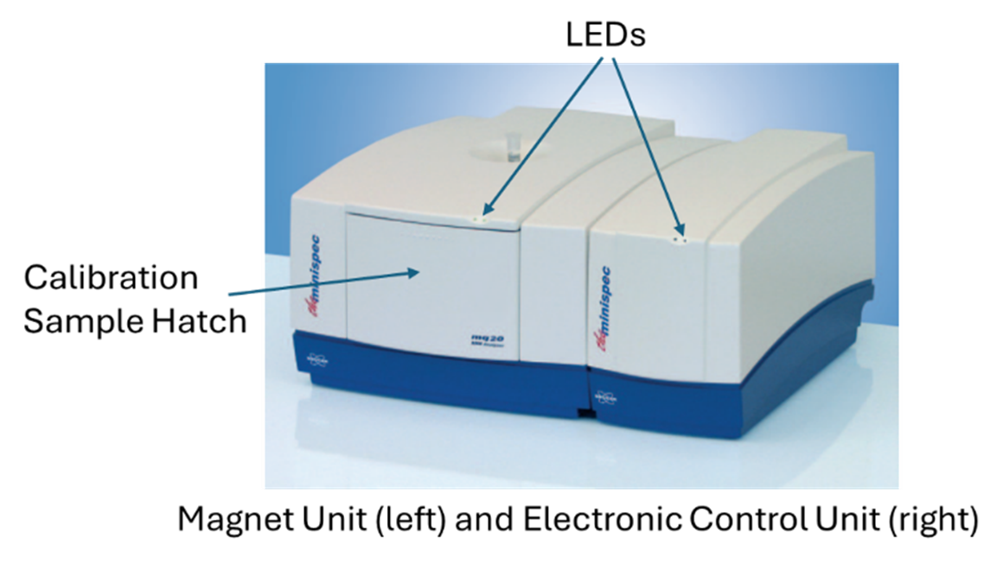
Minispec mq20 (Bruker)
Equipment and supplies
- the Minispec mq20 (Bruker)
- mq20 magnet with 25 mm air gap.
- 20 MHz probe assembly for sample tubes of 18 mm outer diameter.
- Electronic control unit
- Minispec Plus software
- Analytical balance (0.00 g)
- Borosilicate tubes -18 x 150 mm
- Dry block heater (set at 40 °C) for 18 mm OD tubes
- Rubber stoppers- size 0
Procedure
- Turn on the minispec and the PC.
- Check if the light emitting diodes (LEDs) in front of the instrument are lighting green.
  - Electronic control unit (ECU)
    - Right LED, connection status indicator: ON (green) – PC communication to the ECU is OK; OFF – No communication between the ECU and the PC
    - Left LED, status indicator: ON (green) – The ECU is powered and working; OFF – The ECU is not working
  - Magnet Unit (MU)
    - Right LED, magnet temperature status indicator: RED – Pre-heating; YELLOW – Transition to normal heating temperature fine adjustment; GREEN – Temperature is OK (It will take up to three hours for magnet’s temperature to stabilize.)
    - Left LED, connection status indicator: ON (green) – communication between the MU and ECU is OK; OFF – no communication between MU and ECU.
- Click on the minispec NF icon on the display to get into the main menu.
- Check if the daily check is still valid, otherwise perform the daily check using the check sample tube stored in the compartment/front cover of the magnet. The instrument is ready to use after passing the daily check.
- Select the method for oil content measurement. If the method has not been established yet, proceed to calibration (below).
- Prepare samples for analysis
  - Clean seed sample of impurities. Use a magnet to remove metal particles, if present.
  - Determine the moisture content of the samples. Moisture content of the samples for TD-NMR analysis should be < 10%.
  - If moisture content is > 10%, dry in an oven set at ≤ 80 °C. to bring moisture to less than 10%.
  - Fill the tube with 3 g of samples. Record weight to nearest cg.
  - Plug tube with rubber stopper.
  - Place the tubes with samples in the dry block heater for at least 30 min.
  - Analyze the samples.
- Choose the method for oil content analysis.
- Click on measure and follow the prompts to insert samples. The result may be displayed as g of oil or % oil, depending on how the method was set up.
- Calculate % oil content (for results in g of oil). Note: Percent oil content will be displayed if sample weights were entered before analysis.
$$Oil content \%=\frac{oil \left[g\right]}{weight of sample \left[g\right]}×100$$
Calibrating the TD-NMR (for oil content measurement only)
- Prepare 5 borosilicate tubes. Pack the bottom of each borosilicate tube with cotton fiber (~3 mm height).
- Carefully add aliquots (0.25 g, 1.00 g, 1.175 g, 2.50 g) of hempseed oil directly onto the packed cotton fiber in each tube. Record the exact weight (0.00 g) of oil added to each tube. Do not add oil to tube 1.
- Plug each tube with a rubber stopper and place in the dry block heater.
- Open the Minispec Plus menu and perform the daily check.
- Click on the calibrate button to enter the calibration menu.
- Select create a new calibration and give a descriptive name for the method.
- Select the corresponding Bruker pre-defined calibration method that suits your sample type or select the new method you intend to use.
- Verify and adjust important acquisition settings such as the number of scans and recycle delay times. Default settings are shown in the below table.

Parameter | Value
Scans | 16
Rd [s] | 2.00
Gain [dB] | 50
Dig. Bw [Hz] | 781
Det. Mode | magnitude
Magnitude Mode | DIODE
Dummy Shots | 0
Gradient Unit | None

Setting | Value
90 Pls. Len. [us] | 15.92
180 Pls. Len. | 31.52
Det Angle.B [deg] | 355
H Offs. [Steps] | 1108
NMR Freq1 [MHz] | 19.950000
Pulse Atten [dB] | 19
Instr. Gain [db] | 45
Dead Time [ms] | 0.0336
Homog. Limit [ms] | 0.20
Instr. Rd [s] | 2.00
Stat Grad X [%] | 0.00
Stat Grad Y [%] | 0.00
Stat Grad Z [%] | 0.00
SFC | no
- Start the calibration and perform gain tuning with the sample having the highest amount of oil to optimize signal acquisition.
- Continue measuring each calibration sample sequentially following the prompts in measuring one sample after another.
- Review calibration data. Add or remove samples as necessary to improve calibration fit and accuracy (≥0.990).
- Sign and save the calibration.
- Exit the calibration menu.
References
- American Oil Chemists’ Society (AOCS) Official Method Ak 3-94 - Oil Content of Oilseeds by Nuclear Magnetic Resonance. Collison, M.W. (ed.). (2017). Official Methods and Recommended Practices of the AOCS, 7th Edition. AOCS Press.

6.8 Fatty acid composition
🧪Oil fatty acid composition analysis🧪
Developed by Roque Evangelista at USDA-ARS NCAUR in accordance with (AOAC 2024a; Isbell et al. 2015).
Equipment
- Handheld homogenizer drive (CAT X120 or equivalent)
- Homoginizer (CAT T10-V or equivalent)
- 20 mL scintillation vials with cap
- Dry block heater for scintillation vials
- GC vial 12 x 32 mm (National C4000-1W)
- Screw tread cap for GC vials (National C5000-51B)
- Adjustable volume bottle top dispensers for dispensing sodium methoxide, hexane, and saturated NaCl solution
- Glass transfer pipettes
- GC equipped with flame-ionization detector (FID) and autosampler/injector
- GC column – 30 m X 0.25 mm i.d. X 0.20 µm thickness (Zebron Capillary GC Colum ZB-FAME, Part No. 7HG-G033-10, phenomere)
Reagents
- 0.25M sodium methoxide in methanol
- Hexane (high purity gas chromatographic grade)
- NaCl, reagent grade, saturated. Dissolve 36 g NaCl in 1 L distilled water
- Helium (carrier gas) – 99.995% or better, gas chromatography quality
- Nitrogen (make-up gas) – 99.995% min, chromatography grade
- FAME standards - a mix of saturated and unsaturated fatty acid methyl esters (FAME) C8-C30 and 18:1, 18:2, 18:3, 20:1, 22:1(Nu-Check Prep)
Preparing fatty acid methyl esters (FAME) from seeds
- Coarse grind seeds using a coffee grinder.
- Transfer 1.0 g ground sample into a 20 mL scintillation vial.
- Add 5 mL 0.25M sodium methoxide in methanol solution.
- Blend using a homogenizer for ~10 sec. Rinse the homogenizer with methanol.
- Cap the vial and incubate in the dry heating block (60 °C) for 30 minutes.
- Remove vial from heating block and cool to room temperature.
- Add 5 mL of hexane followed by 5 mL of saturated sodium chloride solution.
- Cap the vial and mix thoroughly. Let stand to allow layers to separate.
- Draw ~0.25 mL from the top (hexane) layer and transfer into a GC target vial.
- Add 2 mL hexane to the target vial and then cap.
- Prepare test sample in duplicate.
Prepare reference standard mix
- Transfer the contents of one Nu-Chek Pre vial FAME standard mix to a clean 100 mL volumetric flask. Use hexane to rinse remaining FAME in the vial and add to the volumetric flask.
- Fill volumetric flask with hexane to the fill line. Place a stopper and mix.
- Remove the stopper and heat slightly using the steam bath to dissolve solid methyl esters. Ensure the final volume is at the line, add more if hexane if needed.
- Transfer ~1.5-2 ml of standard mix solution into crimp cap GC vials using a glass transfer pipette. Crimp the vials with the lids, making sure that they seal tightly. Should make between 50 to 65 vials.
- Label vials with “STD MIX” and “DATE” and store in the freezer (-20℃).
FAME Analysis
- GC operating conditions
  - Temperature program
    - Initial 160 °C, hold 4 min, program ramp 160 - 195 °C at 7.5 °C/min, 195 - 280 °C with 5 min hold
    - Injector and detector temperature - 250°C.
  - Septum purge of 4.0 mL/min
  - Helium flow rate to the column - 1.2 mL/min at 138 kPa (20 psi)
  - Injection volume – 2.0 µL
  - Split ratio - 100:1.
- Run blank. Check the chromatogram of the blank vial for any interference (contamination and background noise) that may introduce errors in the test sample measurements.
- Run the standard mix. Check the chromatogram of reference standards to make sure the FAMEs are accounted for.
- Run test samples. Identify peaks in test samples by comparing their retention times with reference standards.
- Calculate the fatty acid distribution as percent of total peak areas. Exclude unidentified peaks in the summation of peak areas unless they have been confirmed to be fatty acids.
Area [%] of the component $i$ expressed as methyl ester:
$$\frac{A_{i}}{100∑A}$$
Where,
$A_{i}$ = peak area of component $i$
$∑A$ = sum of areas of all identified peaks
References
- American Oil Chemists’ Society (AOCS) Official Method Ce 1a-13 (revised 2017) - Fatty acids in edible oils and fats by capillary GLC. Collison, M.W. (Ed.). (2017). Official Methods and Recommended Practices of the AOCS, 7th Edition. AOCS Press.
- Isbell, T.A., Cermak, S.C., 2015. Registration of Katelyn Thlaspi arvense L. (Pennycress) with improved nondormant traits. J. Plant Regist. 9:212-215. https://doi.org/10.3198/jpr2014.08.0053crg

6.9 Protein content

6.9.1 Kjeldahl
🧪Kjeldahl Method for Crude Protein🧪
Developed by Roque Evangelista at USDA-ARS NCAUR in accordance with (Latimer 2023; AOAC 2023).
Equipment
- Digestion block with temperature control, digestion tube rack, heat shield, and fume exhaust manifold connected to a water aspirator in a hooded sink. (Tecator Digestion System 20, 1015 Digestor, Foss North America or equivalent)
- Digestion tubes (250 mL)
- Distillation unit to accept 250 mL digestion tubes (Tecator 2200, or equivalent)
- Titration flask (500 mL)
- Weighing paper (low N)
- Balance (0.000g)
- Adjustable volume pipetting dispenser (≤25 mL) attached to 2.4 L acid bottle
- Safety equipment (cotton lab coat, safety glasses, chemical resistant gloves, gloves for handling hot tubes)
- Titration burette – 25 mL
- Magnetic stirrer and stir bar
Reagents
- Sulfuric acid - 95-98% H₂SO₄, reagent grade
- Catalyst – 7.0g K₂SO₄ + 0.8 g CuSO₄ (commercially available in tablet form, 3.5 K₂SO₄ + 0.4 g CuSO₄ per tablet)
- Sodium hydroxide – 40% w/w NaOH, low N (≤5µg N/g)
- Kjeldahl boric acid solution with indicators (bromocresol green/methyl red) – 4% (commercially available)
- Hydrochloric acid standard solution - 0.10M (commercially available)
- Reference standards
  - Acetamilide (Baker A068-05)
  - Tryptophan (Sigma T 8659)
  - (NH₄)₂SO₄ (100% assay)
- Sucrose (N-free)
Procedure
Sample preparation
- Grind the seed sample using a knife mill (recommended for seeds with high oil content) to 0.7-1 mm particle size.
- Transfer ground sample into a capped bottle.
- Determine the moisture content of starting seed sample and ground sample.
Digestion
- Turn on the digestion block and heat to 420 °C.
- Weigh 1 g of ground sample onto a tared low N weighing paper. Fold paper around material and drop into the Kjeldahl tube. Record the exact weight of the sample to the nearest mg.
- Add into the Kjeldahl tube 2 tablets of catalyst and 15 mL of sulfuric acid using the pipetting dispenser.
- Place tube in the tube rack.
- Attach heat side shield to tube racks and fume manifold on tubes.
- Turn water aspirator on completely.
- Place rack in preheated digestion block
- After 10 min, turn the water aspirator down until acid fumes are just contained within the exhaust hood. A condensation zone should be maintained within the tube. After bulk of sulfur oxide fumes are produced during the initial stages of digestion, reduce vacuum source to prevent loss of H₂SO₄. Continue digestion for 50 min. Total digestion time is approximately 60 min.
- Turn the digestor off and remove the digestion rack with exhaust still in place and allow it to cool for 10-20 min. Remove the manifold and shut off the aspirator once fuming has stopped.
- Remove the heat shields and let the tubes cool.
- Carefully add a few mL of deionized water to each tube up to 80 mL. This can be omitted if the distillation unit uses steam to equilibrate the digested sample.
Distillation
- Fill the distillation unit’s alkali tank with 40% NaOH and adjust volume dispensed to 50 mL.
- Attach the digestion tube to the distillation unit.
- Fill Erlenmeyer flask with 30 mL of the 4% H₃BO₃ solution with indicator and place on receiving platform of the distillation unit. Immerse the tube from the condenser below the surface of the H₃BO₃ solution.
- Steam distill until ≥150 mL distillate is collected (≥180 mL total volume).
Titration
- Remove flask and add stir bar and set flask on the magnetic stirrer.
- Fill the burette with standard 0.100M HCl. Record the starting volume.
- Add titrant slowly to the sample and titrate to violet end point (just before the solution turns pink). Record the volume of HCl used to the nearest 0.05 mL.
Verification of Nitrogen Recovery
- Nitrogen loss: Use 12 g (NH4)₂SO₄ and 0.67 g sucrose per flask and perform distillation as described above. Recoveries must be ≥99%.
- Distillation and titration efficiency: Distill 0.12 g (NH4)₂SO₄. Recoveries must be ≥99.5%.
- Digestion efficiency: Use 0.3 g acetamide or 0.18 g tryptophan, with 0.67 g sucrose per flask. Digest and distill as described above. Recoveries must be ≥98%.
References:
- Association of Official Analytical Chemists (AOAC) Official Method 2001.11 – Protein (Crude) in Animal Feed, Forage (Plant Tissue), Grain, and Oilseeds: Block Digestion Method Using Copper Catalyst and Steam Distillation into Boric Acid. Latimer Jr., G. (ed.), 2023. Official Methods of Analysis of AOAC International (22nd Ed).

6.9.2 Combustion
🧪Combustion Method (Dumas N) for Crude Protein🧪
Developed by Roque Evangelista at USDA-ARS NCAUR in accordance with (Corporation 2022).
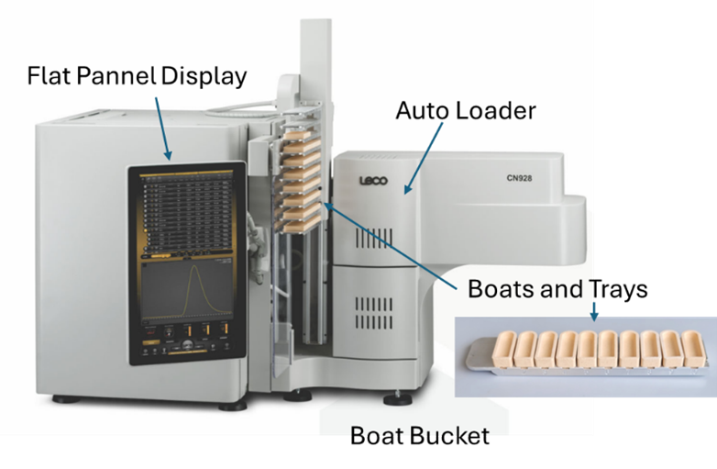
LECO FP928 Macro N Analyzer
Equipment
- LECO FP928 Macro N analyzer with Cornerstone® software
- Unglazed ceramic combustion boats (LECO 528-203)
- Analytical balance (0.0001 g)
- Carrier gas -Helium. 99.99% pure, 25 psi %
- Combustion gas – Oxygen, 99.99% pure, 25 psi ± 10%
- Pneumatic gas – Compressed air, oil and water free, 40 psi ± 10%
- EDTA LCRM (LECO 502-896-250
Procedure
- Prepare instrument for operation as outlined in the operator’s instruction manual. Select the method for the analysis.

Parameter | Value
Gas | Helium
Furnace temperature | 1,100 °C
Ramp rate | 12 °C/min
Dehydration time | 0 s
Nominal sample mass | 1.000 g
Purge cycles | 3
Ballast equilibrate time | 10 s
Ballast not filled timeout | 300 s
Aliquot loop fill pressure drop | 200 mmHg
Aliquot loop equilibrate time | 4 s
Dose loop size | 3 $cm^{3}$ (small)

Burn Steps | Parameter | Value
Step 1 | Lance flow | No
 | Furnace flow | Yes
 | Time | 5 s
Step 2 | Lance flow | Yes
 | Furnace flow | Yes
 | Time | 5 s
Step 3 | Lance flow | Yes
 | Furnace flow | No
- Condition the System.
  - Select five or more blank replicates in the Login screen (ceramic combustion boat is not required).
  - Initiate the analysis sequence.
- Determine blank.
  - Select five or more blank replicates in the Login screen.
  - Place ceramic combustion boats in the appropriate positions in the autoloader.
  - Initiate the analysis sequence.
  - Set the blank following the procedure outlined in the operator’s instruction manual.
  - Note: The standard deviation of the last five blanks should be less than or equal to 0.001% (10 ppm) when utilizing Helium as a carrier gas. Additional blanks beyond the recommended five may be required to achieve the recommended precision.
- Calibrate/Drift Correct.
  - Select the desired number of Calibration/Drift replicates in the Login screen (minimum of five).
  - Weigh an appropriate mass of suitable reference material into a 528-203 Ceramic Combustion Boat.
  - Enter sample mass and identification into the Login screen.
  - Transfer the ceramic combustion boat containing the reference material to the appropriate position in the autoloader.
  - Perform steps 4b through 4d a minimum five times for each calibration/drift material used.
  - Initiate the analysis sequence.
  - Calibrate or Drift Correct the instrument following the procedure outlined in the operator’s instruction manual.
  - Verify the calibration by analyzing an appropriate mass of another suitable reference material and confirm that the results are within the acceptable tolerance range.
  - Note: Typically, the LECO FP928 can be calibrated utilizing several replicates of a single mass range (nominal 0.75 g) of EDTA utilizing a single standard calibration (linear, force through origin calibration). This is a cost effective and simple process. The calibration can be verified by analyzing different compounds such as nicotinic acid (0.15 to 0.35 g), or phenylalanine (0.15 to 0.5 g). A multi-point calibration (fractional masses or multiple calibration samples) may be used to calibrate if desired.
- Analyze Samples.
  - Select the desired number of sample replicates in the Login screen.
  - Weigh approximately 1.0 g of the sample material into a 528-203 Ceramic Combustion Boat.
  - Enter sample mass and identification information into the Login screen.
  - Transfer the ceramic combustion boat containing the sample to the appropriate position in the autoloader.
  - Perform steps 5b through 5d for each sample to be analyzed.
  - Initiate the analysis sequence.
  - Note: If soot (carbon black) is noticed in the primary filter (steel wool filter), reduce the sample mass to prevent soot build-up in this filter. Soot can be produced when larger masses of high fat samples are analyzed. Use 0.400 g for hempseeds.
References
- LECO Application Note (Instrument: FP928), 2022. Determination of nitrogen/protein in feed, grains, and pet food. LECO Corporation, Saint Joseph, Michigan USA
📚Additional References📚
- Boyce (1900)
- Mah (1923)
- Tuma (1972)
- Ribnicky et al. (2000)
- Vaknin et al. (2011)
- Sera et al. (2012)
- Small and Brookes (2012)
- Serkov (2015)
- Suriyong et al. (2015)
- Yadav and Murthy (2016)
- Citti, Pacchetti, et al. (2018)
- H. Hu, Liu, and Liu (2018)
- Devi and Khanam (2018)
- Jian et al. (2018)
- Williams (2019)
- He et al. (2020)
- Moon, Cha, et al. (2020)
- Punja and Holmes (2020)
- Schultz et al. (2020)
- Serkov et al. (2020)

7. FIBER
Samples submitted to NPGS will be evaluated by a USDA-ARS laboratory using similar protocols as described below.

7.1 Yield
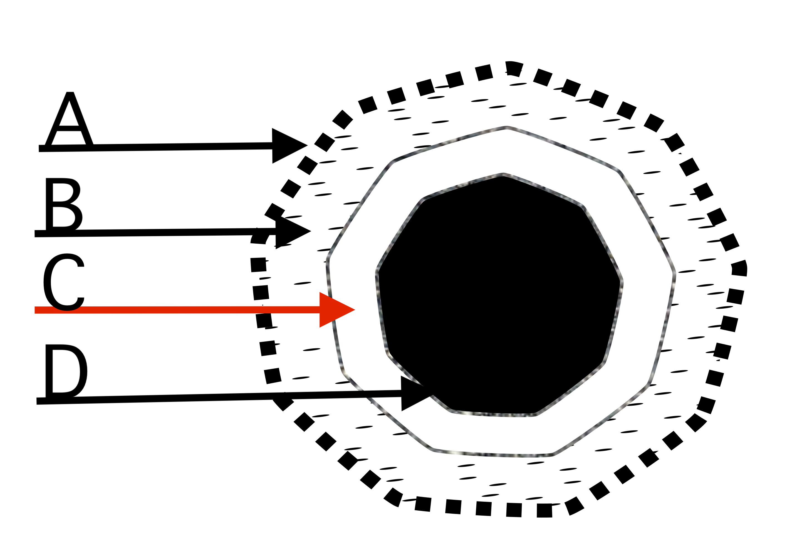
Hemp stem cross section. A = epidermis; B = bast and cortex; C = pith, also known as hurd, D = inner core, usually hollow but not at joints.
fiber_yield [decimal; $\frac{kg}{Ha}$]
Fiber yield; modified from Serkov (2015). See also Backer et al. (2018). Harvest 10 plants, remove top and bottom 15 cm, defoliate run sample through a chipper, and measure mass. Calculate fiber_yield based on planting density.
wet_fiber_biomass [decimal; g]
Harvest stems 15 cm from base, remove top 15 cm, and defoliate. Wet biomass is average weight per stem without inflorescences from a sample of 10 plants Modified from Carlson et al. (2021).
dry_fiber_biomass [decimal; g]
Use sample from wet_fiber_biomass measurements. Dry biomass is average weight per stem dried at 65 ˚C until brittle from a sample of 10 plants. Modified from Carlson et al. (2021).
bast [decimal; %]
Stems collected from a sample of 10 plants, dried until brittle, and separated into bast (bark) and hurd (core) using a flax breaker, or by hand. Record as fraction of oven-dried mass.
hurd [decimal; %]
Stems collected from a sample of 10 plants, dried until brittle, and separated into bast (bark) and hurd (core) using a flax breaker, or by hand. Record as fraction of oven-dried mass.
📐Bast & hurd content📐
bast = $\frac{bast}{dry}×100\%$
hurd = $100\%-bast$
bast_soluble & fiber_solubility [decimal; %]
Soluble materials in bark after evaluation with sodium hydroxide evaluation.
🧪Sodium hydroxide evaluation🧪
Protocol
- 10 - 15 g isolated hurd samples isolated from dry stems, or 10 - 15 g isolated bast samples from dry stems.
- Pulp dispersion apparatus, consisting of a variable speed motor and a stainless steel stirrer with a shell.
- Thermometer
- Vacuum source
- Filtering flasks, 100 mL
- Graduated cylinder, 100 mL
- Watch glasses
- Stirring rods
- Tall, 200 mL beakers
- Water bath with cover and holes to securely submerge the bottoms of tall, 200 mL beakers.
- Filtering crucibles, 30 mL, 10 - 15 µm maximum pore size.
- 1000 mL sodium hydroxide solution, 1.0 % ± 0.1 NaOH (0.25 N)
- 1000 mL acetic acid, 10%.
- Grind hurd or bast sample into a fine meal.
- Dry filtering crucibles before use in an oven at 105° ± 3 °C for 60 min, cool in a desiccator, and record weight.
- Heat water bath to 97 - 100 ˚C
- Adjust speed of the motor and the angle of the blades so that no air is drawn into the pulp suspension during stirring.
- Place 10 g meal into 200 mL beaker and add 100 mL 1% NaOH and stir with glass rod.
- Cover beaker with watch glass and place into water bath for 1 h. Keep water level above level of alkali solution in the beaker at all times.
- Stir the meal with a rod for about 5 s at 10, 15, and 25 min after placing into the bath.
- At the end of 1 h, transfer the material to a tared filtering crucible and wash with 100 mL of hot water.
- Add 25 mL of 10 /% acetic acid and allow to soak for 1 min before removal. Repeat this step once again.
- Wash material with 100 mL hot water three times to remove acid.
- Dry crucible and contents in the oven at 105 - 108 ˚C until constant weight.
- Cool in desiccator.
📐% Soluble materials📐
$$\frac{meal.before-meal.after}{meal.before}×100\%$$
non_fiber [TBD]
Protocol for evaluating stem non-fiber components not determined.

7.2 Quality
There is little modern research on hemp fiber quality evaluation protocols. This work will be conducted in collaboration with the Southern Regional Research Center (SRRC).
📜Candidate fiber traits📜
- fiber length
- fiber strength
- fiber flexibility; see Werf, Haasken, and Wijlhuizen (1994)
- fiber length/diameter ratio; see Ranalli (1999)
- tensile strength; see Ranalli (1999)
- brittleness; see Ranalli (1999)
- crystallization/cellulose crystallinity Rongpipi et al. (2019)
- cross linking
- elasticity; see Ranalli (1999)
- ease of decortication
- mechanical vs microbial retting
- cellulose:lignin ratio
fiber_remarks [nvarchar]
Remarks are used to add notes or to elaborate on fiber descriptors
📚Additional References📚
- Charles (1708)
- Unknown (1720)
- David (1729)
- Slator (1735)
- Marcandier (1764)
- Gee (1767)
- Farmer (1775)
- Wissett (1808)
- Humphrey (1919)
- Vavilov (1957)
- Werf et al. (1995)
- Daryl T. Ehrensing (1998)
- Rustichelli et al. (1998)
- Hampton (2000)
- Struik et al. (1999)
- Hillig (2005)
- Pahkala, Pahkala, and Syrjälä (2008)
- Zatta, Monti, and Venturi (2012)
- Piluzza et al. (2013)
- Salentijn et al. (2015)
- Serkov (2015)
- Mishchenko and Lajko (2016)
- Grassi and McPartland (2017)
- Tang et al. (2016)
- Weijde et al. (2016)
- Johnson (2018)
- Musio, Müssig, and Amaducci (2018)
- Salentijn, Petit, and Trindade (2019)
- Williams (2019)
- Petit et al. (2020)

8. SECONDARY METABOLITES
Unless otherwise stated, collect from a sample of 10 plants at harvest. Samples submitted to NPGS will be evaluated by a USDA-ARS laboratory using similar protocols as described below.

8.1 Chemotype
chemotype [int; 1-6]
Note that living tissues synthesize acid forms of most cannabinoids (i.e. THC-a, CBD-a) and these are often decarboxylated to non-acid forms during evaluation (i.e. THC, CBD). Chemotype is largely driven by segregation of alleles at the $B$ or $O$ loci Toth et al. (2020).
1 = Mostly THC(A)
2 = ~1.5:1 CBD(A):THC(A)
3 = Mostly CBD(A)
4 = Mostly CBG(A)
5 = Low overall cannabinoid content
6 = Other
chemotype_segregation [nvarchar]
To not mask chemotype, we recommend measuring cannabinoids from 10 individual plants rather than pooling samples. If multiple individuals are evaluated for chemotype and differing chemotypes are observed in the same population, indicate the percentage of each chemotype using the chemotype scale (1:#;2:#;3:#,4:#,5:#).

8.2 Cannabinoids
While PGRU runs a rapid six cannabinoid HPLC assay DOWNLOAD FILE (370 KB️⬇️) for routine regenerations, we prefer the complete cannabinoid methods developed or adapted by Korey Brownstein at USDA-ARS NCAUR for routine phenotyping and germplasm characterization efforts.
cannabinoids [decimal; $\frac{μg}{mg}$]
Cannabinoid content is evaluated either by UPLC or HPLC. THC is a ‘’sticky’’ compound and residues will persist on laboratory equipment and analytical vessels following cleaning. THC carryover onto subsequent samples may erroneously increase the reported THC content. We strongly advise against re-using sample vials for UPLC and HPLC cannabinoid evaluation.
UPLC uses a shorter run time per sample, however HPLC provides better resolution for minor cannabinoids. Both methods are sufficient for quantifying total THC in compliance with the 2021 USDA-AMS Hemp Final Rule.
10 samples collected from 10 individual plants. Each sample should be analyzed in triplicate. Cannabinoid content is variable across the height of the plant. THC-a decarboxylates into THC following exposure to heat. We advise against decarboxylating cannabis samples prior to instrument evaluation, as this process introduces error through the volatilization of a variable percentage of the total cannabinoid content.
Instead, we recommend combining the THC-a and THC content of unheated plant samples to calculate the total THC content. The formula for this is:
📐THC & Cannabinoid analytes📐
$$THC_{total.potential}\left(μg/mg\right)=THC+0.877⋅THC_{a}$$
$$Cannabinoid.analyte=C_{e}\frac{V_{f}}{W_{s}}$$
where:
$C_{e}$: Conc of the sample in the extraction solution ($\frac{μg}{μL}$)
$V_{f}$: Final volume of the sample ($μl$)
$W_{s}$: Weight of the sample ($mg$)
🧪UPLC cannabinoid evaluation🧪
Sample run time: 10 min.
Equipment
• Sonicator
• Number 35 sieve
• Thermo Scientific UltiMate 3000 LC system controlled by Chromeleon software
• Supelco Ascentis® Express 90 Å C18, 2 μm, 15 cm × 2.1 mm (or use a Supelco Ascentis® Express 90 Å C18, 2.7 μm, 15 cm × 2.1 mm on lower pressure LC systems)
• 5 mM aqueous ammonium formate
• 95% formic acid
• Acetonitrile
• Volumetric flasks: 1.5 L, 50 mL
• 0.20-µm Nylon (or PTFE) membrane filter
Standards:
- Cannabidivarinic Acid (CBDVA; CAS #: 31932-13-5)
- Cannabigerovarinic Acid (CBGVA; CAS #: 64924-07-8)
- Cannabidivarin (CBDV; CAS #: 24274-48-4)
- Cannabivarin (CBV; CAS #: 33745-21-0)
- Cannabidiolic Acid (CBDA; CAS #: 1244-58-2)
- Cannabigerolic Acid (CBGA; CAS #: 25555-57-1)
- Tetrahydrocannabivarin (THCV; CAS #: 31262-37-0)
- Cannabigerol (CBG; CAS #: 25654-31-3)
- Cannabidiol (CBD; CAS #: 13956-29-1)
- Tetrahydrocannabivarinic Acid (THCVA; CAS #: 39986-26-0)
- Cannabichromevarinic Acid (CBCVA; CAS #: 1628112-69-5)
- Cannabinol (CBN; CAS #: 521-35-7)
- Cannabinolic Acid (CBNA; CAS #: 2808-39-1)
- Δ9-Tetrahydrocannabinol (THCd9; CAS #: 1972-08-3)
- Δ8-Tetrahydrocannabinol (THCd8; CAS #: 5957-75-5)
- Δ9-Tetrahydrocannabinolic acid A (THCA or THCAA; CAS #: 23978-85-0)
- Cannabicyclol (CBL; CAS #: 21366-63-2)
- Cannabichromene (CBC; CAS #: 20675-51-8)
- Cannabichromenic Acid (CBCA; CAS #: 185505-15-1)
- Cannabicyclolic Acid (CBLA; CAS #: 40524-99-0)
Standard preparation
- All standard solutions are to be prepared at a concentration of 100 µg/mL.
- Cannabinoid acid standards are prepared in acetonitrile. Decarboxylated cannabinoids are prepared in methanol.
Reagent preparation
- 1 L reagent for Mobile Phase A: Combine 0.21 mL 95% formic acid with 5 mM ammonium hydroxide (0.62 mL 30% ammonium hydroxide solution) with millipore water to 999 mL. Add 1 mL formic acid.
- 1 L reagent for Mobile Phase B: Combine acetonitrile with formic acid to 0.1% formic acid.
Protocol
- Dry inflorescences at room temperature (20 °C) to < 10% moisture.
- Grind samples (without introducing heat).
- Pass through a number 35 (500 μm) sieve.
- Place 0.100 grams of ground hemp material in a 20 mL glass scintillation vial.
- Prepare each sample in triplicate.
- Calibrate the pipetter to ensure it is delivering the correct volume of 200-proof ethanol. Check that the weight of 20 mL of ethanol delivered is 15.78 g (density: 0.789 g/cm3).
- Add 20 mL of HPLC grade 200-proof ethanol to the sample.
- Sonicate (40 kHz) in a sonication bath for 30 min at room temperature.
- Remove from sonication bath.
- Allow the sample to sit overnight (18 h) in the dark at room temperature.
- The next day filter the supernatant through a 0.20-μm Nylon (or PTFE) membrane filter into a sample vial for analysis.
- Set flow rate to 0.350 mL/min.
- The autosampler chamber (if a temperature-controlled sample tray is available) and column temperature are set to 8 °C and 10 °C, respectively.
- Inject 1 µL sample volume.
- LC gradient program: 0-2 min, 90% B (convex curve 1); 2-5 min, hold at 90% B; 5-5.1 min, 100% B (linear curve 5); 5.1-6.1 min, hold at 100% B; 6.1-6.2 min, 75% B (linear curve 5); and 6.2-8, hold at 75% B followed by 2.0 min of equilibration at 75% B between injections.
- Five-point standard curves are developed for the cannabinoids using a setting of 228 nm from the diode array detector.
- Integrate peaks using the Cobra algorithm in Chromeleon software.
Method developed by Dr. Korey Brownstein with updates in 2025.

8.3 Other metabolites
terpenes [decimal]
🧪Terpene evaluation🧪
Equipment
- GC/MS (Agilent 7890B GC, Agilent 5977B MSD, PAL 3) controlled by LabSolutions software
- HP-5MS UI, 30 m × 0.25 mm, film 0.25 μm column
- 0.45 μm filter
- Hexane
Standards
- β-bisabolol
- Bulnesol
- m-Camphorene
- p-Camphorene
- Δ3-Carene
- β-Caryophyllene
- 10-epi-γ-Eudesmol
- α-eudesmol
- β-eudesmol
- α-humulene
- Limonene
- Linalool
- β-Myrcene
- Plastochromanol-8
- α-Phellandrene
- α-Pinene
- cis-Sabinene hydrate
- γ-Selmene
- Selna-3,7(11)-diene
- α-Tocopherol
- β-Tocopherol
- δ-Tocopherol
- γ-Tocopherol
- β-Pinene
- Nerolidol
- Camphene
- Terpinolene
- Ocimene
- α-Terpinene
- γ-Terpinene
Protocol
- Dilute essential oil standards with hexane to a concentration of 0.1 mg/mL.
- Dry inflorescences at room temperature (20 ˚C) to > 10% moisture.
- Grind samples.
- Combine 20 mg plant material with hexane.
- Pass through the 0.45 µm filter to extract terpenes.
- Dilute filtrate 1:20 with hexane.
- Inject samples into split injection port (1:5).
- Instrument settings as follows:
  - Injection port held at 100 ˚C with an initial time of 4 min.
  - Inlet temperature fixed at 250 ˚C.
  - Detector temperature fixed at 280 ˚C.
  - Column held at 35 °C for 5 min, then raise to 150 °C at 5 °C/min. Then raise to 250 ˚C at 15˚ C/min. Hold time 90 min.
  - Helium serves as carrier gas, with flow rate 1 mL/min.
Adapted from Hanuš and Hod (2020).
See also hops methods
flavonol_index [decimal]
🧪Flavonol evaluation🧪
A handheld MPM-100 meter by ADC BioScientific can do this measurement instantly. (see citation and instrument)
- Flavonoids: Spectroscopic measurement of fluorescence at different wavelengths (F660 nm and F325 nm):
- Flavonols: (F660 nm/F325 nm).
anthocyanins [decimal]
🧪Anthocyanin evaluation🧪
Sample prep and extraction
- Samples are ground into a fine powder with a coffee mill and passed through a 60 mesh filter to collect the fine ground fraction.
- Batches of 250 grams of ground sample are extracted with 1% HCl in methanol with stirring overnight at room temperature.
- The liquid is decanted and filtered through Whatman 54 filter paper.
- The remaining solid material is extracted with only methanol a second time with stirring overnight and decanted and filtered.
- The extracts are pooled, and approximately 400 mL of water is added, and allowed to evaporate over 72 hours in the hood or rotovaped at 45 °C to remove the methanol.
- The concentrated extract is filtered gain to remove any remaining solid material.
Method A: Preparative Chromatography
- A Buchi (Newcastle, DE) Sepacore flash chromatography system with dual C-605 pump modules, C-615 pump manager, C-660 fraction collector, C-635 UV photometer, with SepacoreRecord 1.2 chromatography software is used.
- A 40 x 150 mm flash cartridge column with approximately 90 grams of preparative C18 reverse phase end capped bulk packing material (Silicycle SiliSep BUC18 (17%) 60 Angstroms, 40-63 um, Silicycle, Quebec, Canada) is used for the preparative separation.
- The columns are installed in the flash chromatography system, and new dry columns are initially washed with methanol and then equilibrated with 0.2% acetic acid in water for five minutes at a flow rate of 50 mL per min.
- After samples (50-100 mL) are loaded on the column, the column is developed with a binary gradient to 40% methanol over 10 minutes, then to 100% methanol over an additional 5 minutes. For anthocyanins, the effluent is monitored at 520 nm and 50 mL fractions are collected in the fraction collector by the software program.
- Fractions are concentrated by evaporation in the hood at room temperature or methanol is removed by rotovap at 45 °C.
- The fractions containing the DGA are pooled and freeze dried over 2-5 days to dryness.
Method B: HPLC Analysis
- Samples are run on a stand-alone Shimadzu 10A HPLC system (SCL-10A system controller, two LC-10A pumps, CTO-10A column oven, and SIL-10A autoinjector).
- Peaks are monitored using a Hewlett-Packard 1040A photodiode array detector running under the HP Chemstation software version A.02.05.
- The column used is an Inertsil ODS-3 reverse phase C-18 column (5 µM, 250 x 4.6 mm, with a Metaguard column, from Varian).
- The initial conditions are 2% acetonitrile and 0.5% acetic acid in water, at a flow rate of 1 ml per minute.
- The effluent is monitored at 520 nm on the PDA.
- After injection (typically 25 µL), the column is held at the initial conditions for 2 minutes, and then developed to 100% acetonitrile in a linear gradient over 60 minutes.
- Standard curves based on nanomoles injected are prepared from a pure standard of delphnidin-3-O-glucoside purchased from Chromadex (Irvine, CA).
- Extinction coefficients are calculated from a linear regression formula based on four different nanomole concentrations of anthocyanin standards (purchased from Chromadex) injected and their respective mAbs areas.
- The extinction coefficient for each anthocyanin is then used to calculate respective anthocyanin glycoside concentration in the samples by the following formula:
$$\begin{matrix} & mAbs\left(\text{area}\right)⋅extc.coef\left(\frac{\text{nM}}{\text{mAbs}}\right)⋅\frac{1}{inj.vol\left(μ\text{L}\right)} \\ & ⋅ vol.extract\left(\text{mL}\right)⋅MW_{\text{anth.glucoside}}\left(\frac{μ\text{g}}{\text{nM}}\right)⋅\frac{1}{sample\left(\text{g}\right)}\end{matrix}$$
- Addition of a glycosyl groups to the anthocyanin has little effect on its absorption profile, so anthocyanin aglycones can be used to prepare standard curves for anthocyanin glycosides on a molar basis (Berhow 2002, Mabry 1970, Markham, 1982).
Method C: LC-ESI-MS Analysis of Anthocyanins
- Samples are run on an Thermo Electron LTQ Orbitrap Discovery Mass Spectrometer – a linear ion trap (LTQ XL) MS, coupled to a high precision electrostatic ion trap (Orbitrap) MS with a higher energy C-trap dissociation (HCD) cell attached – with an Ion Max electrospray ionization (ESI) source; a Thermo Scientific ACCELA series HPLC system (ACCELA 1250 UHPLC pump; ACCELA1 HTC cool stack autoinjector; and a ACCELA 80 Hz PDA detector); all running under Thermo Scientific Xcalibur 2.1.0.1140 LC-MS software.
- HPLC conditions: The column is a 3 mm x 150 mm Inertsil reverse phase C-18, ODS 3, 3 µ column (Metachem, Torrance, CA).
- For anthocyanin analysis, the initial solvent system is 10% methanol verses water with 0.1% formic acid at a flow rate of 0.25 mL per minute.
- After injection (1 µl or less) the column is held at the initial conditions for 2 minutes then developed with a linear gradient to 100% methanol and 0.1% formic acid over 50 additional min.
- The column effluent is monitored at 520 nm by the PDA detector.
- The MS is run with the ESI probe in the positive mode.
- The source inlet temperature is set to 300 ˚C, the sheath gas rate is set at 50 arbitrary units, the auxiliary gas rate is set at 5 arbitrary units and the sweep gas rate is set at 2 arbitrary units.
- The maximal mass resolution is set at 30,000, the spray voltage is set at 3.0 kV, the tube lens is set at 100 V.
- The MS is typically calibrated at least weekly with a standard calibration mixture recommended by Thermo Scientific and the signal detection optimized by running the autotune software feature as needed.
- Other parameters are determined and set by the calibration and tuning process.
- The software package will usually be set to collect mass data between 100-2000 AMUs.
- Generally the most significant sample ions generated under these conditions are [M]⁺.
Methods provided by Berhow and Gude (2021), see also Giusti and Wrolstad (2001).
phenolics [decimal]
🧪Phenolic evaluation🧪
Sample prep and extraction
- Freeze-dry samples overnight and grind each to a fine powder.
- Weigh samples ~0.25 g and place in vial with 3 mL methanol:DMSO (1:1) solvent.
- Sonicate for 30 min, allow to stand overnight at room temperature.
- Filter extract through a 0.45 µM nylon 66 filter
Methodology
- We use a Shimadzu LC-20 HPLC system (LC-20AT quaternary pump, DGU-20A5 degasser, SIL-20A HT autosampler, and a SPD M20A photodiode array detector, running under Shimadzu LCSolutions version 1.22 chromatography software, Columbia, MD, USA) and an Inertsil ODS-3 reverse phase C-18 column (5 µm, 250 x 4.6 mm, GL Sciences, Torrance, CA).
- For phenolic compound analysis, the initial conditions are 10% methanol (or acetonitrile) with 0.25% trifluroacetic acid and 90% water with 0.25% trifluroacetic acid, at a flow rate of 1 ml per minute.
- The effluent is monitored at 280 and 340 nm on the VWD
- After injection (typically 25 µL), the column is held at the initial conditions for 2 minutes, then developed to 100% methanol with 0.25% trifluroacetic acid in a linear gradient over 50 additional minutes.
- Five-point standard curves are used for the evaluation of the concentration of the identified phenolics for the determination of extinction coefficients at 280 and 340 nm.
LC-ESI-MS Confirmation
- Samples are run on an Thermo Electron LTQ Orbitrap Discovery Mass Spectrometer – a linear ion trap (LTQ XL) MS, coupled to a high precision electrostatic ion trap (Orbitrap) MS with a high energy collision (HCD) cell – with an Ion Max electrospray ionization (ESI) source, and a Thermo Scientific ACCELA series HPLC system (ACCELA 1250 UHPLC pump, ACCELA1 HTC cool stack autoinjector, and a ACCELA 80 Hz PDA detector) all running under Thermo Scientific Xcalibur 2.1.0.1140 LC-MS software.
  - The MS is typically calibrated at least weekly with a standard calibration mixture recommended by Thermo Scientific and the signal detection optimized by running the autotune software feature as needed.
  - The MS is run with the ESI probe in the negative mode.
  - The source inlet temperature is 300 ˚C, the sheath gas rate is typically set at 50 arbitrary units, the auxiliary gas rate is usually set at 5 arbitrary units and the sweep gas rate is set at 2 arbitrary units.
  - The maximal mass resolution is set at 30,000, the spray voltage is set at 3.0 kV, the tube lens is set at -100 V.
  - Other parameters are determined and set by the calibration and tuning process.
  - For phenolic analysis, the initial solvent system is 10% methanol verses water with 0.25% formic acid at a flow rate of 0.25 mL per minute.
  - After injection (5 µl or less) the column is developed with a linear gradient to 100% methanol over 50 to 60 min.
  - The column effluent is monitored at 280 nm and 340 nm in the PDA detector. * The software package is set to collect mass data between 100-2000 AMUs. Generally, the most significant sample ions generated under these conditions are [M-1]- and [M+HCOO]-.
- Six mass spec “events” are programmed to run in sequence in the MS detection scheme.
  - LTQ(IT)-MS full scan m/z 150 to 2000.
  - LTQ(IT)-MS set to trap the most abundant ion above a threshold of 500 units and perform CID at 35% energy, with the resulting ions being detected by the IT-MS.
  - FT-MS (Orbitrap) full scan m/z 150 to 2000.
  - Mass-dependent MS/MS on the most abundant ion trapped by the IT-MS in Event 1 and perform HCD at 25% energy with the resulting fragmentation ions being detected by the FT-MS.
  - Mass-dependent MS3 on the most abundant fragment ion generated from Event 2 and perform HCD at 25% energy with the resulting fragmentation ions being detected by FT-MS.
  - Mass-dependent MS3 on the most abundant fragmentation ion generated from Event 2 and perform CID at 35% energy with the resulting ions being detected by IT-MS.
- For the evaluation of Xcalibur accurate mass data by the Cerno BioScience LLC MassWorks 5.0.0.0 software the FTMS is set to collect spectra at a resolution of 7500 and a range of m/z of 100 to 2000 and then evaluated by sCLIPS (self Calibrating Line-shape Isotope Profile Search) which enhances formula ID accuracy.

8.4 Remarks
metabolite_remarks [nvarchar]
Identification of other metabolites may be provided in the metabolite_remarks field.
📚Additional References📚
- Turner, Hemphill, and Mahlberg (1978)
- Rustichelli et al. (1998)
- Meijer and Hammond (2005)
- De Backer et al. (2009)
- USDA (2009)
- Casano et al. (2011)
- Russo (2011)
- Hazekamp and Fischedick (2012)
- Pertwee (2014)
- Pandohee et al. (2015)
- Lynch et al. (2016)
- Weijde et al. (2016)
- Brighenti et al. (2017)
- Dufresnes et al. (2017)
- Jin et al. (2017)
- Patel, Wene, and Fan (2017)
- Ciolino, Ranieri, and Taylor (2018)
- Citti, Braghiroli, et al. (2018)
- Citti, Pacchetti, et al. (2018)
- Palmieri et al. (2018)
- Pellati et al. (2018)
- Pollastro, Minassi, and Fresu (2018)
- Wang et al. (2018)
- Zivovinovic et al. (2018)
- Booth and Bohlmann (2018)
- Comeau et al. (2018)
- Hädener, König, and Weinmann (2018)
- Laverty et al. (2018)
- Mandrioli et al. (2018)
- Protti et al. (2018)
- Reimann-Philipp et al. (2018)
- Pavlovic et al. (2019)
- Nahar, Onder, and Sarker (2020)
- Križman (2020)
- Danziger and Bernstein (2021)
- Hurgobin et al. (2021)
- Stack et al. (2021)

9. PATHOGEN/PEST
Diseases are scored by indicating percent area of planting affected and whether crop failure occurred in conjunction with infection. If one data score is provided for multiple plantings, provide the highest area coverage observed. Ideally the hemp community should decide on a set of check-varieties to include in every trial to compare between seasons.
For consistent scoring of disease and stress data, it is recommended that the same individual be responsible for rating the entire planting.
Refrain from capturing data for a small set or singular accessions, instead prefer an actual growout of a replicated trial that contains numerous accessions in a single season.
Record other relevant information in the disease_remarks field. Specifically, it will be useful to distinguish between hop powdery mildew, caused by P. macularis, and cannabis powdery mildew, caused by Golovinomyces ambrosiae. These appear to possess varying degrees of aggressiveness and phenotyping remarks should include information about which pathogen species was used for phenotyping.

9.1 Fungal and oomycetes
Individual plants are visually inspected for powdery mildew severity based on a continuous scale of 0–100% plant area showing disease symptoms according to Stack et al. (2021). Three powdery mildew severity examples are shown below.
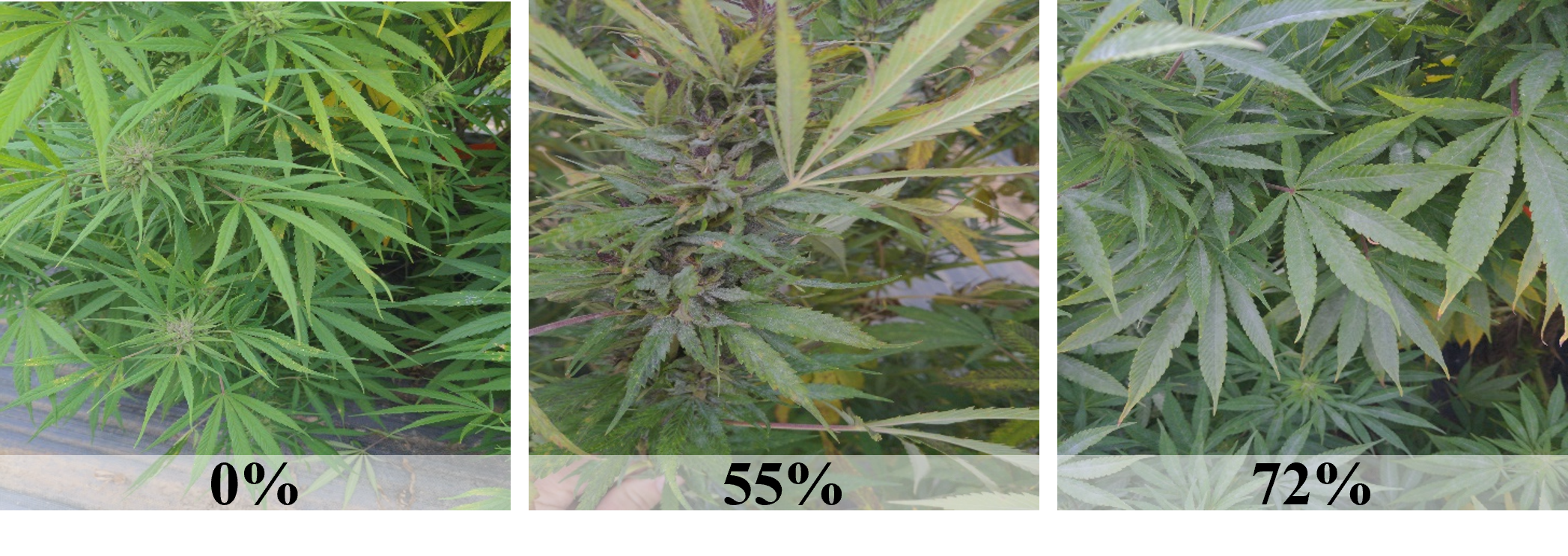
Powdery mildew on hemp; photo credit Tyler Gordon
fungal_xxx [decimal; %]
Known or suspected fungal/oomycete pathogens:
- Alternaria spp
- Ascochyta spp
- Athelia rolfsii or Sclerotium rolfsii
- Bipolaris spp
- Bipolaris gigantea
- Boeremia
- Botrytis cinerea
- Botrytis pseudocinerea
- Botrytis porri
- Cercospora cf. flagellaris
- Chaetomium globosum
- Cladosporium spp
- Colletotrichum spp
- Curvularia spp
- Diaporthe eres/ D. subordinaria
- Exserohilum spp
- Fusarium avenaceum
- Fusarium brachygibbosum
- Fusarium chlamydosporum
- Fusarium equiseti
- Fusarium graminearum
- Fusarium lichenicola
- Fusarium oxysporum
- Fusarium proliferatum
- Fusarium solani
- Fusarium sporotrichiodes
- Fusarium tricinctum
- Globisporangium irregulare
- Globisporangium ultimum
- Golovinomyces ambrosiae
- Golovinomyces cichoracearum
- Golovinomyces spadiceus
- Lasiodiplodia theobromae
- Leveillula taurica
- Leptosphaeria
- Neofusicoccum parvum
- Penicillium spp
- Phoma spp
- Phoma multirostrata
- Phomopsis spp
- Phytophthora spp
- Podosphaera macularis (syn. Sphaerotheca macularis)
- Pseudocercospora spp
- Pythium aphanidermatum
- Pythium catenulatum
- Pythium dissotocum
- Pythium myriotylum
- Rhizoctonia solani
- Sclerotinia sclerotiorum
- Sclerotinia minor
- Sclerotium rolfsii
- Septoria spp
- Stemphylium spp
- Thielaviopsis basicola
- Uredo kriegeriana
- Verticillium dahliae

9.2 Bacterial
bacterial_xxx [decimal; %]
Known or suspected bacterial pathogens:
- Agrobacterium tumefaciens
- Pseudomonas koreensis
- Pseudomonas syringae
- Serratia marcescens
- Sphingomonas yanoikuyae
- Xanthomonas campestris pv. cannabis

9.3 Virus/Viroid
virus_xxx [decimal; %]
Known or suspected virus/viroid/phytoplasma pathogens:
- Alfalfa mosaic virus (AMV)
- Arabis mosaic virus (ArMV)
- Beet curly top virus
- Cannabis sativa mitovirus 1
- Cannabis cryptic virus
- Citrus yellow-vein associated virus
- Cucumber mosaic virus (CMV)
- Curly top virus
- Lettuce chlorosis virus (LCV)
- Tobacco ringspot virus (TRSV)
- Tomato ringspot virus (ToRSV)
- Tobacco streak virus (TSV)
- Tomato mosaic virus (ToMV)
viroid_xxx [decimal; %]
- Hop latent viroid (HLVd)
phytoplasma_xxx
- Candidatus phytoplasma trifolii
nematode_xxx
- Meloidogyne incognita (Root knot nematodes)

9.4 Remarks
disease_remarks [nvarchar]
In a short paragraph, describe the disease. Please include the anatomy of the plant affected, the growth stage of the plant affected, symptoms of infection, patterns of spread in field or greenhouse, evidence leading to conclusion of the nature of the pathogen, and any other relevant observations.

9.5 Invertebrate
Key pests
Many insects and mites can be observed in hemp and the pest complex can differ depending on whether the crop is cultivated indoors or outdoors. While many arthropods can be found in hemp, some of the most often-seen pests include corn earworm, twospotted spider mite, cannabis aphid, and hemp russet mite.
Invertebrate pests are scored by indicating % area of planting affected and whether crop failure occurred in conjunction with infestation.
Refrain from capturing data for a small set or singular accessions, instead prefer an actual growout of a replicated trial that contains numerous accessions in a single season. Ideally the hemp community should decide on a set of check-varieties to include in every trial to compare between seasons.
Images and text were very generously provided by Kadie Britt (2021). We reviewed John Michael McPartland, Clarke, and Watson (2000), W. Cranshaw et al. (2019), and Britt (2021) as excellent overviews.

9.5.1 Corn earworm
helicoverpa_zea [decimal; %]
Helicoverpa zea or corn earworm is the most damaging pest of hemp grown in outdoor environments as it targets marketable portions of hemp plants – floral regions of CBD and seeds of grain varieties -Kadie Britt (2021).
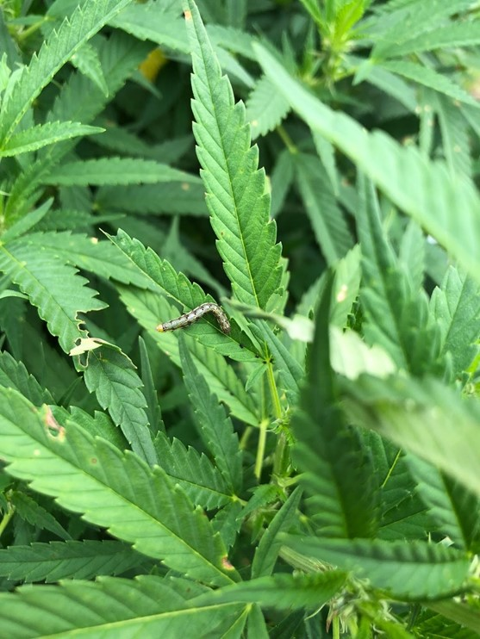
Young corn earworm larva. (Photo credit: Kadie Britt)
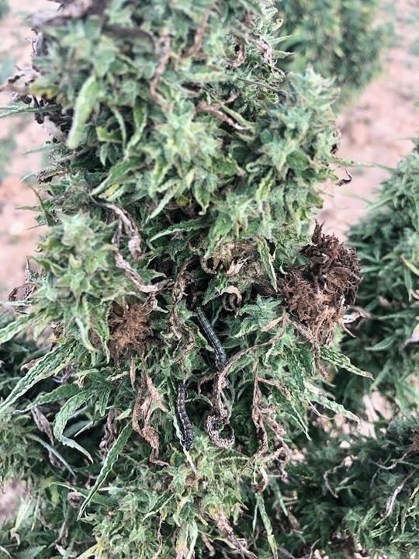
Bud rot in floral hemp bud from corn earworm feeding. (Photo credit: Kadie Britt
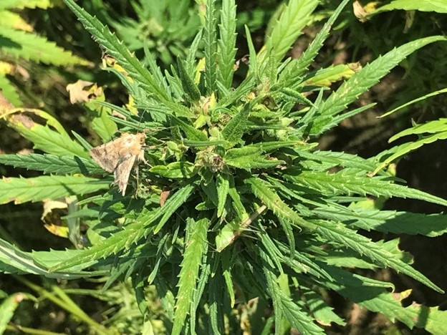
Adult corn earworm moth on hemp plant. (Photo credit: Katlyn Catron)

9.5.2 Hemp russet mite
aculops_cannabicola [decimal; %]
Aculops cannabicola or hemp russet mite is a microscopic, cannabis-specific mite that can be found in indoor and outdoor hemp. Mites have four legs on their white- to beige-colored, cigar shaped bodies and are not visible without the use of magnification Kadie Britt (2021) and John M. McPartland and Hillig (2003).
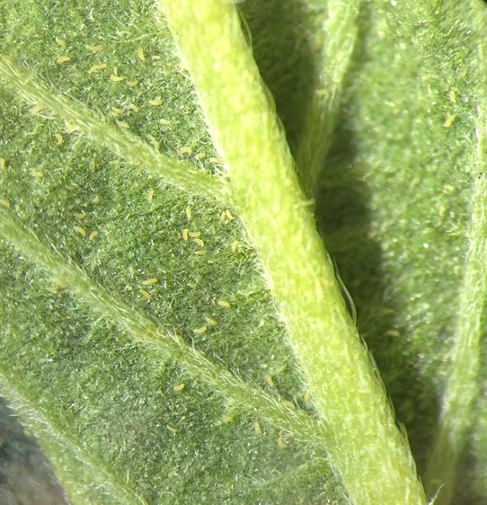
Hemp russet mites on underside of hemp leaf. (Photo credit: Kadie Britt)
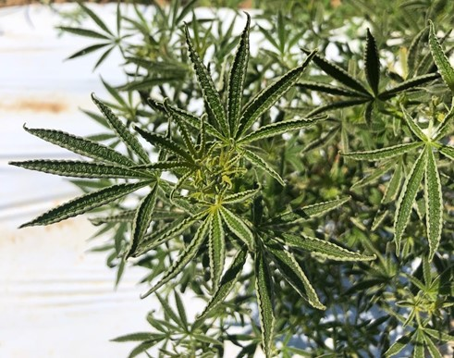
Upward curling of hemp leaves. Can sometimes be a symptom of hemp russet mite feeding injury to hemp but depends on cultivar. (Photo credit: Kadie Britt)

9.5.3 Twospotted spider mite
tetranychus_urticae [decimal; %]
Tetranychus urticae or twospotted spider mite is a generalist mite pest that can be found indoors and outdoors. Feeding injury causes stippling marks on leaves (Figure 1.7) and webbing can sometimes be observed in apical portions of plants (Figure 1.8). This mite is small and oval in shape, has 8 legs, and can be orange/red or brown with two distinct dark spots on the body -Kadie Britt (2021).
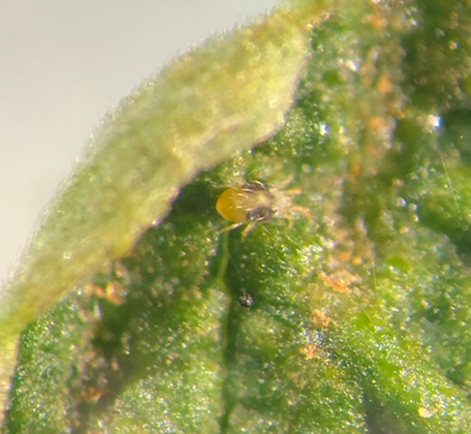
Twospotted spider mite on hemp leaf. (Photo Credit: Kadie Britt)
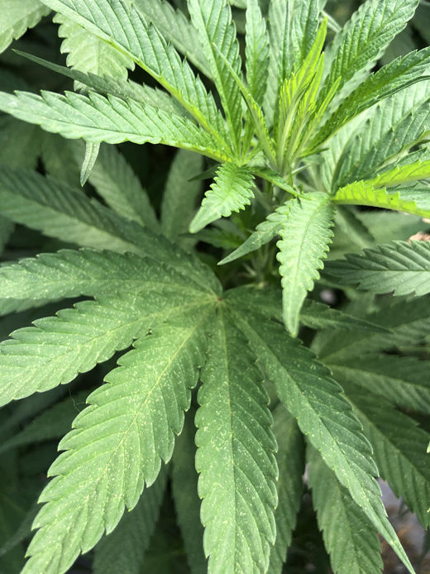
Stippling on leaves due to twospotted spider mite feeding. (Photo credit: Kadie Britt)
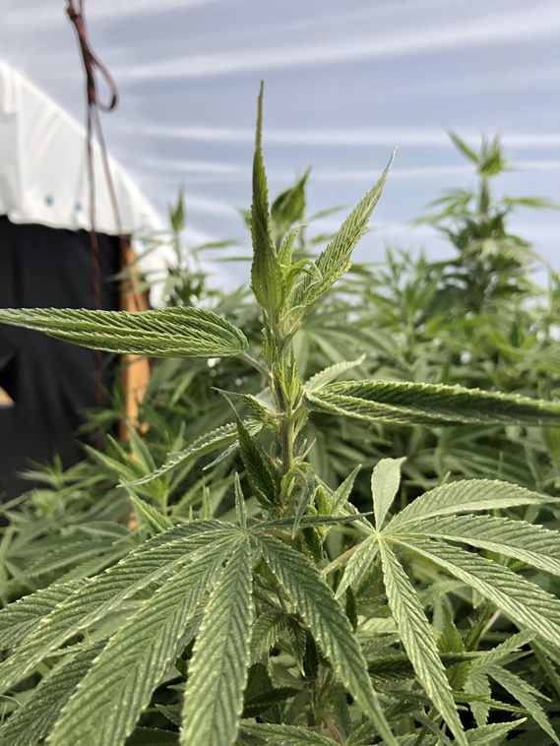
Webbing in apical portion of plant due to twospotted spider mite populations. (Photo credit: Kadie Britt)

9.5.4 Cannabis aphid
phorodon_cannabis [decimal; %] Phorodon cannabis or cannabis aphid is a specialist, piercing-sucking insect that feeds exclusively on hemp. Populations can rapidly increase in favorable environments (Figure 1.10) as aphids can reproduce via asexual reproduction Kadie Britt (2021) and W. S. Cranshaw et al. (2018).
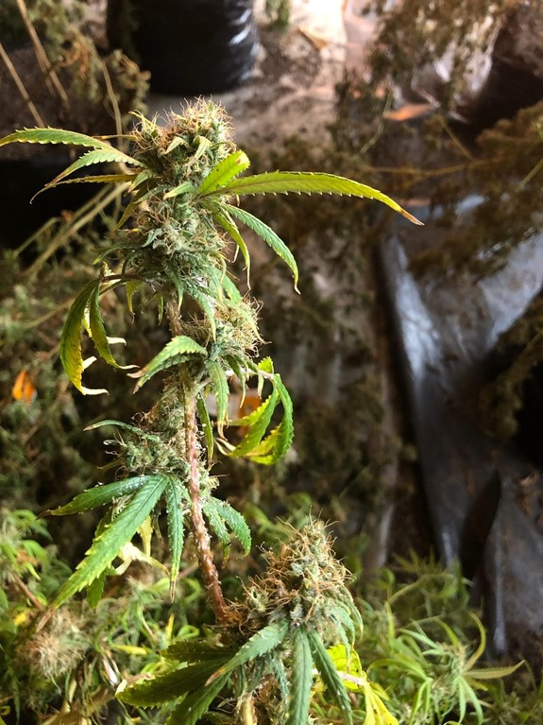
Cannabis aphid infestation on indoor hemp plant. (Photo credit: Kadie Britt)
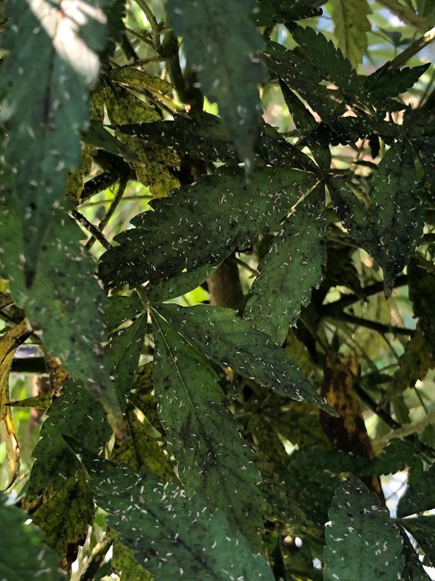
Cannabis aphid skins caught in honeydew on surface of hemp leaves. (Photo credit: Kadie Britt)

9.5.5 Other pests
Known or suspected pests:
- Acherontia atropos
- Aculops cannabicola
- Aecidium cannabis
- Agallia constricta
- Aglais urticae
- Agromyza reptans
- Aphis fabae
- Aphis gossypii
- Camnula pellucida
- Ceutorhynchus assimilis
- Chinavia hilaris
- Chloealtis conspersa
- Chlorochroa ligata
- Chlorochroa uhleri
- Chromatomyia horticola
- Cosmopepla lintneriana
- Bemisia tabaci
- Diabrotica undecimpunctata howardi
- Ditylenchus dipsaci
- Empoasca fabae
- Estigmene acrea
- Euschistus servus
- Frankliniella fusca
- Frankliniella occidentalis
- Graphocephala versuta
- Grapholita delineana
- Halyomorpha halys
- Helicoverpa zea
- Heterodera humuli
- Hysteroneura setariae
- Liorhyssus hyalinus
- Liriomyza cannabis
- Liriomyza strigata
- Loxostege sticticalis
- Mamestra configurata
- Melanchra picta
- Melanoplus bivittatus
- Melanoplus femurrubrum
- Melanoplus lakinus
- Melanoplus differentialis
- Microtechnites bractatus
- Micrutalis calva
- Miridae
- Nezara viridula
- Oebalus pugnax
- Ostrinia nubilalis
- Pentatomidae
- Peridroma saucia
- Phorodon cannabis
- Phyllophaga tristis
- Phyllotreta pusilla
- Podosphaera macularis
- Polyphagotarsonemus latus
- Popillia japonica
- Prionus
- Pseudoperonospora cannabina
- Pseudoperonospora humuli
- Psylliodes attenuata
- Rhopalidae
- Rhopalosiphum abdominalis
- Spilosoma virginica
- Spissistilus festinus
- Spodoptera exigua
- Spodoptera ornithigalli
- Strymon melinus
- Systena blanda
- Systena elongata
- Tetramorium caespitum
- Tetranychus urticae
- Thamnurgus caucasicus
- Thrips tabaci
- Thyanta custator
- Trichiocampus cannabis
- Uredo kriegeriana
- Vanessa cardui
- Known European species
📚Additional References📚
- H M G Van der Werf, W C A van Geel, and M Wijlhuizen (1995)
- Punja, Rodriguez, and Chen (2017)
- W. Cranshaw et al. (2019)
- Eric Anderson (2019)
- Campbell et al. (2019)
- McKernan et al. (2020)
- Szarka et al. (2020)
- Farinas and Peduto (2020)
- Thiessen et al. (2020)
- J. Hu, Masson, and Dickey (2020)
- Stack et al. (2021)

10. APPENDICES

10.1 Germplasm Regeneration Protocol
️DOWNLOAD FILE (1.17 MB⬇️)️

10.2 Feral Hemp Collection
Feral hemp collection protocol by Dr. Shelby Ellison and Dr. Ademola Aina at University of Wisconsin Madison. Germplasm collected from this work COLLECTION, PRE-CHARACTERIZATION, AND PRESERVATION OF AMERICAN HEMP GERMPLASM will be donated to the Plant Genetic Resources Unit.
️DOWNLOAD FILE (18 KB⬇️)️
🧪Feral Hemp Collection🧪
Materials needed:
- Paper bags #10 (6.5 x 4 x 13.25”) (50 per population)
- Reflective vests
- Waterproof folders/bags for datasheets
- Datasheets
- Sharpies
- Pens
Tools required:
- Gloves
- Tape measure
- Camera (Phone’s camera is okay)
- Loppers
- Pruning shears
Protocol
- Secure state or federal licensing to possess industrial hemp in your jurisdiction.
- Secure written authorization from your regulatory agency (state department of agriculture) and the University or institutional legal counsel (if required) to collect and hold feral hemp that has not been certified as < 0.3% Δ9 THC. Maintain copies of permits, licenses, and/or written authorization during fieldwork and with collected material through all subsequent steps in the protocol.
- Investigate locations identified by citizen scientists (either through iNaturalist or word of mouth) as potential feral hemp populations. Avoid cultivated fields of industrial hemp (with potential proprietary genetics) and cultivated marijuana, be it state-registered or clandestine and illegal. Endeavor to cover the broadest range of ecoregions that can feasibly be accessed during fieldwork.
- Secure verbal and/or written permission from the landowner/tenants to collect plant material.
- Collect GPS coordinates and take pictures of the plants while capturing their immediate surroundings using a smartphone. Upload new coordinates along with pictures on iNaturalist for future collection purposes. Record a brief description of the site – drainage patterns, surrounding vegetation, elevation, and soil classification from the web soil survey on the provided datasheet.
  - Preferred population size > 50 female individuals, at a minimum of 10 females.
  - Populations separated by at least 5 miles (8km) are preferred to increase the likelihood of pollen isolation.
  - Give each population an ID code in this scheme: state (WI), year (23), collector’s initials (SE), two-digit sequential program number (01), and plant number (01) -i.e. WI-23-SE-01-01.
  - Upload photos to a shared computer drive for backup
- Locate up to 50 female (seed-bearing) plants. For each plant, label a large paper bag with an ID code. Chop down at the base of plant with the loppers, lay on the ground, and measure length (primary meristem to base of plant) with a tape measure, record the ID code and length in the nearest inch on the datasheet. Use the pruning shears to cut the terminal and lateral seed-bearing branches into 6-8” sections and fill the bag up to ¾ of its height, allowing enough space to fold the top of the bag over. Do not collect more material than would fit a single bag. Collecting each plant in a single, separate bag is essential. If there are more seed-bearing branches on a plant than fit the bag, you might prioritize the most heavily seeded branches but do not overstuff the bag and do not put material from multiple plants in the same bag.
- Hot, moist conditions are detrimental to seed viability. Bagged material should begin drying within 12 hours of collection. At no point should the paper bags be enclosed in plastic. Samples should be kept as cool as possible during transport from the field to a location where they can be dried.
- Dry the bags at room temperature with a fan to move air for at least one week. Seed and plant material can be placed in a drying oven as long as temperatures are less than 35 °C (95 °F). Conditions exceeding 35 °C (95 °F) are detrimental to viability.
- Once the plants are dried, hand-strip the branches to remove the bulkier stems from each bag. Stems may be discarded in compost or as waste. Fold the top of the bag over and staple or tape it closed.
- Line in a shipping box with a plastic bag, place paper bags and the datasheet(s) inside the plastic bag, seal the box. Attach the shipping label provided and arrange for a Fedex pickup or deliver to a Fedex drop-off location. Refer to the contents only as “Dried plant material for scientific research”. Not hazardous and of no commercial value.
Data collection sheet should have the following details:
- Collector’s name
- Date (YYYY-MM-DD)
- Location (verbal)
- Latitude and Longitude (decimal)
- State
- Population #
- Site Description
- Column Headers: Plant, Length (cm)

10.3 Threshing
🧪Threshing🧪
Hemp has valuable seed and grain that can be difficult to harvest by hand, especially in large quantities.
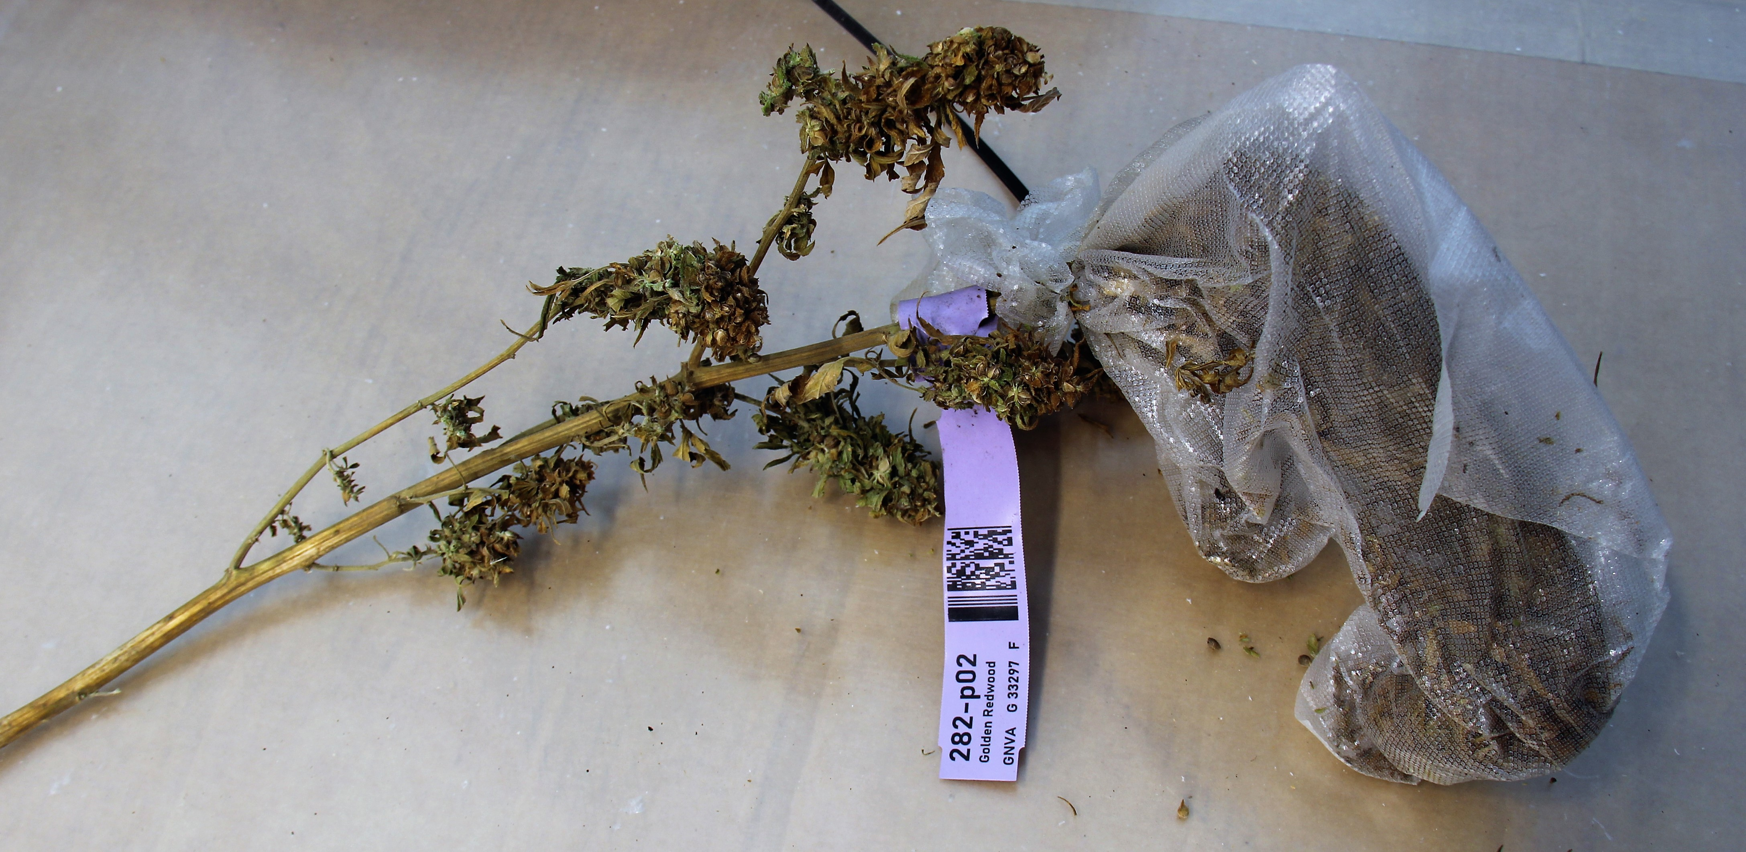
Example sample from PGRU trials
PGRU runs fatty acid and protein analysis for all germplasm held in the repository using three small, electric Almaco BT 14 belt threshers.
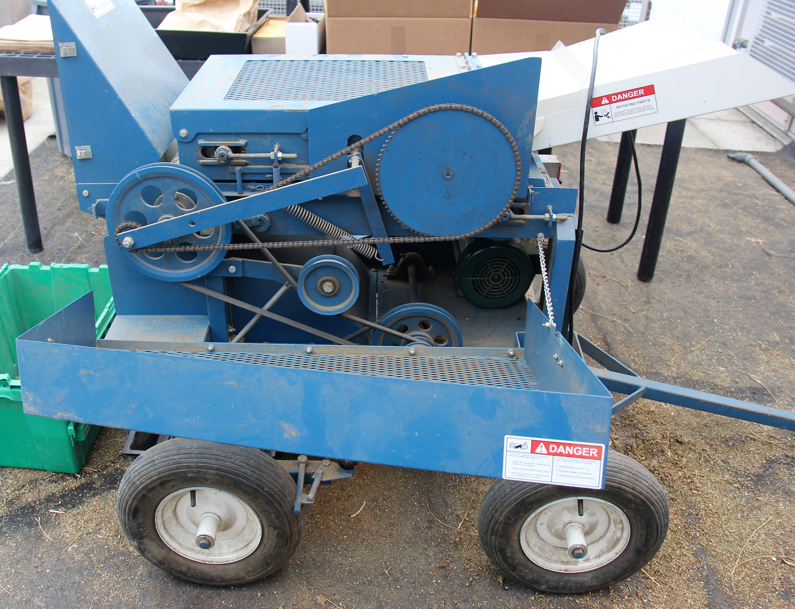
Belt threshing rig at PGRU
To safely and efficiently remove and separate seed from hemp stalks, PGRU follows the following protocol:
Personal Protective Equipment (PPE)
Protective eye wear, ear plugs, N-95 mask, gloves, closed-toed shoes, long pants, long sleeve shirt.
Useful Items
Trash bin, pruning shears, working table, bins for seed collection and chaff, vacuum, air compressor.
Procedure
- Verify the room you are using is well ventilated, turn on system.
- Verify the machine was cleaned after last use. Ensure that the thresher has been properly maintained and the belts, chain, and electric connections are in good working condition.
- Move thresher into open space and let others know that you will be threshing (generating dust and noise).
- Set up a seed collection tray on the back end of the thresher under the seed collection compartment.
- Turn machine on and verify both belts are operating smoothly. The belt speed can’t be adjusted. The distance between belts can be adjusted.
- The fan on the thresher has variable air flow and can be turned off depending on the application.
- Set up a line of bags and a trash bin on the side you will be threshing.
- Pull individual stalks from the harvest bag and inspect them for seeds/chaff, if no seed or chaff is observed, discard the stalks. If seed or chaff is observed, hold the base of the stalk, and place it on the tray of the thresher. Slide the stalk into the running belts of the thresher and let the stalk go through the thresher. Sometimes the thresher is unable to remove all the seed, if this happens manually remove the seeds from the stalk onto belt. When all the seed has been removed, discard the stalks. Continue this until all stalks have been removed from the bag.
- The harvest bag will have smaller stems, seed, and chaff after the larger stalks have been removed. Empty the remaining bag contents into the thresher.
- Remove any large stalks from the seed collection bin and empty the collected seeds and chaff back into the harvest bag.
- Roll or fold the bag down to a small size and place the bag in a cool dry room for further processing.
- Turn off the thresher and clean the area at the end of the workday.
Considerations
- Consider the max diameter of half an inch for stalks that can go through the belts
- Constant monitoring of your airflow can be achieved by checking for clean seed (lacks chaff and stalk)
- One full sized stalk should only take 10-30 seconds run through the belts.
- Hemp variety plays a key role in threshing efficiency. Make notes of any hemp lines that have unique characteristics (i.e., lack of shattered seeds before threshing).

10.4 Cloning
🧪Cloning🧪
Cuttings should be harvested from disease-free stock plants under non-stressed conditions. Collect turgid cuttings during optimal water conditions (non-wilted plants). Environmental conditions that increase propagation success are provided by an atmosphere that reduces water loss and maintains leaf turgidity, with optimal humidity between 75 and 90%, often achieved using humidity domes or “mini greenhouses”. Ample but not excessive light and clean, moist, and well aerated rooting media should also be provided (Casillas 2016). Ideal temperature should be around 25-27 °C (78-80 °F) with a root zone temperature of about 27-30 °C (80-85 °F). Once cuttings are taken, check for disease daily along with moisture content of media. If using humidity domes, monitor humidity levels and include fresh air daily.
Materials
- Scissors/Pruning shears
- Lab Gloves
- IBA based rooting Hormone (we use Clonex™)
- Beakers/Cups
- Spray Bottle w/ water
- Sterile medium (potting soil/Oasis Cubes/Water)
- Humidity domes (if using potting soil + trays)
- 70% ethanol (alternative isopropyl alcohol)
- Paper towels
- Seedling flats
- Disease-free Cannabis plants (ideally in the vegetative state)
- Aeroponic apparatus
- Mist timer
- Heating mat
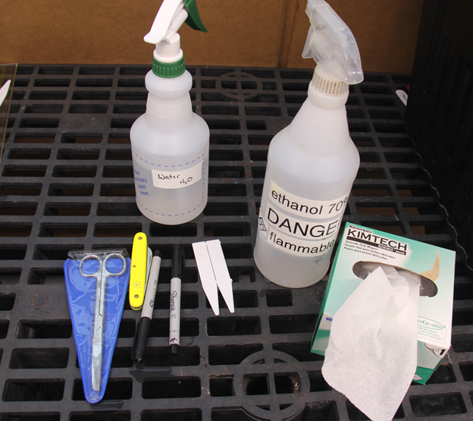
Common cloning tools and supplies
Methods (Aeroponic/Hydroponic)
- Start with clean water (DI or tap) with no fertilizer
- Cut lateral branch close to a node at a 45-degree angle
- Gently scrape the stem around the cut to expose cambium layer
- Remove any lower branches, keep approximately 3-5 nodes worth of leaves, leaving cutting looking like a “palm tree”
- If taking many cuttings at a time, place cuttings in a beaker/cup of water until ready to dip into rooting hormone
- Dip bottom 2 cm of cutting in rooting hormone, IBA (Clonex™)
- Place cutting in aeroponic/hydroponic system
- Let sit and watch for roots (7-14 days)
- Use alcohol to disinfect tools before moving on to the next accession
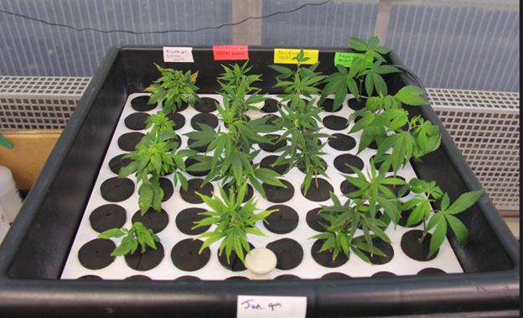
Aeroponic cloning setup at PGRU
Methods (Potting soil/Oasis Cubes/Humidity Dome)
- Cut lateral branch close to a node at a 45-degree angle
- Gently scrape the stem around the cut to expose cambium layer
- Remove any lower branches, keep approximately 3-5 nodes worth of leaves, leaving cutting looking like a “palm tree”
- If taking many cuttings at once, place cuttings into beaker/cup filled with water until ready to dip into rooting hormone
- When ready to root cuttings, emerge bottom 2cm of cutting in rooting hormone (Clonex™)
- Place cutting with rooting hormone into seedling tray with potting soil or oasis cubes
- Place humidity dome onto tray, mist water on inside of humidity dome
- Let sit and watch for roots (7-14 days)
- Use isopropyl alcohol to disinfect tools before moving on to the next accession
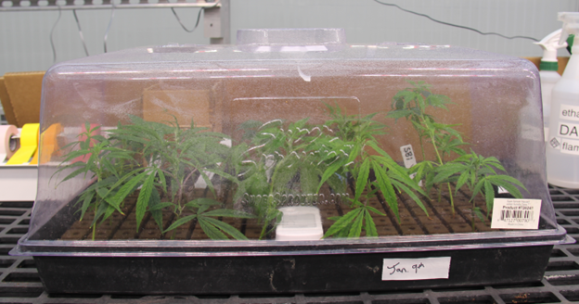
Typical humidity dome setup
Modified aeroponic rooting system protocol (Regas et al. 2021)
- Generation of a mother plant for clonal propagation
  - Select healthy, female mother plant that exhibits desirable traits
  - Allow mother plant to reach the appropriate size (roughly 25 mature shoots) for clonal propagation
  - Allow mother plants to remain in the vegetative growth stage (light:dark = 18h:6h) to promote shoot growth for future propagation
- Construction and preparation of aeroponic system
  - Begin by positioning the lid on top of the container. Drill desired number of holes into the lid while providing adequate space (~3cm) between each
  - Position water pump in the center of the container
  - Pour 7-8 L of distilled water into the container so that the pump nozzle remains roughly 2.3 cm above the waterline. NOTE: This ensures the submersible water pump can push water with enough force to spread across the container lid. Distilled water is recommended; however, regular tap water may also be used.
  - Situate the appropriate amount of Oasis Cubes or media of choice into each slot. Turn on the pump and allow it to run for 24 h on a set timer.
- Selecting and excising appropriate shoots
  - Collect shoots near the apical meristem using a sterilized scalpel or scissor. Cuttings are ~10 cm in length, ideally with several nodes. NOTE: Cut the stem at a 45° angle. Cutting at a 45° angle increases the surface area of the basal portion of the cutting, allowing more space for root development.
  - Remove all foliage except foliage present on the top three nodes
  - Dip the newly excised cutting into the rooting solution containing indole-3-butyric acid (IBA) ~ 2-5 cm up from the base of the stem for ~5 s
  - Insert the cutting into the center of an Oasis cube positioned in the aeroponic system. NOTE: the cutting insertion depth is to remain ~1-2 cm from the bottom of the Oasis Cube
  - Mist the unrooted cuttings with the water every 100 seconds for 20 seconds
  - Grow the cuttings with 18-24 h of light per day with a photosynthetic photon flux density (PPFD) of 100 µmol/m2/s at 24-29 °C and 40-60% relative humidity.
- Aeroponic system maintenance and propagule health
  - Replenish the system with water at a pH between 5.0-6.0 every 2-5 days
  - Lightly mist the cuttings every 100 seconds for 20 seconds
  - Add 5 mL of each nutrient solution to the reservoir every 3-5 days
  - Add 15 mL of the algae and bacteria cleaning solution containing hypochlorous acid (0.028%) per 10 L of water every 5 days
- Transplanting propagules
  - Select the cuttings with long, white, fibrous roots. NOTE: Avoid cuttings with brown, slimy, and short root systems as this is an indicator for the presence of root rot and will usually take longer to acclimate to the new growing medium and can bring unwanted diseases.
  - Place cutting into potting soil media, transplant propagules to 4 L nursery pot filled with a nutritious soil mix. NOTE: Watering immediately is recommended to prevent the roots from drying out.
- Cleaning and storage of aeroponic system
  - When the system is no longer in use, wash with water and clean with 70% ethanol or another disinfectant (i.e Greenshield)
  - Remove the filter from the water pump and rinse with water to remove debris
  - Dry the system by wiping it down with paper towels or washcloth
  - Place pump inside the tub with the lid on and store until it is needed.

10.5 Tissue Culture
- PGRU Hemp Tissue Culture Protocol developed by Kevin Hernandez ️DOWNLOAD FILE (218 KB⬇️)

10.6 Pollen Collection Protocol
🧪Pollen Collection🧪
Watch the pollen collection training tutorial by Tony Barraco!
Created by: Daniel Meyers (last updated: March 30, 2023). Based on an unwritten protocol developed by Nicholas Genna during Summer 2022.
Background
Reliable pollen collection and storage methods are important for germplasm conservation, breeding efforts, and scientific inquiry. This protocol evolved during the collection and study of hemp (Cannabis sativa L.) pollen at the Plant Genetic Resources Unit (USDA-ARS) in Geneva, New York during the summer of 2022. The fine meshes were added to the existing components to eliminate the collection of insects and parts of flowers and leaves.
Materials
- Spore collection kit (Large Spore Cyclone, GRA-101, Tallgrass Solutions Inc.)
- Vacuum (Super Coach Pro 6, 107310, ProTeam)
- Glass vials (three included in above kit)
- 100 µm mesh, cut into squares (~12 cm x 12 cm)
- Rubber bands
- Air compressor or shop-vac with a blower port
- OPTIONAL: 10 µm mesh, cut into squares (~12 cm x 12 cm)
- RECOMMENDED:
  - Cooler with ice packs
  - Gloves
  - Ethanol (70%, spray bottle)
  - Face mask (for use if collecting for a long time, the author recommends N-95 or comparable)
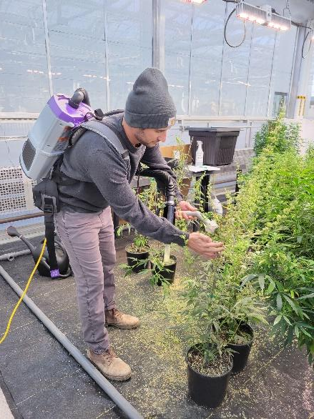
Figure 1: Demonstration of pollen collection. Picture of Tony Barraco, by Anthony Rampulla.

Methods
- Assemble the pollen collection apparatus and attach it to your vacuum (figs. 4-7). OPTIONAL: Place the 10µm mesh between the collection device and the vacuum. This is advised when collection of all pollen is the goal (e.g., if you are measuring total pollen produced at the individual level), as minimal pollen is lost into the vacuum, and some suction power is sacrificed.
- Place a 100 µm mesh square on the nozzle of the pollen collection apparatus and fix in place with a rubber band. NOTE: As collection goes on, suction power will be lost over time due to the mesh getting plugged up with a mixture of pollen and secondary metabolites. This issue can be resolved by moving the mesh over slightly and fixing it in place again, and eventually by replacing the mesh sheet. Mesh sheets are reusable after washing. The author recommends scrubbing with dish soap and, if the mesh is still sticky or stained, soaking it in 10% bleach for 24 hours, then rinsing with DI water.
- Turn on the vacuum and collect the desired pollen by holding the pollen collection apparatus in one hand to an inflorescence and using the other hand to cup the inflorescence opposite the nozzle. Collect from the entire plant moving from inflorescence to inflorescence, and from lower branches to upper branches, attempting not to shake the plant during this process (and therefore lose pollen).
- Turn off the vacuum, unscrew the collection vial and cap it. If you are not using the pollen or taking it back to be stored immediately, place it in a cooler with ice packs while you continue collecting.
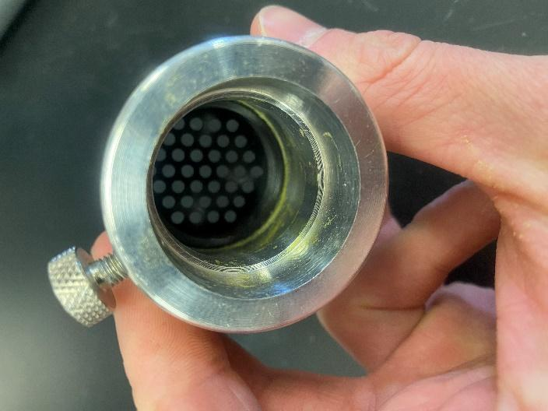
Figure 3: Pollen can collect along internal grooves and corners of the collection apparatus.

- To minimize contamination, take the following steps between pollen collections:
  - Replace all mesh used for the previous collection.
  - Disassemble the pollen collection apparatus and blow it out using an air compressor or the blower port on a shop-vac. Make sure to clean out inside corners of the apparatus where pollen can collect (fig. 3).
  - Wear gloves, sterilize with 70% ethanol, and allow to dry.

10.7 Management of Fungal Specimens and Isolates Generated through Hemp Research
🧪Management of Fungal Specimens and Isolates 🧪
By: Daniel Meyers & Tyler Gordon (last updated: 23 Mar 2023) Collaborators: Lisa Castlebury, Kirk Broders, Kathryn Bushley, Nicole Gauthier
Background
Understanding and documenting fungal pathogens and other symbionts of hemp (Cannabis sativa L.) has important implications for both genetic conservation and production of this crop. In 2022, the USDA ARS PGRU Hemp Genetic Resources project began extensive field evaluations of hemp accessions in Geneva, NY. Several fungal specimens were collected from this evaluation, and isolates were generated for future study.
To ensure fungal specimens and isolates collected from hemp have unique identification and do not repeat within and across years, a master numbering system was generated: an alpha numeric system beginning with the letters HF (Hemp Fungus) followed by three numbers, for example, the first specimen is HF001. While this system does have a theoretical end (HF999), if or when that number is reached, another digit can be inserted in the thousands place for subsequent collections, and so on in perpetuity. This system will track both specimens and isolates in a unique, non-repeating fashion. Each collection event, defined here as an independent occurrence based on the acquisition of new material, will be given the next sequential HF number.
Most specimens will be autoclaved and discarded. However, if a specimen or culture is of scientific importance past its use in our research collection, for example it was a first report, or used in a published experiment, it will be deposited in the proper institution. Important herbarium specimens will be sent to the U.S. National Fungus Collection (BPI Herbarium, 10300 Baltimore Ave., Beltsville, MD 20705, USA; USDA-ARS (2023a)), and live cultures will be sent to the USDA-ARS Culture Collection (NRRL 1815 N. University St., Peoria, IL 61604, USA; USDA-ARS (2023b)).
Numeration System in Practice
The collection and isolation of fungi from plant material can generate a single specimen tied to multiple isolation attempts and multiple organisms isolated. For this reason, isolation attempts (if more than one in number) will be described as they differ, numbered increasingly after a decimal place. If multiple organisms of interest are present from a single isolation attempt, those cultures will be appended with an underscore and a letter. At its most complex, the system could produce an isolate named as follows: HF019.1_B; this would indicate a culture from hemp fungal collection HF019, generated from the first isolation attempt, which was the second distinct fungus identified from that attempt.
Some explanative examples of this system in practice can be seen in the first three collections, with the currently retained materials in bold:
- HF001: a dried specimen of a few leaves from the 2022 PGRU Hemp Field trail with powdery mildew. Since powdery mildew is an obligate biotroph and our focus was not currently on isolates of this sort, there is no culture attempt.
- HF002: a dried specimen of an old, rooted cutting from our greenhouse with wilt symptoms and three cultures. These cultures (HF002.1, HF002.2, & HF002.3) were taken from differently symptomatic sections of the same plant stem (each symptomatic region described, and visible on the single dried specimen), and since then, both colony morphotypes represented in these three cultures have been sequenced and tentatively identified based on the EF1- α locus as Fusarium oxysporum and F. sporotrichioides.
- HF003: two cultures (HF003.1 & HF003.2) isolated from leaf tissue within an inflorescence showing bud rot symptoms, with no preserved specimen. One culture identified via morphology as an Aspergillus sp. & the other potentially a Fusarium sp.
Culture-based experiments tend to produce far more isolates than isolates of interest given the abundance of potential contaminants in the environment, tendency to isolate the same organism multiple times, and selectivity of the method. This could quickly lead to an absurdly large database to manage with relatively few collections retained as important in our research. To address this issue, within any formal culture-based experimental setup a non-HF numbering system will first be used. At the conclusion of the experiment, isolates relevant to our research will be given an HF number, added to our database, and retained.
Data collection
For each collection event, the following data will be recorded and internally maintained (based on USDA-ARS BPI Herbarium Deposition Form, see Appendix II):
- HF number
- Scientific name & authority (can be tentative until further identified)
- Host plant (should be almost exclusively Cannabis sativa L., but data such as accession, inventory number, & plot or regeneration ID can be captured here)
- Identification method
  - Sequence data when applicable
- Collection date
- Collector(s)
- Locality (locations assumed to be in Geneva, Ontario County, New York, United States unless otherwise specified)
- Collection type (specimen, culture(s), both)
- If the collection results in isolation(s):
  - Isolation method
  - If the culture is still maintained
- Herbarium or culture collection accession number (if applicable)
- Images of diagnostically useful features, including cultures (taken before long-term storage)
- Additional notes
Collection processing best practices
Specimens: Isolation attempts should be made before further processing a physical specimen. Specimens should be dried before storing for any extended period. Larger material should be dehydrated, and specimens that are primarily leaves should be pressed. Cultures can also be dehydrated as specimens. After this process, specimens should be frozen at -20 °C for at least a week. Additional recommendations for processing specimens can be found from BPI (2022).
Cultures: Isolation method for each culture should be described in detail, including but not limited to the post-collection treatment, the part of the plant isolated from, the symptoms present where the isolation occurred, and the type of media isolated on. Once a pure culture is obtained, if it cannot be identified (or can only be identified to a certain extent) based on morphology, mycelium should be collected, DNA extracted, and a diagnostic locus (e.g., ITS, TEF1-α, β-tubulin, etc.) should be sequenced for identification. After identification if there is no immediate need for fresh cultures in current experiments, cultures should be photographed (front and reverse of plate, with growth media recorded) and then processed for long-term cold storage. For most filamentous fungi, the following protocol can be used (based on methods developed by USDA-ARS NRRL & USDA-ARS ARSEF, see Appendices II & III respectively):
- In two 2 mL cryovials, defined here as able to withstand -80 °C temperatures, add 4-8 agar plugs taken from the growing edge of a fungal culture. This can be accomplished via using the back end of a 200 µL pipette tip and a pair of sterilized tweezers or a Trasfertube (Repligen, Item 190195P).
- Using sterile pipettes, add enough 20-25% glycerol solution to cover the agar plugs.
- Store vials at 4 °C for 30-60 minutes.
- Then store the vials at -80 °C, checking viability at one week. If this check is passed, fresh cultures can be discarded. Continue to check viability on an as-needed basis.
Additional suggestions
Recording more information when collecting material is often preferable to less information. For some of our research plots, we attach information and collect data on the individual plant basis.
In culture-based experiments, a morphotyping step, defined here as grouping based on similar culture morphology and randomly selecting a smaller representative number of cultures, should often be taken to reduce workload and expense if identification is primarily via sequencing methods.
For original culture storage methods, other long-term storage methods, and methods for specific groups of fungi and other plant pathogens, see below sections.
Appendices:
Appendix I: Herbarium Deposition Form (received on 7 Feb 2023 from Lisa Castlebury, BPI)
Appendix II: SOP – ARS Culture Collection Cryopreservation Protocol (received on 27 Feb 2023 from Kirk Broders, NRRL)
Appendix III: Protocol for Cryopreservation of Fungi at -80 °C in Glycerol (received on 1 Mar 2023 from Kathryn Bushley, ARSEF)
Appendix IV: SOP – Preservation of Morels & Other Select Fungal Strains (received on 27 Feb 2023 from Kirk Broders, NRRL)
Appendix V: SOP – Preservation of Oomycetes (received on 27 Feb 2023 from Kirk Broders, NRRL)
Appendix VI: SOP – Accession of Strains into the ARS Culture Collection (received on 27 Feb 2023 from Kirk Broders, NRRL)

11. REFERENCES
Adal, Ayelign M., Ketan Doshi, Larry Holbrook, and Soheil S. Mahmoud. 2021. “Comparative RNA-Seq Analysis Reveals Genes Associated with Masculinization in Female Cannabis Sativa.” Planta 253 (1). https://doi.org/10.1007/s00425-020-03522-y.
Adriel Garay, and Sabry Elias. 1998. “Ploidy by Flow Cytometry: An Ideal Technology for Determining the Ploidy Level in Ryegrass and Other Species.” https://seedlab.oregonstate.edu/sites/seedlab.oregonstate.edu/files/value-ploidy-test-2006.pdf.
Amaducci, Stefano, Michele Colauzzi, Gianni Bellocchi, and Gianpietro Venturi. 2008. “Modelling Post-Emergent Hemp Phenology (Cannabis Sativa L.): Theory and Evaluation.” European Journal of Agronomy 28 (2): 90–102. https://doi.org/10.1016/j.eja.2007.05.006.
Anderson, Loran C. 1980. “Leaf Variation Among Cannabis Species From a Controlled Garden.” Botanical Museum Leaflets, Harvard University 28 (1): 61–69. http://www.jstor.org/stable/41762825.
AOAC, International. 2023. “Official Methods of Analysis, 22nd Edition (2023).” https://www.aoac.org/official-methods-of-analysis/.
———. 2024a. “Fatty Acids in Edible Oils and Fats by Capillary GLC.” https://library.aocs.org/Ce-1a-13/.
———. 2024b. “Moisture and Volatile Matter in Flaxseed.” https://library.aocs.org/Af-2-54/.
———. 2024c. “Moisture and Volatile Matter in Sunflower Seed.” https://library.aocs.org/Ai-2-75/.
———. 2024d. “Oil Content in Oilseeds.” https://library.aocs.org/Am-2-93/.
———. 2024e. “Oil Content of Oilseeds by Nuclear Magnetic Resonance.” https://library.aocs.org/Ak-3-94/.
———. 2024f. “Oil Content of Sunflower Seeds.” https://library.aocs.org/Ai-3-75/.
Backer, Rachel, Timothy Schwinghamer, Phillip Rosenbaum, Vincent McCarty, Samuel Eichhorn Bilodeau, Dongmei Lyu, Md Bulbul Ahmed, et al. 2018. “Closing the Yield Gap for Cannabis: A Meta-Analysis of Factors Determining Cannabis Yield.” Frontiers in Plant Science 10. https://doi.org/10.3389/fpls.2019.00495.
Berhow, Mark, and Kelly Gude. 2021. “Materials and Methods - UPLC & HPLC for Cannabinoid Analysis in Hemp.” National Center for Agricultural Utilization Research.
Bioversity International, FAO. 2015. “Fao/Bioversity Multi-Crop Passport Descriptors V.2.1.” FAO/Bioversity Multi-Crop Passport Descriptors V.2.1 [MCPD V.2.1]. https://www.bioversityinternational.org/fileadmin/user_upload/online_library/publications/pdfs/FAOBIOVERSITY_MULTI-CROP_PASSPORT_DESCRIPTORS_V.2.1_2015_2020.pdf.
Booth, Judith K., and Jörg Bohlmann. 2018. “Terpenes in Cannabis Sativa – From Plant Genome to Humans.” Plant Science 284: 67–72. https://doi.org/10.1016/j.plantsci.2019.03.022.
Boyce, Sidney Smith. 1900. Hemp (Cannabis Sativa) a Practical Treatise on the Culture of Hemp for Seed and Fiber: With a Sketch of the History and Nature of the Hemp Plant. New York: Orange Judd co.
Brighenti, Virginia, Federica Pellati, Marleen Steinbach, Davide Maran, and Stefania Benvenuti. 2017. “Development of a New Extraction Technique and HPLC Method for the Analysis of Non-Psychoactive Cannabinoids in Fibre-Type Cannabis Sativa L. (Hemp).” Journal of Pharmaceutical and Biomedical Analysis 143: 228–36. https://doi.org/10.1016/j.jpba.2017.05.049.
Britt, Kadie Elizabeth. 2021. “Insect Pest Management in Hemp in Virginia,” April. https://vtechworks.lib.vt.edu/handle/10919/103014.
Cameron, Arthur C., and Michael S. Reid. 1981. “The Use of Silver Thiosulfate Anionic Complex as a Foliar Spray to Prevent Flower Abscission of Zygocactus1.” HortScience 16 (6): 761–62. https://pdfs.semanticscholar.org/1f81/abb4a77525683817e6d6bdccbabb8b0d0eb7.pdf.
Campbell, Brian J., Abdel F. Berrada, Chris Hudalla, Stefano Amaducci, and John K. McKay. 2019. “Genotype × Environment Interactions of Industrial Hemp Cultivars Highlight Diverse Responses to Environmental Factors.” Agrosystems, Geosciences & Environment 2 (1): 180057. https://doi.org/https://doi.org/10.2134/age2018.11.0057.
Carlson, Craig H., George M. Stack, Yu Jiang, Bircan Taşkıran, Ali R. Cala, Jacob A. Toth, Glenn Philippe, Jocelyn K. C. Rose, Christine D. Smart, and Lawrence B. Smart. 2021. “Morphometric Relationships and Their Contribution to Biomass and Cannabinoid Yield in Hybrids of Hemp (Cannabis Sativa).” bioRxiv, 2021.05.09.443329. https://doi.org/10.1101/2021.05.09.443329.
Casano, S., G. Grassi, V. Martini, and M. Michelozzi. 2011. “Variations in Terpene Profiles of Different Strains of Cannabis Sativa L.” Acta Horticulturae, no. 925: 115–21. https://doi.org/10.17660/ActaHortic.2011.925.15.
Casillas, A. 2016. “Propagation of Cannabis Sativa for Commercial Production\copyright.” In Proceedings of the 2016 Annual Meeting of the International Plant Propagators’ Society 1174, 157–58.
Charles, Bill. 1708. An Act for Continuing the Act for Ascertaining the Tythes of Hemp and Flax. [London: printed by Charles Bill,; the executrix of Thomas Newcomb, deceas’d; printers to the Queens most excellent Majesty. http://galenet.galegroup.com/servlet/ECCO?c=1&stp=Author&ste=11&af=BN&ae=N053264&tiPG=1&dd=0&dc=flc&docNum=CW124018875&vrsn=1.0&srchtp=a&d4=0.33&n=10&SU=0LRJ&locID=cornell.
Ciolino, Laura A., Tracy L. Ranieri, and Allison M. Taylor. 2018. “Commercial Cannabis Consumer Products Part 2: HPLC-DAD Quantitative Analysis of Cannabis Cannabinoids.” Forensic Science International 289: 438–47. https://doi.org/10.1016/j.forsciint.2018.05.033.
Citti, Cinzia, Daniela Braghiroli, Maria Angela Vandelli, and Giuseppe Cannazza. 2018. “Pharmaceutical and Biomedical Analysis of Cannabinoids: A Critical Review.” Journal of Pharmaceutical and Biomedical Analysis, Review issue 2017, 147: 565–79. https://doi.org/10.1016/j.jpba.2017.06.003.
Citti, Cinzia, Barbara Pacchetti, Maria Angela Vandelli, Flavio Forni, and Giuseppe Cannazza. 2018. “Analysis of Cannabinoids in Commercial Hemp Seed Oil and Decarboxylation Kinetics Studies of Cannabidiolic Acid (CBDA).” Journal of Pharmaceutical and Biomedical Analysis 149: 532–40. https://doi.org/10.1016/j.jpba.2017.11.044.
Collison, Mark W. 2017. Official Methods and Recommended Practices of the AOCS. American Oil Chemists Society.
Comeau, Zachary J., Nicholas T. Boileau, Tiah Lee, Owen A. Melville, Nicole A. Rice, Yen Troung, Cory S. Harris, Benoît H. Lessard, and Adam J. Shuhendler. 2018. “On the Spot Detection and Speciation of Cannabinoids Using Organic Thin-Film Transistors.” ACS Sensors 4 (10): 2706–15. https://doi.org/10.1021/acssensors.9b01150.
Corporation, Leco. 2022. “FP928 Nitrogen/Protein in Feeds Grains Pet Food 203-821-656 Application Note LECO Corporation.” Saint Joseph, Michigan USA. https://knowledge.leco.com/results/application-note-nitrogen-protein-feeds-grains-pet-food-using-fp928-656/viewdocument/2220.
Cosentino, Salvatore Luciano, Giorgio Testa, Danilo Scordia, and Venera Copani. 2012. “Sowing Time and Prediction of Flowering of Different Hemp (Cannabis Sativa L.) Genotypes in Southern Europe.” Industrial Crops and Products 37 (1): 20–33. https://doi.org/10.1016/j.indcrop.2011.11.017.
Cranshaw, Whitney S., Susan E. Halbert, Colin Favret, Kadie E. Britt, and Gary L. Miller. 2018. “Phorodon Cannabis Passerini (Hemiptera: Aphididae), a Newly Recognized Pest in North America Found on Industrial Hemp.” Insecta Mundi, October. https://journals.flvc.org/mundi/article/view/0662.
Cranshaw, Whitney, Melissa Schreiner, Kadie Britt, Thomas P Kuhar, John McPartland, and Jerome Grant. 2019. “Developing Insect Pest Management Systems for Hemp in the United States: A Work in Progress.” Journal of Integrated Pest Management 10 (1). https://doi.org/10.1093/jipm/pmz023.
Danziger, Nadav, and Nirit Bernstein. 2021. “Light Matters: Effect of Light Spectra on Cannabinoid Profile and Plant Development of Medical Cannabis (Cannabis Sativa L.).” Industrial Crops and Products 164: 113351. https://doi.org/10.1016/j.indcrop.2021.113351.
Daryl T. Ehrensing. 1998. “Feasibility of Industrial Hemp Production in the United States Northwest.” Department of Crop; Soil Science Oregon State University. https://catalog.extension.oregonstate.edu/sites/catalog/files/project/pdf/sb681.pdf.
David, James. 1729. “Short Rules and Observations for Sowing of Lint-Seed and Hemp-Seed, and for Pulling and Dressing the Flax and Hemp.” Commissioners; Trustees for Improving Fisheries; Manufactures in Scotland.
Dayanandan, P., and Peter B. Kaufman. 1976. “Trichomes of Cannabis Sativa L. (Cannabaceae).” American Journal of Botany 63 (5): 578–91. https://doi.org/10.2307/2441821.
De Backer, Benjamin, Benjamin Debrus, Pierre Lebrun, Laetitia Theunis, Nathalie Dubois, Lies Decock, Alain Verstraete, Philippe Hubert, and Corinne Charlier. 2009. “Innovative Development and Validation of an HPLC/DAD Method for the Qualitative and Quantitative Determination of Major Cannabinoids in Cannabis Plant Material.” Journal of Chromatography B 877 (32): 4115–24. https://doi.org/10.1016/j.jchromb.2009.11.004.
Devi, Vibha, and Shabina Khanam. 2018. “Comparative Study of Different Extraction Processes for Hemp (Cannabis Sativa) Seed Oil Considering Physical, Chemical and Industrial-Scale Economic Aspects.” Journal of Cleaner Production 207: 645–57. https://doi.org/10.1016/j.jclepro.2018.10.036.
Dowling, Caroline A., Rainer Melzer, and Susanne Schilling. 2021. “Timing Is Everything: The Genetics of Flowering Time in Cannabis Sativa.” The Biochemist 43 (3): 34–38. https://doi.org/10.1042/bio_2021_138.
Dufresnes, Christophe, Catherine Jan, Friederike Bienert, Jérôme Goudet, and Luca Fumagalli. 2017. “Broad-Scale Genetic Diversity of Cannabis for Forensic Applications.” PLOS ONE 12 (1): e0170522. https://doi.org/10.1371/journal.pone.0170522.
Eichhorn Bilodeau, Samuel, Bo-Sen Wu, Anne-Sophie Rufyikiri, Sarah MacPherson, and Mark Lefsrud. 2019. “An Update on Plant Photobiology and Implications for Cannabis Production.” Frontiers in Plant Science 10. https://doi.org/10.3389/fpls.2019.00296.
Eric Anderson. 2019. “Industrial Hemp Production in Michigan,” 8.
Farinas, C., and Hand F. Peduto. 2020. “First Report of Golovinomyces Spadiceus Causing Powdery Mildew on Industrial Hemp (Cannabis Sativa) in Ohio.” Plant Disease 104 (10): 2727–27. https://doi.org/10.1094/PDIS-01-20-0198-PDN.
Farmer. 1775. An Essay on the Culture and Management of Hemp: More Particularly for the Purpose of Making Coarse Linens.: [Two Lines in Latin from Virgil]. Annapolis. http://opac.newsbank.com/select/evans/14022.
Faux, A. -M., X. Draye, R. Lambert, R. d’Andrimont, P. Raulier, and P. Bertin. 2013. “The Relationship of Stem and Seed Yields to Flowering Phenology and Sex Expression in Monoecious Hemp (Cannabis Sativa L.).” European Journal of Agronomy 47: 11–22. https://doi.org/10.1016/j.eja.2013.01.006.
Gee. 1767. Considerations on the Expediency of a Bounty Upon Hemp and Flax of Home Growth, &c. &C. [London. http://galenet.galegroup.com/servlet/ECCO?c=1&stp=Author&ste=11&af=BN&ae=T140824&tiPG=1&dd=0&dc=flc&docNum=CW106517206&vrsn=1.0&srchtp=a&d4=0.33&n=10&SU=0LRL+OR+0LRI&locID=cornell.
Giusti, M. Mónica, and Ronald E. Wrolstad. 2001. “Characterization and Measurement of Anthocyanins by UV-Visible Spectroscopy.” Current Protocols in Food Analytical Chemistry 00 (1): F1.2.1–13. https://doi.org/bmsmfw.
Grassi, Gianpaolo, and John M. McPartland. 2017. “Chemical and Morphological Phenotypes in Breeding of Cannabis Sativa L.” In Cannabis Sativa L. - Botany and Biotechnology, edited by Suman Chandra, Hemant Lata, and Mahmoud A. ElSohly, 137–60. Cham: Springer International Publishing. https://doi.org/10.1007/978-3-319-54564-6_6.
Grishko, NN and Levchenko, VI and Seletski, VI. 1937. “Question of Sex in Hemp, the Production of Monoecious Forms and of Varieties with Simoultaneous Ripening of Both Sexes.” Vszesoy. Nauchno-Issled. Inst. Konopli, Moskow, Leningrad 5: 73–108.
H M G Van der Werf, W C A van Geel, and M Wijlhuizen. 1995. “Agronomic Research on Hemp in The Netherlands, 1987-1993.” http://druglibrary.net/olsen/HEMP/IHA/iha02107.html.
Hädener, Marianne, Stefan König, and Wolfgang Weinmann. 2018. “Quantitative Determination of CBD and THC and Their Acid Precursors in Confiscated Cannabis Samples by HPLC-DAD.” Forensic Science International 299: 142–50. https://doi.org/10.1016/j.forsciint.2019.03.046.
Hall, Jack, Surya P. Bhattarai, and David J. Midmore. 2012. “Review of Flowering Control in Industrial Hemp.” Journal of Natural Fibers 9 (1): 23–36. https://doi.org/10.1080/15440478.2012.651848.
Hampton, Joe. 2000. Industrial Hemp Investigative and Advisory Task Force Report. State of Illinois. http://hdl.handle.net/2027/uiug.30112032826049.
Haney, Alan, and Benjamin B. Kutscheid. 1975. “An Ecological Study of Naturalized Hemp (Cannabis Sativa L.) in East-Central Illinois.” American Midland Naturalist 93 (1): 1. https://doi.org/10.2307/2424101.
Hanuš, Lumír Ondřej, and Yotam Hod. 2020. “Terpenes/Terpenoids in Cannabis: Are They Important?” Medical Cannabis and Cannabinoids 3 (1): 25–60. https://doi.org/10.1159/000509733.
Hazekamp, A., and J. T. Fischedick. 2012. “Cannabis - from Cultivar to Chemovar.” Drug Testing and Analysis 4 (7-8): 660–67. https://doi.org/10.1002/dta.407.
He, Bingqing, Penglin Shen, Hongjuan Zheng, Yi Chu, Jinqiu Guan, and Lan Li. 2020. “Effects of Different Hormones on Germination and Callus Induction of Hemp Seeds.” IOP Conference Series: Earth and Environmental Science 526: 012043. https://doi.org/10.1088/1755-1315/526/1/012043.
Hillig, Karl W. 2005. “A Combined Analysis of Agronomic Traits and Allozyme Allele Frequencies for 69 Cannabis Accessions.” Journal of Industrial Hemp 10 (1): 17–30. https://doi.org/10.1300/J237v10n01_03.
Hu, Huaran, Hao Liu, and Feihu Liu. 2018. “Seed Germination of Hemp (Cannabis Sativa L.) Cultivars Responds Differently to the Stress of Salt Type and Concentration.” Industrial Crops and Products 123: 254–61. https://doi.org/10.1016/j.indcrop.2018.06.089.
Hu, Jiahuai, Robert Masson, and Laura Dickey. 2020. “First Report of Beet Curly Top Virus Infecting Industrial Hemp (Cannabis Sativa) in Arizona.” Plant Disease. https://doi.org/gmtg62.
Humphrey, John R. 1919. Marketing Hemp. Lexington : http://hdl.handle.net/2027/uiug.30112019587614.
Hurgobin, Bhavna, Muluneh Tamiru-Oli, Matthew T. Welling, Monika S. Doblin, Antony Bacic, James Whelan, and Mathew G. Lewsey. 2021. “Recent Advances in Cannabis Sativa Genomics Research.” New Phytologist 230 (1): 73–89. https://doi.org/10.1111/nph.17140.
International Union for the Protection of New Varieties of Plants. 2012. “Guidelines for the Conduct of Tests for Distinctness, Uniformity and Stability.” https://www.upov.int/edocs/tgdocs/en/tg276.pdf.
Isbell, Terry A., Steven C. Cermak, David A. Dierig, Fred J. Eller, and Laura F. Marek. 2015. “Registration of Katelyn Thlaspi Arvense L. (Pennycress) with Improved Nondormant Traits.” Journal of Plant Registrations 9 (2): 212–15. https://doi.org/10.3198/jpr2014.08.0053crg.
Jian, Fuji, Md Abdullah Al Mamun, Noel D. G. White, Digvir S. Jayas, Paul G. Fields, and Jennifer McCombe. 2018. “Safe Storage Times of FINOLA® Hemp (Cannabis Sativa) Seeds with Dockage.” Journal of Stored Products Research 83: 34–43. https://doi.org/10.1016/j.jspr.2019.05.013.
Jin, Dan, Shengxi Jin, Yang Yu, Colin Lee, and Jie Chen. 2017. “Classification of Cannabis Cultivars Marketed in Canada for Medical Purposes by Quantification of Cannabinoids and Terpenes Using HPLC-DAD and GC-MS.” Journal of Analytical & Bioanalytical Techniques 08. https://doi.org/10.4172/2155-9872.1000349.
Johnson, Renée. 2018. “Hemp as an Agricultural Commodity.” CRS Report, 47.
Kadie Britt. 2021. “Key Insect and Mite Pests of Cannabis Sativa.” Department of Entomology, University of California, Riverside.
Kovalchuk, I., M. Pellino, P. Rigault, R. van Velzen, J. Ebersbach, J. R. Ashnest, M. Mau, et al. 2020. “The Genomics of Cannabis and Its Close Relatives.” Annual Review of Plant Biology 71 (1): 713–39. https://doi.org/10.1146/annurev-arplant-081519-040203.
Križman, Mitja. 2020. “A Simplified Approach for Isocratic HPLC Analysis of Cannabinoids by Fine Tuning Chromatographic Selectivity.” European Food Research and Technology 246 (2): 315–22. https://doi.org/10.1007/s00217-019-03344-7.
Latimer, George W, Jr., ed. 2023. “AOAC Official Method 2001.11Protein (Crude) in Animal Feed, Forage (Plant Tissue), Grain, and Oilseeds: Block Digestion Method Using Copper Catalyst and Steam Distillation into Boric Acid.” In Official Methods of Analysis of AOAC INTERNATIONAL, 0. Oxford University Press. https://doi.org/10.1093/9780197610145.003.1403.
Laverty, Kaitlin U., Jake M. Stout, Mitchell J. Sullivan, Hardik Shah, Navdeep Gill, Larry Holbrook, Gintaras Deikus, et al. 2018. “A Physical and Genetic Map of Cannabis Sativa Identifies Extensive Rearrangements at the THC/CBD Acid Synthase Loci.” Genome Research 29 (1): 146–56. https://doi.org/10.1101/gr.242594.118.
Lisson, S. N., N. J. Mendham, and P. S. Carberry. 2000. “Development of a Hemp (Cannabis Sativa L.) Simulation Model 2.The Flowering Response of Two Hemp Cultivars to Photoperiod.” Australian Journal of Experimental Agriculture 40 (3): 413–17. https://doi.org/10.1071/ea99059.
Lubell, Jessica D., and Mark H. Brand. 2018. “Foliar Sprays of Silver Thiosulfate Produce Male Flowers on Female Hemp Plants.” HortTechnology 28 (6): 743–47. https://doi.org/10.21273/HORTTECH04188-18.
Lynch, Ryan C., Daniela Vergara, Silas Tittes, Kristin White, C. J. Schwartz, Matthew J. Gibbs, Travis C. Ruthenburg, Kymron deCesare, Donald P. Land, and Nolan C. Kane. 2016. “Genomic and Chemical Diversity in Cannabis.” Critical Reviews in Plant Sciences 35 (5-6): 349–63. https://doi.org/10.1080/07352689.2016.1265363.
Magagnini, Gianmaria, Gianpaolo Grassi, and Stiina Kotiranta. 2018. “The Effect of Light Spectrum on the Morphology and Cannabinoid Content of Cannabis Sativa L.” Medical Cannabis and Cannabinoids 1 (1): 19–27. https://doi.org/10.1159/000489030.
Mah, Lawrence Murphy. 1923. “Hemp. Cannabis Sativa; an Agronomic Study.” PhD thesis, [Berkeley]. http://hdl.handle.net/2027/uc1.b3807516.
Mandolino, G., A. Carboni, S. Forapani, V. Faeti, and P. Ranalli. 1999. “Identification of DNA Markers Linked to the Male Sex in Dioecious Hemp (Cannabis Sativa L.):” Theoretical and Applied Genetics 98 (1): 86–92. https://doi.org/10.1007/s001220051043.
Mandrioli, Mara, Matilde Tura, Stefano Scotti, and Tullia Gallina Toschi. 2018. “Fast Detection of 10 Cannabinoids by RP-HPLC-UV Method in Cannabis Sativa L.” Molecules 24 (11): 2113. https://doi.org/10.3390/molecules24112113.
Marcandier. 1764. A Treatise on Hemp: In Two Parts. Containing I. Its History, ... II. The Methods of Cultivating, Dressing, and Manufacturing It, ... Translated from the French of M. Marcandier, . London: printed for T. Becket,; P. A. de Hondt. http://galenet.galegroup.com/servlet/ECCO?c=1&stp=Author&ste=11&af=BN&ae=T122611&tiPG=1&dd=0&dc=flc&docNum=CW108992661&vrsn=1.0&srchtp=a&d4=0.33&n=10&SU=0LRM&locID=cornell.
McKernan, Kevin J., Yvonne Helbert, Liam T. Kane, Heather Ebling, Lei Zhang, Biao Liu, Zachary Eaton, et al. 2020. “Sequence and Annotation of 42 Cannabis Genomes Reveals Extensive Copy Number Variation in Cannabinoid Synthesis and Pathogen Resistance Genes.” bioRxiv, 2020.01.03.894428. https://doi.org/10.1101/2020.01.03.894428.
McPartland, John M., and Karl W. Hillig. 2003. “The Hemp Russet Mite.” Journal of Industrial Hemp 8 (2): 107–12. https://doi.org/b4wzwq.
McPartland, John Michael, Robert Connell Clarke, and David Paul Watson. 2000. Hemp Diseases and Pests: Management and Biological Control : An Advanced Treatise. CABI.
Meijer, E. P. M. de, and K. M. Hammond. 2005. “The Inheritance of Chemical Phenotype in Cannabis Sativa L. (II): Cannabigerol Predominant Plants.” Euphytica 145 (1): 189–98. https://doi.org/10.1007/s10681-005-1164-8.
Meijer, E. P. M. de, and L. C. P. Keizer. 1996. “Patterns of Diversity in Cannabis.” Genetic Resources and Crop Evolution 43 (1): 41–52. https://doi.org/10.1007/BF00126939.
Mishchenko, S. V., and I. M. Lajko. 2016. “Variability of Quantitative Characters of Linear Hemp Hybrids F1-F3 of Mid-Russian and Southern Eco-Geographical Types.” Herald of the Ul’ianovskoj Gorudarstvennoj Sel’skokhoziajstvennoj Akademii, 30–36. https://doi.org/10.18286/1816-4501-2016-2-30-36.
Moon, Youn-Ho, Young-Lok Cha, Ji-Eun Lee, Kwang-Soo Kim, Da-Eun Kwon, and Yong-Ku Kang. 2020. “Investigation of Suitable Seed Sizes, Segregation of Ripe Seeds, and Improved Germination Rate for the Commercial Production of Hemp Sprouts (Cannabis Sativa L.).” Journal of the Science of Food and Agriculture 100 (7): 2819–27. https://doi.org/10.1002/jsfa.10294.
Moon, Youn-Ho, Yoon Jeong Lee, Sung Cheol Koo, Mok Hur, Yun Chan Huh, Jae-Ki Chang, and Woo Tae Park. 2020. “Effect of Timing of Ethephon Treatment on the Formation of Female Flowers and Seeds from Male Plant of Hemp (Cannabis Sativa L.).” Korean Journal of Plant Resources, no. 682-688 (December). https://doi.org/10.7732/kjpr.2020.33.6.682.
Musio, Salvatore, Jörg Müssig, and Stefano Amaducci. 2018. “Optimizing Hemp Fiber Production for High Performance Composite Applications.” Frontiers in Plant Science 9. https://doi.org/10.3389/fpls.2018.01702.
Nahar, Lutfun, Alev Onder, and Satyajit D. Sarker. 2020. “A Review on the Recent Advances in HPLC, UHPLC and UPLC Analyses of Naturally Occurring Cannabinoids (2010–2019).” Phytochemical Analysis 31 (4): 413–57. https://doi.org/https://doi.org/10.1002/pca.2906.
Pahkala, Katri, Elina Pahkala, and Heidi Syrjälä. 2008. “Northern Limits to Fiber Hemp Production in Europe.” Journal of Industrial Hemp 13 (2): 104–16. https://doi.org/10.1080/15377880802391084.
Palmieri, Sara, Marcello Mascini, Antonella Ricci, Federico Fanti, Chiara Ottaviani, Claudio Lo Sterzo, and Manuel Sergi. 2018. “Identification of Cannabis Sativa L. (Hemp) Retailers by Means of Multivariate Analysis of Cannabinoids.” Molecules 24 (19): 3602. https://doi.org/10.3390/molecules24193602.
Pandohee, Jessica, Brendan J. Holland, Bingshan Li, Takuya Tsuzuki, Paul G. Stevenson, Neil W. Barnett, James R. Pearson, Oliver A. H. Jones, and Xavier A. Conlan. 2015. “Screening of Cannabinoids in Industrial-Grade Hemp Using Two-Dimensional Liquid Chromatography Coupled with Acidic Potassium Permanganate Chemiluminescence Detection.” Journal of Separation Science 38 (12): 2024–32. https://doi.org/https://doi.org/10.1002/jssc.201500088.
Patel, Bhupendra, Daniel Wene, and Zhihua (Tina) Fan. 2017. “Qualitative and Quantitative Measurement of Cannabinoids in Cannabis Using Modified HPLC/DAD Method.” Journal of Pharmaceutical and Biomedical Analysis 146: 15–23. https://doi.org/10.1016/j.jpba.2017.07.021.
Pavlovic, Radmila, Sara Panseri, Luca Giupponi, Valeria Leoni, Cinzia Citti, Chiara Cattaneo, Maria Cavaletto, and Annamaria Giorgi. 2019. “Phytochemical and Ecological Analysis of Two Varieties of Hemp (Cannabis Sativa L.) Grown in a Mountain Environment of Italian Alps.” Frontiers in Plant Science 10. https://doi.org/10.3389/fpls.2019.01265.
Pellati, Federica, Virginia Brighenti, Johanna Sperlea, Lucia Marchetti, Davide Bertelli, and Stefania Benvenuti. 2018. “New Methods for the Comprehensive Analysis of Bioactive Compounds in Cannabis Sativa L. (Hemp).” Molecules 23 (10): 2639. https://doi.org/10.3390/molecules23102639.
Pertwee, Roger. 2014. Handbook of Cannabis. OUP Oxford.
Petit, Jordi, Elma M. J. Salentijn, Maria-João Paulo, Christel Denneboom, Eibertus N. van Loo, and Luisa M. Trindade. 2020. “Elucidating the Genetic Architecture of Fiber Quality in Hemp (Cannabis Sativa L.) Using a Genome-Wide Association Study.” Frontiers in Genetics 11. https://doi.org/10.3389/fgene.2020.566314.
Piluzza, G., G. Delogu, A. Cabras, S. Marceddu, and S. Bullitta. 2013. “Differentiation Between Fiber and Drug Types of Hemp (Cannabis Sativa L.) from a Collection of Wild and Domesticated Accessions.” Genetic Resources and Crop Evolution 60 (8): 2331–42. https://doi.org/10.1007/s10722-013-0001-5.
Pollastro, Federica, Alberto Minassi, and Luigia G. Fresu. 2018. “Cannabis Phenolics and Their Bioactivities.” Current Medicinal Chemistry 25 (10): 1160–85. https://doi.org/10.2174/0929867324666170810164636.
Protti, Michele, Virginia Brighenti, Maria Rita Battaglia, Lisa Anceschi, Federica Pellati, and Laura Mercolini. 2018. “Cannabinoids from Cannabis Sativa L.: A New Tool Based on HPLC–DAD–MS/MS for a Rational Use in Medicinal Chemistry.” ACS Medicinal Chemistry Letters 10 (4): 539–44. https://doi.org/10.1021/acsmedchemlett.8b00571.
Punja, Zamir K., and Janesse E. Holmes. 2020. “Hermaphroditism in Marijuana (Cannabis Sativa L.) Inflorescences – Impact on Floral Morphology, Seed Formation, Progeny Sex Ratios, and Genetic Variation.” Frontiers in Plant Science 11. https://doi.org/10.3389/fpls.2020.00718.
Punja, Zamir K., Gina Rodriguez, and Sarah Chen. 2017. “Assessing Genetic Diversity in Cannabis Sativa Using Molecular Approaches.” In Cannabis Sativa L. - Botany and Biotechnology, edited by Suman Chandra, Hemant Lata, and Mahmoud A. ElSohly, 395–418. Cham: Springer International Publishing. https://doi.org/10.1007/978-3-319-54564-6_19.
Ranalli, Paolo. 1999. Advances in Hemp Research. New York: Food Products Press.
Razumova, O. V. 2014. “Using of Sex Linked Dna Markers for Assessment the Quality of Monoecious Hemp Seeds.” https://cyberleninka.ru/article/n/ispolzovanie-polospetsifichnyh-dnk-markerov-dlya-otsenki-kachestva-semyan-odnodomnyh-sortov-konopli-posevnoy.
Razumova, Olga V., Oleg S. Alexandrov, Mikhail G. Divashuk, Tatiana I. Sukhorada, and Gennady I. Karlov. 2016. “Molecular Cytogenetic Analysis of Monoecious Hemp (Cannabis Sativa L.) Cultivars Reveals Its Karyotype Variations and Sex Chromosomes Constitution.” Protoplasma 253 (3): 895–901. https://doi.org/10.1007/s00709-015-0851-0.
Regas, Trevor, Han Joon-Hee, Pauli Christopher S., and Park Sang-Hyuck. 2021. “Employing Aeroponic Systems for the Clonal Propagation of Cannabis.” Journal of Visualized Experiments, no. 178: e63117–17. https://doi.org/10.3791/63117.
Reimann-Philipp, Ulrich, Mark Speck, Cindy Orser, Steve Johnson, Aaron Hilyard, Helen Turner, Alexander J. Stokes, and Andrea L. Small-Howard. 2018. “Cannabis Chemovar Nomenclature Misrepresents Chemical and Genetic Diversity; Survey of Variations in Chemical Profiles and Genetic Markers in Nevada Medical Cannabis Samples.” Cannabis and Cannabinoid Research. https://doi.org/10.1089/can.2018.0063.
Ribnicky, David, Alexander Poulev, Slavik Dushenkov, Ilya Raskin, and Cary Leizer. 2000. “The Composition of Hemp Seed Oil and Its Potential as an Important Source of Nutrition.” Journal of Nutraceuticals, Functional & Medical Foods 2 (4): 35–53. https://doi.org/10.1300/J133v02n04_04.
Rongpipi, Sintu, Dan Ye, Enrique D. Gomez, and Esther W. Gomez. 2019. “Progress and Opportunities in the Characterization of Cellulose – An Important Regulator of Cell Wall Growth and Mechanics.” Frontiers in Plant Science 9. https://doi.org/10.3389/fpls.2018.01894.
Russo, Ethan B. 2011. “Taming THC: Potential Cannabis Synergy and Phytocannabinoid-Terpenoid Entourage Effects.” British Journal of Pharmacology 163 (7): 1344–64. https://doi.org/10.1111/j.1476-5381.2011.01238.x.
Rustichelli, C., V. Ferioli, M. Baraldi, P. Zanoli, and G. Gamberini. 1998. “Analysis of Cannabinoids in Fiber Hemp Plant Varieties (Cannabis Sativa L.) by High-Performance Liquid Chromatography.” Chromatographia 48 (3-4): 215–22. https://doi.org/10.1007/BF02467674.
Salentijn, Elma M. J., Jordi Petit, and Luisa M. Trindade. 2019. “The Complex Interactions Between Flowering Behavior and Fiber Quality in Hemp.” Frontiers in Plant Science 10. https://doi.org/10.3389/fpls.2019.00614.
Salentijn, Elma M. J., Qingying Zhang, Stefano Amaducci, Ming Yang, and Luisa M. Trindade. 2015. “New Developments in Fiber Hemp (Cannabis Sativa L.) Breeding.” Industrial Crops and Products, FIBRE CROPS: From production to end use, 68: 32–41. https://doi.org/10.1016/j.indcrop.2014.08.011.
Schaffner, John H. 1921. “Influence of Environment on Sexual Expression in Hemp.” Botanical Gazette 71 (3): 197–219. https://doi.org/10.1086/332818.
Schultz, Carolyn J., Wai L. Lim, Shi F. Khor, Kylie A. Neumann, Jakob M. Schulz, Omid Ansari, Mark A. Skewes, and Rachel A. Burton. 2020. “Consumer and Health-Related Traits of Seed from Selected Commercial and Breeding Lines of Industrial Hemp, Cannabis Sativa L.” Journal of Agriculture and Food Research 2: 100025. https://doi.org/10.1016/j.jafr.2020.100025.
Seed Laboratory Oregon State University. 2018. “AOSCA Testing Rules.” Seed Laboratory. https://seedlab.oregonstate.edu/industrial-hemp.
Sera, Bozena, Iveta Gajdova, Bogdan Gavril, Eugen Hnatiuc, Michal Sery, and Petr Spatenka. 2012. “Hemp (Cannabis Sativa L.) Seeds After Plasma Treatment.” In 2012 13th International Conference on Optimization of Electrical and Electronic Equipment (OPTIM), 1371–74. Brasov, Romania: IEEE. https://doi.org/10.1109/OPTIM.2012.6231981.
Serkov, V. A. 2015. “Influence of Growth Regulators on Expression of Sex and Formation of a Complex of Useful Traits in Monoecious Hemp Plants.” Estestvennye Nauki: Biologiia (Natural Sciences: Biology) 3 (11). https://doi.org/633.522:631.527.
Serkov, V. A., L. V. Klimova, M. V. Danilov, R. O. Belousov, M. R. Aleksandrova, and O. K. Davydova. 2020. “New Source Material for the Selection of Nonnarcotic Varieties of Seed Hemp.” International Agricultural Journal 2 (374): 75–80. https://doi.org/10.24411/2587-6740-2020-12036.
Shams, Rezvan, Ali Azizi, Javad Hamzei, Alireza Noroozisharaf, Shoeib Moghadam, and Mojtaba Kordrostami. 2020. “Genetic Structure and Diversity of Iranian Cannabis Populations Based on Phytochemical, Agro-Morphological and Molecular Markers.” Industrial Crops and Products 158: 112950. https://doi.org/10.1016/j.indcrop.2020.112950.
Shao, Hong, Shu-Juan Song, and Robert C. Clarke. 2003. “Female-Associated DNA Polymorphisms of Hemp (Cannabis Sativa L.).” Journal of Industrial Hemp 8 (1): 5–9. https://doi.org/10.1300/J237v08n01_02.
Slator, Lionel. 1735. Instructions for the Cultivating and Raising of Flax and Hemp: In a Better Manner, Than That Generally Practis’d in Ireland. Boston: N.E.
Small, Ernest, and Brenda Brookes. 2012. “Temperature and Moisture Content for Storage Maintenance of Germination Capacity of Seeds of Industrial Hemp, Marijuana, and Ditchweed Forms of Cannabis Sativa.” Journal of Natural Fibers 9 (4): 240–55. https://doi.org/10.1080/15440478.2012.737179.
Spitzer-Rimon, Ben, Shai Duchin, Nirit Bernstein, and Rina Kamenetsky. 2019. “Architecture and Florogenesis in Female Cannabis Sativa Plants.” Frontiers in Plant Science 10. https://doi.org/10.3389/fpls.2019.00350.
Stack, George M., Jacob A. Toth, Craig H. Carlson, Ali R. Cala, Mariana I. Marrero‐González, Rebecca L. Wilk, Deanna R. Gentner, et al. 2021. “Season-Long Characterization of High-Cannabinoid Hemp (Cannabis Sativa L.) Reveals Variation in Cannabinoid Accumulation, Flowering Time, and Disease Resistance.” GCB Bioenergy n/a (n/a). https://doi.org/https://doi.org/10.1111/gcbb.12793.
Struik, P. C., S. Amaducci, M. J. Bullard, N. C. Stutterheim, G. Venturi, and H. T. H. Cromack. 1999. “Agronomy of Fibre Hemp (Cannabis Sativa L.) in Europe.” Industrial Crops and Products 11 (2): 107–18. https://doi.org/10.1016/S0926-6690(99)00048-5.
Suriyong, Sangtiwa, Nattasak Krittigamas, Sarita Pinmanee, Adirek Punyalue, and Suchada Vearasilp. 2015. “Influence of Storage Conditions on Change of Hemp Seed Quality.” Agriculture and Agricultural Science Procedia 5: 170–76. https://doi.org/10.1016/j.aaspro.2015.08.026.
Szarka, Desiree, Bernadette Amsden, Julie Beale, Ed Dixon, Christopher L. Schardl, and Nicole Gauthier. 2020. “First Report of Hemp Leaf Spot Caused by a Bipolaris Species on Hemp (Cannabis Sativa) in Kentucky.” Plant Health Progress 21 (2): 82–84. https://doi.org/10.1094/PHP-01-20-0004-BR.
Tang, K., P. C. Struik, X. Yin, C. Thouminot, M. Bjelková, V. Stramkale, and S. Amaducci. 2016. “Comparing Hemp (Cannabis Sativa L.) Cultivars for Dual-Purpose Production Under Contrasting Environments.” Industrial Crops and Products 87: 33–44. https://doi.org/10.1016/j.indcrop.2016.04.026.
Taylor, John. 1620. The Praise Of Hemp Seed. https://newcatalog.library.cornell.edu/catalog/12809987.
Thiessen, Lindsey D., Tyler Schappe, Sarah Cochran, Kristin Hicks, and Angela R. Post. 2020. “Surveying for Potential Diseases and Abiotic Disorders of Industrial Hemp (Cannabis Sativa) Production.” Plant Health Progress 21 (4): 321–32. https://doi.org/10.1094/PHP-03-20-0017-RS.
Toth, Jacob A., George M. Stack, Ali R. Cala, Craig H. Carlson, Rebecca L. Wilk, Jamie L. Crawford, Donald R. Viands, et al. 2020. “Development and Validation of Genetic Markers for Sex and Cannabinoid Chemotype in Cannabis Sativa L.” GCB Bioenergy 12 (3): 213–22. https://doi.org/10.1111/gcbb.12667.
Tuma, Jimmie Lee. 1972. “Longevity, Germination, and Emergence of Wild Hemp,(Cannabis Sativa L.).” PhD thesis, Kansas State University.
Turner, Jocelyn C., John K. Hemphill, and Paul G. Mahlberg. 1978. “Quantitative Determination of Cannabinoids in Individual Glandular Trichomes of Cannabis Sativa L. (Cannabaceae).” American Journal of Botany 65 (10): 1103–6. https://doi.org/10.1002/j.1537-2197.1978.tb06177.x.
Unknown. 1720. Reasons for Encouraging the Manufacture of British Sail-Duck, and the Growth of Hemp and Flax in Great-Britain. [London. http://galenet.galegroup.com/servlet/ECCO?c=1&stp=Author&ste=11&af=BN&ae=T017275&tiPG=1&dd=0&dc=flc&docNum=CW106547679&vrsn=1.0&srchtp=a&d4=0.33&n=10&SU=0LRL+OR+0LRI&locID=cornell.
USDA. 2009. Testing Guidelines for Identifying Delta-9 Tetrahydrocannabinol (THC) Concentration in Hemp. Vienna: United Nations.
USDA-ARS. 2023a. “How to Prepare Dried Specimens of Cultures : USDA ARS.” https://www.ars.usda.gov/northeast-area/beltsville-md-barc/beltsville-agricultural-research-center/mycology-and-nematology-genetic-diversity-and-biology-laboratory/docs/us-national-fungus-collections-bpi/how-to-prepare-dried-specimens-of-cultures/.
———. 2023b. “How to Prepare Specimens on Substrate : USDA ARS.” https://www.ars.usda.gov/northeast-area/beltsville-md-barc/beltsville-agricultural-research-center/mycology-and-nematology-genetic-diversity-and-biology-laboratory/docs/us-national-fungus-collections-bpi/how-to-prepare-specimens-on-substrate/.
Vaknin, Yiftach, Miriam Ghanim, Shahar Samra, Levana Dvash, Efrat Hendelsman, Dan Eisikowitch, and Yael Samocha. 2011. “Predicting Jatropha Curcas Seed-Oil Content, Oil Composition and Protein Content Using Near-Infrared Spectroscopy—A Quick and Non-Destructive Method.” Industrial Crops and Products 34 (1): 1029–34. https://doi.org/10.1016/j.indcrop.2011.03.011.
Vavilov, N. I. 1957. “World Resources Leguminous Seed of Cereals, Crops and Flax, and Their Utilization in Plant Breeding.”
Vergara, Daniela, Halie Baker, Kayla Clancy, Kyle G. Keepers, J. Paul Mendieta, Christopher S. Pauli, Silas B. Tittes, Kristin H. White, and Nolan C. Kane. 2016. “Genetic and Genomic Tools for Cannabis Sativa.” Critical Reviews in Plant Sciences 35 (5-6): 364–77. https://doi.org/10.1080/07352689.2016.1267496.
Vergara, Daniela, Ezra L. Huscher, Kyle G. Keepers, Rahul Pisupati, Anna L. Schwabe, Mitchell E. McGlaughlin, and Nolan C. Kane. 2021. “Genomic Evidence That Governmentally Produced Cannabis Sativa Poorly Represents Genetic Variation Available in State Markets.” bioRxiv, 2021.02.13.431041. https://doi.org/10.1101/2021.02.13.431041.
Wang, Yan-Hong, Bharathi Avula, Mahmoud ElSohly, Mohamed Radwan, Mei Wang, Amira Wanas, Zlatko Mehmedic, and Ikhlas Khan. 2018. “Quantitative Determination of Δ9-THC, CBG, CBD, Their Acid Precursors and Five Other Neutral Cannabinoids by UHPLC-UV-MS.” Planta Medica 84 (04): 260–66. https://doi.org/10.1055/s-0043-124873.
Weijde, Tim van der, Andres F. Torres, Oene Dolstra, Annemarie Dechesne, Richard G. F. Visser, and Luisa M. Trindade. 2016. “Impact of Different Lignin Fractions on Saccharification Efficiency in Diverse Species of the Bioenergy Crop Miscanthus.” BioEnergy Research 9 (1): 146–56. https://doi.org/10.1007/s12155-015-9669-z.
Werf, H. M. G. van der, W. C. A. van Geel, L. J. C. van Gils, and A. J. Haverkort. 1995. “Nitrogen Fertilization and Row Width Affect Self-Thinning and Productivity of Fibre Hemp (Cannabis Sativa L.).” Field Crops Research 42 (1): 27–37. https://doi.org/10.1016/0378-4290(95)00017-K.
Werf, H. M. G. van der, H. J. Haasken, and M. Wijlhuizen. 1994. “The Effect of Daylength on Yield and Quality of Fibre Hemp (Cannabis Sativa L.).” European Journal of Agronomy 3 (2): 117–23. https://doi.org/10.1016/S1161-0301(14)80117-2.
Williams, D. W. 2019. Industrial Hemp as a Modern Commodity Crop. ASA, CSSA, and SSSA Books. Madison, WI, USA: American Society of Agronomy Crop Science Society of America Soil Science Society of America. https://doi.org/10.2134/industrialhemp.
Wissett, Robert. 1808. A Treatise on Hemp, Including a Comprehensive Account of the Best Modes of Cultivation and Preparation as Practised in Europe, Asia, and America: With Observations on the Sunn Plant of India, Which May Be Introduced as a Substitute for Many of the Purposes to Which Hemp Is Now Exclusively Applied. London: J. Harding.
Yadav, Praduman, and I. Y. L. N. Murthy. 2016. “Calibration of NMR Spectroscopy for Accurate Estimation of Oil Content in Sunflower, Safflower and Castor Seeds.” Current Science 110 (1): 73–76. http://www.jstor.org/stable/24906613.
Zatta, Alessandro, Andrea Monti, and Gianpietro Venturi. 2012. “Eighty Years of Studies on Industrial Hemp in the Po Valley (1930–2010).” Journal of Natural Fibers 9 (3): 180–96. https://doi.org/10.1080/15440478.2012.706439.
Zhang, Qingying, Xuan Chen, Hongyan Guo, Luisa M. Trindade, Elma M. J. Salentijn, Rong Guo, Mengbi Guo, Yanping Xu, and Ming Yang. 2018. “Latitudinal Adaptation and Genetic Insights Into the Origins of Cannabis Sativa L.” Frontiers in Plant Science 9. https://doi.org/10.3389/fpls.2018.01876.
Zivovinovic, Sanja, Ruth Alder, Martina D. Allenspach, and Christian Steuer. 2018. “Determination of Cannabinoids in Cannabis Sativa L. Samples for Recreational, Medical, and Forensic Purposes by Reversed-Phase Liquid Chromatography-Ultraviolet Detection.” Journal of Analytical Science and Technology 9 (1): 27. https://doi.org/10.1186/s40543-018-0159-8.

