ACCOMPLISHMENT REPORT
Southeast Regional Biomass Research Center
January 2018 - December 2019
Submitted by: Bill Anderson, Coordinator
- Feedstock Development:
Tifton, GA with Mayaguez, PR
Identified a major dominant gene for resistance to root-knot nematodes in sorghum. Southern root-knot nematodes are a pest on many economically important crop and vegetable species. Control of root-knot nematodes relies on chemicals, plant resistance, and cultural practices such as crop rotation. ARS researchers at Tifton, Georgia, released a collection of tightly linked markers to the major dominant resistance gene which allows the resistance gene to be moved to any fertile sorghum line. This work allows sorghum that is resistant to root knot nematodes to be grown in a cropping system so that the next susceptible crop (ex. cotton, sugar beet, bell pepper, watermelon, soybean) will have reduced nematode problems. In another study we identified a new source of root-knot nematode resistance, created a mapping population, and identified markers associated with egg number and egg number per g of root. We identified a single major QTL on Chr. 5 that is associated with resistance to RKN. These regions on Chr. 5 and Chr. 3, from their respective parents, can be moved into elite sorghum by crossing for durable RKN resistance.

Citation: Harris-Shultz, K.R., Davis, R.F., Wallace, J., Knoll, J.E., Wang, H. 2019. A novel QTL for root-knot nematode resistance is identified from a South African sweet sorghum line. Phytopathology. 109(6):1011-1017. https://doi.org/10.1094/PHYTO-11-18-0433-R.
Testing for heterosis in sweet sorghum hybrids. Sweet sorghum (Sorghum bicolor (L.) Moench) has juicy stalks that accumulate sugars, which could be used as a biofuel feedstock. Most of the available cultivars are inbred lines, which are tall and prone to lodging. This makes seed production difficult, but hybrid seed can be produced on short-statured seed parent plants. Hybrids may also have greater yield than inbreds due to hybrid vigor, also referred to as heterosis. Thus, hybrid cultivars are needed to support an industry based on this crop. The purpose of this study was to compare five inbred sweet sorghum lines and 15 hybrids derived from them, and to determine the extent of environmental effects on estimates of heterosis and heritability for various agronomic traits. The test was repeated across two years (2013 and 2015) and three planting dates each year (April, May, and June) at Tifton, GA, USA. Environmental conditions were highly variable, and thus estimates of heterosis for various traits, as well as correlations between hybrids and midparents (average of the inbred parents), were also variable. In the 2015 season a new insect pest, sugarcane aphid (Melanaphis sacchari Zehntner), appeared to cause reduced juice Brix (an estimate of juice sugar content) in the April planting. Hybrids generally flowered earlier than their inbred male parent lines, and flowering time was highly correlated between midparents and hybrids. Hybrids frequently had greater lodging percentage than inbreds, but lodging was also correlated between midparents and hybrids in four environments. Heterosis for juice Brix and sugar yield was uncommon, while heterosis for panicle (grain) yield was frequently observed. The grain could be used as a secondary product for animal feed or biofuel production. Based on this study, it will be difficult to predict hybrid performance for juice Brix, sugar yield, and panicle yield based on inbred performance. Testing in multiple environments will be essential for development of sweet sorghum hybrids, and there is a critical need for sweet sorghum cultivars with resistance to sugarcane aphids.
Citation: Knoll, J.E., Anderson, W.F., Harris-Shultz, K.R., Ni, X. 2018. The environment strongly affects estimates of heterosis in hybrid sweet sorghum. Sugar Tech. 20(3):261-274.
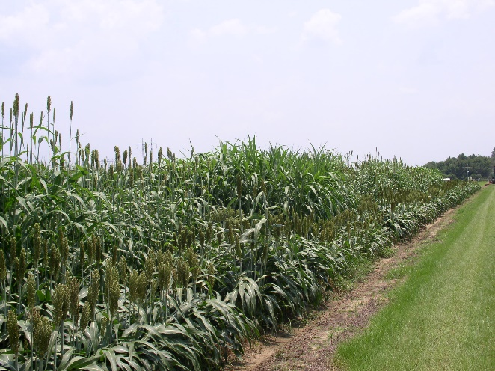
Genetic methods to screen for anthracnose resistance in sorghum. The identification of sorghum accessions resistant to anthracnose in temperate adapted germplasm is imperative to sustain productivity and profitability in the U.S. To achieve this goal, 335 temperate-adapted accessions of sorghum representing genetic diversity from public and private breeding programs were evaluated for anthracnose resistance response and resulted in the identification of 75 resistant accessions. Phylogenetic analysis suggests the presence of multiple resistant sources that could be strategically used in breeding programs to increase resistance durability. Three resistance loci at chromosome 5 and two at chromosome 1 were detected through genome-wide association analysis and can help breeders to introgress these resistance genes into elite breeding lines.
Citation: Cuevas, H.E., Prom, L.K., Copper, E.A., Knoll, J.E., Ni, X. 2018. Genome-wide association mapping of anthracnose (Collectotrichum sublineolun) resistance in the U.S. sorghum association panel. The Plant Genome. 11:170099.
Genetic mapping of napiergrass. Napiergrass is a tropical perennial grass used for forage and has potential for use as a lignocellulosic feedstock for fuel ethanol. Improvement of napiergrass for agronomic traits such as flowering time, abiotic and biotic stress tolerance, etc. has been limited and few genetic resources exist for napiergrass. In this study millions of sequencing reads were generated for napiergrass and the largest resulting contigs (overlapping reads) were aligned to the genome of pear millet. From these sequences, 5339 simple sequence repeat (SSR) markers were created which will be useful for napiergrass breeding. Furthermore, a linkage map was constructed using single nucleotide polymorphism markers in napiergrass using the progeny of a cross between two napiergrass parents. The linkage map will be used for the identification of genomic regions in napiergrass that are associated with traits of interest. Thus, this study provided genetic resources for napiergrass and identified regions of similarity that exist between the napiergrass linkage groups and the pearl millet chromosomes.
Citation: Paudel, D., Kannan, B., Yang, Y., Harris-Shultz, K.R., Thudi, M., Varshney, R., Altpeter, F., Wang, J. 2018. Surveying the genome and constructing a high-density genetic map of napiergrass (Cenchrus purpureus). Scientific Reports. 8:14419.
Canal Point
Identifying fiber components that influence bioenergy conversion in sugar cane. The energy crisis of the 1970s spurred the exploration of renewable energy. As an energy-efficient C4 plant, sugarcane is an important feedstock for producing bio-ethanol, contributing approximately 60% bio-ethanol globally. Evaluation of fiber composition and dissection of underling loci in sugarcane are critical for breeding sugarcane cultivars for bio-ethanol production. Different fiber components of the cell wall could greatly affect conversion of lignocellulose to bio-ethanol. The objectives of this study were to evaluate the fiber composition of each accession in a sugarcane association panel including 299 germplasm accessions and 9 breeding materials in three replicates, and to identify the markers associated with the fiber compositions through whole genome wide association analyses. This is the first investigation of molecular factors controlling the fiber composition of the cell wall in sugarcane. This study provides a large number of novel genomic resources for selecting/modifying fiber composition in sugarcane simultaneously to improve bio-ethanol production. Moreover, the current study suggests that introduction of diverse or wide germplasm in breeding programs to enhance other sugarcane traits would not change sugarcane lignocellulose quality for bio-ethanol production.
Citation: Yang, X., Todd, J.R., Arunadale, R., Binder, J., Luo, Z., Islam, M.S., Sood, S.G., Wang, J. 2019. Identifying loci controlling fiber composition in polyploid sugarcane (Saccharum spp.) through genome wide association study. Industrial Crops and Products. 130:598-605.

College Station
Screening for succinic acid production from bioenergy feedstocks: Succinic acid is one of the Department of Energy's top value-added chemicals produced by plants grown for biomass. It is a chemical that can be used as a key building block for a broad range of products including biodegradable plastics, cosmetics, food ingredients, and pharmaceuticals. Recent studies reported that succinic acid synthesis and accumulation increased in bermudagrass, a warm-season perennial grass, when the grass was grown under drought stress. This indicates more succinic acid can be produced and extracted directly from biomass feedstocks when the plant is grown under adverse environmental conditions. In order to investigate this, the objectives of this research were to: 1) evaluate succinic acid content and total yield for nine candidate lignocellulosic feedstocks (pearl millet, napiergrass, pearl millet x napiergrass hybrids [PMN], annual sorghum, perennial forage sorghum, switchgrass, giant miscanthus, energy cane, and sunn hemp) when grown in the field, and 2) characterize the impact of deficit irrigation on succinic acid accumulation across these nine species under greenhouse conditions. The highest succinic acid yields (up to 556 kg ha-1) were found in PMN, napiergrass, sunn hemp, and energy cane when grown in the field. Napiergrass and PMN entries also had the highest succinic acid yields under greenhouse conditions; however, irrigation treatments did not alter succinic acid accumulation in this study. Of these nine species evaluated, napiergrass, PMN, and energy cane appeared to be the most promising biorefinery feedstocks for succinic acid recovery.

Citation: Xu, Y., Foster, J.L., Muir, J.P., Burson, B.L., Jessup, R.W. 2018. Succinic acid production across candidate lignocellulosic biorefinery feedstocks. American Journal of Plant Sciences. 9:2141-2153. https://doi.org/10.4236/ajps.2018.911155.
Screening for silica production from bioenergy feedstocks: During the past several years production of cellulosic ethanol from non-food crops including forage and bioenergy grasses has decreased because hydraulic fracking has increased oil production in the U.S. The amount of cellulosic ethanol previously mandated to be in gasoline by previous government administrations also has been greatly reduced. However, cellulosic ethanol is not the only product that can be obtained from integrated biorefining of these grasses. Several other value-added biomass co-products can be recovered. One of these is amorphous silica, which has the potential of increasing the profitability of biofuel refining. Silica is used in a range of industrial products such as semiconductors, nanotechnology products, reinforcing agents, and specialty chemicals. Most silica today is produced by heating quartz at very high temperatures, which is expensive because of the amount of energy required. Recovering silica from plants by biorefining is more economical. This study was undertaken to determine the amount of biomass and silica produced by eight different grasses (pearl millet, napiergrass, a pearl millet x napiergrass hybrid [PM x N], annual sorghum, perennial sorghum, switchgrass, giant miscanthus, and energy cane) and one legume (sunn hemp). The PM x N hybrid, napiergrass, energy cane, and sunn hemp produced the most biomass. They also had the highest silica yields except for sunn hemp. Because of their high biomass and silica yields, the PM x N hybrid, napiergrass, and energy cane are the most promising biorefinery feedstock candidates for improving biofuel profitability.

Citation: Xu, Y., Porter, N., Foster, J., Muir, J., Schwab, P., Burson, B.L., Jessup, R. 2020. Silica production across candidate lignocellulosic biorefinery feedstocks. Agronomy. 10(1):82. https://doi.org/10.3390/agronomy10010082.

- Feedstock Production:
Houma, LA
Sugarcane as a bioenergy feedstock. Sugarcane grows on over 170,000 ha in the state of Louisiana as part of a sugar industry that generates over $2 billion in annual economic impact. The multipurpose crop produces sugar, molasses, bagasse, boiler fly ash, filter press mud, water, and electricity. As a component of a theoretical bioenergy economy, bagasse and sugarcane itself may find a value-added niche as a renewable feedstock source. The objectives were to characterize yields of ‘Ho 02-113’ at two locations over 2 years and compare two harvest strategies, green-cane harvest (stalks-only), or complete biomass harvest (intact plants). The first- and second-ratoon crop and the plant-cane and first-ratoon crop were harvested monthly at the Ardoyne Farm or Spanish Trail, respectively. Total biomass yields of 120 Mg ha⁻¹ and up to 35 Mg dry matter (DM) ha⁻¹ at the Ardoyne Farm and total biomass of 140 Mg ha⁻¹ and 50 Mg DM ha⁻¹ at Spanish Trail were observed. Sucrose levels ranging from 2000 to 8000 kg ha⁻¹ were recorded between August and September of each year. However, freezing conditions rapidly reduced sucrose levels from as high as 12,000 kg ha⁻¹ to below detection limits within 60 days. Dry matter energy content of intact plants, stalks, and dry leaves was 17.0, 17.4, and 16.5 kJ g⁻¹, respectively. The overall energy yields were 530 and 620 GJ ha⁻¹ for the Ardoyne Farm and Spanish Trail, respectively. Results demonstrate that Ho 02-113 is a versatile feedstock and can meet sucrose and/or lignocellulosic feedstock needs in areas with temperate to subtropical temperatures.

Citation: White Jr, P.M., Webber III, C.L., Viator, R.P., Aita, G. Sugarcane biomass, dry matter, and sucrose availability and variability when grown on a bioenergy feedstock production cycle. BioEnergy Research (2019) 12:55–67 https://doi.org/10.1007/s12155-018-9951-y

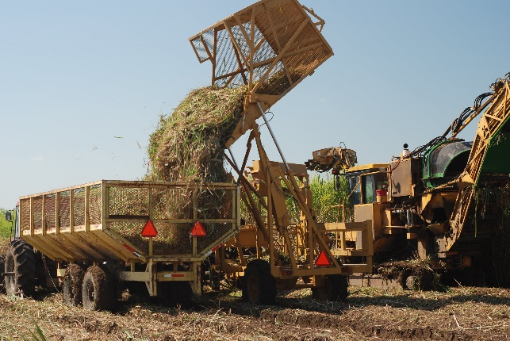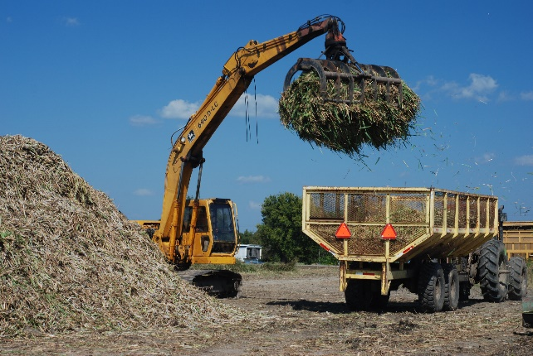

Tifton, GA

Economic competitiveness of napier grass as a renewable biofuel feedstock. Although the southeastern U.S. has been identified as the most promising region for production of renewable biofuels feedstocks, developing a reliable supply chain that can provide 50% of the nation’s feedstock production requires both agronomic and economic information that producers and lenders can use to evaluate the bottom-line. ARS researchers at Dawson and Tifton, Georgia, compared the production cost of napier grass as a cellulosic feedstock crop to that of a traditional row crop rotation in the coastal plain region of Georgia. The team demonstrated that the price required for napier grass to compete ranged from $99 to $121 Mg-1 with total costs mainly dependent on irrigation, and that napier grass would outcompete the traditional cropping system only under non-irrigated production regimes.

Citation: Lamb, M.C., Anderson, W.F., Strickland, T.C., Coffin, A.W., Sorensen, R.B.,
Knoll, J.E., Pisani, O. 2018. Economic competiveness of napier grass in irrigated and non-irrigated Georgia Coastal Plain cropping systems. BioEnergy Research. 11:574-582. https://doi.org/10.1007/s12155-018-9916-1. 2018.

Evaluation of Miscanthus for bioenergy in the Southeast. Second generation biofuels, such as perennial grasses, have potential to provide biofuel feedstock while growing on degraded land with minimal inputs. Perennial grasses have been reported to sequester large amounts of soil organic carbon (SOC) in the Midwestern United States (USA). However, there has been little work on biofuel and carbon sequestration potential of perennial grasses in the Southeastern US. Biofuel productivity for dryland Miscanthus × gigantus and irrigated maize in Georgia, USA were quantified using eddy covariance observations of evapotranspiration (ET) and net ecosystem exchange (NEE) of carbon. Miscanthus biomass yield was 15.54 Mg ha⁻¹ in 2015 and 11.80 Mg ha⁻¹ in 2016, while maize produced 30.20 Mg ha⁻¹ of biomass in 2016. Carbon budgets indicated that both miscanthus and maize fields lost carbon over the experiment. The miscanthus field lost 5 Mg C ha⁻¹ in both 2015 and 2016 while the maize field lost 1.37 Mg C ha⁻¹ for the single year of study. Eddy covariance measurement indicated that for 2016 the miscanthus crop evapotranspired 598 mm and harvest water use efficiencies ranged from 6.95 to 13.84 kg C ha⁻¹ mm⁻¹. Maize evapotranspired 659 mm with a harvest water use efficiency of 19.12 kg C ha⁻¹ mm⁻¹. While biomass yields and gross primary production were relatively high, high ecosystem respiration rates resulted in a loss of ecosystem carbon. Relatively low biomass production, low water use efficiency and high respiration for Miscanthus × gigantus in this experiment suggest that this strain of miscanthus may not be well-suited for dryland production under the environmental conditions found in South Georgia USA.

Citation: Maleski J.J, Bosch D.D, Anderson R.G, Coffin A.W, Anderson W.F, Strickland T.C. Evaluation of miscanthus productivity and water use efficiency in southeastern United States. Sc. Total Environment. 692:1125-1134. doi: 10.1016/j.scitotenv.2019.07.128.

Bio-typing sugarcane aphid on sorghum and strategies for mitigation. Since 2013 the sugarcane aphid (Melanaphis sacchari) has become a significant pest of all types of sorghum in the United States. Because sweet sorghum is used to produce an edible syrup, very few pesticides are labeled for use on this crop, so alternative strategies are needed to manage sugarcane aphids in sweet sorghum. This paper highlights some of the recent research carried out by the USDA-ARS at Tifton, GA as part of the sugarcane aphid Areawide Pest Management project, as it pertains to sweet sorghum. Each year since 2015, sugarcane aphids were collected from across the southern states. Their DNA was analyzed in order to monitor their genetic diversity. The sugarcane aphids infesting sorghum and Johnsongrass (a weedy relative of sorghum) in the United States were found to be largely genetically identical, constituting what is known as a ‘superclone.’ Although sugarcane aphids have been an occasional pest of sugarcane in Louisiana and Florida for many years, this superclone has not been observed in North America prior to the outbreak on sorghum in 2013. Because sugarcane aphids must migrate north each year to infest sorghum, a planting date study was conducted to determine if cultural practices, such as late or early planting, could minimize sugarcane aphid damage in sweet sorghum in Tifton. For three years, sweet sorghum was planted in April, May, and June within the same field. Sugarcane aphids arrived in mid-late June and built to very high numbers in the first two plantings, until the population ‘crashed’ apparently due to naturally occurring fungal disease. The third planting thus escaped major damage. We observed this same result all three years, which suggests this could be exploited for managing sugarcane aphid in small sweet sorghum fields. Further study is needed to determine the causal fungus and to determine the conditions which trigger an aphid population collapse. Our long-term strategy is to develop new sweet sorghum cultivars with genetic resistance to the sugarcane aphid. Several sources of resistance have been identified, and efforts to breed sugarcane aphid resistant sweet sorghum are continuing. In another study we evaluated the host suitability of Johnsongrass, a known host of the sugarcane aphid, and compared it to other biomass sources such as giant miscanthus, napiergrass cv "Merkeron", giant reed, switchgrass cv GA-001, and Erianthus in terms of aphid survival, reproduction from one generation to the next. Non-viable hosts that will never support sugarcane aphids include napiergrass cv Merkeron, giant reed, and switchgrass cv GA-001. The Erianthus supported sugarcane aphid for one generation, but not a second and is identified as a poor host. Our findings indicate that widespread planting of these bioenergy grasses like napiergrass, giant reed, and switchgrass may prevent the further increase of the sugarcane aphid populations. Whereas the planting of the energycane and giant miscanthus may exacerbate sugarcane aphid damage on sorghum.
Citations: Armstrong, J.S., Harris-Shultz, K.R., Ni, X., Wang, H., Knoll, J.E., Anderson, W.F. 2019. Utilizing biodemographic indices to identify perennial bioenergy grasses as sugarcane aphid (Hemiptera: Aphididae) host plants. Trends in Entomology. 15:1-14.
Harris-Shultz, K.R., Brewer, M., Wadl, P.A., Ni, X., Wang, H. 2018. A sugarcane aphid 'Super-Clone' predominates on sorghum and johnsongrass from four US states. Crop Science. 58:2533-2541.
Knoll, J.E., Harris-Shultz, K.R., Ni, X. 2019. Update on sugarcane aphid genetics, management in sweet sorghum, and breeding for resistance. In: Lima, I., Eggleston, G, and Clayton, C. (eds.) Advances in Sugar Crops Processing and Conversion, May 15-18, 2018, New Orleans, LA. pp. 172-186.
Paudyal, S., Armstrong, J.S., Harris-Shultz, K.R., Wang, H., Giles, K.L., Rott, P.C., Payton, M.E. 2019. Evidence of host plant specialization among the U.S. sugarcane aphid (Hemiptera: Aphididae) genotypes. Trends in Entomology. 15:47-58.
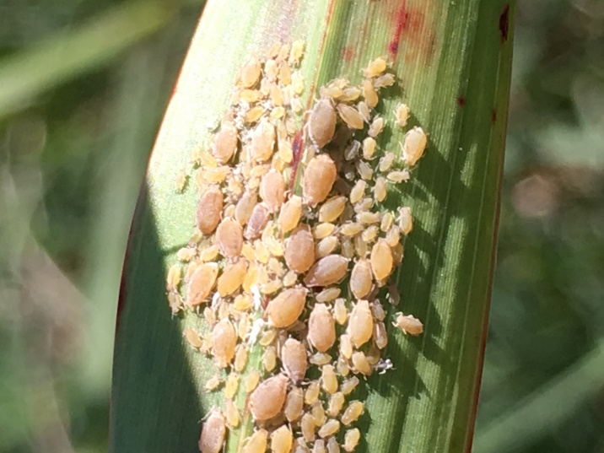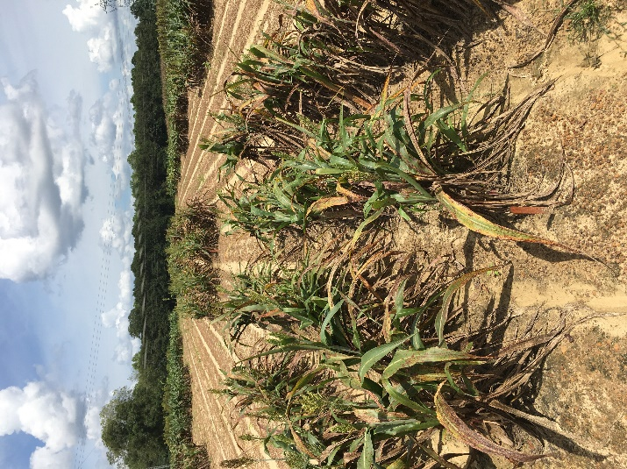
Temple, TX
Rainfall and nitrogen rates affecting switchgrass production. Perennial grasses, such as switchgrass, are high in cellulose and an important source of renewable bioenergy. Rainfall amount and its variability among years and among sites, has undefined influences on the fertilizer response of switchgrass productivity. Likewise, global climate models predict changes in rainfall patterns towards lower and increasingly variable soil water availability in several productive areas worldwide. This should have major impacts on the production of biofuel crops. We analyzed annual values for switchgrass production from 48 publications with numerous locations, soil types, switchgrass cultivars, and fertilizer inputs. Lowland ecotypes had doubled production with N rates > 131 kg N per ha per yr, but upland ecotypes showed only 50% increases. The optimum N rate was 30 to 60 kg N per ha per yr for both groups of ecotypes, after which biomass gain per unit of N added decreased. Growing season rainfall, long-term mean annual rainfall and inter-annual rainfall variability differentially affected lowland and upland productivity, depending on the N level. Productivity responses to mean annual rainfall and growing season rainfall were similar for both upland and lowland ecotypes at low N rates. When N increased beyond 60 kg N per ha per yr, lowland ecotypes had a greater growth response to mean annual rainfall than upland ecotypes. Productivity increased with increasing growing season rainfall and mean annual rainfall, and had a positive linear response to mean annual rainfall ranging from 600 to 1200 mm per yr. The N fertilization effect increased at higher levels of mean annual rainfall, more so in lowland than in upland ecotypes. After accounting for mean annual rainfall, sites with higher intern-annual rainfall variability had lower switchgrass productivity than sites with lower intern-annual rainfall variability. In lowland ecotypes, N fertilization mitigated the negative effect of intern-annual rainfall variability on productivity. Higher precipitation increased switchgrass yield more consistently among upland than lowland ecotypes. Increased inter-annual variation in precipitation reduced production of both ecotypes. Predicted changes in the amount and timing of precipitation thus likely will exert greater influence on production of upland than lowland ecotypes of switchgrass.
Citation: Reichmann, L.G. Collins, H.P., Jin, V.L., Johnson, M.V.V, Kiniry, J.R., Mitchell, R.B., Polley, H.W., Fay, P.A. Inter-annual precipitation variability decreases switchgrass productivity from arid to mesic environments. BioEnergy Research. https://doi.org/10.1007/s12155-018-9922-3
Switchgrass can recover from drought after good rainfall years. Switchgrass is a warm-season perennial grass often considered for biofuel. To be successful, switchgrass production must be on low-quality landscapes with minimal inputs while facing future climates that could be more extreme and more variable. We propose that previous years’ growing season rainfall constrains how plants respond to drought, as well as subsequently recover from drought. To test this idea, we examined how six switchgrass genotypes responded to a 1-year severe drought and then recovered under normal rainfall in the following year. These plants had previously grown for 3 years under a range of dry to wet irrigation levels in a shallow-soil common garden with no fertilizer. Plants previously exposed to drought produced less biomass and basal area after the severe drought was relieved compared to previously well-watered plants. In addition, there were legacy effects caused by plant size: plants that were larger pre-drought were more likely to survive the severe drought and plants that were larger during the severe drought recovered more biomass, basal area, and tillers post-drought. Although genotypes differed somewhat in their responses, the size constraint was consistent across genotypes. These findings suggest that we can establish more drought-resilient switchgrass stands by, for example, planning for initial irrigation or planting during a wet year to allow plants to grow larger prior to experiencing drought. Additional studies are needed to understand if these rainfall and size legacies persist.
Citation: Hawkes, C.V., Kiniry, J.R. Legacies in switchgrass resistance to and recovery from drought suggest that good years can sustain plants through bad years. Bioenerg. Res. (2018) 11:86–94 https://doi.org/10.1007/s12155-017-9879-7
Plant biomass and water use efficiency of perennial grasses. Plant productivity obviously is the ultimate product of leaf photosynthesis. As a result, there have been numerous efforts to relate the two. However, often with perennial grasses, plant productivity is more dependent on the number and size of growing leaves and stems than the actual photosynthetic rate, causing linkage between photosynthesis and productivity to be weak or nonexistent. This has led to a different approach, characterizing plant productivity in terms of efficiency of intercepted light to produce biomass, or radiation use efficiency. Likewise, the efficiency of use of water to produce plant biomass, or water use efficiency, has been the object of much interest. Use of a computer simulation model to quantify biomass, using radiation use efficiency, in parallel with a daily water balance simulation, allows effective calculation of water use efficiency. In this project, the process of determining radiation use efficiency with field data is described as well as example values for highly productive perennial grasses useful for feedstock for bioenergy. In addition, values for water use efficiency for these grasses are reported and compared with other perennial grasses and common cultivated crops.
Citation: Kiniry, J.R., Kim, S. Plant productivity and water use efficiency of highly productive perennial grasses useful for bioenergy. Submitted to Agronomy.
Vetivergrass is a multi-purpose crop with untapped potential for biofuel production. We conducted a field study at Temple, Texas (TX) to determine and evaluate plant growth characteristics that make vetivergrass an ideal candidate bioenergy feedstock crop. The high biomass yield is due to the high leaf area index, amount of biomass produced per unit intercepted light (radiation use efficiency), and high growth rates. Plant tissue N and P concentrations varied over the growing season. Biomass yield was highly correlated to plant height and leaf area index. Data from the field experiment provided plant coefficients that were used to simulate vetivergrass biomass yield, its inter-annual variability, and spatially distributed production potential under rainfed and irrigated conditions across TX. Simulations were made over a 21- year time series for combinations of soils and climates across 21 agroclimatic zones. Simulated average dryland and irrigated biomass yields ranged from 2 to 20 Mg ha-1 and 6 to 27 Mg ha-1, respectively. There was high inter-annual yield variation for both dryland and irrigated conditions. These state-wide simulation model assessments complement field studies in a cost-effective way and will further allow bioenergy companies and investors to better estimate biofuel production potential for new crops such as vetivergrass.
Citation: Meki, M.N., Worqlul, A., Kim, S., Reilley, J., Williams, A.S., Kiniry, J.R. A field and simulation-based assessment of vetivergrass bioenergy feedstock production potential in Texas. Submitted to Agronomy Journal
Evaluating mustard oilseed for biofuel. Oilseed crops belonging to the mustard family provide rotational benefits to wheat and are being targeted for biofuel feedstock production in the western U.S. wheat-growing regions. Several different mustard species can be used for biofuel feedstock such as “green” renewable jet fuel. However, little is known about which species produces the greatest yield or is best suited for a given region across the dryland wheat producing area of the U.S. Therefore, a team of scientists from USDA-ARS and one university collaborated to determine the productivity and drought tolerance of 12 modern mustard varieties from six different species across eight different environments spanning four ecoregions within the U.S. The objective was to explore how various environments affect their agronomic performance and identify the greatest yielding species/variety for a given region. Environment greatly affected oilseed performance. Both seed and oil yields increased with increasing seasonal rainfall. Generally, commercial varieties of canola (Brassica napus) and Indian mustard (Brassica juncea) produced the greatest oil yields, in part, because of their high seed oil concentration. However, some species such as Ethiopian mustard (Brassica carinata) performed very well in certain environments but poorly in others. Results indicated that out of the six species tested, camelina (Camelina sativa) possessed the greatest degree of drought resistance. Research identified varieties well suited for certain environments but also showed that more work is needed to improve the oil concentration of some high seed yielding varieties to make them more useful as biofuel feedstock. This information will benefit producers interested in incorporating oilseeds into their rotations, extension specialists working with farmers to adopt oilseeds, the biofuel industry, crop breeders, and agronomists.
Citation: Gesch, R.W., Long, D.S., Palmquist, D., Allen, B.L., Archer, D.W., Brown, J., Davis, J.B., Hatfield, J.L., Jabro, J.D., Kiniry, J.R., Vigil, M.F., Oblath, E.A., Isbell, T.A. Agronomic performance of Brassicaceae oilseeds in multiple environments across the Western USA. BioEnergy Research (2019) 12:509–523 https://doi.org/10.1007/s12155-019-09998-1
Effect of climate change on sugarcane yields. Future climate change effects on common sugarcane varieties can guide decision-making and help ensure the economic stability of numerous rural households. This study assessed the potential impact of future climatic change on a widely grown sugarcane cultivar in Mexico. Climate change impacts were evaluated for dryland conditions in two regions. The goal was to identify the key climate factors influencing yield under various climate change scenarios. The Almanac model was used to simulate sugarcane development and yield under current and future climate conditions. Management, soil and climate data from farm sites in Jalisco (Pacific region) and San Luis Potosi (Northeastern Mexico) were used to simulate baseline yields. The baseline climatic scenario was developed with 30 years of past weather data. Future climate for 2021-2050 we estimated by adding forecasted climate values from global circulation models to baseline values. Climate change impacts were assessed by comparing baseline yields with those in future decades. Climatic change during 2021-2050 had a positive impact on sugarcane yields in the two regions, with increases of 1 to 13 % (0.6 to 8.0 Mg ha-1). The midsummer drought or canicula that is usually more intense in the Pacific region, reduced plant weights -0.6 to -1.7 Mg ha-1 in July-August. Thus, planting in October and November should be avoided. In both regions, harvest may be one to two months earlier to increase production and avoid early flowering. Integrating pest and diseases under climate change in future crop modeling will fine-tune yield forecasting.
Citation: Baez-Gonzalez, A.D., Kiniry, J.R., Meki, M.N., Williams, J.R. Alvarez Cilva, M., Ramos Gonzalez, J. L., Magallanes Estala, A., Potential impact of future climate change on sugarcane under dryland conditions in Mexico. J Agro Crop Sci. 2018;1–14.
Estimate of biomass storage and transportation costs. This study presents a two-step framework for computer modeling of optimal locations to store biomass for biofuel. Location of storage facilities is critical for the whole bioenergy process. The proposed framework has two computer simulation phases: (1) predicting switchgrass production with the Agricultural Land Management Alternative with Numerical Assessment Criteria (ALMANAC) model and (2) estimating transportation costs of the biofuel using a computer model linked to the geographic information system (GIS). The second model finds the best locations of biomass storage. The proposed approach simulates plant production and transportation and storage aspects. It provides reliable locations for storing biomass to improve the bioenergy production system.
Citation: Kim, S., Kim, S. Kiniry, J.R. Two-phase simulation-based location-allocation optimization of biomass storage distribution. Simulation Modelling Practice and Theory 86 (2018) 155–168.
New Orleans
Sugar loss due to storage of sweet sorghum: Sweet sorghum has potential as a feedstock for bioproducts production due to its ability to grow in marginal soils that are low in moisture and fertilization. The return on the financial investment in equipment used to collect and process juice from sorghum stalks can be enhanced by extending processing past harvest season. A limitation of storing sorghum juice for delayed processing is the degradation of sugar in the juice. Degraded sugars are no longer available for fermentation into bioproducts. Microbes in the environment are a source of sugar degradation. The ability to store sorghum stalks after harvest would extend output from the mill and increase profitability. This work evaluates the degree of sugar loss in billets of the size prepared commercially, and whole stalks.

Citation: Wright, M. 2019. Impact of storage on sugar loss in sorghum stalks. African Journal of Agricultural Research. 14(33):1629-1634. https://doi.org/10.5897/AJAR2019.14232.

- Conversion and Co-product Utilization:
Tifton, GA with Peoria, IL and New Orleans, LA
Production of ethanol and sugars from napiergrass in Georgia. Napier grass (Pennisetum purpureum (L) Schum) is being developed as a bioenergy crop for production in the southeastern United States. Important criteria for selecting a feedstock are cost, consistent biomass production, composition, and process related quality. In this study, we considered the effects of fertilizer application and cutting regimes on production yield, chemical composition, and process yields. Napier grass was grown for 4 years in field plots (Shellman, GA) with three treatments, which were selected to maximize production yields and replicated in four sub-plots. It was observed that multiple seasonal cuts negatively impacted production yield by 21% over the total 4 years. Samples from years 2 and 4 were analyzed for composition. Glucan, xylan, and acid insoluble lignin differed among the samples. Carbohydrate yields were 11.1 – 25.7 Mg/ha. Samples were pretreated with low moisture ammonia hydroxide (110°C, 2 days) and evaluated for conversion to sugars using commercial cellulases as well as to ethanol using separate hydrolysis and fermentation with Scheffersomyces stipitis. Glucose and xylose yields were 317-379 kg/Mg and 141 – 164 kg/Mg, respectively for years 2 and 4. Ethanol yields were 268 – 313 L/Mg or 61.3 – 79.3% of maximum. Ethanol yields were 5.9 – 12.8 m3/ha. Ethanol yields for year 4 were over 50% higher for the crop harvested in winter versus the crops harvested in summer and winter. Ethanol production per hectare from winter harvested Napier grass is comparable to grain-based biofuel crops.
Citation: Dien

, B.S, Anderson, W.F.,

Cheng, M

, Knoll, J.E.,

Lamb, M.,

O’Bryan P.,

Singh, V.,

Sorensen, R.B.,

Strickland, T.C.,

Slininger, P.J. Field Productivities of Napier Grass for Production of Sugars and Ethanol,

ACS Sustainable Chem. Eng. 2020, 8, 4, 2052-2060. Publication Date: January 8, 2020, https://doi.org/10.1021/acssuschemeng.9b06637

Fast evaluation methods developed for Napiergrass used for conversion to bioenergy. Tall perennial grass species have been studied for use as a biomass feedstock for conversion to biofuels. Napiergrass (Pennisetum purpureum Schum.) is one of the highest yielding feedstocks for bio-based products and biofuel in the Southern Plains of the United States. Thirty genetically diverse napiergrass accessions were selected from a collection of material originally from Latin America and analyzed for traits that accommodate conversion of the biomass to ethanol. A near infrared reflectance spectroscopy (NIRS) calibration was developed from this material to predict ethanol production, and multiple other traits by separating leaves and stems running chemical analyses in the lab and then correlating with scans from NIRS. The NIRS develops unique reflectance data for individual sources of biomass. This technique makes it 20 to 30 fold faster to analyze different material to determine the effectiveness for conversion to bio-based products. Most of the time, genetic material that had lower biomass had the best traits for conversion to biofuels. However, some napiergrass clones had good quality and quantity. These can be used for genetic improvements by using them as parents or for direct use by producers of biomass for industrial conversion. Also this information is important internationally, where napiergrass with high quality could be used as forage in a ‘cut and carry’ system used in Asia and Africa.
Citation: Anderson, W.F., Dien, B.S., Masterson, S.D., Mitchell, R. 2018. Development of near infrared reflectance spectroscopy (NIRS) calibrations for traits related to ethanol conversion from genetically variable napiergrass (Pennisetum purpureum Schum.). BioEnergy Research. 12(1):34-42. https://doi.org/10.1007/s12155-018-9946-8.

Specialized chemicals from sweet sorghum. Carboxylates and other specialized chemicals are important feedstock to produce renewable biobased products including plastics and composite materials. This study developed methods to predict the amounts of specialized chemical produced by different sweet sorghum breeds. The method is based on simple visible light absorption, or fluorescence reflectance. Both genetic and environmental effects influence the ability of sweet sorghum to accumulate carboxylates and polyphenols. Developed methods will allow feedstock accounting for bioenergy plants and chemical factories. Inexpensive and sensitive chemistry methods are required to streamline any factory operation to produce biobased products or bioenergy. Another study developed highly sensitive methods to detect important chemical feedstock (trans-aconitic acid) in sugar feedstock obtained from sweet sorghum. The method does not require separation and utilizes least expensive detection methods based on UV/visible and fluorescence. Developed "omics" method will facilitate breeders' efforts to develop pest resistant cultivars in bottom-up fashion, i.e., by elucidating the pest resistance/tolerance mechanisms.
Citations: Uchimiya, M., Knoll, J.E. 2018. Prediction of carboxylic and polyphenolic chemical feedstock quantities in sweet sorghum. Energy and Fuels. 32:5252-5263.
Uchimiya, M., Knoll, J.E. 2019. Accumulation of carboxylate and aromatic fluorophores by a pest-resistant sweet sorghum [Sorghum bicolor (L) Moench] genotype. ACS Omega. 4:20519-20529. https://doi.org/10.1021/acsomega.9b02267.
Florence, SC
Nitrogen loss mitigation using biochars: Agriculture accounts for about 60 percent (%) of global anthropogenic nitrous oxide (N2O) emissions, largely due to organic and mineral nitrogen (N) fertilizer use and the extended use of legumes either as crops (soy, pea, bean or groundnut) or as green cover. Biochar can reduce both N2O emissions and nitrate (NO3)-leaching. However, refining biochar’s use for estimating these types of losses remains elusive. For example, biochar properties such as ash content and labile organic compounds may induce transient effects that alter N-based losses. Thus, the aim of this meta-analysis was to assess interactions between biochar-induced effects on N2O emissions and NO3- retention, regarding duration of experiment as well as soil and land use properties. Data were compiled from 88 peer-reviewed publications resulting in 701 observations up to May 2016 and corresponding response ratios used to perform a random effects meta-analysis, testing biochar's impact on cumulative N2O emissions, soil NO3- concentrations and leaching. This meta-analysis revealed that biochar stimulates an overall N2O emissions reduction of 38% with greater reductions immediately after application. The time dependent impact of biochar application on soil N2O emissions is a crucial factor requiring consideration in order to develop and test resilient and sustainable biochar-based greenhouse gas mitigation strategies. Adding biochar to sandy or coarse textured soils reduced both N2O emissions and NO3- leaching, which reduces soil N losses and presumably improves both N-use efficiency and mitigates climate change. Our results provide a valuable starting point for future biochar-based N loss mitigation studies.
Citation: Borchard, N., Schirrmann, M., Cayuela, M.L., Kammann, C., Wrange-Monnig, N., Estavillo, J., Fuertes-Mendizabal, T., Sigua, G.C., Spokas, K.A., Ippolito, J., Novak, J.M. 2018. Biochar, soil and land-use interactions that reduce nitrate leaching and N2O emissions: A meta-analysis. Science of the Total Environment. 651:2354-2364. https://doi.org/10.1016/j.scitotenc.2018.10.060.
Mitigating odors from swine manure: Biochar is a carbonaceous solid product from heating biomass in the absence of air. It has been widely researched as a soil amendment to improve soil quality. In this research, we evaluated the potential of various biochars in removing swine manure odorous volatile organic compounds via laboratory sorption experiments. The biochars were made from pyrolyzing poultry litter, swine manure, oak, and coconut shell at 350 and 500 degree Celsius (0C) along with swine-manure and commercial coconut-shell activated carbons. Among the fifteen odorous volatile organic compounds (VOCs) examined, acetic acid was the most predominant compound in the emitted gas from swine manure; however, its contribution to the complex swine manure odor mixture was minimal. Animal-manure-based biochars were poor sorbents for reduced sulfur compounds. In contrast, plant-biomass-based biochars had considerably larger sorption capacity for the sulfur compounds. Oak biochar pyrolyzed at 500 oC (OK500) showed high sorption capacities. Although the sorption capacity of OK500 is less than that of commercial activated carbon, it may be more economically advantageous if the spent biochar can be applied to soil as a soil amendment.
Citation: Hwang, O., Lee, S.R., Cho, S.B., Ro, K.S., Spiehs, M.J., Woodbury, B.L., Silva, P.J., Han, D.W., Choi, H.C., Kim, K.Y., Jung, M. 2018. Efficacy of different biochars in removing odorous volatile organic compounds (VOCs) emitted from swine manure. ACS Sustainable Chemistry & Engineering. https://doi.org/10.1021/acssuschemeng.8b02881.
New technique that screens for biochar effects on soil characteristics: In soils that are degraded, biochar is being evaluated as an amendment to improve their fertility and increase crop yields. Unfortunately, there are few rapid tests to determine the effects of biochar on soil and associated plant responses. Seed germination is a critical parameter for plant establishment and may be a rapid indicator of biochar effects. Since evaluating biochars for their potential soil fertility improvement is time-consuming, we developed a rapid (2-weeks) tool using seed germination procedures to screen for effects of biochar on seed germination and soil characteristics. We also examined whether their were any beneficial or detrimental impacts of biochar on soil fertility characteristics such as pH, electrical conductivity (EC) and phoshorus (P). Our research demonstrated that the biochars had few negative effects on seed germination, but increased shoot dry weight for carrot, lettuce, oat and tomato; primarily with biochars produced from poultry litter. The test detected increased soil pH and EC, especially with biochar produced from poultry litter and swine solids, and the response varied with plant species. The test provided an indicator that biochar increased P, especially with the poultry litter and swine solids with very little difference among species. Our technique can be completed in a small space under controlled conditions to reduce environmental variability and indicate biochar impacts on soil characteristics after a relatively brief period of time. We conclude that since the new technique is flexible, it could be adapted for evaluating other soil-based stressors using a limited amount of soil and contaminant.

Citation: Olszyk, D.M., Shiroyama, T., Novak, J.M., Johnson, M.G. 2018. A rapid-test for screening biochar effects on seed germination. Communications in Soil Science and Plant Analysis. https://doi.org/10.1080/00103624.2018.1495726.
Economic feasibility of using agricultural residues to product ethanol: In this study, the economic feasibility of producing ethanol from gasification followed by syngas fermentation via commercially available technologies was theoretically evaluated using a set of selected livestock, agricultural and forest residuals ranging from low valued feedstocks (i.e., wood, wheat straw, wheat straws blended with dewatered swine manure, and corn stover) to high valued rapeseed meal via commercially available technologies. Although the cost for rapeseed meal is much higher than other low-value feedstocks, it was selected for comparing its competing use as animal feed. A preliminary cost analysis of an integrated commercial system was made for two cases, a regional scale 50 million gallon per year facility (MGY) and a co-op scale 1-2 MGY facility. The estimates for the minimum ethanol selling prices (MESP) depend heavily on the facility size and feedstock costs. For the 1-2 MGY facility, the MESP ranged from $5.61 - $7.39 per gallon for the four low-value feedstocks and $9.49 - $9.54 per gallon for the high-value rapeseed meal. These high costs suggest that the co-op scale even for the low-value feedstocks may not be sustainable. However, the MESP for the 50 MGY facility were significantly lower and comparable to gasoline prices ($2.24 - $2.96 per gallon), for these low-value feedstocks, clearly showing the scale-up reduction on construction costs and MESP.
Citation: Ro, K.S., Dietenberger, M.A., Libra, J.A., Proeschel, R., Atiyeh, H.K., Sahoo, K., Park, W.J. 2019. Production of ethanol from livestock, agricultural, and forest residuals: an economic feasibility study. Environments [MDPI]. 6(8):97. https://doi.org/10.3390/environments6080097.
Soil bioremediation using biochar and earthworms: Intensive use of agrochemicals is considered one of the major threats for soil quality. The use of biochar, a carbonaceous material produced from pyrolysing biomass, represents an attractive option enhancing both remediation and soil carbon storage potentials. Currently, activation of biochar with chemical or physical agents seeks for improving its remediation potential, but most of them have some undesirable drawbacks such as high costs and generation of chemical wastes. This paper briefly introduces current biochar bioactivation methodologies and the mechanisms underlying the coating of biochar with enzymes mostly utilizing laboratory microbial cultures. We then propose a new conceptual model using earthworms to activate biochar with extracellular enzymes. This new technique can be used to produce a new material called vermichar, vermicompost mixed with bioactivated biochar. The vermichar can be used to improve soil quality and remove pollutants from soil.
Citation: Sanchez-Hernandez, J.C., Ro, K.S., Diaz, F.J. 2019. Biochar and earthworms working in tandem: research opportunities for soil bioremediation. Science of the Total Environment. 688:574-583. https://doi.org/10.1016/j.scitotenv.2019.06.212.
How does biochar affect corn yields and soil properties in the South?: Biochar is used as an amendment in agricultural soils to improve their ability to bolster important fertility properties. Biochars ability to improve soil fertility is explained by its composition of organic compounds which rebuilds soil organic carbon (SOC) levels and ash material comprised of plant nutrients like phosphorus and potassium. Biochars are expensive and there must be a financial realization that crops or biomass yields are significantly improved. Sandy soils in the Southeastern USA coastal plain region have marginal fertility characteristics, so we conceived a field experiment to determine if biochars applied to a sandy soil would improve both corn grain yields and corn biomass. We conducted this field experiment in South Carolina over three years by planting corn in plots treated with different types of biochars produced from wood and animal manures. We also measured plant available nutrient concentrations after soil extraction with reagents. We found that the biochars did increase plant available soil phosphorus and potassium concentrations. There was no increase, however, in corn grain yields or biomass production. It was speculated that the biochars did not work in our sandy soil because there were no prior soil fertility constraints that limited corn crop production.
Citation: Novak, J.M., Sigua, G.C., Ducey, T.F., Watts, D.W., Stone, K.C. 2019. Designer biochars impact on corn grain yields, biomass production, and fertility properties of a highly-weathered ultisol. Environments MDPI. 6:64-79. https://doi.org/10.3390/environments6060064.
Reduction of high cadmium and zinc in soils with biochar: Mining activities and ensuing disposal of waste products can have profound impacts on soil health characteristics (low pH, toxic heavy metals concentrations, etc.) where mine wastes are stored. Stabilizing mine tailings and mine-impacted soils with a ground cover is an important management practice because plants can minimize off-site movement of toxic metals and can add organic matter to improve soil chemical characteristics for better plant growth. Without treatment, these poor soil conditions are known to reduce ground cover establishment and influence the degree of site phytostabilization. Thus, in mine soil remediation project, various materials are often utilized as amendments to improve soil health characteristics. Current literature adjudicates the use of biochar as an amendment in mine reclamation sites, however, their difference in physical and chemical properties will influence their ability to react with toxic metals and improve soil chemical conditions. We conducted an experiment to determine the effectiveness of three different biochars produced from manures and wood feedstocks and compost blends with reducing the availability of toxic heavy metals to switchgrass. Mine-impacted soil was obtained from a EPA Superfund site known to contain high concentrations of cadmium (Cd) and zinc (Zn). We found that switchgrass growth was facilitated more by a manure-based biochar because they were able to reduce more water and bioavailable Cd and Zn concentrations in soil compared to a pine wood-based biochar.
Citation: Novak, J.M., Ippolito, J.A., Watts, D.W., Sigua, G.C., Ducey, T.F., Johnson, M. 2019. Biochar compost blends facilitate switchgrass growth in mine soils by reducing Cd and Zn bioavailability. Biochar Journal. https://doi.org/10.1007/s42773-019-00004-7.

