Chapter 16
Innovative modeling approaches for risk assessments in food safety
Thomas P. Oscar
U. S. Department of Agriculture, Agricultural Research Service

Introduction
Food safety involves preventing foodborne illness by describing ways to properly handle, prepare and store food. Regulation of food safety is applied to companies that produce food with the goal of reducing human pathogens to acceptable levels at the processing plant through proper handling, processing and storage of food. Food in the processing plant is classified as safe when it meets established microbial performance standards. A limitation of this approach to food safety is that it does not consider differences in virulence among pathogens and post-processing risk factors, such as temperature abuse, cross-contamination, under-cooking, and at-risk consumers.
Risk assessment is a holistic approach to food safety that considers differences in virulence among pathogens and post-processing risk factors. Risk assessment consists of four steps: 1) hazard identification; 2) exposure assessment; 3) hazard characterization; and 4) risk characterization. Application of risk assessment at the processing plant can simultaneously improve food safety and security when its goal is to maximize the public health benefit of food by ensuring both its safety and consumption. This chapter will focus on innovative modeling methods for application of risk assessment at the processing plant. More specifically, this chapter will describe and demonstrate the Food Assess Risk Model or FARM, which was developed in an Excel (MicroSoft Corp., Redmond, WA) notebook and is simulated with @Risk (Palisade Corp., Newfield, NY), a spreadsheet add-in program.
Recent Advances
Hazard Identification
Historical data linking specific foods and pathogens to outbreaks of foodborne illness forms the basis for hazard identification. In addition, hazard identification involves determining the number and distribution of pathogens in food at some point in the farm-to-table pathway. Since enumeration of pathogens in food is time consuming and expensive, it is only practical to perform at one point in the risk pathway. In FARM, hazard identification is performed at packaging in the processing plant.
Most pathogens are minority members of the microbial community of food and as a result most food samples do not contain pathogens. Pathogens in food are present in multiple forms: unattached, attached and entrapped. The enumeration method used must be capable of quantifying pathogens regardless of how they are associated with food. For risk assessment purposes, sampling methods such as rinsing, swabbing and sponging are not adequate for enumeration because they fail to recover all pathogens in food.
A recent advance is development of an enumeration method that can quantify pathogens regardless of how they are associated with food. The method involves enumeration based on detection time during whole food sample enrichment (5,6). This method allows enumeration of pathogens in food samples with bones or other hard structures that are not amenable to homogenization and most probable number methods.
Exposure Assessment
To predict how initial distributions of pathogens in food change between hazard identification and consumption, the risk pathway is modeled as a series of unit operations and associated human actions and pathogen events; hereafter, referred to as nodes. Mathematical models that predict behavior of pathogens within each node are developed and used to define input distributions in FARM (7). To reduce uncertainty, predictive models are developed in food with native microflora and with an initial dose of pathogen strains found in the food.
Hazard Characterization
A recent study (4) using data from a human feeding trial indicates that when a food is contaminated with multiple pathogen strains of differing virulence, the dose-response curve is non-sigmoid in shape. These results suggest that sigmoid-shaped dose-response curves are an artifact of feeding trials that employ uniform food, pathogen and host populations. A recent advance in hazard characterization is development of a method that simulates the disease triangle (interaction among the pathogen, food and host) effect on foodborne illness and yields non-sigmoid dose-response curves; this method is used in FARM and is described below.
Risk Characterization
Modeling severity of the host response to pathogen exposure is an important aspect of risk assessment. Epidemiological data indicate that progression of foodborne illness to the more severe outcomes of hospitalization and death differs among pathogens (2). Accounting for these differences in severity among pathogens is important for assessing food safety risks. A recent advance in risk characterization is use of epidemiological data to predict severity of foodborne illness (1); this method is used in FARM and is described below.
Methods and/or software
Rare Events’ Modeling
Presence of a pathogen in a food serving is a rare event meaning that it occurs much less than 100% of the time. Likewise, human actions, such as temperature abuse and cross-contamination, which result in pathogen growth and spread, respectively, are rare events. Rare events occur randomly and exhibit biological variation and thus, their outcomes are uncertain. For example, if ten servings of food are consumed and only one is contaminated with pathogens, it is by random chance who consumes the contaminated food serving because it is not possible to visually see pathogens and avoid their consumption. If only one of the ten consumers in this example can get sick from eating the contaminated food, the probability of foodborne illness ranges from 0 to 100% with a most likely probability of 10% and thus, is highly uncertain.
To model rare events, a discrete distribution for incidence of the event is linked to a continuous distribution for extent of the event (3). In FARM, discrete distributions for incidence of pathogen events are defined in Excel spreadsheets using the following @Risk function:
=RiskDiscrete({0,1},{90,10})
where the output of this distribution is ‘0’ when the food serving is pathogen-negative and ‘1’ when the food serving is pathogen-positive. In this scenario, 90% of food servings are pathogen-negative and 10% are pathogen-positive.
To model the extent of pathogen events in FARM, the @Risk function for a pert distribution defined by minimum, most likely and maximum values is used:
=RiskPert(0,1,4)
where the output of the pert distribution is a log number. To simulate pathogen-negative servings, the log number is converted to its antilog using the “POWER” function of Excel:
=POWER(10,RiskPert(0,1,4))
Next, discrete distributions for incidence of pathogen events and pert distributions for extent of pathogen events are linked using the “IF’ function of Excel:
=IF(RiskDiscrete({0,1},{90,10})=0,0,POWER(10,RiskPert(0,1,4)))
where the output of the pert distribution is ignored when the output of the discrete distribution is ‘0’.
Since it is not possible to have a fraction of a pathogen, the Excel function “ROUNDDOWN” is used to convert outputs that are fractions to whole numbers. This is the basic formula used in the rare events’ modeling approach for risk assessment in FARM:
=ROUNDDOWN(IF(RiskDiscrete({0,1},{90,10})=0,0,POWER(10,RiskPert(0,1,4))),0)
However, it can be modified to handle other situations. For example, if the incidence of pathogen growth during refrigeration is 100% but 20% of the time the growth is accelerated due to temperature abuse, the formula can be modified as follows to simulate this scenario:
=ROUNDDOWN(IF(RiskDiscrete({0,1},{80,20})=0, POWER(10,RiskPert(0,0.1,1))),0), POWER(10,RiskPert(0,0.5,2))),0)
where the pert distributions simulate the log cycles of growth during proper refrigeration and temperature abuse, respectively.
Finally, to properly link the discrete distributions and pert distributions for sensitivity analysis, the RiskMakeInput function of @Risk is added as follows:
=RiskMakeInput(ROUNDDOWN(IF(RiskDiscrete({0,1},{80,20})=0, POWER(10, RiskPert(0,0.1,1))),0), POWER(10,RiskPert(0,0.5,2))),0),0)

Sensitivity analysis provides information about which input distributions in the model have the largest influence on the output of interest.
Multiple Pathogen Modeling
Most food is contaminated with multiple pathogen types (8), which often behave differently under the same conditions. For example, during refrigeration of food, some pathogens grow (Listeria monocytogenes), some survive (Salmonella enterica) and some die (Campylobacter jejuni). Thus, it is important to include multiple pathogens in a risk assessment for food safety.
Disease Triangle Modeling
The interaction among the food, pathogens and host or the disease triangle determines the host response, which falls on a continuum from no response to death. To model the host response, criteria are used to classify the host response into discrete categories, such as infection, mild illness, illness, severe illness (hospitalization) or death. Whether or not the host becomes ill from consuming a contaminated food serving is a discrete event that is modeled as follows:
=IF(DC<ID,0,1)
where DC is the dose consumed, ID is the illness dose, ‘0’ means no illness and ‘1’ means illness. In the disease triangle modeling method for hazard characterization in FARM, illness dose is first modeled by classifying pathogen, food and host factors as normal or high risk. A highly virulent strain of the pathogen, consumption of an anti-acid pill with the food serving and a consumer with an underlying health problem are all examples of attributes resulting in a classification of high risk for pathogen, food and host factors, respectively. The formula used in FARM to model incidence of high risk events for illness dose is:
=RiskDiscrete({0,1},{92,8})
where an output of ‘0’ indicates normal risk and an output of ‘1’ indicates high risk. Separate discrete distributions are used for pathogen, food and host factors. The outputs of the discrete distributions for pathogen, food and host factors are summed to yield outcomes of 0, 1, 2 or 3. These outcomes correspond to four pert distributions for illness dose as follows:
=RiskMakeInput(ROUNDDOWN(POWER(10,IF(sum=0,RiskPert(4,6,9),IF(sum=1,RiskPert(2,3,4),IF(sum=2,RiskPert(1,2,3), RiskPert(0,1,2))))),0))

Thus, if all three outcomes are ‘1’ for a total of ‘3’, the illness dose will range from 1 to 100 cells with a most likely value of 10 cells.
Scenario Analysis
A scenario is defined as a unique set of input distributions in a risk assessment model. Comparison of scenarios provides a relative assessment of risk and is used to make food safety decisions. In rare events’ models, the outcome is uncertain because of the random and variable nature of events in the risk pathway. To assess this uncertainty, replicate simulations are conducted using different random number generator seeds (RNGS). The RNGS is a number that initiates the random selection of numbers by @Risk. Each RNGS generates a unique outcome of the model.
Severity Assessment
To model severity of foodborne illness, epidemiological data are used to determine the cases of foodborne illness (C₁) that progress to more severe outcomes:
$$\begin{aligned}C_{2}=α_{2}⋅C_{1} \\ C_{3}=α_{3}⋅C_{1}\end{aligned}$$
where C₂ is hospitalizations, α₂ is the hospitalization rate, C₃ is deaths and α₃ is the death rate. Next, the illnesses, hospitalizations and deaths are multiplied by severity factors and summed to obtain a single severity value (SV) for foodborne illness:
$$\text{SV}=\sum{C_{1}+2C_{2}+\text{10}C_{3}}$$
This calculation summarizes the complex risk assessment into a single number that can be used to manage and communicate the risk of foodborne illness.
Food Assess Risk Model (FARM)
FARM was created in an Excel notebook and contains the following worksheets:
- ‘C’ = contact information;
- ‘D’ = flow diagram (Figure 1);
- ‘I’ = instructions for simulation;
- ‘Q’ = questions whose answers define the input distributions (Figure 2);
- ‘Lm’ = model for Listeria monocytogenes (Figure 3);
- ‘Se’ = model for Salmonella enterica (Figure 4);
- ‘Cj’ = model for Campylobacter jejuni (Figure 5);
- ‘R’ = detailed statistics results for the last simulation;
- ‘T’ = table of results for the last simulation (Figure 6);
- ‘EA1’ = graph: exposure assessment for Lm (incidence) (Figure 7);
- ‘EA2’ = graph: exposure assessment for Lm (total log number) (Figure 8);
- ‘EA3’ = graph: exposure assessment for Se (incidence) (Figure 9);
- ‘EA4’ = graph: exposure assessment for Se (total log number) (Figure 10);
- ‘EA5’ = graph: exposure assessment for Cj (incidence) (Figure 11);
- ‘EA6 = graph: exposure assessment for Cj (total log number) (Figure 12);
- ‘HC’ = graph: hazard characterization for Lm, Se and Cj (Figure 13); and
- ‘RC’ = graph: risk characterization for Lm, Se and Cj (Figure 14).
The models for Lm, Se and Cj in FARM consist of 14 nodes. There are two routes of pathogen exposure: 1) directly from the cooked food; and 2) indirectly from other foods. The models for Lm, Se and Cj all have the same unit operations and human actions but the pathogen events differ because of physiological differences among the pathogens. The ‘Q’ worksheet contains a set of questions whose answers define the input distributions for incidence of pathogen events, whereas the pert distributions for extent of pathogen events are fixed in an attempt to simplify use of FARM.
Detailed statistics from simulation of FARM are exported to a separate Excel worksheet and then they are copied and pasted into the ‘R’ worksheet in FARM. The pasted results are linked to formula in the ‘T’ worksheet of FARM where the risk assessment results are calculated and then graphed automatically in the ‘EA1-EA6’, ‘HC’ and ‘RC’ worksheets of FARM. The ‘EA’ worksheets are graphs of the hazard identification and exposure assessment results for all three pathogens as a function of node for both exposure pathways (pathway #1 = direct exposure; and pathway #2 = indirect exposure). The ‘HC’ worksheet contains a graph of the non-sigmoid dose-response curves for all three pathogens, whereas the ‘RC’ worksheet contains a graph of the number of illnesses, hospitalizations and deaths as well as severity of foodborne illness for all three pathogens.
There are two versions of FARM. Version 1.0 has 51 outputs and is used to generate the aforementioned results for a single simulation of a scenario. Version 1.0s has one output and is used to conduct replicate simulations of a scenario with the single output being the total severity of foodborne illness.
Node 1 (packaging). The number and distribution of pathogens in food at packaging depend on the food, pathogen and serving size. In fact, it has been shown that incidence and number of pathogens in a food serving increases in a non-linear manner as a function of serving size (5). Thus, it is not appropriate to multiply the pathogen concentration (number/g) by the amount of food consumed to arrive at the number of pathogens consumed because this calculation incorrectly assumes that pathogens are uniformly distributed in food and that pathogen number increases in a linear manner as a function of serving size. Rather, it is appropriate to simulate a single size serving and if needed, to perform separate simulations for different sized servings. Such is the approach in FARM.
As mentioned above, input distributions for incidence of pathogen events in FARM are defined by answering questions in the ‘Q’ worksheet. In contrast, input distributions in FARM for extent of pathogen events are fixed. In FARM, the pert distributions for extent of pathogen contamination at packaging are:
Worksheet | Graph | Function
Lm |  | RiskPert(0,1,3)
Se |  | RiskPert(0,1,4)
Cj |  | RiskPert(0,2,6)

where the extent of contamination in log numbers is highest for Cj, intermediate for Se and lowest for Lm.
Node 2 (retail transport). During transport of food from the processing plant to retail outlets, the food can experience cold storage or ambient storage conditions that allow pathogens to growth, survive or die. Time and temperature data for the storage conditions during retail transport can be used in predictive models to estimate the incidence and extent of pathogen events during retail transport. Moreover, it is possible to structure predictive models so that their output serves as input in FARM (7). Modeling physiological differences among pathogens is important. For example, Lm can grow at refrigeration temperatures, whereas Se survives and Cj dies. However, Se can grow if the refrigeration temperature is high enough. The input distributions used in FARM to model extent of Lm growth, Se growth and Cj death during retail transport are:
Worksheet | Graph | Function
Lm |  | RiskPert(0,0.1,0.5)
Lm |  | RiskPert(0,0.25,1)
Se |  | RiskPert(0,0.1,1)
Cj |  | RiskPert(-1,-0.25,0)
Cj |  | RiskPert(-0.5,-0.1,0)

where two pert distributions are used to model Lm growth and Cj death because during temperature abuse, Lm growth and Cj death are more extensive. One pert distribution is used to model Se behavior, because during proper refrigeration Se survives with no or little change in number, whereas during temperature abuse, Se grows.
Node 3 (retail display). During retail display food can experience cold storage or ambient storage conditions that allow pathogens to growth, survive or die. Again, time and temperature data for storage conditions during retail display can be used in predictive models to estimate incidence and extent of pathogen events during retail display. Input distributions used in FARM to simulate extent of pathogen growth or death during retail display are:
Worksheet | Graph | Function
Lm |  | RiskPert(0,0.1,0.5)
Lm |  | RiskPert(0,0.25,1)
Se |  | RiskPert(0,0.1,1)
Cj |  | RiskPert(-1,-0.25,0)
Cj |  | RiskPert(-0.5,-0.1,0)

Node 4 (consumer transport). Very few consumers practice cold storage of food during transport from the retail store to home. Thus, ambient storage of food is the most common practice. Temperature abuse at ambient temperatures will result in faster growth of Lm and Se than during cold storage and it will cause Cj to die faster. Thus, temperature abuse will increase risk of foodborne illness for Lm and Se but will lower risk of foodborne illness for Cj. Input distributions used in FARM to model extent of pathogen growth or death during consumer transport are:
Worksheet | Graph | Function
Lm |  | RiskPert(0,0.25,1)
Lm |  | RiskPert(0,0.5,1.5)
Se |  | RiskPert(0,0.5,2)
Cj |  | RiskPert(-2,-0.5,0)
Cj |  | RiskPert(-1,-0.25,0)

Node 5 (consumer storage). There is likely to be more temperature abuse of food in home refrigerators than at retail display. Again, this would increase risk of foodborne illness for Lm and Se but reduce risk of foodborne illness for Cj. This is why it is important to consider multiple pathogens in a risk assessment. Input distributions used in FARM to model extent of pathogen growth or death during consumer storage are:
Worksheet | Graph | Function
Lm |  | RiskPert(0,0.1,0.5)
Lm |  | RiskPert(0,0.25,1)
Se |  | RiskPert(0,0.1,1)
Cj |  | RiskPert(-1,-0.25,0)
Cj |  | RiskPert(-0.5,-0.1,0)

Node 6a (meal preparation). During meal preparation food is often subjected to temperature abuse at ambient temperatures and thus, extent of Lm and Se growth and Cj death are higher than when food is subjected to temperature abuse during refrigerated storage. If the only pathogen present on the food is Cj, the net effect of temperature abuse during meal preparation will be a reduction in the risk of foodborne illness. Input distributions used in FARM to simulate pathogen growth and death during meal preparation are:
Worksheet | Graph | Function
Lm |  | RiskPert(0,0.25,1)
Lm |  | RiskPert(0,0.5,1.5)
Se |  | RiskPert(0,0.5,2)
Cj |  | RiskPert(-2,-0.5,0)
Cj |  | RiskPert(-1,-0.25,0)

Node 6b (utensils). Food is removed from the package and processed during meal preparation and thus, provides opportunity for pathogens to spread to other foods via the food preparation environment. In FARM, pathogens transferred to food preparation utensils are subtracted from those associated with the food serving. Here, utensils refer to anything that could be a vehicle for transferring pathogens from the raw food to the cooked food or other foods served with the meal. This would include hands, cutting boards, knives, forks etc… In FARM, it is assumed that transfer rate is independent of pathogen type or strain. Input distributions used in FARM to simulate cross-contamination during meal preparation are:
Worksheet | Graph | Function
Lm |  | RiskPert(-4,-2,0)
Se |  | RiskPert(-4,-2,0)
Cj |  | RiskPert(-4,-2,0)

where the transfer rate is the log of the proportion of pathogens transferred.
Node 7a (cooking). During cooking food is normally not heated uniformly and therefore, location of pathogens in food rather than small differences in thermal resistance might determine whether or not pathogens survive in food that is not thoroughly cooked. If pathogens are located on the surface of the food that contacts a heat source, such as a hot frying pan, regardless of their thermal resistance they will die immediately. In contrast, if pathogens are located on a corner of the food that by random chance does not contact the heat source during cooking and thus, is uncooked, they will survive, regardless of their thermal resistance. Most people have had the experience of cooking a food where parts are well-done and other parts are still raw. Thus, it is important to consider pathogen location as well as thermal resistance when modeling pathogen death and survival during cooking. In FARM, incidence in this node refers to the percentage of servings that are not properly cooked or that contain a portion of the serving where not all pathogens have been eliminated. In FARM, when a food serving is properly cooked, the log reduction is assumed to be 12 and the pathogen load after cooking is zero. In FARM, when a food serving is not properly cooked, it is assumed that the most likely log reduction of pathogens is 6 with a range from 7 to 0 with the zero log reduction simulating the possibility that the pathogens were on a portion of the food serving that was completely uncooked or raw. The pert distributions used in FARM to model under-cooking are:
Worksheet | Graph | Function
Lm |  | RiskPert(-7,-6,0)
Se |  | RiskPert(-7,-6,0)
Cj |  | RiskPert(-7,-6,0)

Node 7b (utensils). During cooking and cooling, pathogens transferred to utensils during meal preparation can grow, survive or die depending on their physiology and the environment they find themselves in. Again, time and temperature data can be used in predictive models to predict incidence and extent of these pathogen events. In FARM, extent of pathogen growth or death on utensils during cooking and cooling are simulated using the following pert distributions:
Worksheet | Graph | Function
Lm |  | RiskPert(0,0.5,1.5)
Se |  | RiskPert(0,0.5,2)
Cj |  | RiskPert(-2,-0.5,0)

where Se grows slightly more than Lm on utensils and Cj dies.
Node 8a (cooling). Depending on time and temperature profile of food after cooking and before serving, pathogens that survive cooking can grow, survive or die. In FARM, extent of pathogen growth or death during cooling is simulated using the following pert distributions:
Worksheet | Graph | Function
Lm |  | RiskPert(0,0.25,1)
Lm |  | RiskPert(0,0.5,1.5)
Se |  | RiskPert(0,0.5,2)
Cj |  | RiskPert(-2,-0.5,0)
Cj |  | RiskPert(-1,-0.25,0)

Node 8b (serving). There are many routes by which pathogens can be transferred from the raw food to the cooked food or other foods served with the meal. If the pathogen had a chance to multiply on the ‘utensils’ used to serve the meal, the dose served to the consumer could be quite high and dangerous. In FARM, the log transfer rate from ‘utensils’ to cooked food or other foods is assumed to be independent of pathogen type and is simulated using the following pert distributions:
Worksheet | Graph | Function
Lm |  | RiskPert(-4,-2,0)
Se |  | RiskPert(-4,-2,0)
Cj |  | RiskPert(-4,-2,0)

Node 9 (table). In addition to pathogens that survive the cooking process, consumers can be exposed to pathogens that were transferred from the raw food to other foods during meal preparation. Thus, in FARM, the total dose consumed is the sum of the two exposure pathways or in other words, the sum of the pathogens that survived cooking and the pathogens that were transferred from the raw food to utensils and then from utensils to the cooked food or other foods served with the meal.
Node 10 (consumption). There are differences in virulence among pathogen strains and differences in resistance among consumers. In addition, certain food factors (e.g. fat, native microflora, anti-acid pill, protein etc…) can increase or decrease the severity of foodborne illness by altering pathogen virulence or host resistance. In FARM, pathogen, food and host factors are classified as normal or high risk and a very low illness dose (1 to 100 cells) is assigned to the food serving when, by random chance, all three disease triangle factors are high risk. The pert distributions used in FARM to model the disease triangle are:
Worksheet | Graph | Score | Function
Lm, Se & Cj |  | 0 | RiskPert(4,6,9)
Lm, Se & Cj |  | 1 | RiskPert(2,3,4)
Lm, Se & Cj |  | 2 | RiskPert(1,2,3)
Lm, Se & Cj |  | 3 | RiskPert(0,1,2)

where a score of ‘0’ = normal risk for pathogen, food and host factors, ‘1’ = normal risk for two of the three factors, ‘2’ = normal risk for one of the three factors and ‘3’ = normal risk for none of the three factors.
Nodes 11-14 (severity). There are important differences among pathogens in the rate of foodborne illness cases that progress to the more severe outcomes of hospitalization and death. In FARM, the rate of hospitalization is 92% for Lm, 22% for Se and 10% for Cj and the mortality rate is 20% for Lm, 0.8% for Se and 0.1% for Cj (2).
Case studies
Baseline scenario (FARM, version 1.0) – 10,000 servings
A baseline scenario was created (Figures 2 to 5) to demonstrate FARM, version 1.0. In this scenario, incidences of pathogen contamination at packaging were 10% for Lm, 25% for Se and 65% for Cj. Incidences of temperature abuse were 5% during retail transport, 10% during retail display, 15% during consumer transport, 20% during consumer storage, 25% during meal preparation and 10% during cooling. Ten percent of the food servings were not properly cooked and 25% were served using unwashed utensils that came in contact with the raw food. Incidences of high risk strains of the pathogens were 10% for Lm, 20% for Se and 5% for Cj. Ten percent of the meals were high risk and 20% of consumers were young, old or had an underlying health condition that put them at high risk for foodborne illness.
The baseline scenario was simulated with @Risk settings of Latin Hypercube sampling, 10,000 iterations and an RNGS of ‘1’. The detailed statistics results from this simulation were filtered to remove the pathogen-negative servings and then they were exported to a separate Excel worksheet followed by copying and pasting into the ‘R’ worksheet of FARM. Next, the ‘F9’ button on the computer keyword was pressed to signal FARM to recalculate the results of the risk assessment, which are displayed in the ‘T’ worksheet of FARM (Figure 6).
The input setting for incidence of pathogen events in FARM are displayed in the ‘T’ worksheet to provide a record of the scenario simulated with the results. Tables are provided within the ‘T’ worksheet of FARM that summarize the hazard identification and exposure assessment results for exposure pathways #1 and #2 and for all three pathogens. Graphs of these results are provided in worksheets ‘EA1’ to ‘EA6’ (Figures 7 to 12) and demonstrate that pathogen growth events do not alter incidence, that during temperature abuse Lm and Se numbers increase and Cj numbers decrease and that the dose consumed (node 9) is the sum of the pathogen number from exposure pathways #1 and #2.
Tables are also provided in the ‘T’ worksheet of FARM that summarize the hazard characterization and risk characterization results for all three pathogens. Graphs of these results are provided in the ‘HC’ and ‘RC’ worksheets of FARM (Figures 13 and 14). The dose-response curves for this simulation of the baseline scenario were non-sigmoid in shape (Figure 13) and the log dose that caused 50% of consumers to become ill was 5.39 log for Lm, 5.09 log for Se and 5.50 log for Cj. In this simulation of the baseline scenario, only one foodborne illness was predicted to occur and it resulted from exposure to Se (Figure 14).
In addition to tables and graphs provided by FARM, @Risk provides graphs of results from FARM. For example, Figure 15 shows a scatter plot of the occurrence of foodborne illness from Se versus the number of Se on food servings at packaging in the processing plant (node 1). This graph shows that the most highly contaminated servings at packaging did not pose the highest risk of foodborne illness. Rather, the single case of foodborne illness resulted from a serving that had a low level of Se contamination at packaging. To examine why this occurred, the hazard identification and exposure assessment results for the serving causing foodborne illness and the most highly contaminated serving at packaging were obtained from sorting the simulation data from @Risk. These data were then graphed as a function of node in the risk pathway (Figure 16).
Food serving #7409 was the one that caused foodborne illness from Se (Figure 16A). This food serving contained 181 Se at packaging. During retail display (node 3) it was temperature abused and contained 221 Se when purchased by the consumer. During consumer transport the food serving was temperature abused again and contained 704 Se when placed in the consumer’s refrigerator. During meal preparation (node 6a) the food serving was further temperature abused and 19 Se from this food serving were transferred to utensils (node 6b) used to prepare and serve the meal leaving 1,089 Se on the food serving before cooking. Although the raw food was properly cooked resulting in death of all 1,089 Se on the food serving, during cooking and cooling the Se on the utensils multiplied and then the unwashed utensils were used to prepare other foods and(or) serve the meal resulting in transfer and consumption of 60 Se. Unfortunately, the Se strain present was highly virulent and the food serving was consumed by someone that had an underlying health problem. In addition, the consumer ate an anti-acid pill with the meal, which reduced their resistance to Se. The illness dose for the food serving was 54 Se, which was below the dose consumed (60 Se) and thus, the consumer became ill from consuming the food serving.
In contrast, food serving #146 contained the most Se at packaging (5,355 Se). This food serving was temperature abused during retail display (node 3) and contained 9,227 Se when purchased by the consumer (Figure 16B). This food serving was handled properly by the consumer until meal preparation where it was temperature abused and contained 32,983 Se before cooking. However, the consumer did not contaminate utensils with Se and the food serving was properly cooked and thus, at consumption there were no Se on the food serving or on other foods consumed with the meal. The illness dose for this consumption event was 853 Se, which could indicate that this serving contained a less virulent strain of Se and(or) was consumed by someone with higher resistance to Se. Regardless, no illness resulted from this food serving, which was highly contaminated at packaging.
Another graph provided by @Risk is the tornado graph or sensitivity analysis, which shows which inputs have the strongest correlation to the output of interest (Figure 17). In this case, the output of interest was foodborne illness from Se. The Spearman Rank Coefficients of Correlation for this comparison were very low, which is typical for a rare events’ model such as FARM. The highest ranking inputs were cooking (node 7a) and retail display (node 3). Analysis of the scenario for the serving that caused the single case of foodborne illness from Se (Figure 12) indicates that cross-contamination and growth of Se on utensils and the presence of a highly virulent strain of Se and consumption by a high risk consumer with a high risk meal were the most direct causes of foodborne illness from this food serving. Thus, the sensitivity analysis, in this case, did not seem to be very accurate reflection of inputs that caused the foodborne illness.
Baseline scenario (FARM, version 1.0s) – 10⁶ servings
Foodborne illness is a rare event and as shown in the previous section only one serving of food in a batch of 10,000 servings produced a case of foodborne illness in the baseline scenario. To better define the risk of foodborne illness, it is necessary to run a higher number of iterations. However, simulating more than 10,000 iterations of FARM, version 1.0, which is a complex model, is difficult. Therefore, a second version of FARM was developed. FARM, version 1.0s has only one output, which is the total severity of foodborne illness for all pathogens combined. More specifically, the output of FARM 1.0s is a probability distribution of the relative severity of foodborne illness in arbitrary units per 10⁶ servings of food contaminated with multiple pathogens at low incidence (rare events’ model). The probability distribution is generated by running replicate simulations of the scenario using a different random number generator (RNGS) seed to initiate each replicate simulation. For the baseline scenario, the @Risk settings were Latin Hypercube sampling, 10⁶ iterations, 10 replicate simulations and RNGS of 1, 2, 3, 4, 5, 6, 7, 8, 9 and 10. By having only one output, FARM runs faster, which allows it to simulate the higher number of iterations that are needed to properly predict the total severity of foodborne illness.
Test scenario (FARM, version 1.0s) – 10⁶ servings
In the baseline scenario, the initial incidences of pathogen contamination were 10% for Lm, 25% for Se and 65% for Cj. In the test scenario, the initial incidences of pathogen contamination were 15% for Lm, 10% for Se and 75% for Cj. The risk management question was: which scenario (batch of food) poses the higher risk of foodborne illness. In this comparison, it was assumed that post-process risk factors were the same so the difference in risk, if any, was due to the difference in the pattern of contamination of the food with the three pathogens at packaging. Like the baseline scenario, the test scenario was simulated with @Risk settings of Latin Hypercube sampling, 10⁶ iterations, 10 replicate simulations and RNGS of 1, 2, 3, 4, 5, 6, 7, 8, 9 and 10. Results of the simulations are shown in Figure 18. The results of the baseline and test scenarios were compared using a paired t-test in Excel, which is appropriate when the same set of RNGS is used to simulate the baseline and test scenarios.
Results of the comparison of the baseline and test scenario (Test₁) indicated that the total severity of foodborne illness was similar (P > 0.05) for the baseline scenario than the test scenario. Thus, the first batch of food presented a similar risk of foodborne illness as the second batch of food even though its pattern of contamination with the three pathogens differed from the second batch.
In the real world, it is likely that each batch of food will experience different post-process risk factors. Consumer surveys, time and temperature data loggers and predictive microbiology models can be used in tandem to define these differences in post-process risk factors among batches of food and thus, provide a better assessment of the risk posed to public health by individual batches of food. For example, in the second test scenario (Test₂), the incidences of all post-process risk factors for the second batch of food (Test₁) were increased by 5% to simulate a distribution channel and consumer population at higher risk for foodborne illness. Thus, although the second batch of food was found to be of similar risk as the first batch of food when post-process risk factors were assumed to be the same, which is the current approach to risk assessment in the food industry, it was of higher (P < 0.05) risk to public health when post-process risk factors were assumed not to be the same. This simple example illustrates why it is important to consider post-process risk factors when assessing the microbiological safety of food at the processing plant. Failure to do so will result in the improper identification of safe and unsafe food with the result being a reduction in public health.
Future trends/issues
Validity of current approach to food safety
The current approach to food safety involves applying microbial performance standards at the processing plant to identify safe and unsafe food. This approach does not consider multiple pathogens, differences in virulence among pathogen strains or post-processing risk factors. A new approach to food safety is needed that considers multiple pathogens, differences in virulence among pathogen strains and post-processing risk factors in its assessment and management of food safety risks. A risk assessment model, such as the one described here (FARM), that is based on the rare events’ modeling approach has great potential for better assessment and management of food safety risks at the processing plant. FARM is a generic risk assessment model that can be easily adapted to assess and manage risk associated with any food commodity that is contaminated with one or more human disease-causing pathogens.
Role of omics in risk assessment
Rapid detection of multiple pathogens in food samples using microarrays is one application of genomics that will facilitate application of risk assessment in the food industry. In addition, any information obtained from studies in genomics and proteomics of foodborne pathogens can inform the design of a risk assessment model and thus, is of value. However, if this information is obtained with high and non-ecological levels of pathogens in pure broth culture it should be used with caution as gene expression and protein synthesis will not likely reflect that which occurs when low and ecological levels of pathogens are living in a real food matrix with competitive microflora.
Summary points
Risk assessment is a holistic approach to food safety. To apply risk assessment in the food industry to improve food safety, innovative modeling methods are needed, such as: 1) rare events’ modeling; 2) multiple pathogen simulation; 3) multiple risk pathway simulation; 4) disease triangle modeling; 5) replicate simulations for model uncertainty; 6) severity assessment; 7) scenario analysis; and 8) a single risk value to facilitate risk management and risk communication. The goal of a risk assessment approach for food safety should be to maximize the public health benefit of food by ensuring both its safety and consumption.
Suggested reading and key references
1. McNab, W. B. 1998. A general framework illustrating an approach to quantitative microbial food safety risk assessment. J. Food Prot. 61:1216-1228.
2. Mead, P. S., L. Slutsker, V. Dietz, L. F. McCaig, J. S. Bresee, C. Shapiro, P. M. Griffin, and R. V. Tauxe. 1999. Food-related illness and death in the United States. Emerg. Infect. Dis. 5:840-842.
3. Oscar, T. P. 2004. A quantitative risk assessment model for Salmonella and whole chickens. Int. J. Food Microbiol. 93:231-247.
4. Oscar, T. P. 2004. Dose-response model for 13 strains of Salmonella. Risk Anal. 24:41-49.
5. Oscar, T. P. 2004. Simulation model for enumeration of Salmonella on chicken as a function of PCR detection time score and sample size: implications for risk assessment. J. Food Prot. 67:1201-1208.
6. Oscar, T. P. 2008. An approach for mapping the number and distribution of Salmonella contamination on the poultry carcass. J. Food Prot. 71:1785-1790.
7. Oscar, T. P. 2009. General regression neural network and Monte Carlo simulation model for survival and growth of Salmonella on raw chicken skin as a function of serotype, temperature, and time for use in risk assessment. J. Food Prot. 72:2078-2087.
8. Waldroup, A. L. 1996. Contamination of raw poultry with pathogens. World's Poult. Sci. 52:7-25.
Figure Legends
Figure 1. Flow diagram for the risk pathway in the Food Assess Risk Model (FARM). The risk pathway was modeled as a series of unit operations and associated human actions and pathogen events (not shown) or nodes.
Figure 2. Questions used to establish input settings in the Food Assess Risk Model (FARM).
Figure 3. Model for assessing the risk of foodborne illness from Listeria monocytogenes in the Food Assess Risk Model (FARM). Input settings are for the baseline scenario and outputs are for a single iteration of the model.
Figure 4. Model for assessing the risk of foodborne illness from Salmonella enterica in the Food Assess Risk Model (FARM). Input settings are for the baseline scenario and outputs are for a single iteration of the model.
Figure 5. Model for assessing the risk of foodborne illness from Campylobacter jejuni in the Food Assess Risk Model (FARM). Input settings are for the baseline scenario and outputs are for a single iteration of the model.
Figure 6. Table of results for assessing the risk of foodborne illness from Listeria monocytogenes (Lm), Salmonella enterica (Se) and Campylobacter jejuni (Cj) in the Food Assess Risk Model (FARM). Results are from a single simulation of the baseline scenario for 10,000 food servings.
Figure 7. Exposure assessment (EA) graph for incidence of Listeria monocytogenes (Lm) contamination of food servings in the Food Assess Risk Model (FARM). Results are from a single simulation of the baseline scenario for 10,000 food servings.
Figure 8. Exposure assessment (EA) graph for total log number of Listeria monocytogenes (Lm) contamination of food servings in the Food Assess Risk Model (FARM). Results are from a single simulation of the baseline scenario for 10,000 food servings.
Figure 9. Exposure assessment (EA) graph for incidence of Salmonella enterica (Se) contamination of food servings in the Food Assess Risk Model (FARM). Results are from a single simulation of the baseline scenario for 10,000 food servings.
Figure 10. Exposure assessment (EA) graph for total log number of Salmonella enterica (Se) contamination of food servings in the Food Assess Risk Model (FARM). Results are from a single simulation of the baseline scenario for 10,000 food servings.
Figure 11. Exposure assessment (EA) graph for incidence of Campylobacter jejuni (Cj) contamination of food servings in the Food Assess Risk Model (FARM). Results are from a single simulation of the baseline scenario for 10,000 food servings.
Figure 12. Exposure assessment (EA) graph for total log number of Campylobacter jejuni (Cj) contamination of food servings in the Food Assess Risk Model (FARM). Results are from a single simulation of the baseline scenario for 10,000 food servings.
Figure 13. Hazard characterization (HC) graph for Listeria monocytogenes (Lm), Salmonella enterica (Se) and Campylobacter jejuni (Cj) in the Food Assess Risk Model (FARM). Results are from a single simulation of the baseline scenario for 10,000 food servings.
Figure 14. Risk characterization (RC) graph for Listeria monocytogenes (Lm), Salmonella enterica (Se) and Campylobacter jejuni (Cj) in the Food Assess Risk Model (FARM). Results are from a single simulation of the baseline scenario for 10,000 food servings.
Figure 15. Scatter plot of cases of foodborne illness from Salmonella enterica (Se) versus the level of Se contamination per food serving at packaging in the Food Assess Risk Model (FARM). Results are from a single simulation of the baseline scenario for 10,000 food servings.
Figure 16. Risk assessment results for Salmonella enterica (Se) contamination of A) food serving #7409 and B) food serving #146. Results are from a single simulation of the baseline scenario for 10,000 food servings in the Food Assess Risk Model (FARM).
Figure 17. Sensitivity analysis of the most important risk factors for foodborne illness from Salmonella enterica (Se) in the Food Assess Risk Model (FARM). Results are from a single simulation of the baseline scenario for 10,000 food servings.
Figure 18. Total severity results spreadsheet for simulation of the baseline and test scenarios using version 1.0s of the Food Assess Risk Model (FARM).
Figure 1
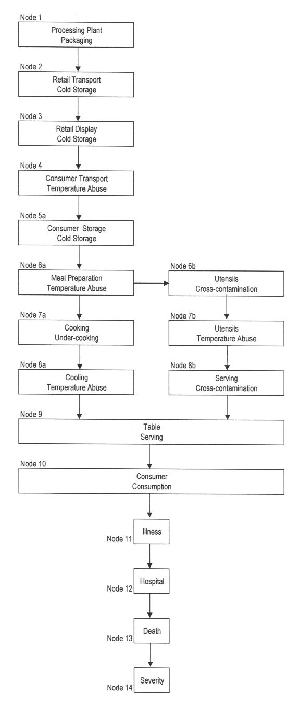
Figure 2
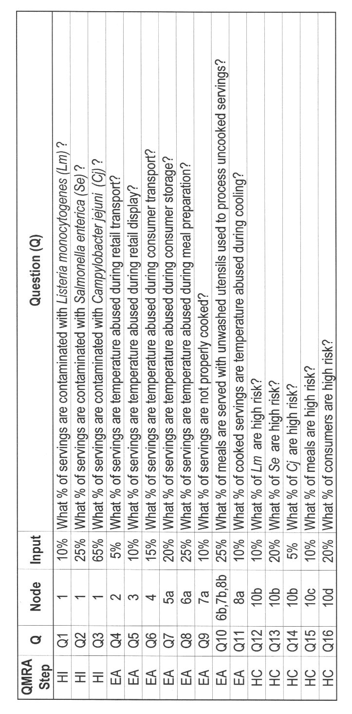
Figure 3
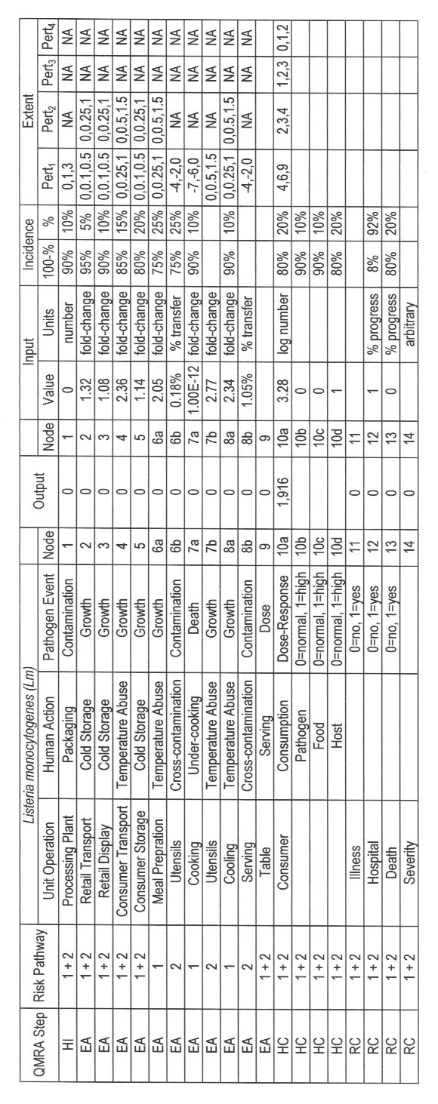
Figure 4
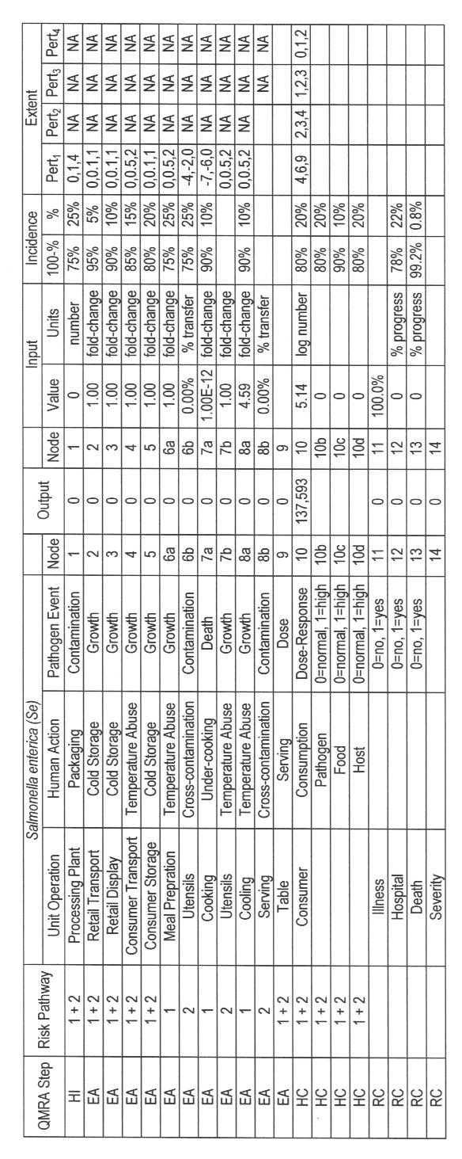
Figure 5
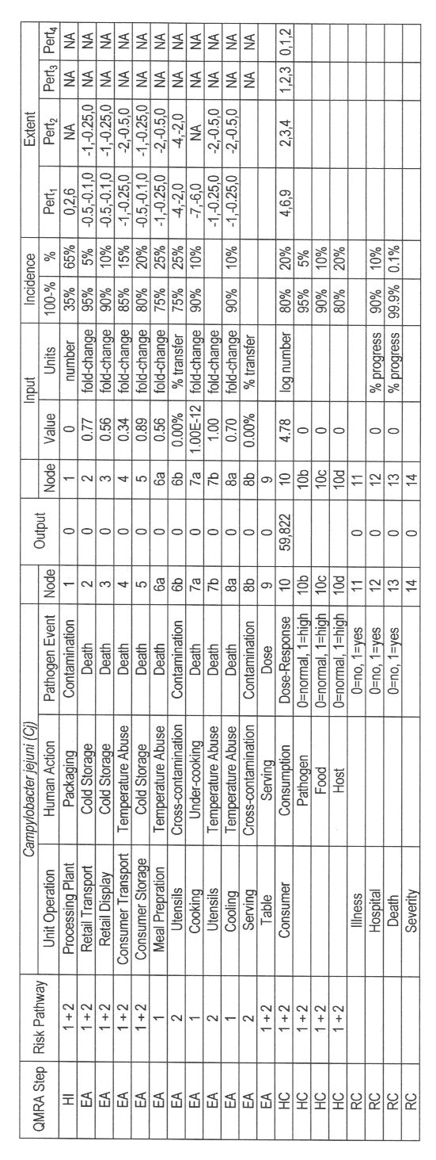
Figure 6
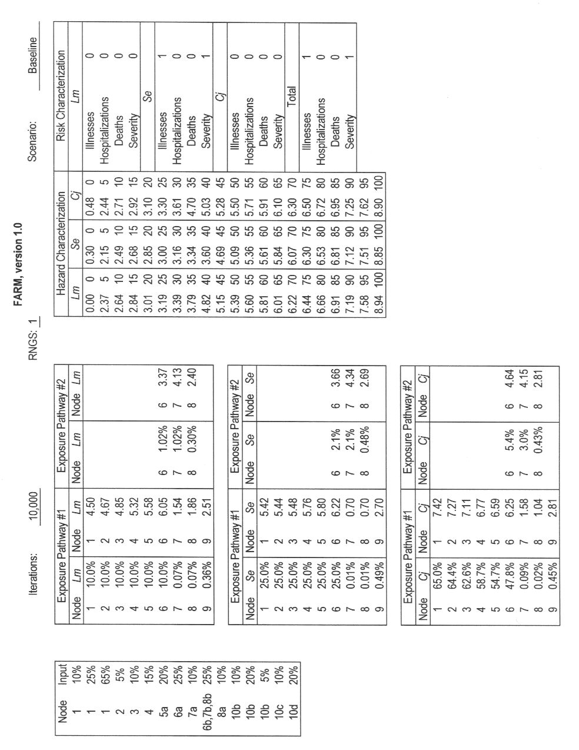
Figure 7
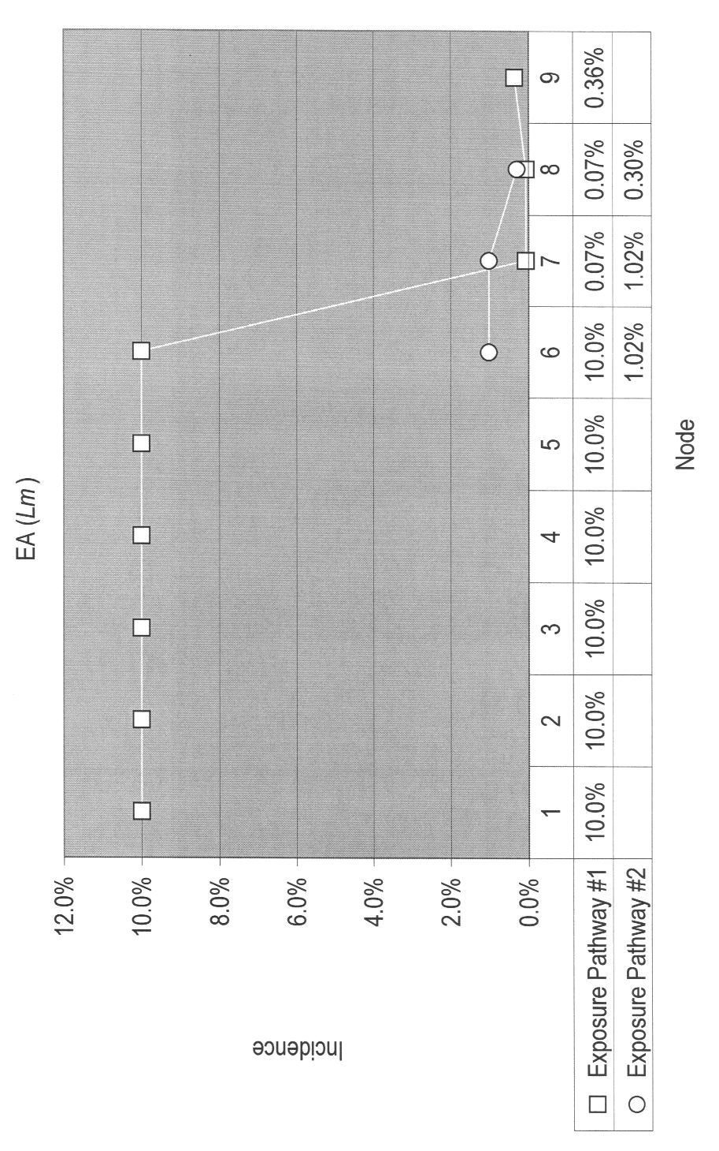
Figure 8
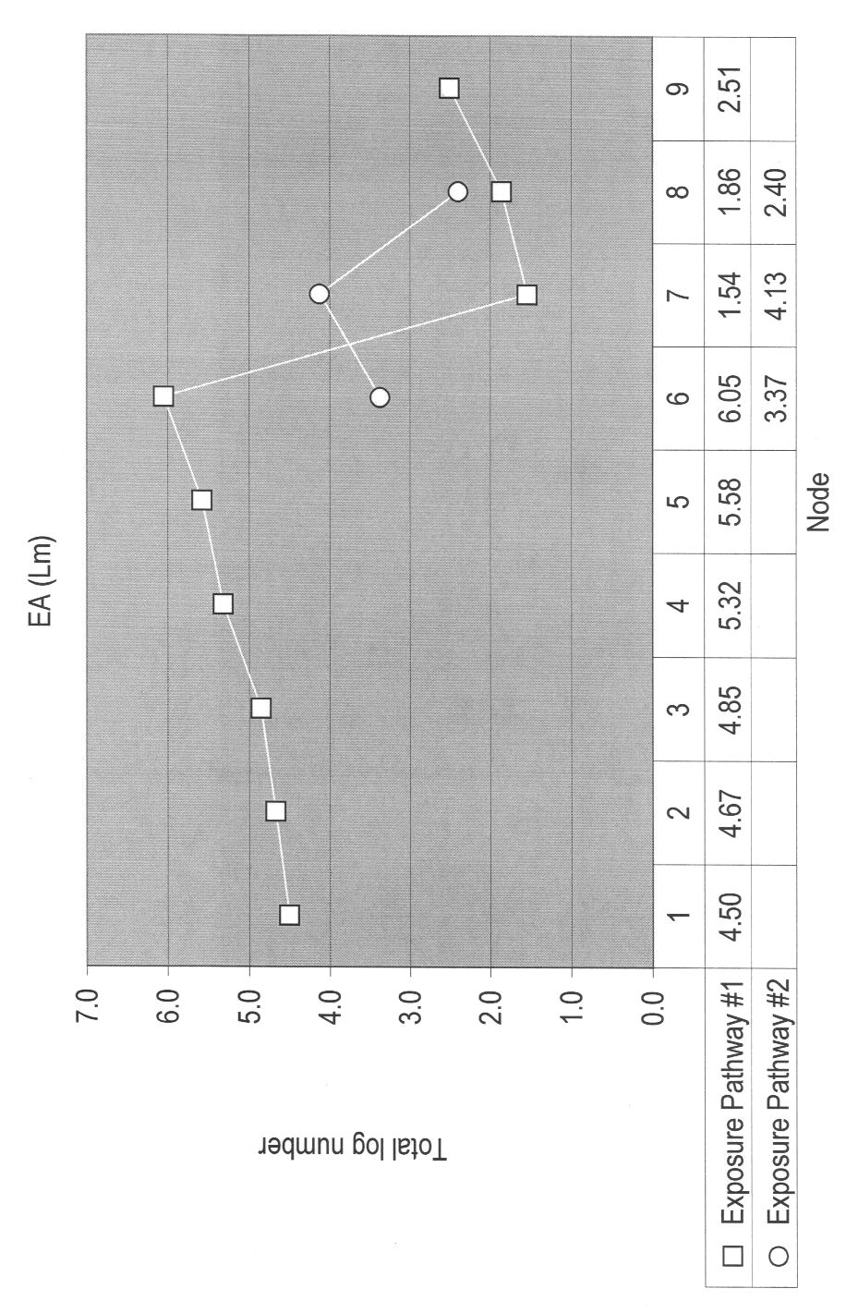
Figure 9
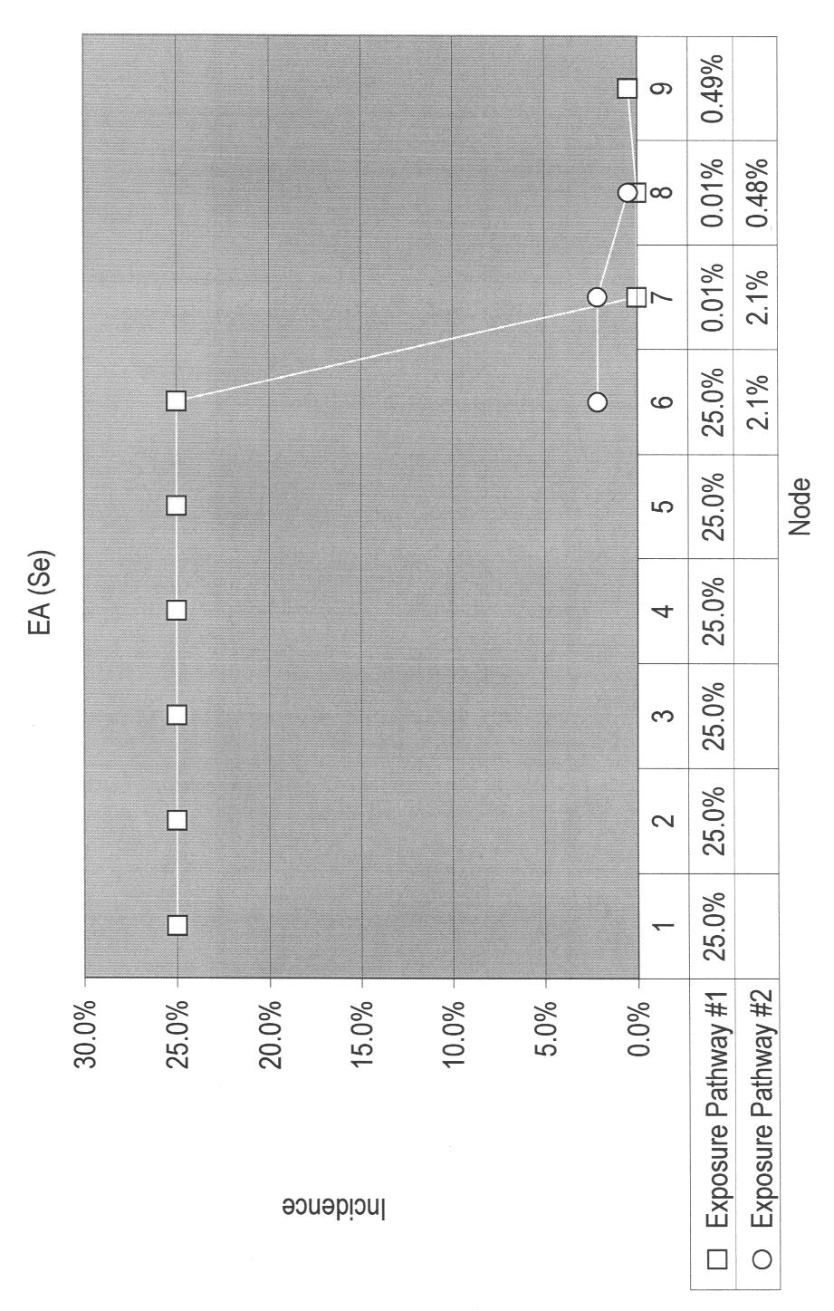
Figure 10
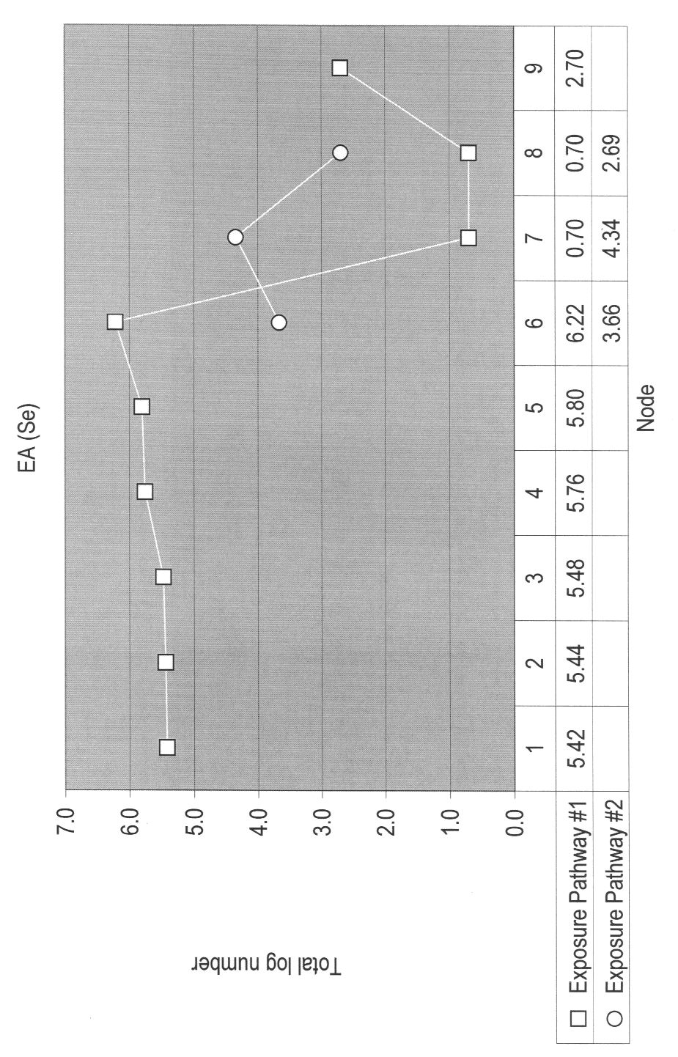
Figure 11
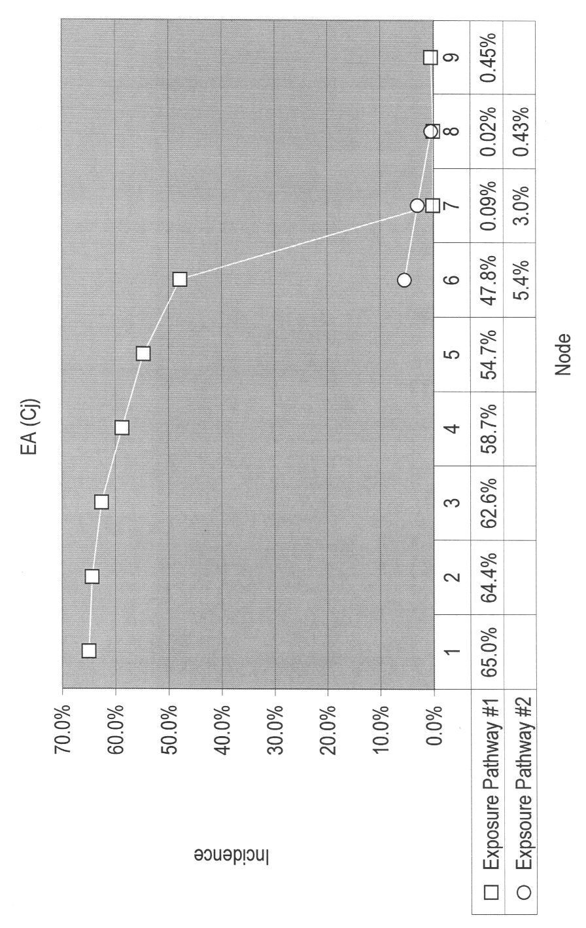
Figure 12
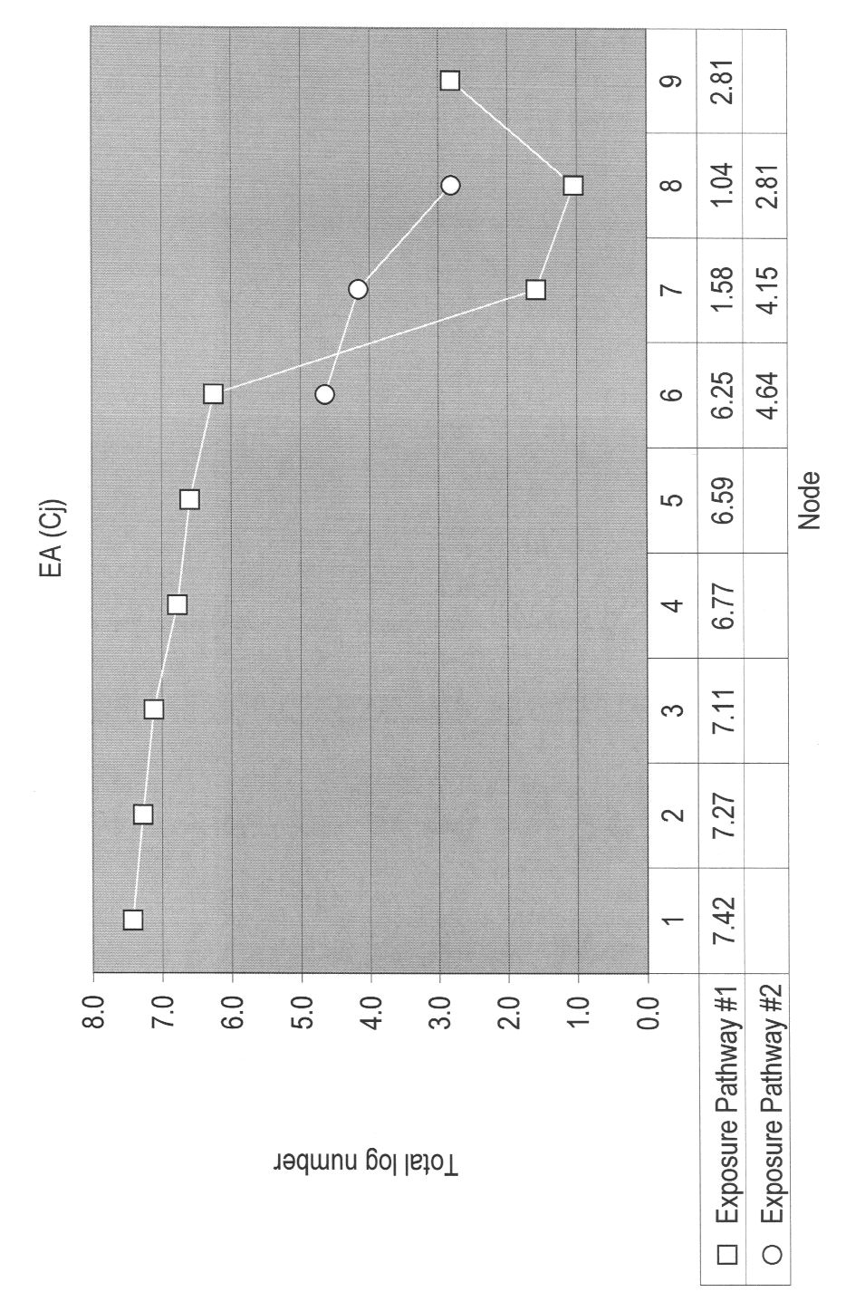
Figure 13
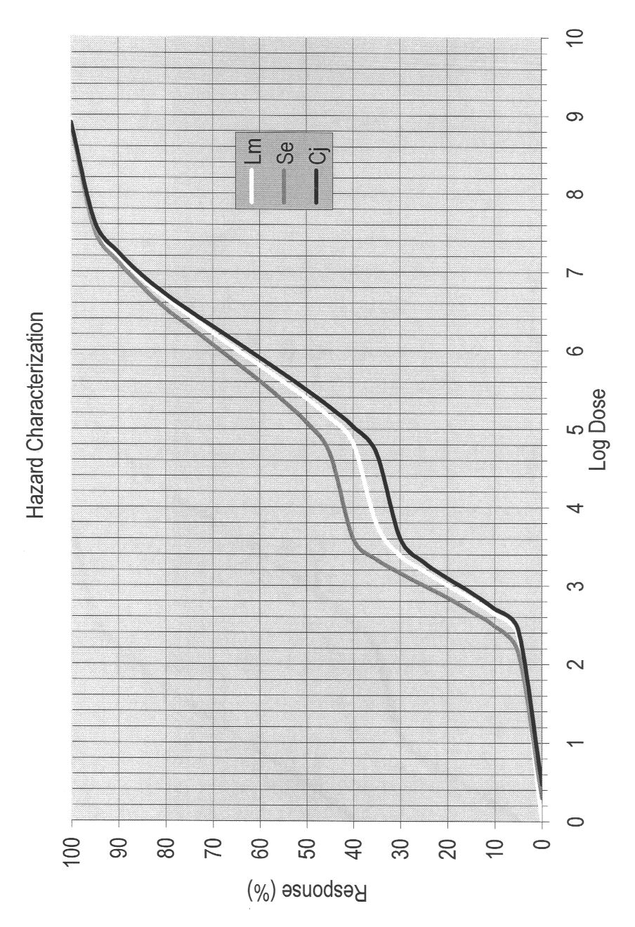
Figure 14
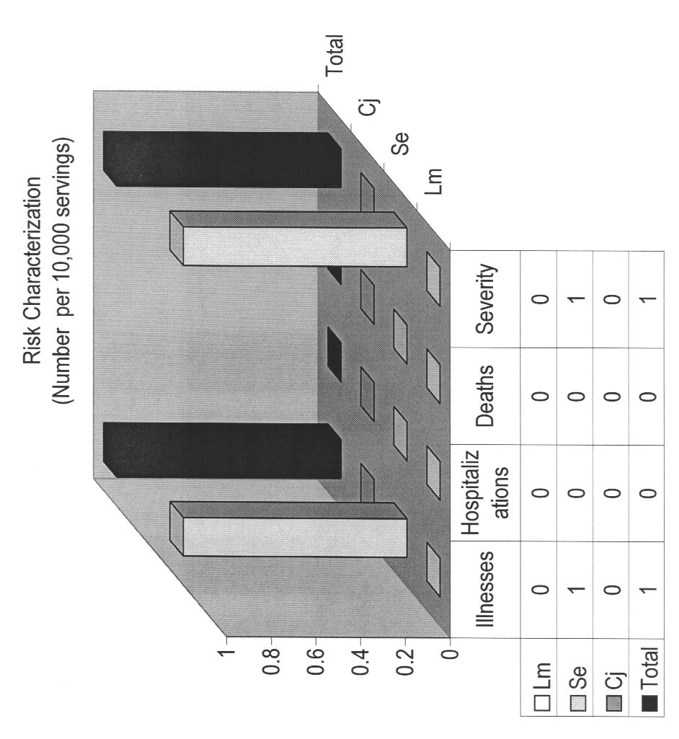
Figure 15
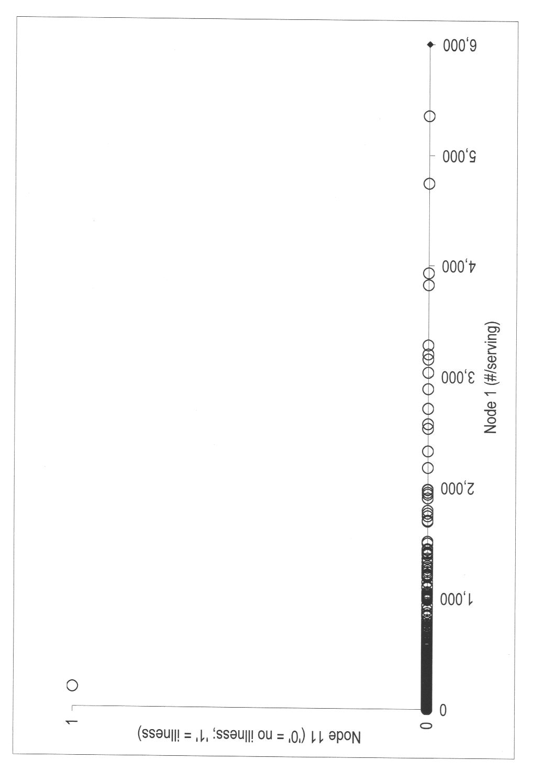
Figure 16
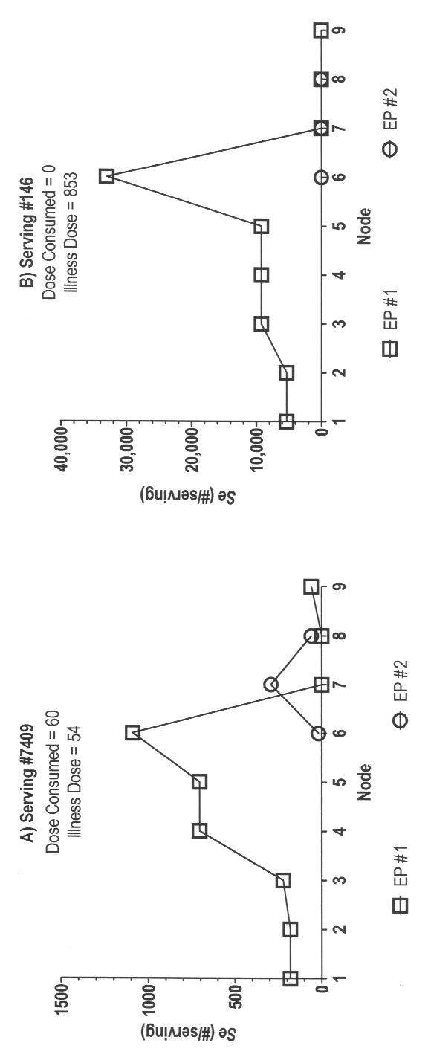
Figure 17
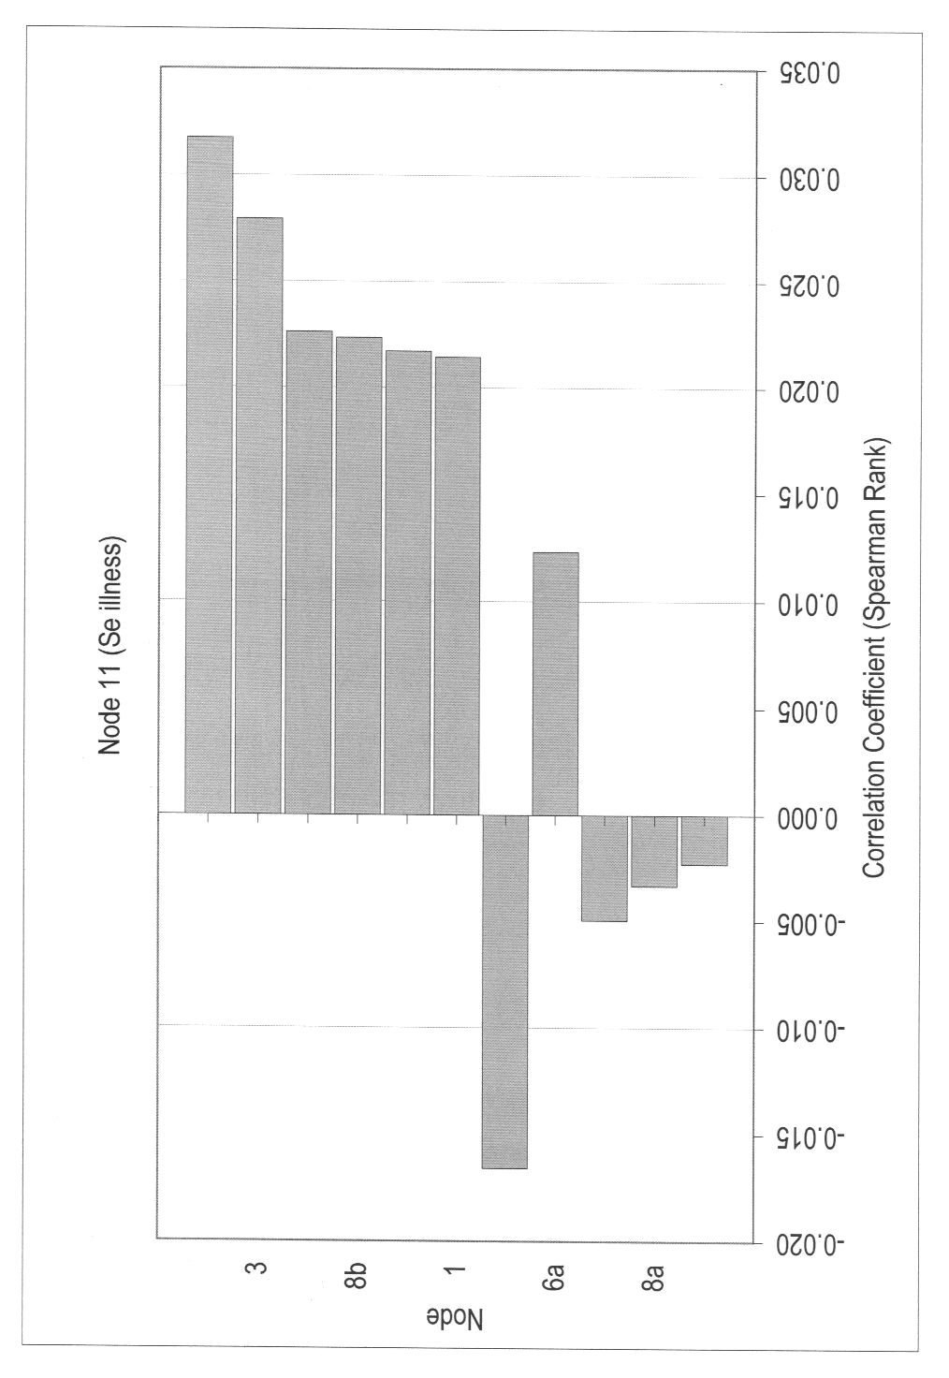
Figure 18
