Food Risk Analysis
Thomas P. Oscar, Ph.D.
U. S. Department of Agriculture, Agricultural Research Service
Thomas.Oscar@ars.usda.gov
Introduction
Risk analysis is a holistic approach to food safety that involves three interactive processes: risk assessment, risk management and risk communication (Dennis et al. 2008). Risk assessment is the scientific process of predicting the risk posed by a hazard, whereas risk management is the process of combining the scientific risk assessment with non-scientific aspects of the problem, such as social, political, cultural and economic considerations, to arrive at a decision of how to manage the risk. Risk communication is the process of informing stakeholders about the risk and how it is being managed (Hallman 2008).
Risk assessment modeling is the foundation of risk analysis and is most often accomplished using Monte Carlo simulation methods to combine existing knowledge and data into a prediction of risk (Vose 1996). The prediction of risk is relative rather than absolute because of knowledge, data and model uncertainty. However, through the process of scenario analysis, relative risk can be assessed and used to help inform risk management decisions.
The purpose of this chapter is to provide an introduction to Monte Carlo simulation methods used in risk assessment modeling and then to provide an example illustrating how risk assessment modeling can be used to provide a relative assessment of risk for informing risk management decisions.
Risk Assessment Modeling Concepts
Risk assessment modeling consists of four steps: 1) hazard identification; 2) exposure assessment; 3) hazard characterization; and 4) risk characterization. The scope and design of a risk assessment model depends on the purpose of the risk assessment and on the food and hazard being evaluated.
Hazard Identification. The first step in building a risk assessment model is to determine the distribution of hazard in the food at some point in the risk pathway. Quantification of a hazard in food is expensive and time consuming and therefore, it is only likely to be performed at one point in the risk pathway. The point in the risk pathway where hazard identification is performed depends on the design and purpose of the risk assessment.
If the hazard is not uniformly distributed in the food, the initial distribution of the hazard will depend on the size of food sample used in hazard identification and will increase in a non-linear fashion as a function of sample size (Oscar 2004c). Therefore, when the hazard is not uniformly distributed in the food, it is recommended that the food unit used in the risk assessment model be the same as the size of food sample used in hazard identification as this will provide the most accurate assessment of relative risk. Alternatively, Monte Carlo simulation methods can be used to extrapolate hazard identification results obtained with one sample size to larger sample sizes (Oscar 2004c).
Exposure Assessment. After hazard identification, risk assessors develop a Monte Carlo simulation model of the risk pathway from hazard identification to consumption and then use the model to predict consumer exposure (Nauta 2008). In microbial risk assessment, the risk pathway consists of a series of process steps and associated hazard events, such as growth and inactivation (Whiting and Buchanan 1997).
Hazard events in food are uncertain (i.e. random), variable (i.e. stochastic) and rare (i.e. occur less than 100% of the time). Modeling of random, stochastic and rare events is accomplished by linking a discrete distribution for incidence of the event with a continuous distribution for extent of the event (Winston 1996). The extent of most hazard events in a microbial risk assessment have either a normal or log normal distribution and thus, a good distribution to use is the pert distribution, which can vary in shape from a normal to a log normal distribution. In addition, the pert distribution is robust and easy to use as it only takes three values (minimum, most likely, maximum) to define it.
Predictive microbiology models that predict growth and inactivation of the microbial hazard as a function of conditions in the risk pathway can be configured and used to define input distributions (i.e. discrete and pert) for hazard events in a microbial risk assessment model (Oscar 2004a). To keep the risk assessment model simple and to reduce simulation time, it is recommended that predictive microbiology models be used outside of the risk assessment model.
Hazard Characterization. When a hazard dose is ingested, whether or not the host has a response and how severe that response is depends on the outcome of the interaction between the hazard, food and host (Coleman and Marks 1998). Knowledge of the dose of hazard that causes a response is obtained from epidemiological investigations and, in the past, from controlled feeding trials with humans (McCullough and Eisele 1951). The response can be acute toxicity, infection, illness, chronic disability (e.g. reactive arthritis), cancer or death.
In most feeding trials a fairly uniform group of humans (e.g. healthy adults) are fed log doses of the hazard in a standard food vehicle and then the percentage of individuals that express the response is determined (McCullough and Eisele 1951). A graph of the percentage of the population expressing the response versus log dose is usually sigmoid in shape (Teunis et al. 1999). The log dose that causes 50% of the population to exhibit the response is the response dose 50 or RD₅₀.
In reality, contaminated food is consumed by a non-uniform population of hosts that includes individuals at high risk for a response to the hazard. In addition, multiple forms of the hazard of different potency are often present in the food, which is consumed with a variety of food and beverage items that can alter the dose-response. In fact, when multiple forms of a hazard with different RD₅₀ are present in food, the population dose-response curve changes from a sigmoid shape to a non-sigmoid shape that reflects the incidence and potency of the hazard forms present (Oscar 2004b).
To model dose-response in a food risk assessment, the random interaction of hazard, food and host is simulated using Monte Carlo methods. Existing data are used to define an array of probability distributions for effects of hazard, food and host factors on response dose (RD):
RD_{i} = Discrete[(f₁, f₂…f_{j}),(x₁, x₂…x_{k})] (1)
x_{k} = Pert(RD_{min},RD₅₀,RD_{max}) (2)
where response dose of the ith food serving (RD_{i}) is a function of the jth frequency of occurrence (f_{j}) of the kth class of hazard, food and host factors (x_{k}) and where RD_{min} is the minimum response dose, RD₅₀ is the median response dose and RD_{max} is the maximum response dose. During simulation of the model, a response dose is randomly determined from equations (1) and (2) for each food unit.
Risk Characterization. In the final step of risk assessment, the hazard identification, exposure assessment and hazard characterization are combined to characterize the risk by predicting the number of responses (R) in the host population:
R_{i} = IF(HD_{i}/RD_{i}<1,0,1) (3)
where HD_{i} is hazard dose and RD_{i} is response dose for the ith food unit and when the ratio of HD to RD is less than one no response (“0”) occurs otherwise a response occurs (“1”).
Risk Assessment Modeling Methods
With the advent of computer software applications for risk assessment it is now possible to develop Monte Carlo simulation models for evaluation and management of food safety risks (Cassin et al. 1998). A Monte Carlo simulation model consists of input distributions, formula and output distributions (McNab 1998). During simulation of the model, input distributions are randomly sampled and the values generated are used in formula to generate output distributions. Each calculation or iteration of the model simulates movement of one food unit through the risk pathway.
In the example presented below, a risk assessment model for a generic food that is contaminated with a generic microbial hazard was developed in an Excel notebook and was simulated using @Risk, a spreadsheet add-in program. The model consists of two spreadsheets: one for hazard identification and exposure assessment (Figure 1) and one for hazard characterization and risk characterization (Figure 2). The formulas used in the model are shown in Tables 1 and 2.
Discrete Distribution. The discrete distribution is used to model the incidence of events in the model. The discrete distribution is defined such that an output of “0” indicates that the event did not occur, whereas an output of “1” indicates that the event occurred. In addition, the discrete distribution is used in hazard characterization to model the frequency of occurrence of the eight combinations of hazard, food and host factors.
Pert Distribution. The pert distribution is used to model the extent of events in the model. Log transformed values are used to define pert distributions so that sampled values more closely reflect the original data; use of untransformed values for data that vary by several orders of magnitude, a common occurrence in microbial risk assessment, results in sampled distributions that do not closely reflect the original data.
Logical Function. Modeling of rare events involves linking discrete and pert distributions using a logical “IF” statement. When the output from the discrete distribution is “0”, the output of the associated pert distribution is not used in the calculation of results, whereas when the output from the discrete distribution is “1”, the output of the associated pert distribution is used in the calculation of results. Use of this logical function nullifies the sensitivity analysis provided by @Risk because it uncouples the correlation between input and output distributions.
“POWER” Function. To simulate uncontaminated servings, the “POWER” function is used to convert log transformed values from pert distributions back to untransformed numbers for calculation of results since it is not possible to take the log of zero. By simulating uncontaminated food units, changes in hazard incidence are predicted and a more realistic simulation of the risk pathway is obtained.
“ROUND” Function. Although chemical hazards can be present in fractional amounts, it is not possible to have a fraction of a microbe. Thus, the “ROUND” function is used to convert output results in microbial risk assessment models to whole numbers. This function also allows contaminated food units to become hazard-free following an inactivation step, such as cooking.
“LOOKUP” Function. In hazard characterization, hazard, food and host factors are classified as normal or high risk and then pert distributions for response dose are defined for each combination of hazard, food and host factors. A discrete distribution is used to model the frequency of occurrence of these combinations. During simulation of the model, the output of the discrete distribution is used in the “LOOKUP” function to determine which output of the pert distributions is used in risk characterization.
@Risk Functions. @Risk is a spreadsheet add-in program that allows use of probability distributions in Excel to describe model variables. In addition, the @Risk function “RiskOutput” allows designation of cells for collection of data for output distributions. After model simulation, results for individual iterations as well as summary statistics are generated by @Risk. These results can be filtered to remove uncontaminated servings; this is a recommended practice because it facilitates calculation of hazard incidence as a function process step.
Scenario Analysis. A scenario in risk assessment modeling is defined as a unique set of input variables. Relative risk is obtained by comparing scenarios. Scenario uncertainty is assessed by using a specified or randomly selected set of random number generator seeds to initiate replicate simulations. The random number generator seed is a number that initiates the random sampling of input distributions. Each random number generator seed generates a unique outcome of the model.
Transparency. The more complex a risk assessment model is, the more difficult it is to make transparent. By keeping the model simple, it is easier to describe the model, assumptions and data used to build it. However, the model should not be so simple that it does not properly simulate the risk pathway.
Risk Analysis Example: Design and Input Settings
In this example, a food company has two processing plants located in different regions of the country but that produce the same food product. End product testing indicated that the food product produced by both plants is contaminated with a single species of a microbial hazard. However, hazard incidence was higher for food from Plant A but only food from Plant B has caused an outbreak in consumers. These observations caused the risk managers in the food company to pose the following risk question: Why did food from plant B cause an outbreak when food from plant B has a lower incidence of the hazard than food from plant A? To answer this question, the food company decided to conduct a risk assessment.
Hazard Identification. As a first step, the food company determined the initial distribution of the hazard in single units of the food at packaging. They found that the incidence of contamination was 25% in Plant A and 10% in Plant B, whereas the extent of contamination in both plants ranged from 0 to 4 log with a most likely level of 1 log per food unit.
Exposure Assessment. After hazard identification, the food company developed a Monte Carlo simulation model to predict consumer exposure. After packaging, the first event in the model was hazard growth during food distribution. A predictive microbiology model that predicted hazard growth in and on the food as a function of storage conditions during product shipping, retail display and consumer transport was used to determine that the incidence of hazard growth in and on the food during distribution was 20% for Plant A and 40% for Plant B and the extent of hazard growth, when it occurred, ranged from 0.1 to 3 log with a most likely value of 1 log per food unit for both plants.
The next event in the model was removal of the hazard by washing during meal preparation. A predictive microbiology model that predicted hazard removal from the food during washing as a function of washing conditions was used to determine that the incidence of hazard removal during washing was 15% for Plant A and 30% for Plant B and the extent of removal of the hazard, when it occurred, ranged from 0.1 to 3 log with a most likely value of 1 log per food unit for both plants.
The next event in the model was cooking of the food. A predictive microbiology model that predicted hazard inactivation during cooking was used to determine that the potential for hazard survival during cooking was 10% for Plant A and 5% for Plant B and the extent of inactivation when the hazard had a chance to survive was the same for both plants and ranged from 0.1 to 7 log with a most likely value of 5 log per food unit.
Cooking conditions that resulted in less than a 7 log reduction in hazard level were considered to present an opportunity for hazard survival. A value of 0.1 log reduction was used to define the minimum extent of inactivation or maximum potential for survival to include the scenario of close to 100% survival for those rare occasions where a portion of the food unit did not receive heat treatment and was consumed raw.
The next event in the model was cross-contamination of the cooked food with hazard removed from the uncooked food by washing. Based on in-house research the food company determined that when a food unit was washed, regardless of the plant of origin, 0.1 to 10% of the removed hazard was transferred to the cooked food and consumed with a most likely transfer rate of 1%. To model cross-contamination during serving and calculate consumer exposure, the food company calculated the amount of hazard removed by washing, multiplied this number by the transfer rate and then added the result to the amount of hazard that survived cooking.
Hazard Characterization. The food company collected data for hazard characterization that included hazard strain, eating habits and consumer demographics. This information was used to classify hazard, food and host effects on response dose as normal or high risk. Hazard was classified as high risk when the hazard strain was one known to cause the response in humans. Food was classified as high risk when the meal consumed with the food was high in fat or when an anti-acid pill was taken with the food. Host effects were classified as high risk when the consumer was from a high risk group, such as very young, very old, diabetic, cancer patient, pregnant etc …
When hazard, food and host effects were classified as normal risk, RD_{min}, RD₅₀ and RD_{max} were set at 4, 6 and 8 log, respectively. When hazard, food or host effects went from normal to high risk, RD_{min}, RD₅₀ and RD_{max} were decreased by 1, 0.5 and 2 log, respectively. When more than one hazard, food or host effect went from normal to high risk, the effect on RD_{min}, RD₅₀ and RD_{max} was additive. The incidence of high risk events for hazard, food, and host effects for Plant A were 20%, 10% and 20%, respectively, whereas for Plant B they were 60%, 10% and 30%, respectively.
Risk Characterization. The risk of an adverse health outcome from consumption of a food unit depends on rare and random events in the risk pathway. It is by random chance which unit of food is contaminated at packaging, temperature abused during distribution, washed during meal preparation, improperly cooked, contaminated with a virulent hazard strain, consumed with a permissive meal and consumed by someone from the high risk population.
In this last step of risk assessment, the randomly determined hazard dose at consumption for a food unit was combined with a randomly selected response dose and the number of responses per 100,000 food units was determined. The model for each scenario (i.e. Plant A and Plant B) was simulated 200 times with @Risk settings of Latin Hypercube sampling, 100,000 iterations and randomly selected and different random number generator seeds for each replicate simulation.
Risk Analysis Example: Results
To assist the risk managers, the risk assessors summarized the results of the risk assessment in a series of tables and graphs.
Hazard Identification and Exposure Assessment. The first graph prepared by the risk assessors for the risk managers showed hazard incidence as a function of process step (Figure 3). As expected, hazard incidence was 25% for Plant A and 10% for Plant B at packaging and did not change during food distribution because microbial growth only changes hazard number and not hazard incidence among food units. Washing during meal preparation caused a slight reduction of hazard incidence to 24% for Plant A and 9.4% for Plant B, whereas cooking caused a dramatic reduction of hazard incidence to 0.11% for Plant A and 0.055% for Plant B. After cooking, hazard incidence among food units increased to 1.55% for Plant A and 1.47% for Plant B due to cross-contamination of the cooked food during serving. Thus, although hazard incidence among food units was 1.5-fold higher in Plant A than Plant B at packaging, hazard incidence at consumption was similar.
The second graph prepared by the risk assessors for the risk managers showed the total hazard number per 100,000 food units as a function of process step (Figure 4). At packaging, total hazard number was 6.37 log for Plant A and 5.97 log for Plant B. However, after distribution, total hazard number increased to 7.27 log for Plant A and 7.16 log for Plant B. Washing before cooking reduced total hazard number to 7.19 log for Plant A and 7.02 log for Plant B, whereas cooking further reduced total hazard number to 3.72 log for Plant A and 2.50 log for Plant B. Cross-contamination of the cooked food during serving increased total hazard number to 4.64 log for Plant A and to 4.72 log for Plant B. Thus, although the total hazard number per 100,000 food units was 1.4-fold higher for Plant A than Plant B at packaging, consumers of food from Plant B were exposed to more hazard units than consumers of food from Plant A because of events that occurred after packaging.
Hazard Characterization. The third graph showed the population dose-response for Plants A and B (Figure 5). The RD₅₀ for Plant B was lower than the RD₅₀ for Plant A because the food from Plant B was more often contaminated with a highly virulent hazard strain and because the consumer population for Plant B had a higher percentage of high risk individuals. Thus, the consumers of food from Plant B were not only exposed to more hazard units, they were also more likely to have a response to hazard exposure than consumers of food from Plant A.
Risk Characterization. In fact, results of the simulation indicated that the predicted number of responses per 100,000 food units was 4 for Plant A and 6 for Plant B. To help the risk managers understand the latter result, the risk assessors prepared a summary (Table 3) of those iterations that resulted in a response. The identified risk factors from this summary were: 1) contamination of the food at packaging with > 50 hazard units; 2) growth of the hazard by > 1 log during distribution, 3) cross-contamination of the cooked food with the hazard, and 4) contamination of the cooked food with a high risk hazard strain and consumption of the food unit by a high risk host without (class 6) or with (class 8) a high risk food factor.
Finally, to assess the uncertainty of the public health impact due to rare and random events in the risk pathway, the food company performed 200 replicate simulations of the scenarios for Plants A and B using randomly selected and different random number generator seeds to initiate each replicate simulation. The results of this analysis confirmed that the risk from food produced by Plant B was higher than the risk posed by food from Plant A. The median level of risk was 3.0 cases per 100,000 (range: 0 to 11) for Plant A and 7.5 cases per 100,000 (range of 1 to 14) for Plant B. The overlap in the distributions for response rate indicated that by random chance, the risk posed by food from Plant B could be less than the risk posed by food from Plant A.
Risk Management and Communication. These results indicated to the risk managers that they needed to focus more attention on Plant B and that they needed to take a multi-hurdle approach to control the food safety risk that included interventions during production and processing to reduce the level of hazard in and on the food at packaging and interventions to reduce growth of the hazard during distribution to consumers.
A dilemma for the risk managers was the finding that washing of the food before cooking, which was previously believed to be a good food safety practice and was promoted by the company, actually increased the food safety risk. Thus, they had to effectively communicate to consumers that to reduce the food safety risk they should not wash the food before cooking in contrast to what they had been told before. They were not sure how this would be received by their customers and what effect it might have on consumer confidence in their company and product.
Nonetheless, the food company was pleased with the risk assessment because it demonstrated to them the importance of taking a holistic look at their food safety risk. Had they only looked at hazard incidence at packaging, the food company would not have detected and been able to properly manage the higher relative risk posed by the food produced by Plant B.
Summary
Food risk analysis is a holistic approach to food safety because it considers all aspects of the problem. Risk assessment modeling is the foundation of food risk analysis. Proper design and simulation of the risk assessment model is important to properly predict and control risk. Because of knowledge, data and model uncertainty, risk assessment models provide a relative rather than absolute assessment of risk. Nonetheless, through the process of scenario analysis, risk management options can be evaluated and risk management decisions aimed at improving public health can be made. Good risk management and communication involves active listening and sound decision making to address not only risk problems but also risk perceptions.

Figure 1. Excel spreadsheet model for hazard identification and exposure assessment. The food unit in this iteration was initially contaminated with 79 hazard units at packaging. During food distribution the food unit was temperature abused resulting in a 1.1 log increase in hazard number to 1,055 hazard units. The food unit was washed before cooking and this resulted in a 1.6 log reduction of the hazard number to 27 hazard units. The food unit was properly cooked resulting in death of all 27 hazard units. However, during serving the cooked food unit was contaminated with 12 hazard units that were removed during washing of the uncooked food unit. The transfer rate was 1.1%.
Figure 2. Excel spreadsheet model for hazard characterization and risk characterization. The food unit in this iteration was contaminated with a high risk strain of the hazard, was consumed with high risk food or beverage items and was consumed by someone from the high risk population (i.e. class 8 – hazard_food_host). The response dose was 1,662, whereas the hazard dose was 12 (Figure 1) and thus, the consumer did not have an adverse health response from consumption of the food unit.
Figure 3. Hazard incidence results for food produced by Plants A and B. The results were obtained with a single simulation of each scenario using @Risk settings of Latin Hypercube sampling, 100,000 iterations and a random number generator seed of 3.
Figure 4. Hazard number results for food produced by Plants A and B. The results are from a single simulation of each scenario using @Risk settings of Latin Hypercube sampling, 100,000 iterations and a random number generator seed of 3. Hazard number refers to the total number of hazard units among the 100,000 food units in the simulation.
Figure 5. Hazard characterization results for Plants A and B where RD₅₀ is the hazard dose at which 50% of the population exhibits a response to the hazard. The results are from a single simulation of each scenario using @Risk settings of Latin Hypercube sampling, 100,000 iterations and a random number generator seed of 3.
Figure 6. Risk characterization results for Plants A and B showing the frequency distribution of response rate for 200 replicate simulations generated using randomly selected random number generator seeds.
References
Cassin MH, Lammerding AM, Todd ECD, Ross W, McColl RS. 1998. Quantitative risk assessment for Escherichia coli O157:H7 in ground beef hamburgers. Int J Food Microbiol 41:21-44.
Coleman ME, Marks HM. 1998. Topics in dose-response modeling. J Food Prot 61:1550-1559.
Dennis SB, Kause J, Losikoff M, Engeljohn DL, Buchanan RL. 2008. Using risk analysis for microbial food safety regulatory decision making. In: Schaffner DW, editor. Microbial Risk Analysis of Foods. Washington, D.C.: ASM Press.p 137-175.
Hallman WK. 2008. Communicating about the microbial risks in foods. In: Schaffner DW, editor. Microbial Risk Analysis of Foods. Washington, D.C.: ASM Press.p 205-262.
McCullough NB, Eisele CW. 1951. Experimental human salmonellosis. I. Pathogenicity of strains of Salmonella meleagridis and Salmonella anatum obtained from spray-dried whole egg. J Infect Dis 88:278-279.
McNab WB. 1998. A general framework illustrating an approach to quantitative microbial food safety risk assessment. J Food Prot 61:1216-1228.
Nauta MJ. 2008. The modular process risk model (MPRM): a structured approach to food chain exposure assessment. In: Schaffner DW, editor. Microbial Risk Analysis of Foods. Washington, D.C.: ASM Press.p 99-137.
Oscar TP. 2004a. A quantitative risk assessment model for Salmonella and whole chickens. Int J Food Microbiol 93:231-247.
Oscar TP. 2004b. Dose-response model for 13 strains of Salmonella. Risk Anal 24:41-49.
Oscar TP. 2004c. Simulation model for enumeration of Salmonella on chicken as a function of PCR detection time score and sample size: implications for risk assessment. J Food Prot 67:1201-1208.
Teunis PFM, Nagelkerke NJD, Haas CN. 1999. Dose response models for infectious gastroenteritis. Risk Analysis 19:1251-1260.
Vose D. 1996. Qunatitative Risk Analysis. A Guide to Monte Carlo Simulation Modeling. West Sussex: John Wiley & Sons.
Whiting RC, Buchanan RL. 1997. Development of a quantitative risk assessment model for Salmonella enteritidis in pasteurized liquid eggs. Int J Food Microbiol 36:111-125.
Winston WL. 1996. Simulation Modeling Using @Risk. Belmont: Wadsworth Publishing Co.

Table 1. Formula used in the hazard identification and exposure assessment spreadsheet A
Column_row | Formula
C5 | =ROUND(IF(D5=0,0,E5),0)
C6 | =ROUND(IF(D6=0,C5,(E6*C5)),0)
C7 | =ROUND(IF(D7=0,C6,(E7*C6)),0)
C8 | =ROUND(IF(D8=0,0,(E8*C7)),0)
C9 | =ROUND((IF(D9=0,C8,E9*(C6-C7)+C8)),0)
D5 | =RiskDiscrete({0,1},C15:D15)
D6 | =RiskDiscrete({0,1},C16:D16)
D7 | =RiskDiscrete({0,1},C17:D17)
D8 | =RiskDiscrete({0,1},C18:D18)
D9 | =D7
E5 | =POWER(10,RiskPert(E15,F15,G15))
E6 | =POWER(10,RiskPert(E16,F16,G16))
E7 | =POWER(10,RiskPert(G17,F17,E17))
E8 | =POWER(10,RiskPert(G18,F18,E18))
E9 | =POWER(10,RiskPert(E19,F19,G19))

Table 2. Formula used in the hazard characterization and risk characterization spreadsheet B
Column/row | Formula
D2 | =RiskDiscrete({1,2,3,4,5,6,7,8},D7:D14)
D3 | =ROUND(LOOKUP(D2,H7:I14),0)
G2 | =RiskOutput("Response")+IF(A!C9/D3<1,0,1)
H2 | =IF(G2=0,"No","Yes")
I7 | =POWER(10,RiskPert(E7,F7,G7))
I8 | =POWER(10,RiskPert(E8,F8,G8))
I9 | =POWER(10,RiskPert(E9,F9,G9))
I10 | =POWER(10,RiskPert(E10,F10,G10))
I11 | =POWER(10,RiskPert(E11,F11,G11))
I12 | =POWER(10,RiskPert(E12,F12,G12))
I13 | =POWER(10,RiskPert(E13,F13,G13))
I14 | =POWER(10,RiskPert(E14,F14,G14))

Table 3. Simulation results for iterations that resulted in an adverse health response.
 |  | Hazard Number per Food Unit
Plant | Iteration | Packaging | Distribution | Washing | Cooking | Serving | Class | Response Dose
A | 9,904 | 1,451 | 300,130 | 36,260 | 0 | 5,945 | 7 | 3,065
A | 64,376 | 202 | 4,539 | 27 | 0 | 23 | 8 | 22
A | 69,075 | 316 | 5,714 | 3,214 | 0 | 20 | 8 | 7
A | 93,039 | 100 | 1,191 | 173 | 0 | 28 | 8 | 15
B | 53,459 | 52 | 4,045 | 509 | 0 | 81 | 6 | 67
B | 65,115 | 62 | 5,188 | 343 | 0 | 111 | 6 | 111
B | 69,075 | 316 | 5,714 | 3,214 | 0 | 20 | 8 | 7
B | 71,656 | 668 | 92,965 | 13,705 | 0 | 948 | 6 | 347
B | 87,865 | 153 | 3,446 | 611 | 0 | 110 | 6 | 106
B | 93,039 | 100 | 1,191 | 173 | 0 | 28 | 8 | 15

Fig. 1

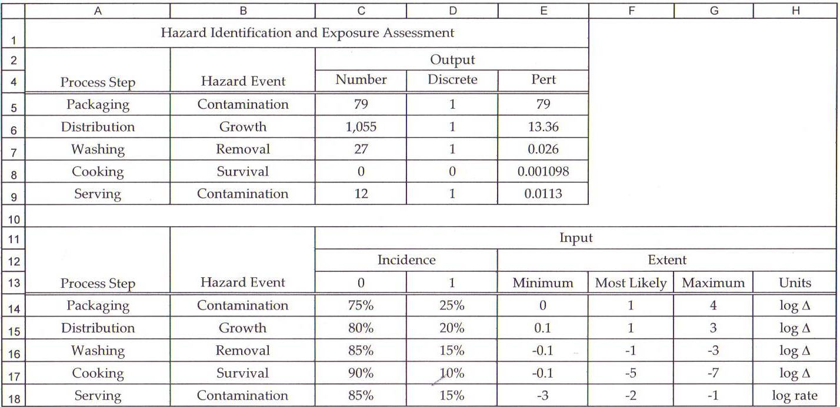
Fig. 2

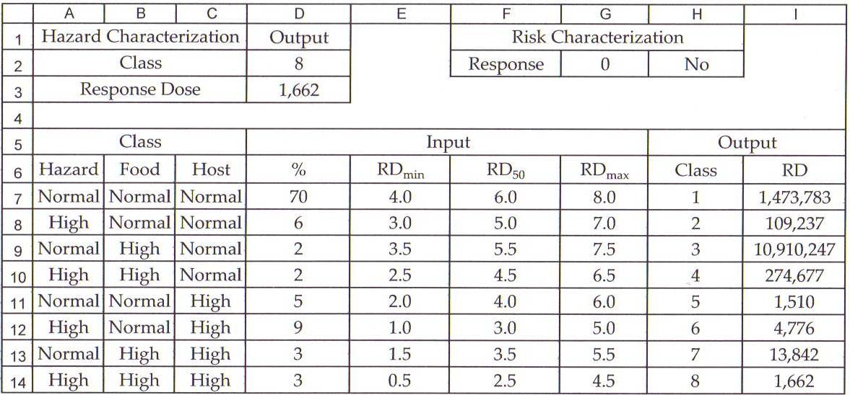

Fig. 3
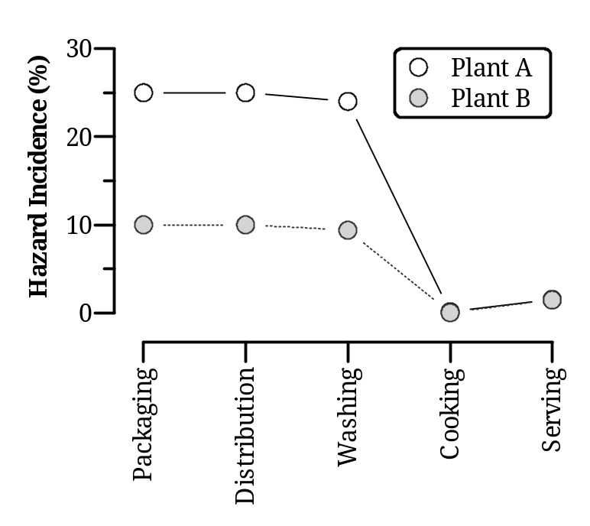

Fig. 4
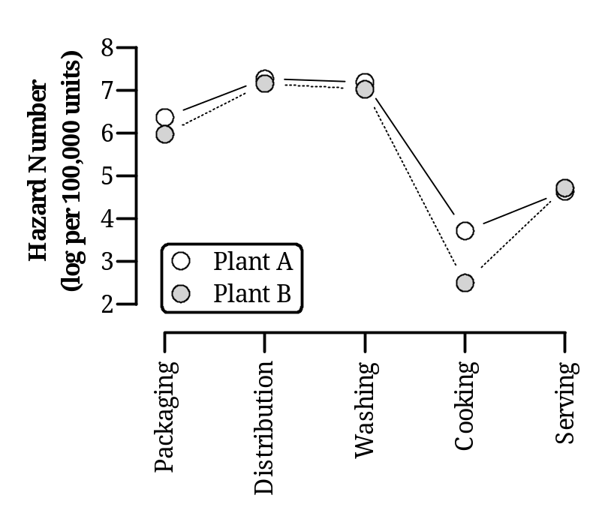

Fig. 5
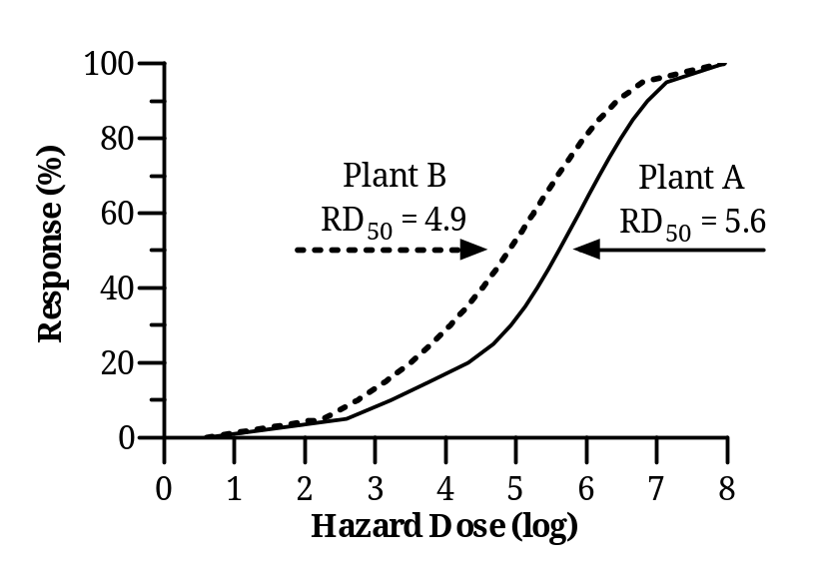
Fig. 6
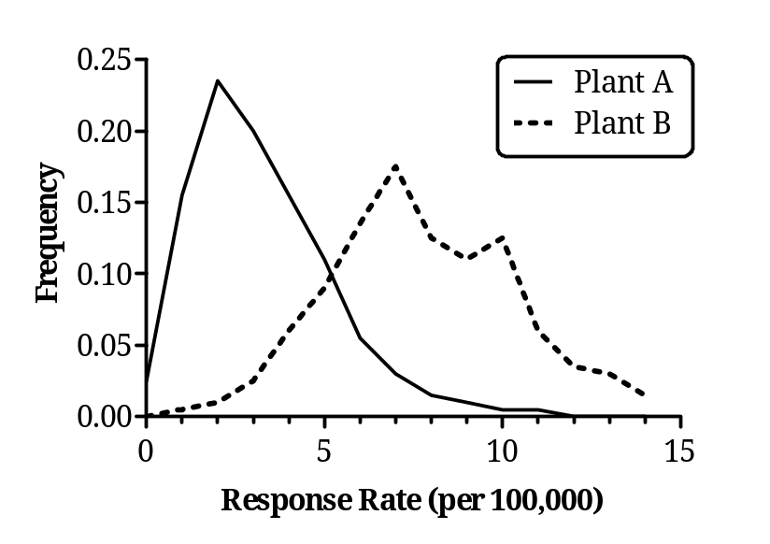

Mention of trade names or commercial products in this publication is solely for providing specific information and does not imply recommendation or endorsement by the U.S. Department of Agriculture.
Palisade Corporation, Newfield, New York.

