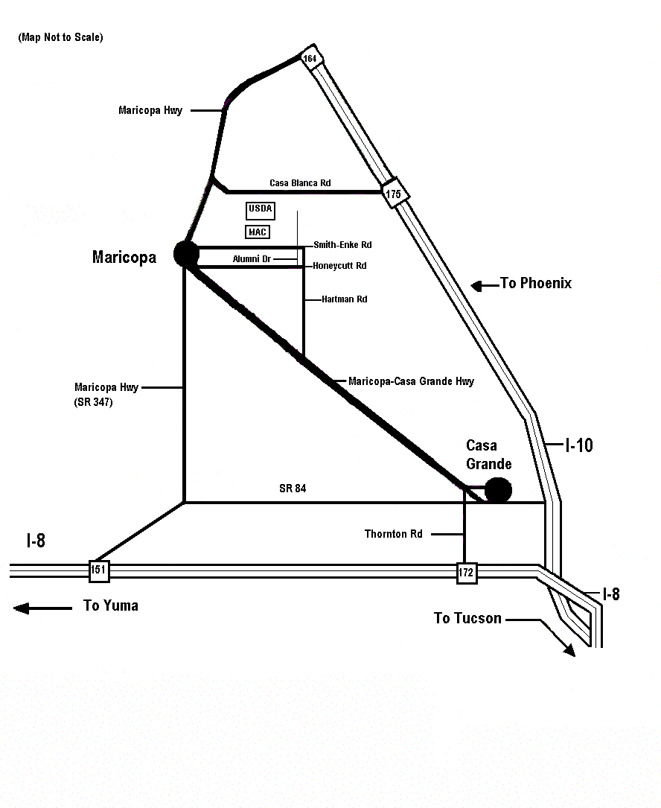

From Phoenix:
1. East on I-10, Take Exit 164
2. Take Maricopa Hwy to Maricopa
3. Turn left (East) at the 3rd stop light onto Smith-Enke Rd
4. Travel 4 miles
5. Turn left (North) on Cardon Lane to U. S. Arid-Land Ag. Res. Center

From Tucson:
1. West on I-10, Take Exit 199 (I-8) to San Diego
2. Take Exit 172 onto Thornton Rd
3. Go North on Thornton Rd to Cottonwood
4. Turn West (left) onto Cottonwood (becomes Maricopa-CG Hwy)
5. Go to White and Parker Rd (approx. 15 miles), turn right (North)
6. Go to Smith-Enke (approx 3.3 miles), turn right (East)
7. Go 1.3 miles, turn left (North) on Cardon Lane to U. S. Arid-Land Ag.
Res. Center

From Yuma:
1. Take Exit 151 into Maricopa
2. Turn right (East) onto Smith-Enke Rd
3. Travel 4 miles
4. Turn left (North) on Cardon Lane to U. S. Arid-Land Ag. Res. Center

U. S. Arid-Land Agricultural Research Center

21881 North Cardon Lane
Maricopa, AZ 85238
Tel: 520-316-6300

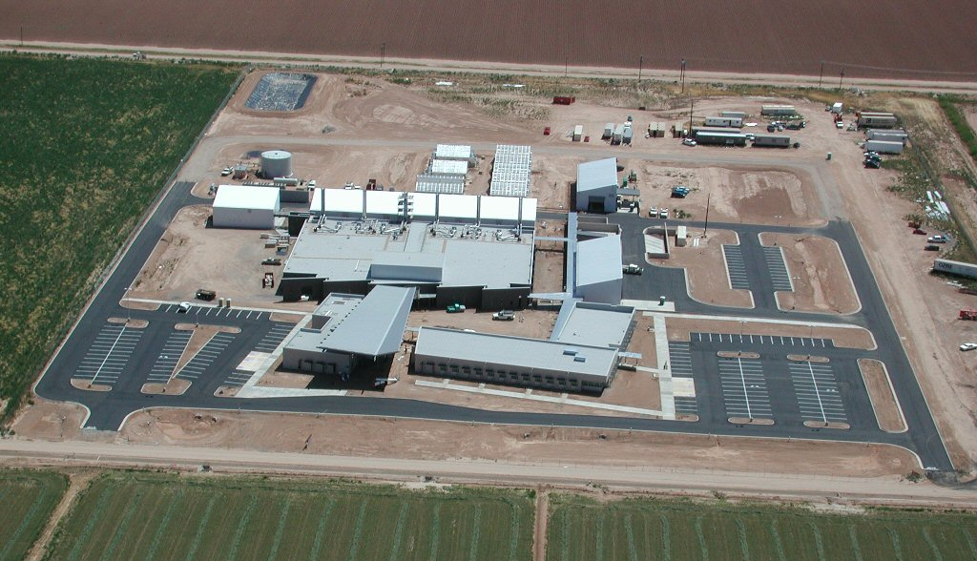
GPS Coordinates:

Latitude = 33.077006 (N 33° 04’ 37’’)
Longitude =-111.973722 (W 111° 58’ 26’’)

Maricopa, AZ

